
Township Foundation Education Centre
P.O. Box 128-40303
Rangwe, Kenya
Mobile: +254 728 583 739 or +254 713 181 678
Email: townshipeducationcenter@gmail.com
Website: www.townshipedufoundation.org
DONATION SUMMARY REPORT
ACKNOWLEDGEMENT
Township Foundation Education Centre management acknowledges with great honor the receipt of donations worth USD 6,101.46 in the months of April (GlobalGiving Accelerator program) through June 2021 from Nike employees via Benevity and individual donors driven through GlobalGiving fundraiser program. We admit that some people make choices that change lives, thank you for being one of them; your donations have indeed changed lives our children and community at large.
APPRECIATION AND ACHIEVEMENTS
We Township Foundation Education Centre do register our gratitude to the Nike employees via Benevity and individual donors for the support they continually give to our children and to the community at large. We truly recognize and appreciate the GlobalGiving for giving us the fundraising platform. The support we got is greatly changing the lives of our young ones; they are able to enjoy and appreciate the good food, this has improved their health status especially the once who would eat one meal at school. The toilet once complete will help reduce cases associated with poor sanitation around the school, in the recent past we have had incidences of diarrhea. The classrooms started once complete will ease the congestion in school and some will move from iron sheet structures (mabati structures) which are very hot and congested during the day to good classrooms.
We have been able to utilize adequately the funds given to us putting into consideration the great need of our children and society, the management through the little farming we do was able to supplement but still very far from reaching our goal.
The analysis and pictures below will highlight how the money was spent as per our budget and direction from our donor.

ANALYSIS OF FUNDS UTILIZATION
GLOBAL GIVING APRIL 2021 ACCELERATOR FUNDS-May 27th 2021 disbursement
Amount Disbursed=$2,126.46
NO | DESCRIPTION | AMOUNT ($) | ITEMS | QUANTITY | DISTRIBUTION
1 | Feeding Program; Food items and other related costs. | 1701.16 | Maize | 10 sacks | USD 400
1 | Feeding Program; Food items and other related costs. | 1701.16 | Beans | 10 Sacks | USD 800
1 | Feeding Program; Food items and other related costs. | 1701.16 | Milk | 4 Cartons | USD 20
1 | Feeding Program; Food items and other related costs. | 1701.16 | Meat | 81.29 Kgs | USD 325.16
1 | Feeding Program; Food items and other related costs. | 1701.16 | Eggs | 20 crates | USD 66
1 | Feeding Program; Food items and other related costs. | 1701.16 | Vegetables | Bundles | USD 20
1 | Feeding Program; Food items and other related costs. | 1701.16 | Cooking Oil | 40ltrs | USD 70
Sub –Total |  |  |  |  | USD 1701.16
2 | Repair of School latrines | 425.30 | Cement | 20 Bags | USD 120
2 | Repair of School latrines | 425.30 | Sand | 1 Canter | USD 80
2 | Repair of School latrines | 425.30 | Ballasts | 1 Pick up | USD 70
2 | Repair of School latrines | 425.30 | D10,D8,Binding Wire |  | USD 65
2 | Repair of School latrines | 425.30 | Water | 1000ltrs | USD 10
2 | Repair of School latrines | 425.30 | Plain polythene | 1roll | USD 10
2 | Repair of School latrines | 425.30 | Weld Mesh | 1roll | USD 40
2 | Repair of School latrines | 425.30 | Labour |  | USD 30.3
Sub-Total |  |  |  |  | USD 425.30
GRAND TOTAL |  |  |  |  | USD 2,126.46

CONSTRUCTION OF LATRINES
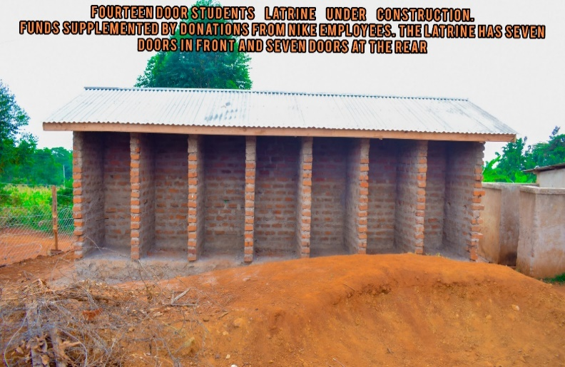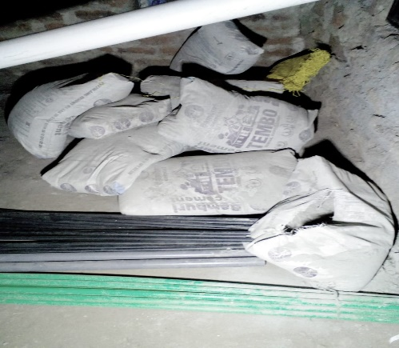

FEEDING PROGRAM
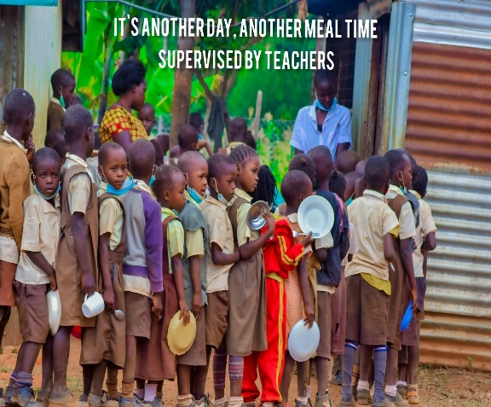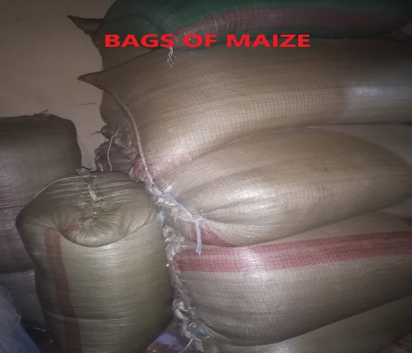
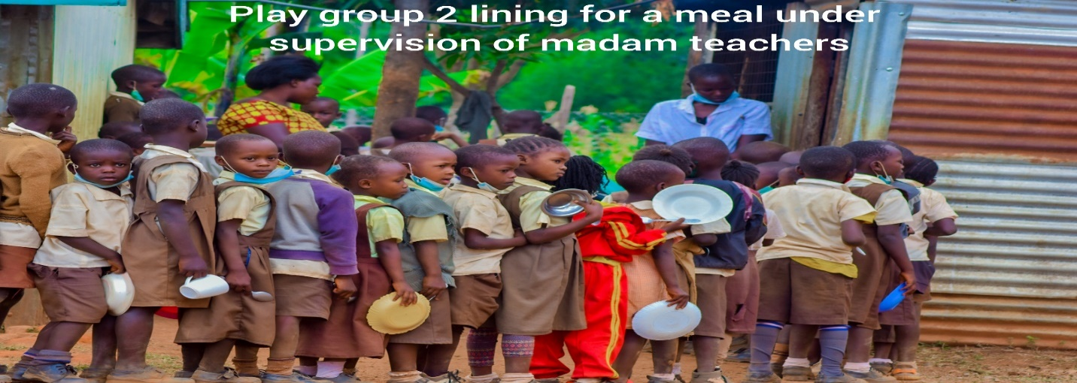

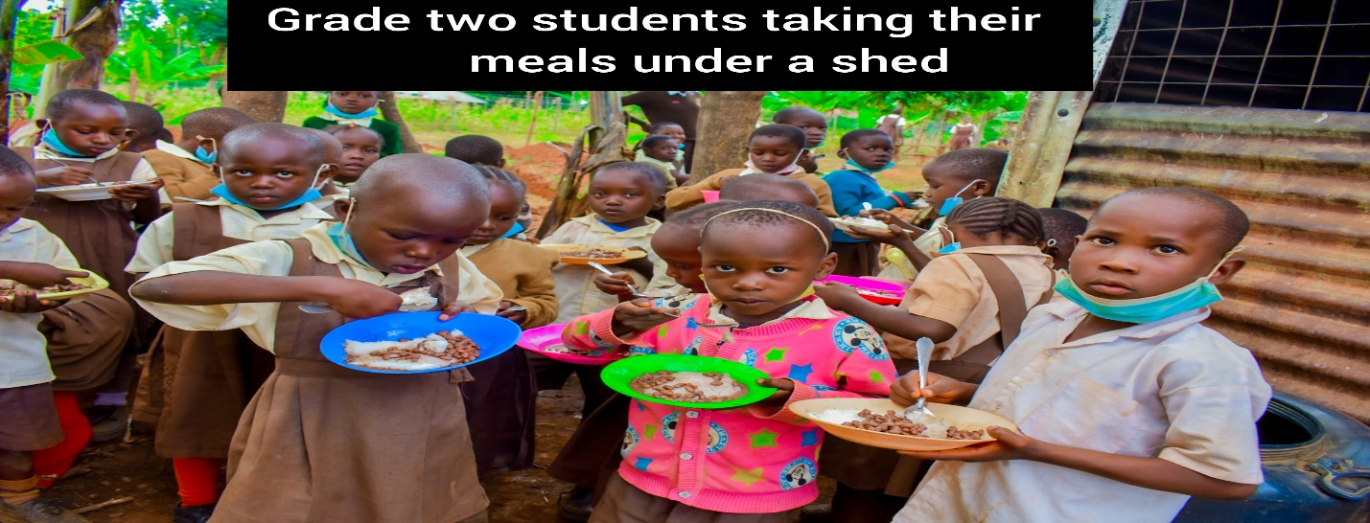

Donations from Nike employees via Benevity through Global Giving –June 25th 2021 disbursement
Amount Disbursed=$ 3,975.00
NO | DESCRIPTION | AMOUNT($) | ITEMS | QUANTITY | DISTRIBUTION
1 | Foundation for 5 class rooms | 1,987.50 | Sand | 3 Faw | USD 780
1 | Foundation for 5 class rooms | 1,987.50 | Ballast | 2 canter | USD 280
1 | Foundation for 5 class rooms | 1,987.50 | Cement | 60 bags | USD 360
1 | Foundation for 5 class rooms | 1,987.50 | D10,D12,Binding Wire |  | USD 200.50
1 | Foundation for 5 class rooms | 1,987.50 | BRC |  | USD 77
1 | Foundation for 5 class rooms | 1,987.50 | Water | 3000ltrs | USD 60
1 | Foundation for 5 class rooms | 1,987.50 | Plain polythene | 3rolls | USD 30
1 | Foundation for 5 class rooms | 1,987.50 | Labor |  | USD 200
Sub Total |  |  |  |  | 1,987.50
2 | Feeding Program | 1,788.75 | Maize | 11 sacks | USD 440
2 | Feeding Program | 1,788.75 | Beans | 10 sacks | USD 800
2 | Feeding Program | 1,788.75 | Milk | 4 Cartons | USD 20
2 | Feeding Program | 1,788.75 | Meat | 81kgs | USD 324
2 | Feeding Program | 1,788.75 | Eggs | 20 crates | USD 66
2 | Feeding Program | 1,788.75 | Vegetables |  | USD 20
2 | Feeding Program | 1,788.75 | Cooking Oil | 40ltrs | USD 70
2 | Feeding Program | 1,788.75 | Clean Water | 243.75lts | USD 48.75
Sub Total |  |  |  |  | USD 1,788.75
3 | Health care and Sanitary towels for girls | 198.75 | Medication |  | USD 98.75
3 | Health care and Sanitary towels for girls | 198.75 | Sanitary pads | 200packs | USD 100
Sub Total |  |  |  |  | USD 198.75
GRAND TOTAL |  |  |  |  | USD 3,975.00

NOTES:
- Number of Pupils- 475
- Both feeding and construction of both the foundations were supplemented by the school administration and from other sources totaling to USD 2000
- The two meals per child will run up to mid-September 2021

SCHOOL GATE
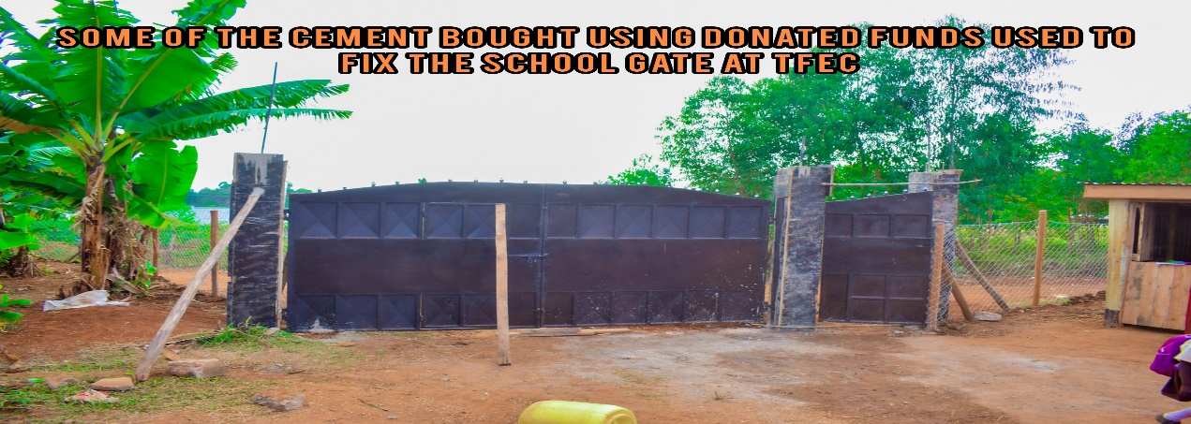
FOUNDATION FOR 5 CLASSROOMS
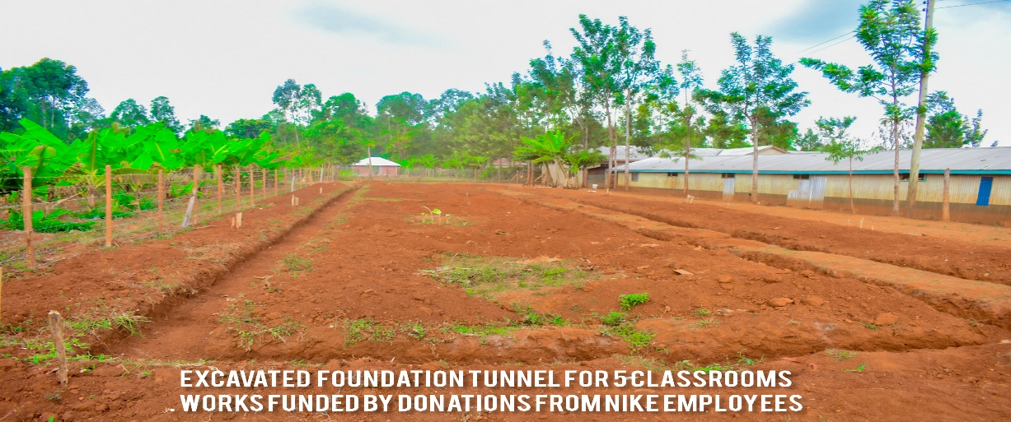

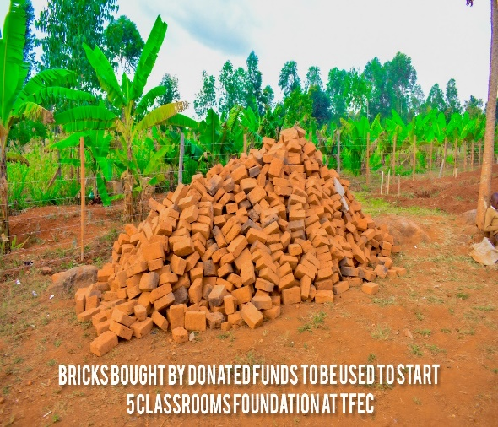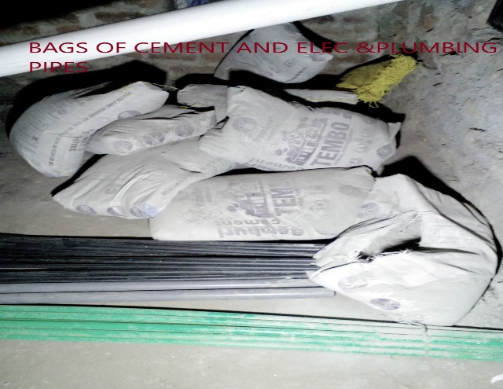

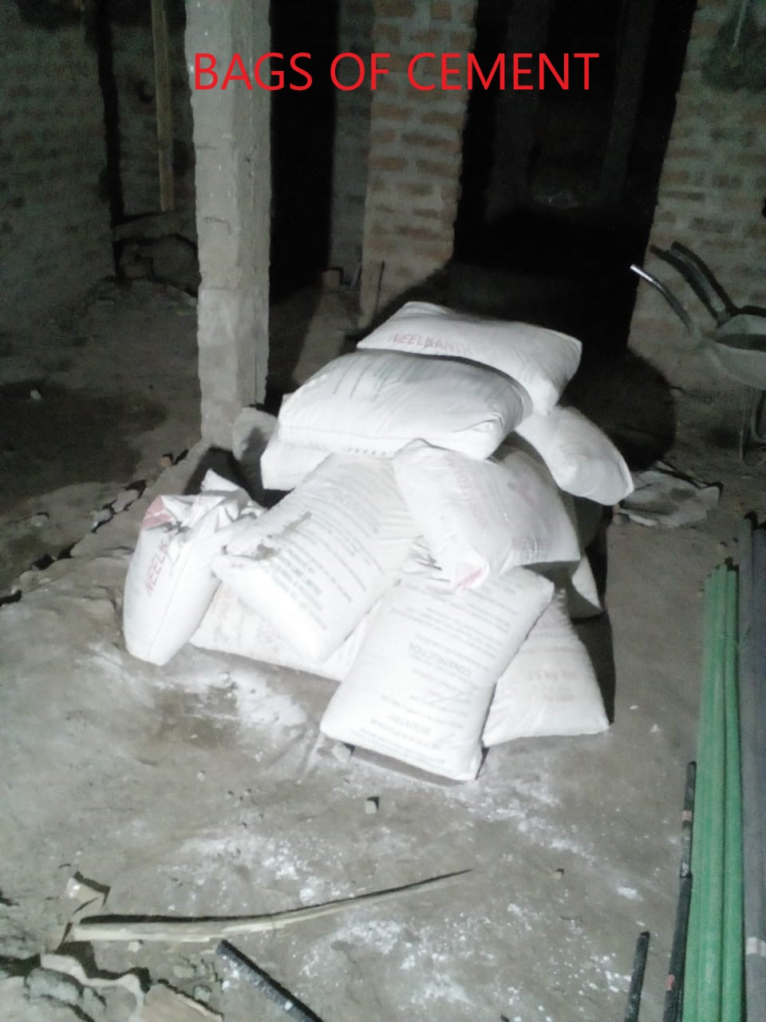

FEEDING PROGRAM

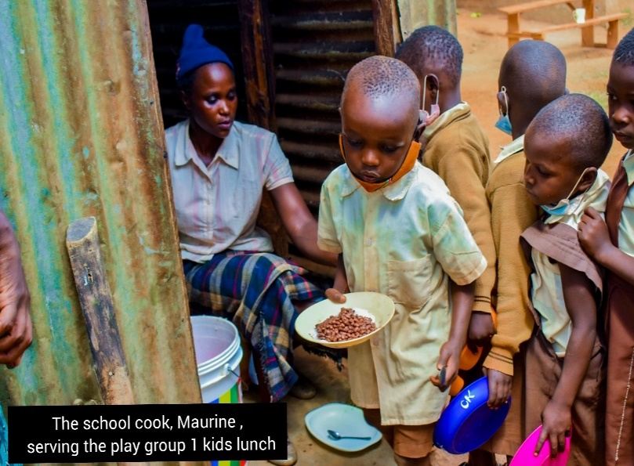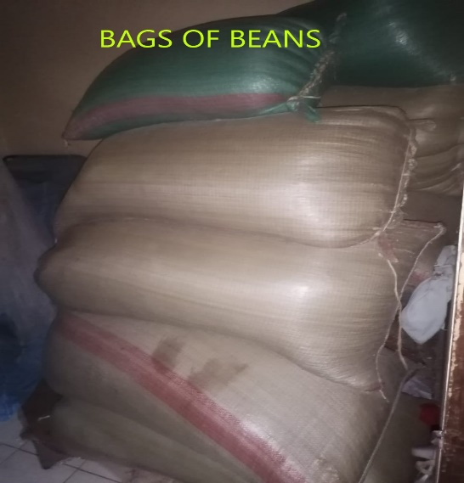

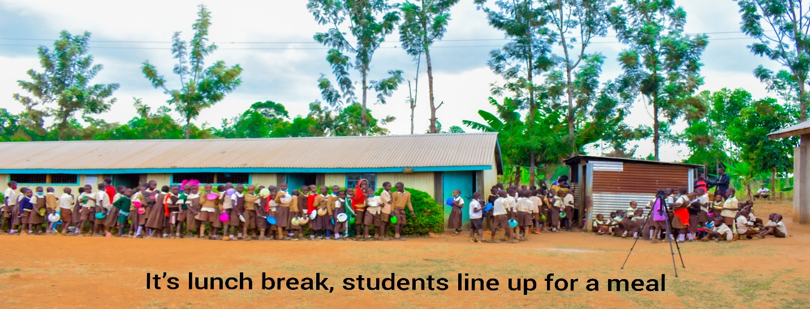

MENTORSHIP PROGRAM
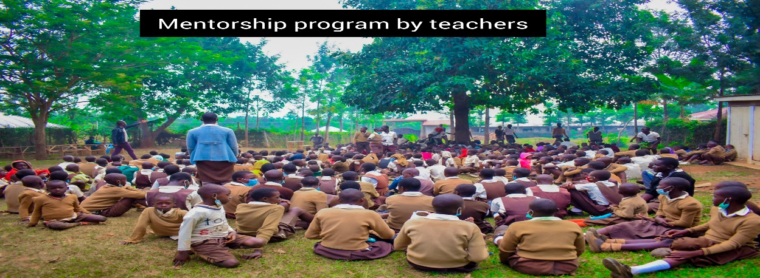
The main aim for this is to meet child’s physical, education, spiritual and social need which we share.
Our donors are our strength. We value, cherish and honor you for your love to the TFEC children. Continue standing with us and we promise that together we shall transform this community.

VIDEO LINK OF OUR CHILDREN FEEDDING AND AIRING THEIR GRATITUDE FOR THE SUPPORT THEY GOT, LOGIN TO YOU TUBE USING https://youtu.be/t_3JpOM65tA

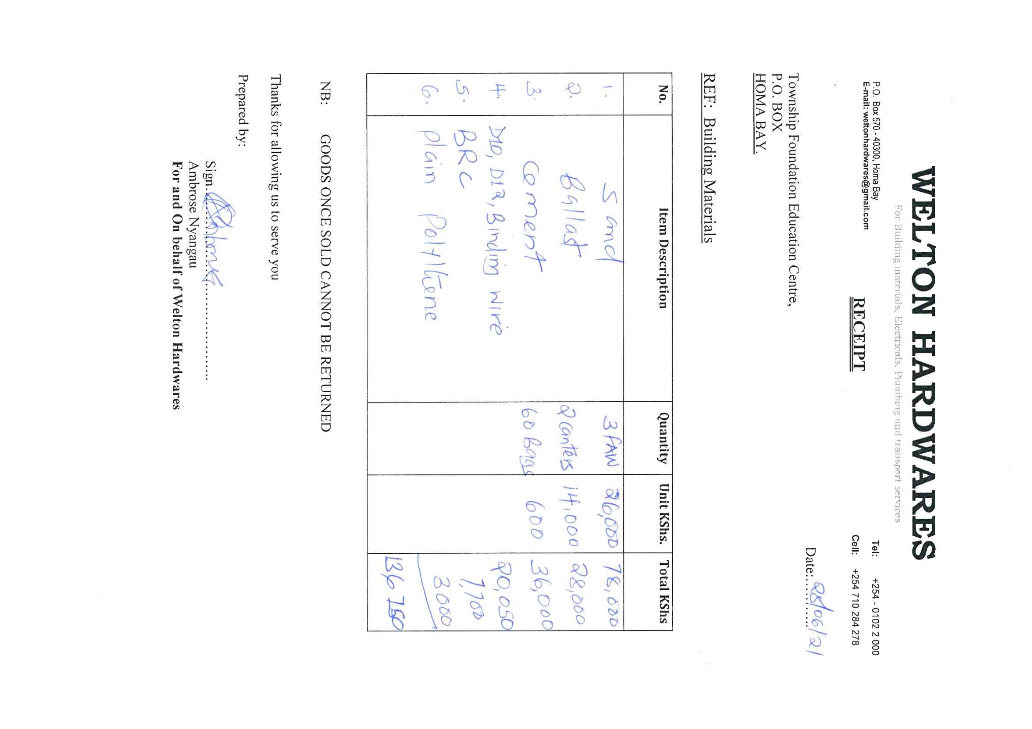
Attached are Some few receipts of purchases made
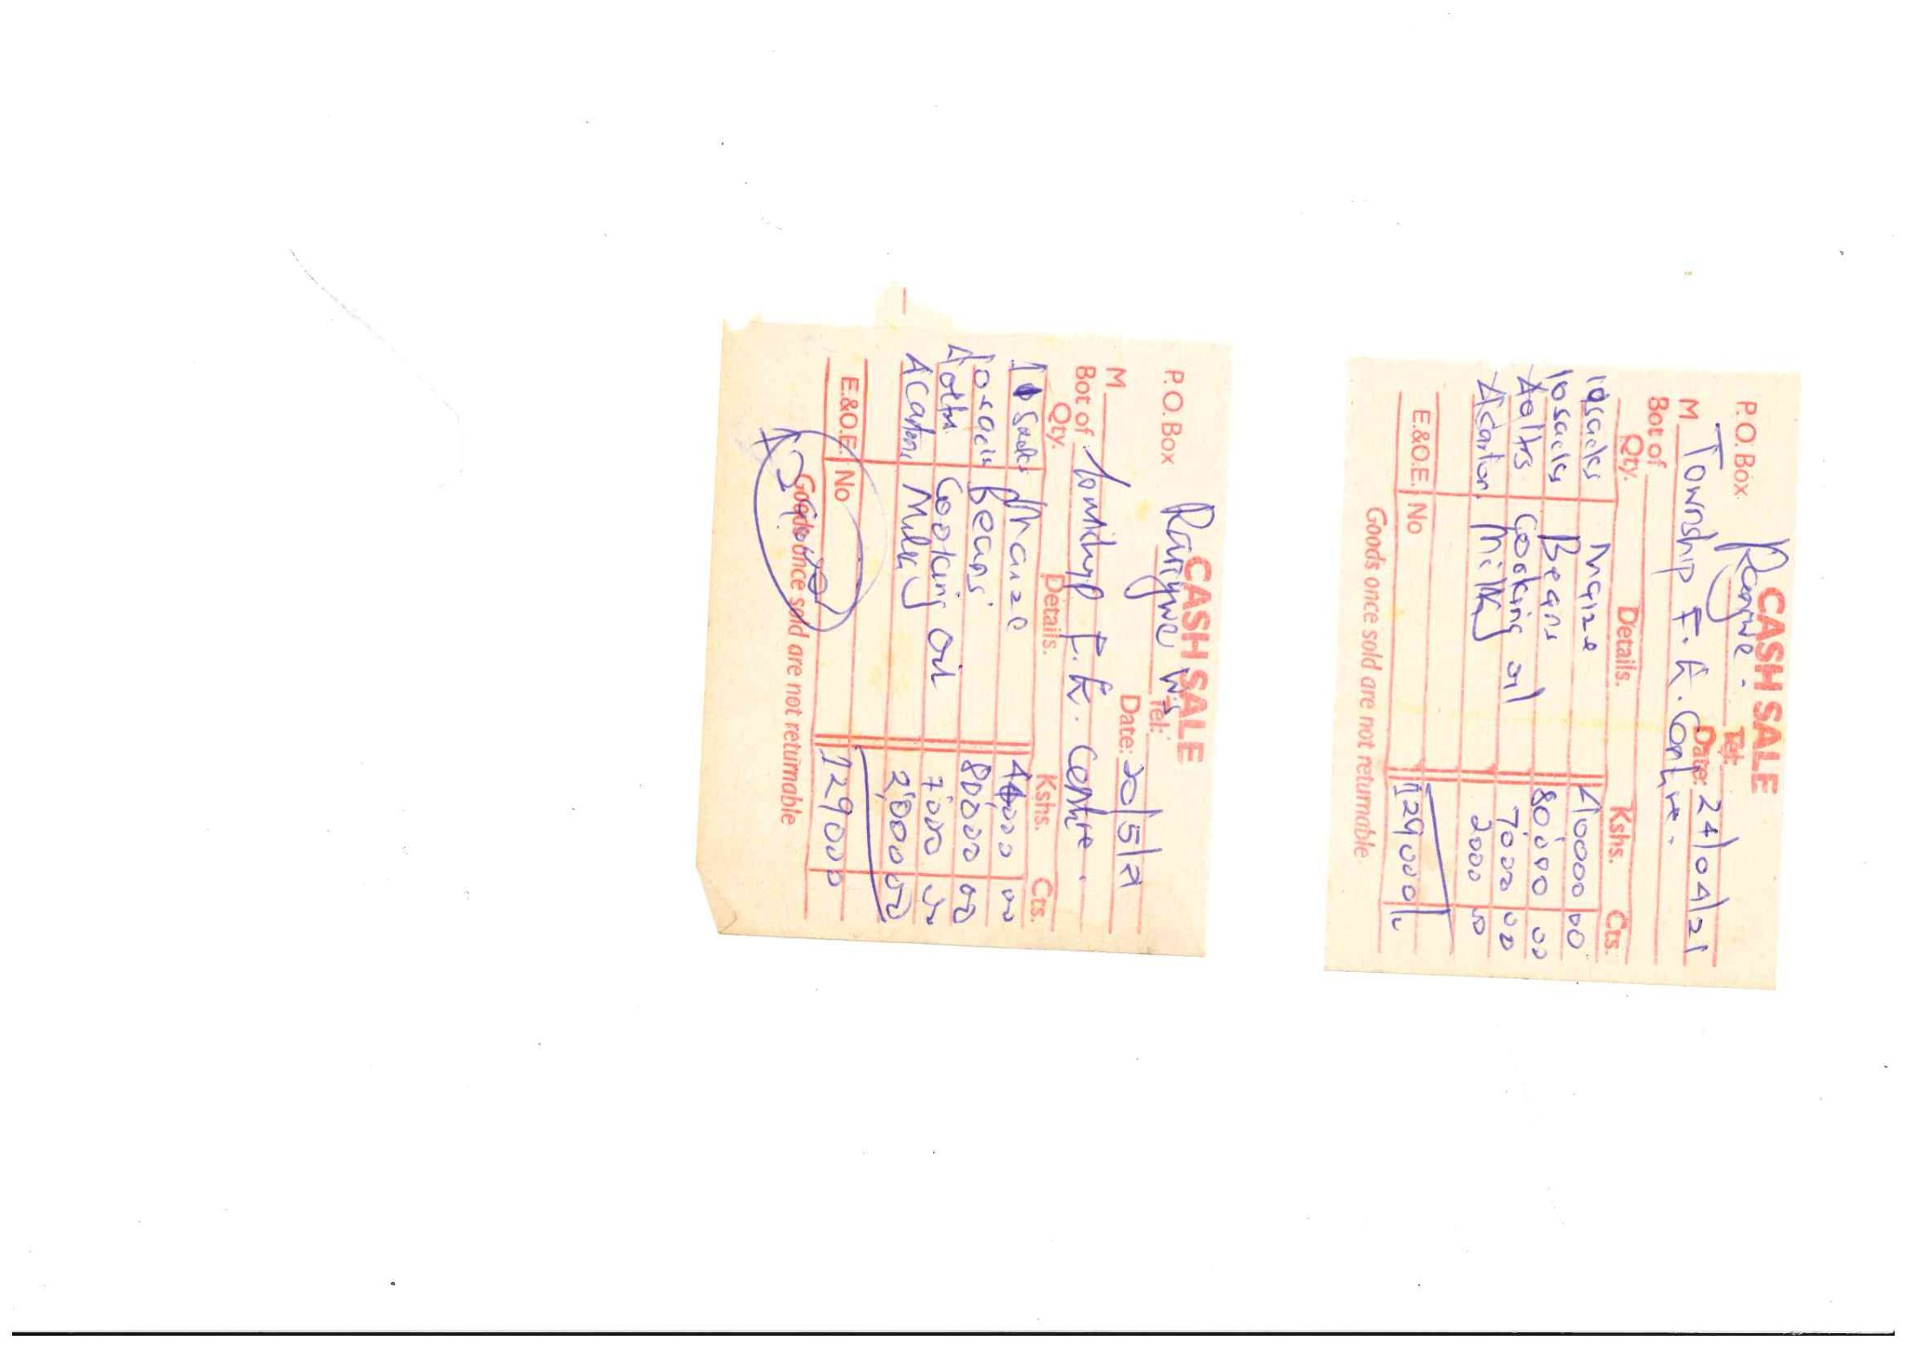
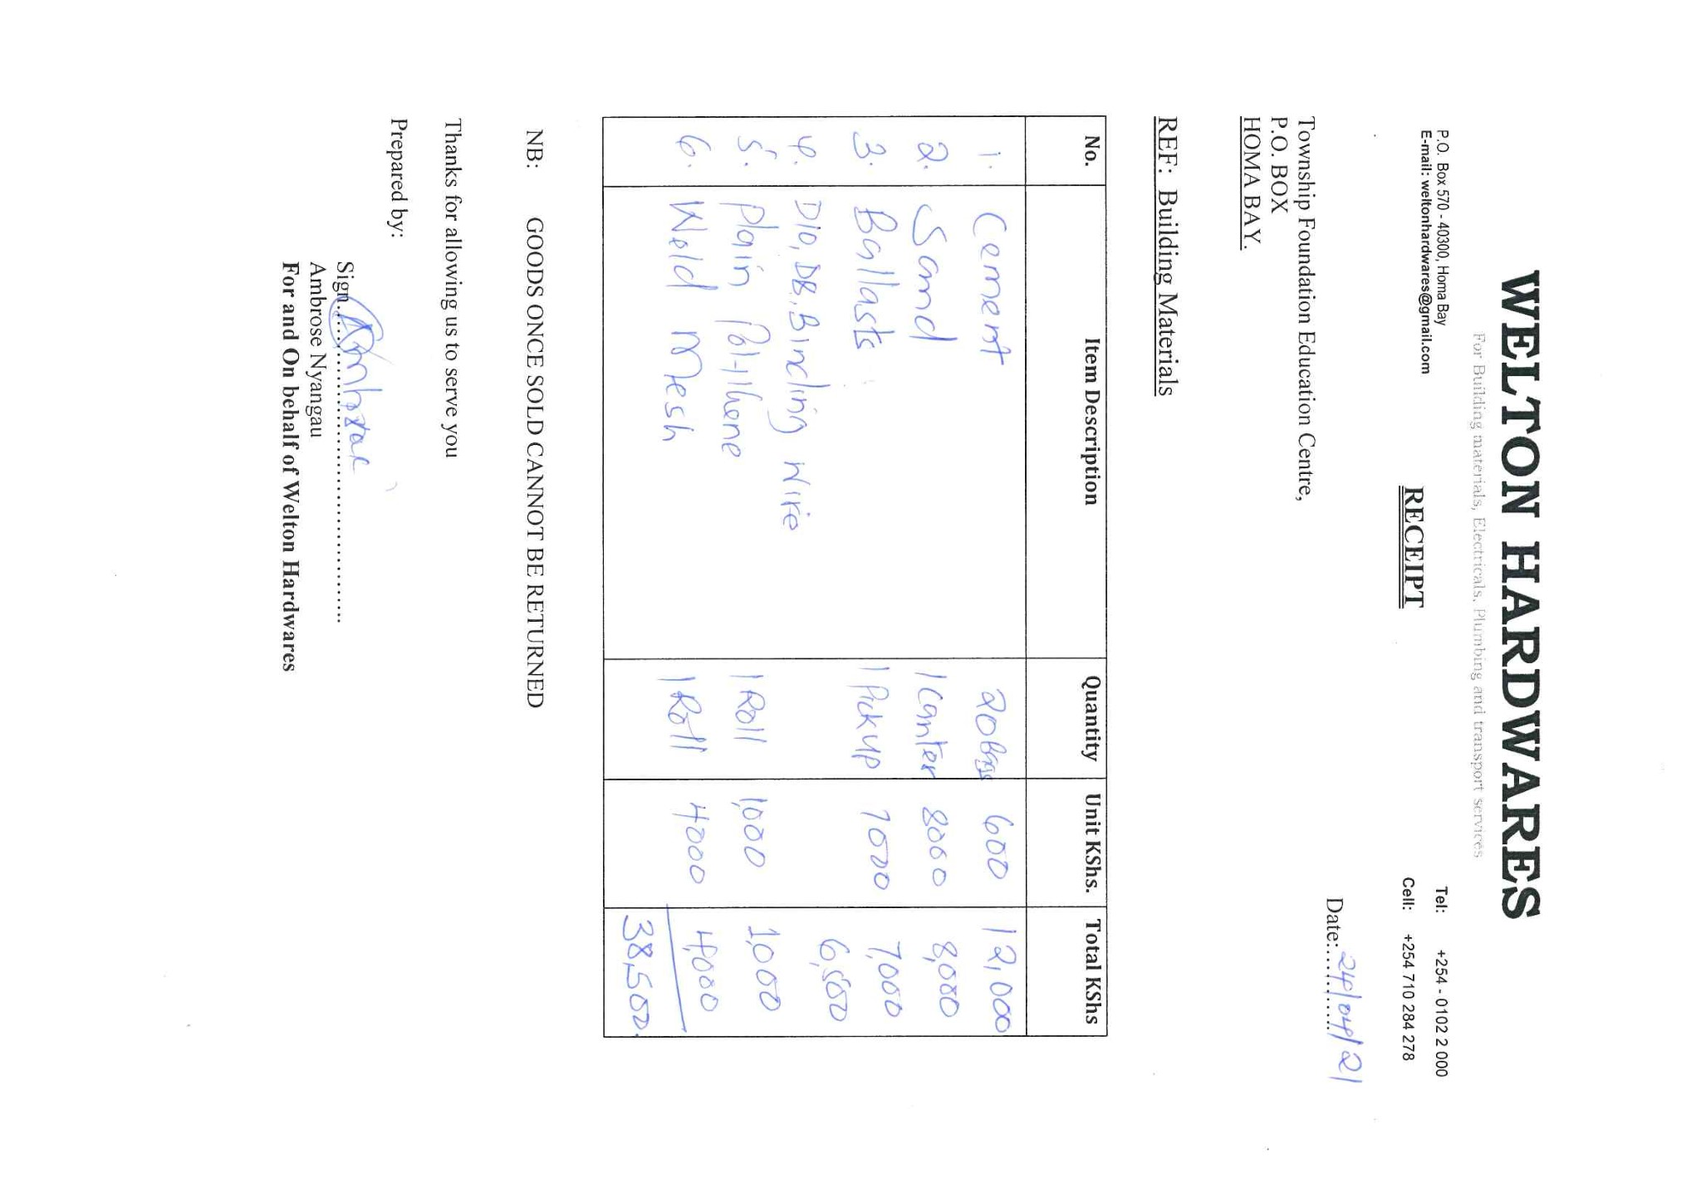
The report is prepared and compiled by
Gonsag $ Charles
Thanks and lots of love

