
Township Foundation Education Centre

P.O. Box 128-40303
Rangwe, Kenya
Mobile: +254 728 583 739 or +254 713 181 678
Email: townshipeducationcenter@gmail.com
Date May 21, 2022
DONATION SUMMARY REPORT FROM JANUARY 2022-MAY 2022
ACKNOWLEDGEMENT
Township Foundation Education Centre management continues to acknowledge with great honor and humility the receipt of donations worth USD 17,473.00 in the months of January through May 2022 from Nike employees via Benevity driven through GlobalGiving fundraiser platform. We sincerely admit that the humanity that has been displayed by our beloved donors super passes our imagination as a non-profit. The lives of the needy children at TFCE continue to change positively.
APPRECIATION AND ACHIEVEMENTS
We Township Foundation Education Centre do register our gratitude to the Nike employees through our loving friend Daniela via Benevity and individual donors for the support they continually give to our children and to the community at large. We truly recognize and appreciate the GlobalGiving for giving us the fundraising platform. The support we got is greatly changing the lives of our young ones; they see hope in feeding continuously because of this great gift of farm land.

ANALYSIS OF THE FUNDS UTILIZATION
Total Amount Disbursed=$17,473
No. | Item description | Unit | Quantity | Unit cost($) | Total amount($)
1 | Buying of farm land | Acre | 2 | 7,000 | 14,000
2 | 14% Government value added tax | Acre | 2 | 980 | 1,960
3 | Lawyer’s fee |  |  |  | 300
4 | Surveying fee |  |  |  | 100
5 | Transport cost for the witnesses |  |  |  | 100
6 | Roselyne’s fee | Term | 3 | 2nd&3rd terms 2021 and 1st term 2022 | 1,004.35
7 | Total |  |  |  | 17,464.35
8 | Balance |  |  |  | 8.65

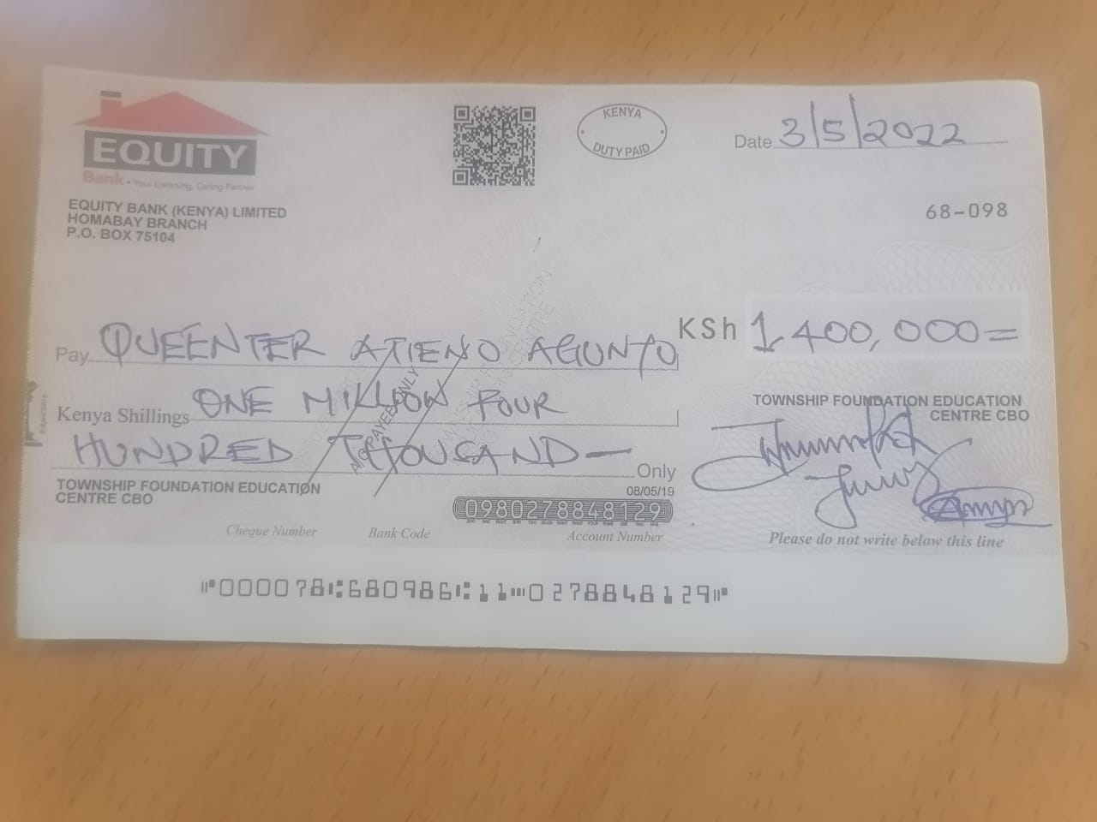

The cheque for the payment of the land seller

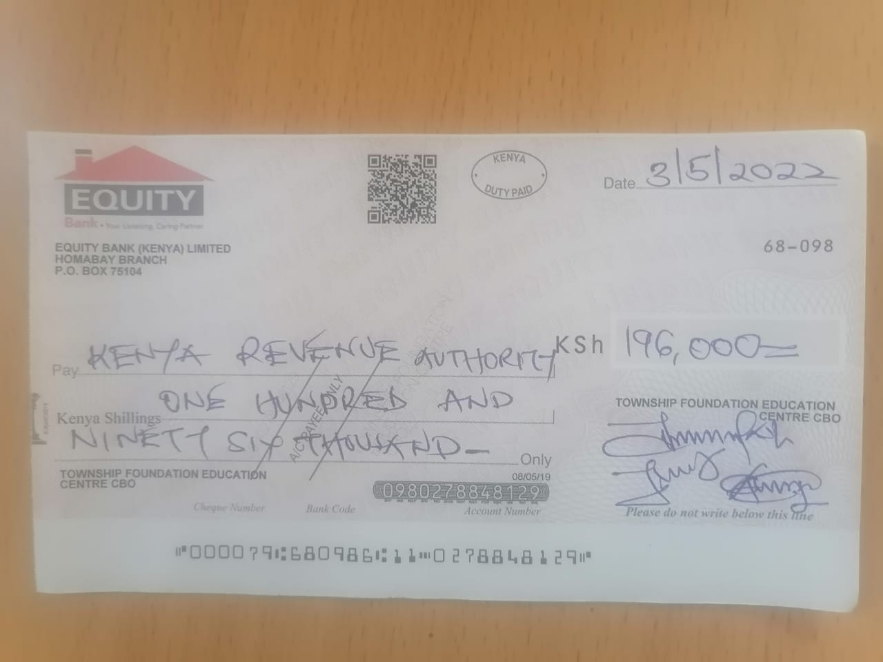
Cheque for the payment of the government tax

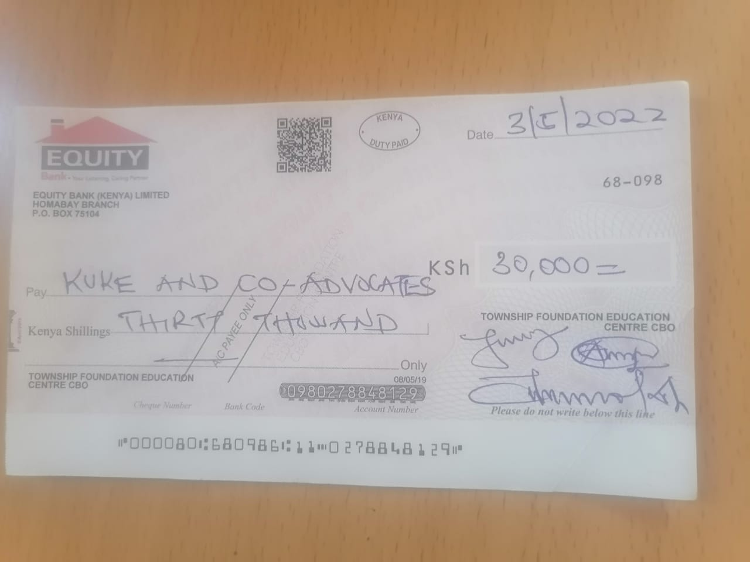
Cheque for the payment of the legal fee to the lawyer making the sale agreement

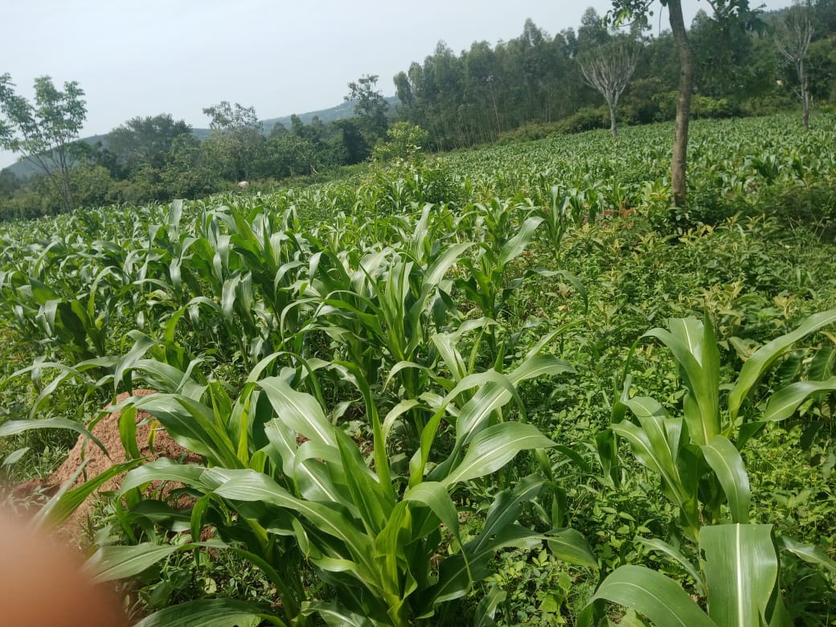
LOWER SECTION OF THE LAND BOUGHT
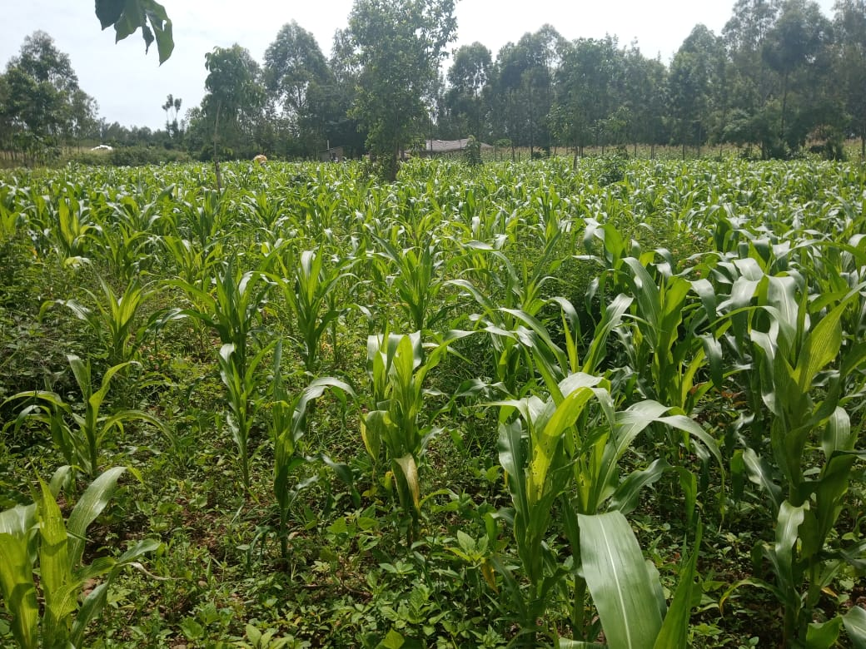
THE UPPER SECTION OF THE LAND BOUGHT

Location of the land:https://maps.google.com/maps?q=-0.5937933%2C34.56263&z=17&hl=en

The land bought is for the school and is meant produce food for feeding the needy children in the Centre. Any surplus products got will be sold to generate income to support other programs in the school. We really appreciate this effort and it’s a great ray of hope to these needy children.
Roselyne is a needy girl from TFEC who joined secondary school through sponsorship by Daniela and is now in the third year. Had it not been for this support her education would have ended at primary level?
We truly honor and appreciate GlobalGiving ,Our donors, Friends and the Nike company for offering us this golden opportunity.

In a special way we cherish our dear friend Daniela of Nike company. We value her so much for all these connections. Her mobilization skills and ability to fundraise are superb and it has made our organization to make great strides since she started her assistance. We also truly appreciate Daniela’s friends and her Nike colleague employees for this great, enormous and continued support.
Thank you so much, blessings and lots of love.
The report is prepared and compiled by
Gonsag $ Charles

Attached below is the sale of land agreement:

