

Township Foundation Education Centre
P.O. Box 128-40303
Rangwe, Kenya
Mobile: +254 728 583 739 or +254 713 181 678
Email: townshipeducationcenter@gmail.com
Date 28th September 2022

DONATION SUMMARY REPORT FROM JUNE 2022 THROUGH SEPTEMBER 2022
ACKNOWLEDGEMENT
Township Foundation Education Centre management acknowledges with great honor the receipt of donations worth USD 6,570.83 from 31st May 2022 to 26th August 2022 from Nike employees via Benevity and individual donors driven through GlobalGiving fundraiser platform
We don’t take it for granted that these donors chose on us over other projects. We admit the gesture has changed lives of our children at TFEC and the community at large.
APPRECIATION AND ACHIEVEMENT
We, Township Foundation Education Centre do register our gratitude to the Nike employees, Benevity and individual donors for the support they continually give to our children and to the community at large. We truly recognize and appreciate the GlobalGiving for giving us the fundraising platform. The support we got is greatly changing the lives of our young ones

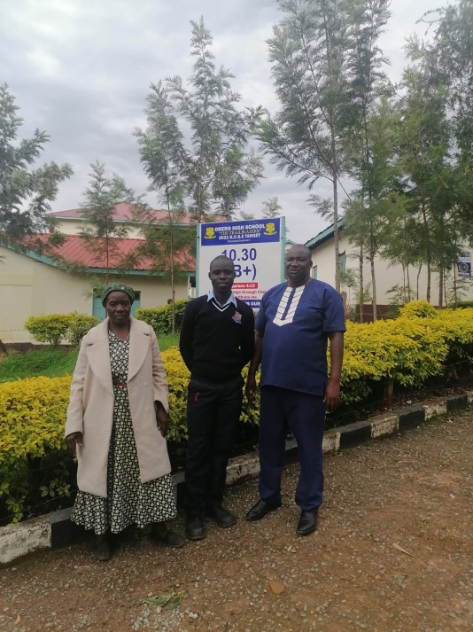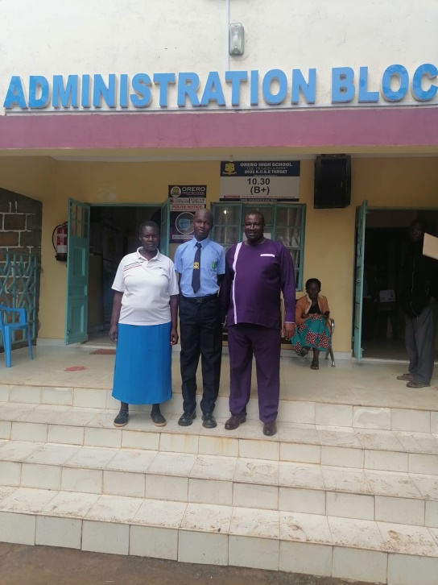

SPONSORED STUDENTS BEING ADMITTED IN SECONDARY SCHOOLS

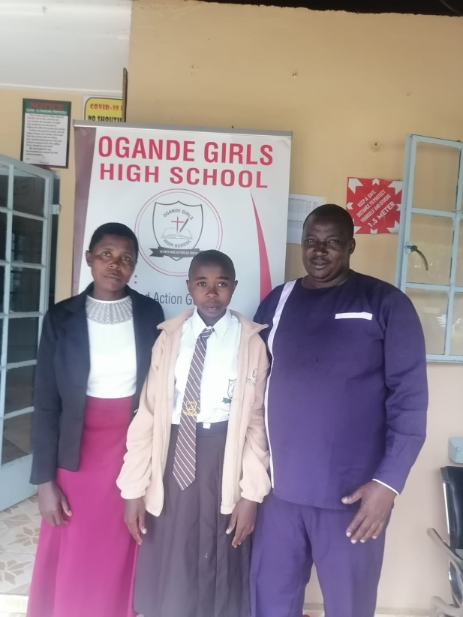 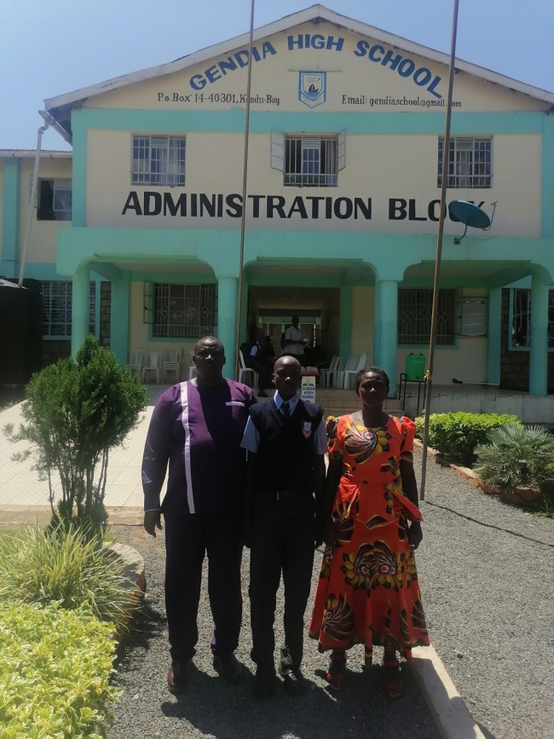 SPONSORED STUDENTS BEING ADMITTED IN SECONDARY SCHOOLS

SECONDARY SCHOOL SPONSORSHIP PROGRAM
We appreciate our dear friend from Nike, Daniela and hear colleague friends Dan, Shayan, Ranjini among others for accepting to sponsor secondary school education for 16 students from Township Foundation Education Centre. They have raised a wonderful $ 4,370.83 for the said period which has been used to pay secondary school fee for the said students.
MENTORSHIP PROGRAM
The main aim for this is to meet child’s physical, education, spiritual and social need which we share. Our donors are our strength. We value, cherish and honor you for your love to the TFEC children. Continue standing with us and we promise that together we shall transform this community.
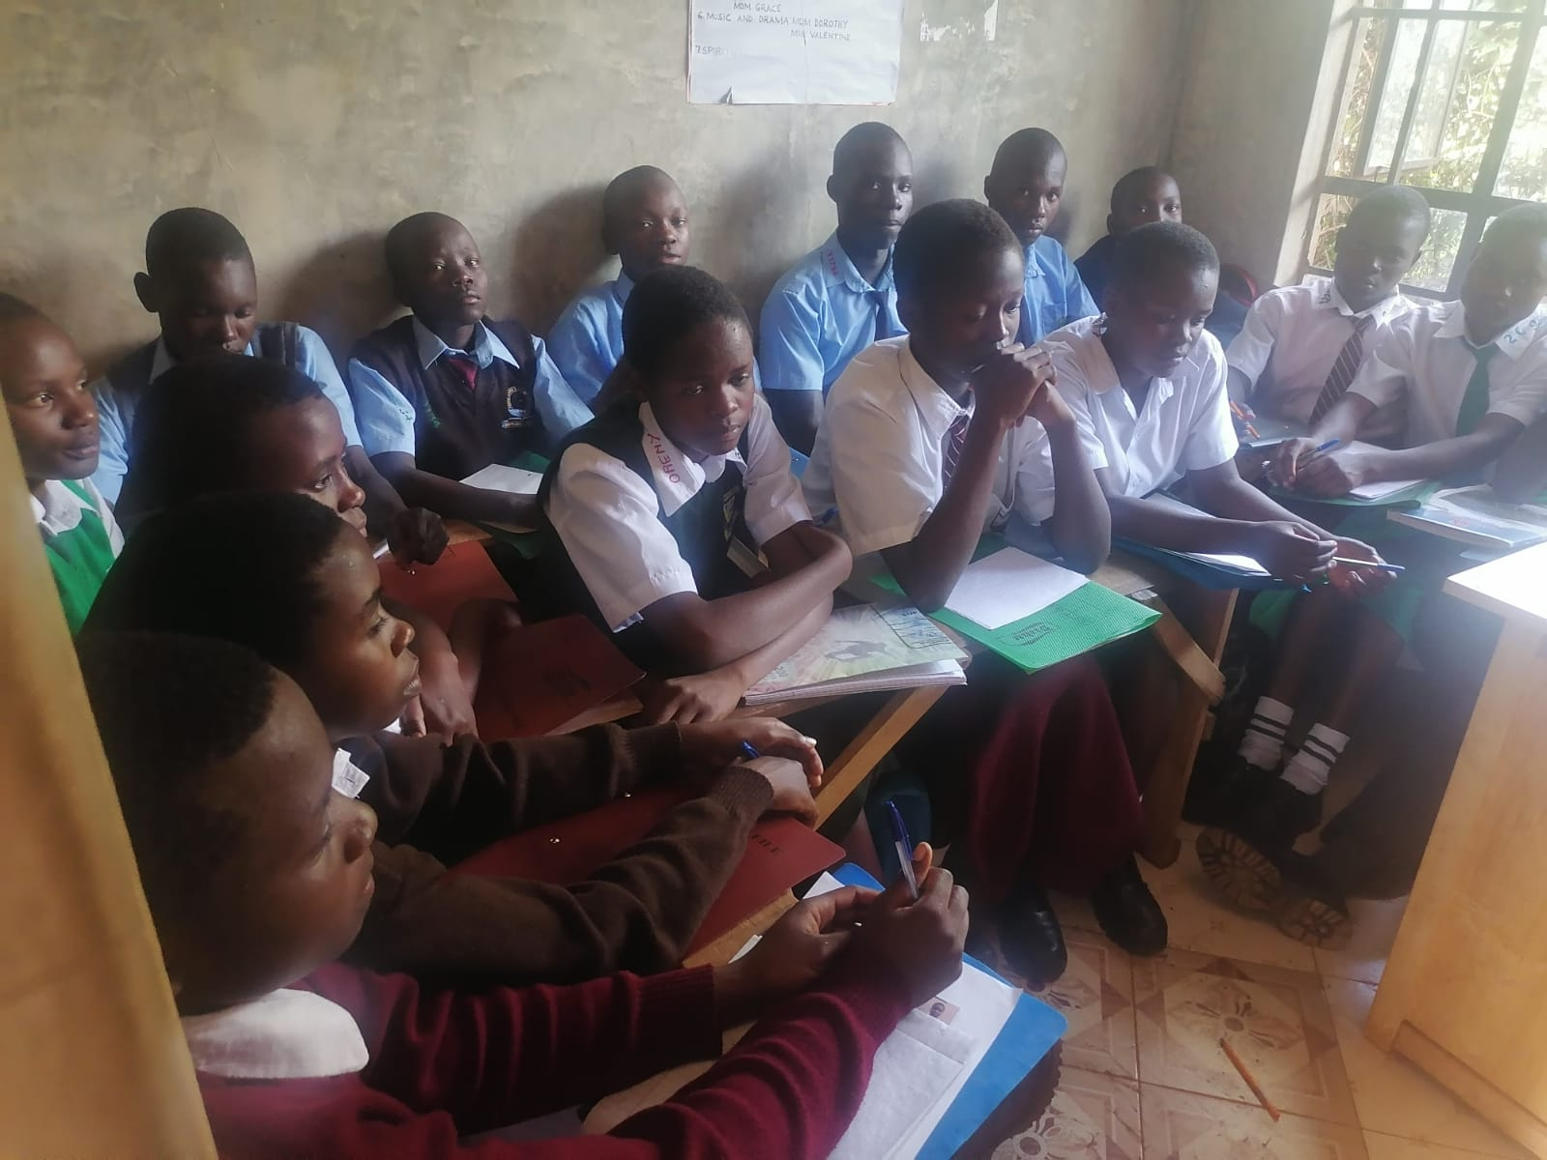THE SPONSORED STUDENTS IN A MENTORSHIP PROGRAM AT THE EMD OF TERM 1 2022
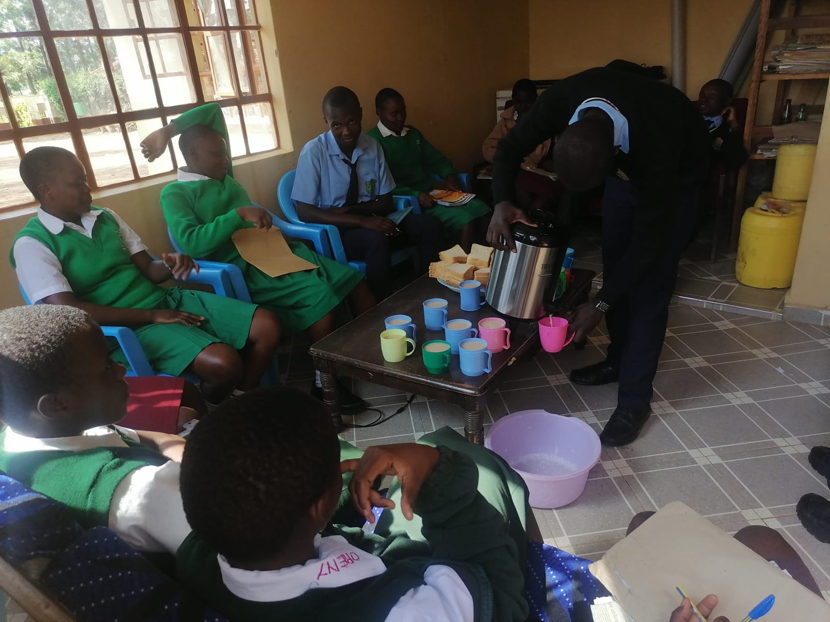 TAKING OF SNACKS AFTER THE MENTORSHIP SESSION

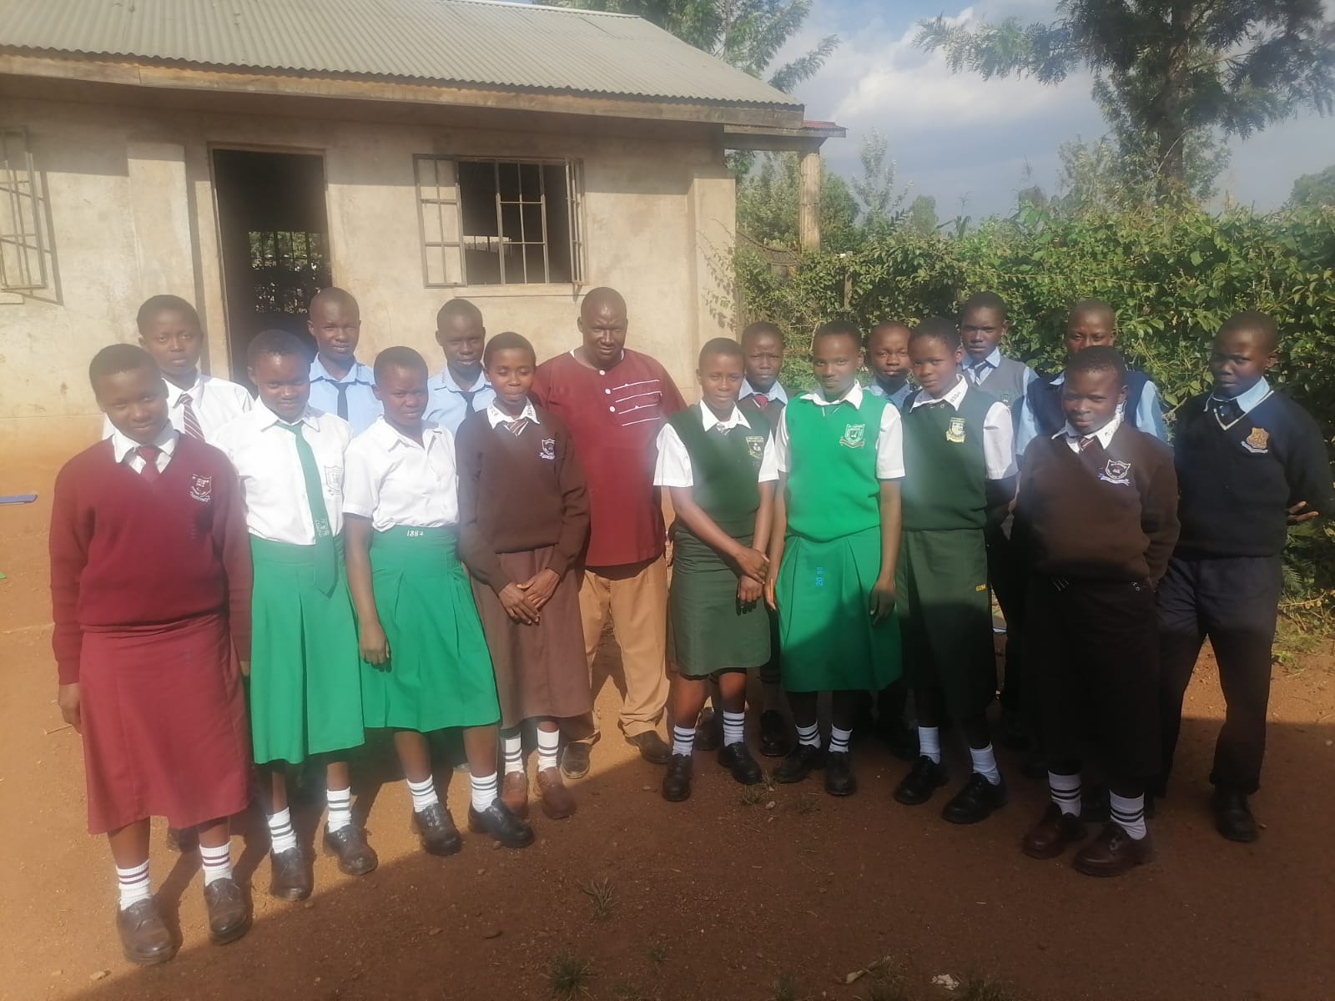 THE SPONSORED STUDENTS AT TFEC, WITH CHARLES,READY TO GO BACK TO SECONDARY SCHOOLS FOR SECOND TERM 1N 2022

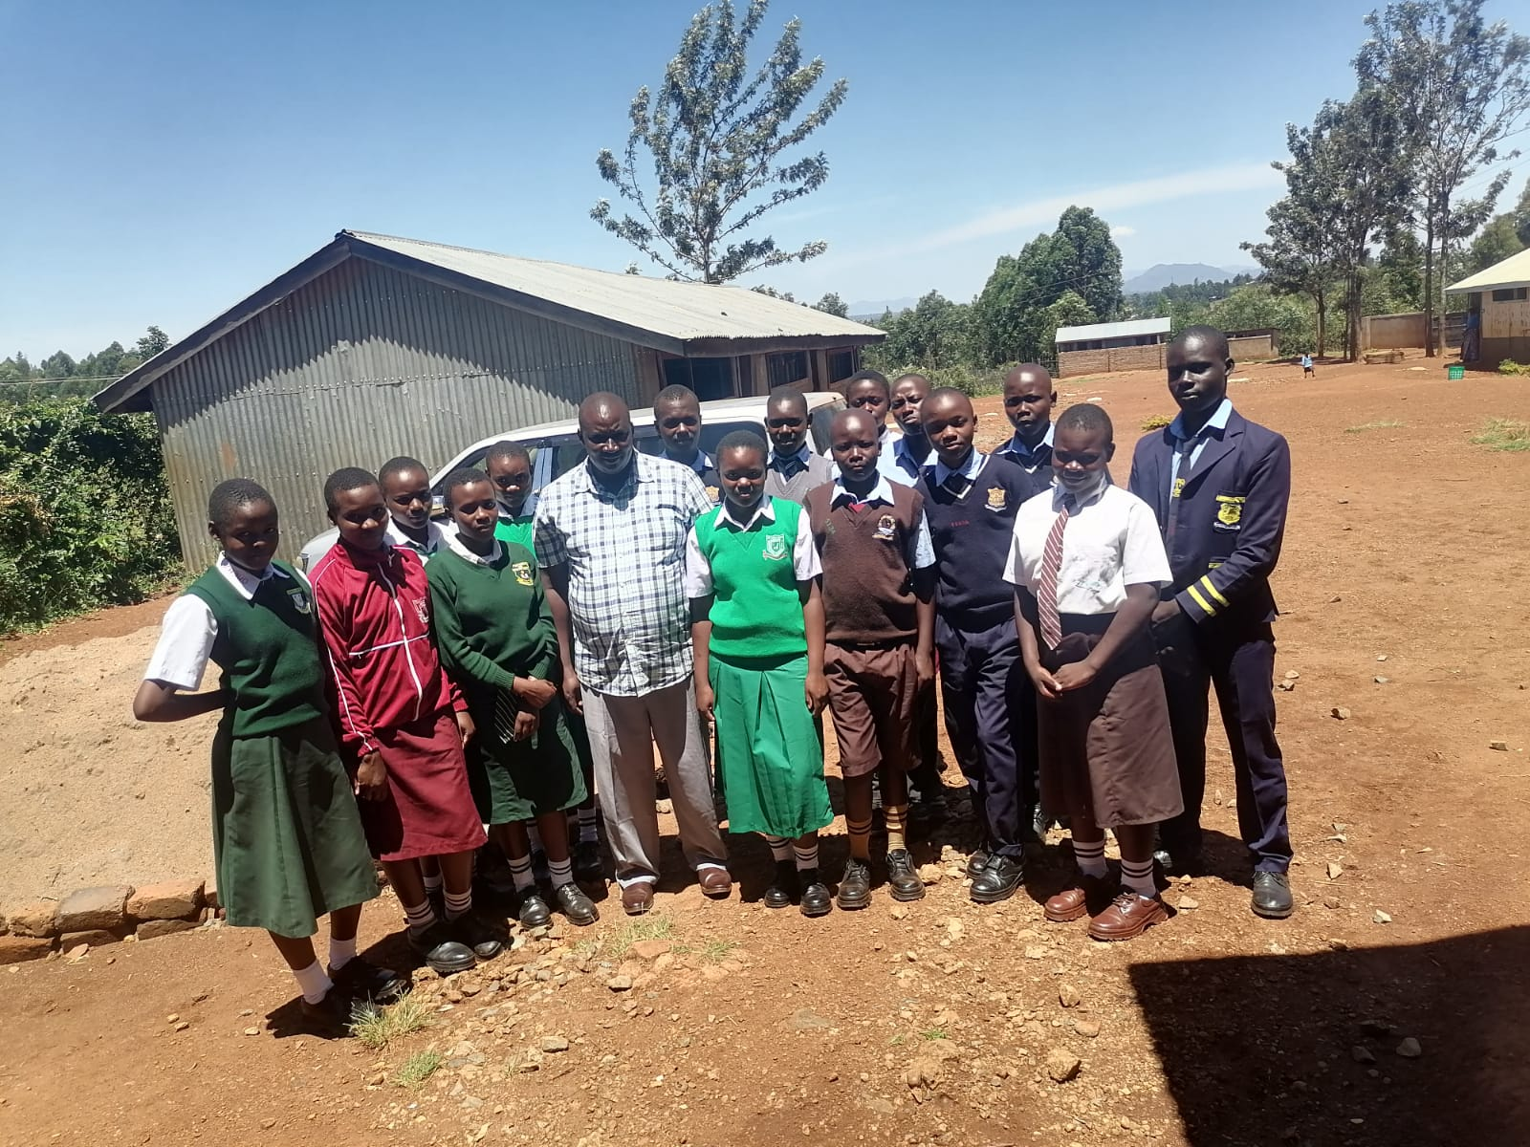

THE STUDENTS AT TFEC,WITH THE DIERCTOR CHARLES TO PRESENT END OF TERM TWO RESULTS BEFORE REPORTING BACK TO THE SECONDARY SCHOOLS.
FEEDING PROGRAM
We appreciate Renie, a lady from the US for her individual, family and Fidelity Charitable donations of $2,200 meant to support our feeding program. They students have been able to enjoy and appreciate the good food, this has improved their health status especially the once who would eat one meal at school. We have been able to utilize adequately the funds given to us putting into consideration the great need of our children and society, the management through the little farming we do was able to supplement but still very far from reaching our goal.
ANALYSIS OF FUNDS UTILIZATION
NO | DESCRIPTION | AMOUNT ($) | ITEMS | QUANTITY | DISTRIBUTION
1 | Feeding Program | $2,200 | Maize | 20 sacks | USD 1200
1 | Feeding Program | $2,200 | Beans | 10 Sacks | USD 930
1 | Feeding Program | $2,200 | Vegetables | Bundles | USD 20
1 | Feeding Program | $2,200 | Cooking Oil | 40ltrs | USD 70
 | Sub-Total |  |  |  | USD 2,200
2 | Sponsorship Program | 4,370.83 |  | 16 Student | 4,370.83
 | Sub –Total |  |  |  | 4,370.83
Grand Total |  |  |  |  | 6,570.83

END OF TERM 1 2022 STUDENTS EXAMINATION RESULTS

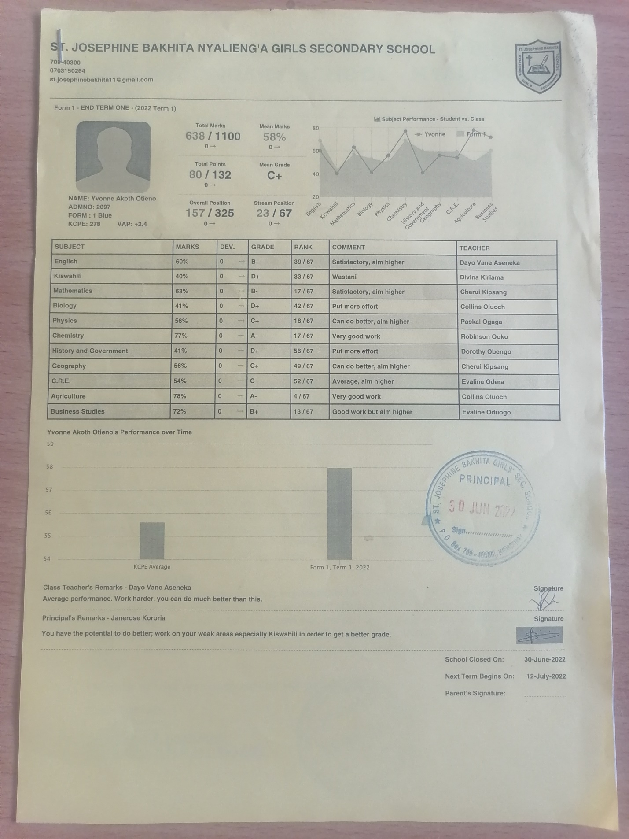

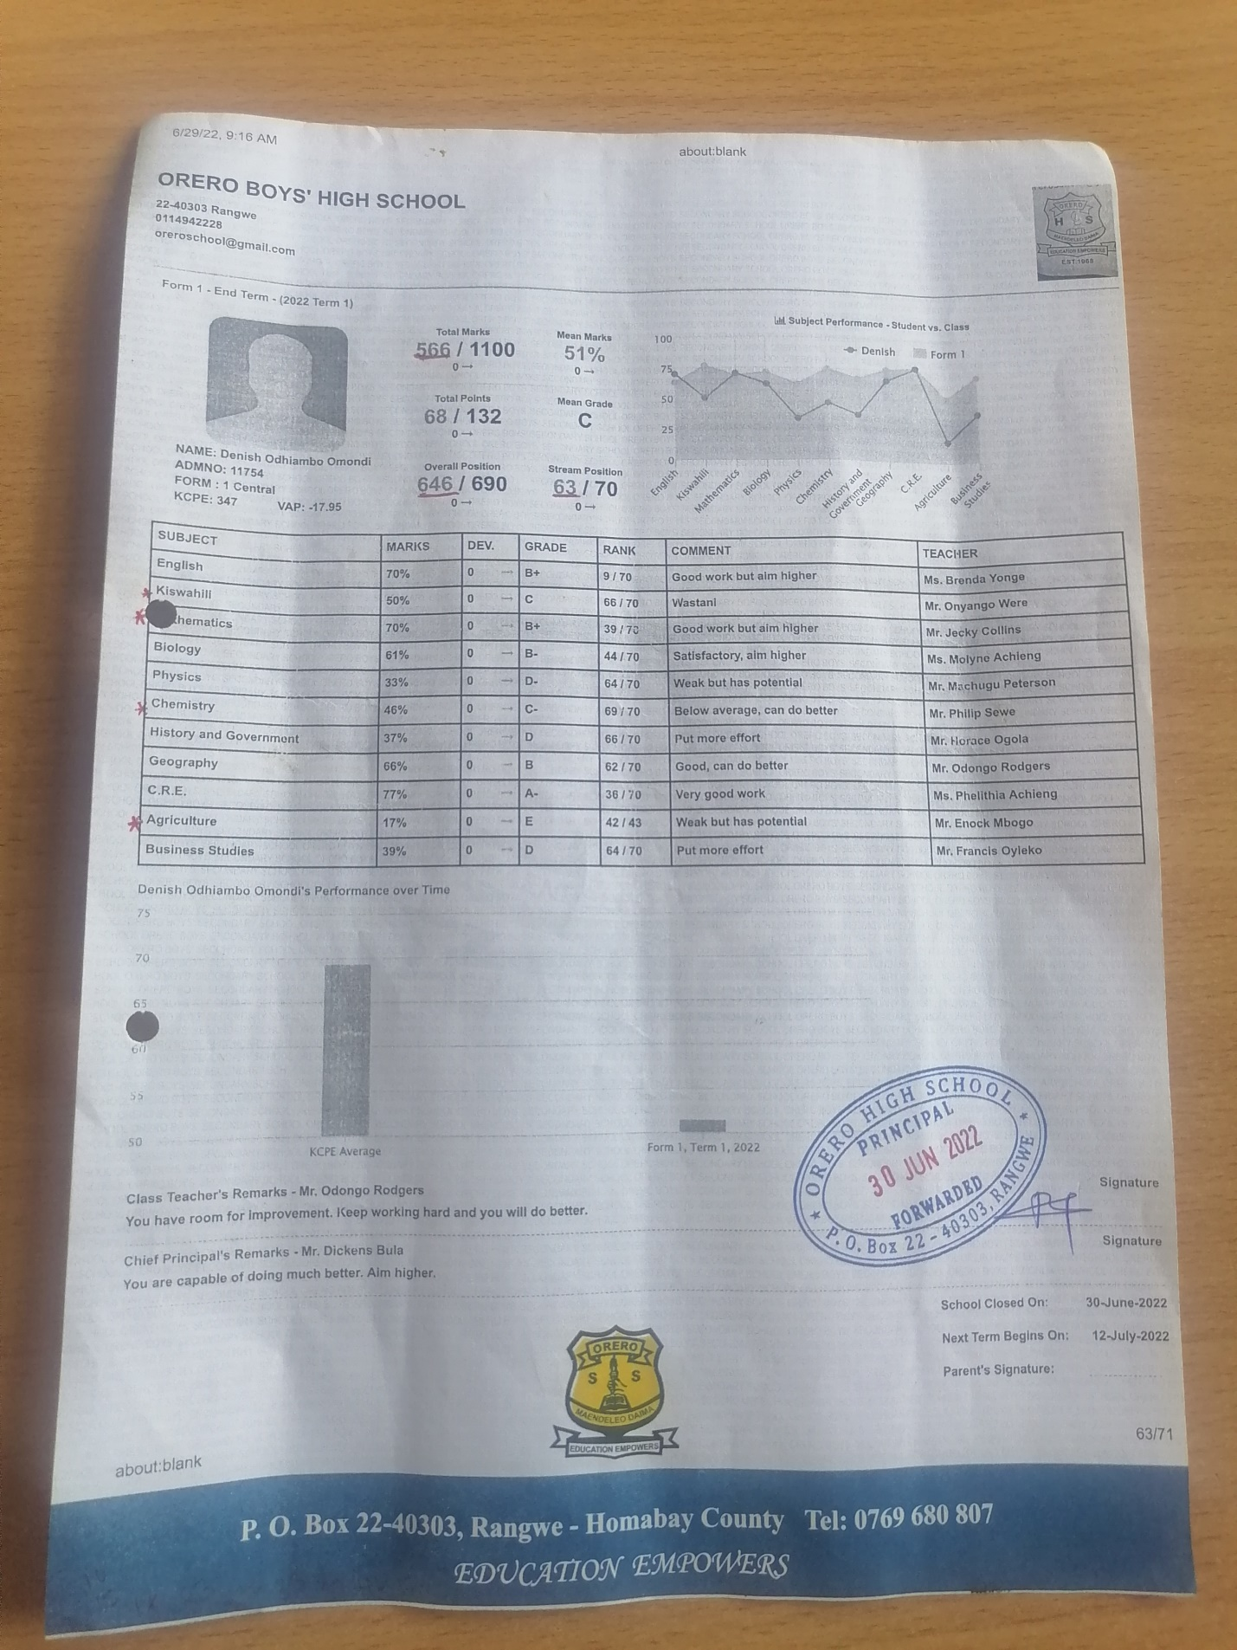
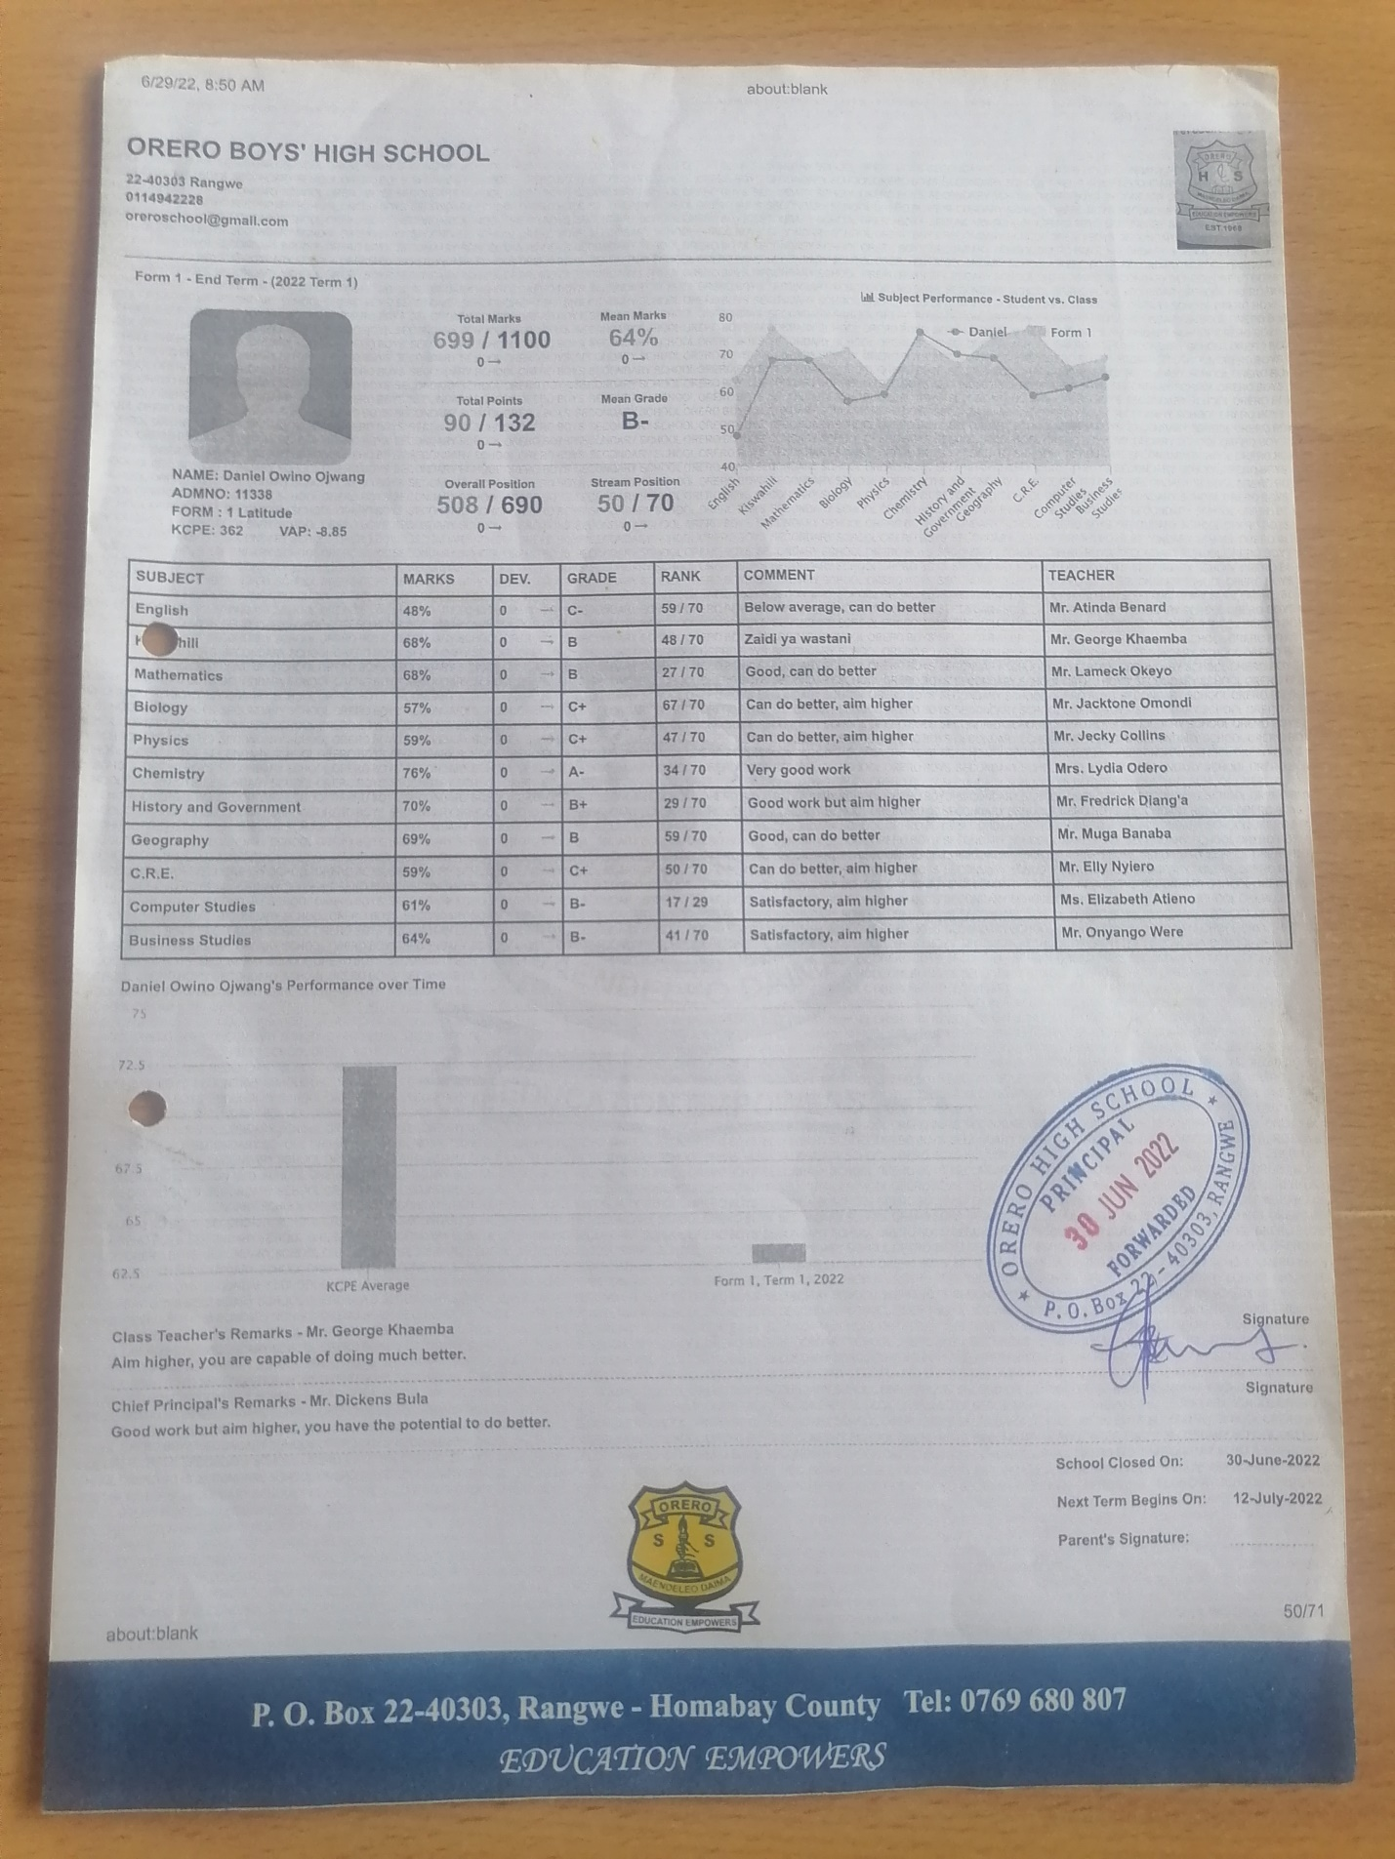

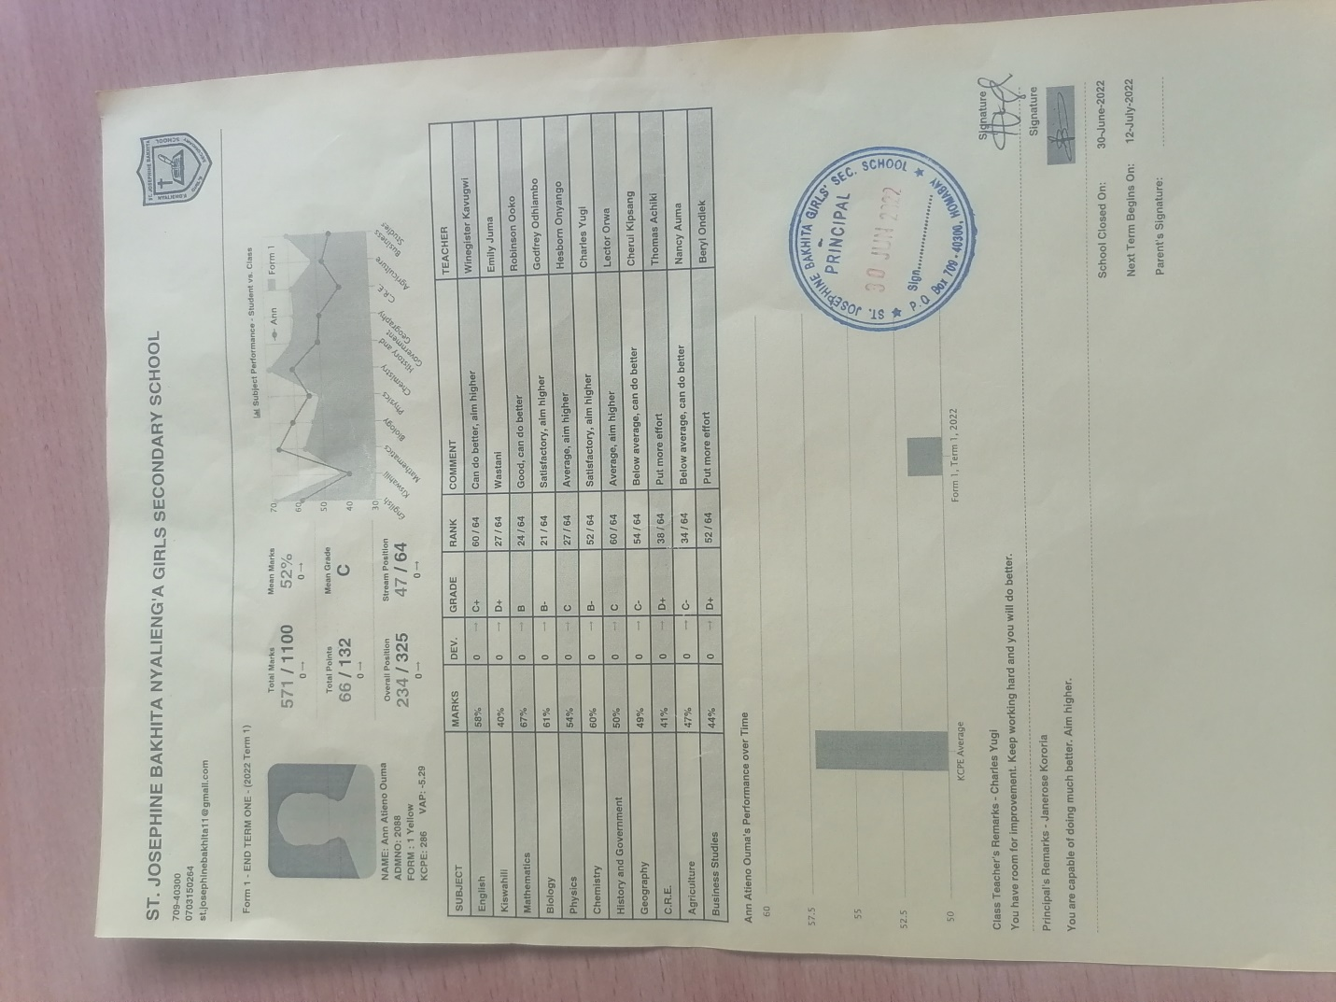
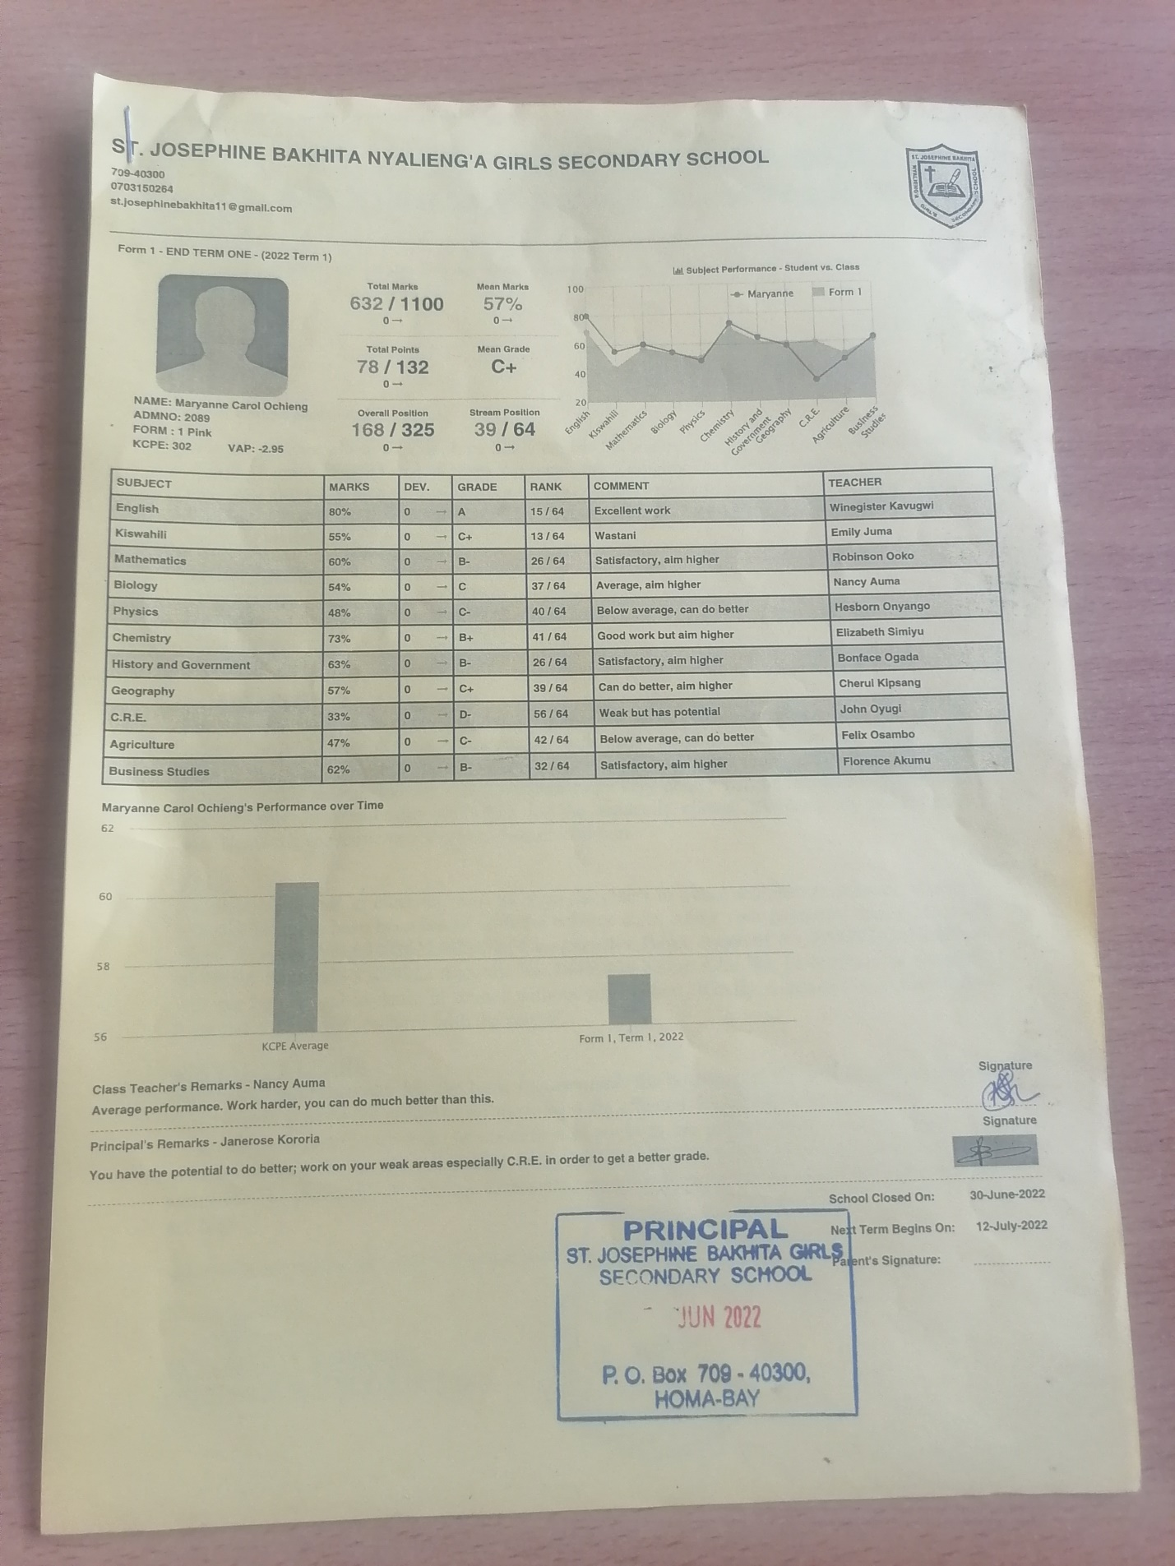
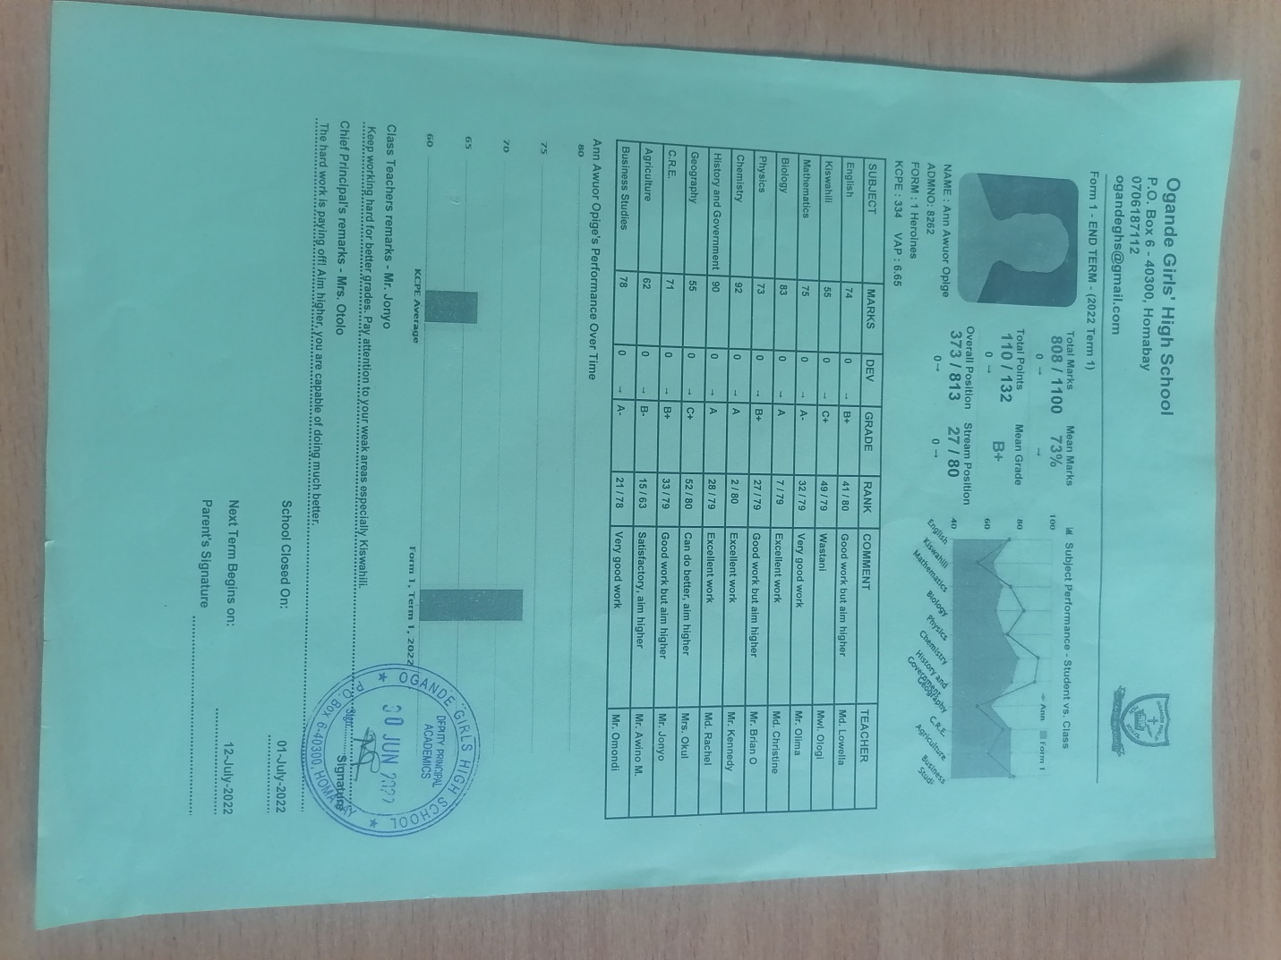
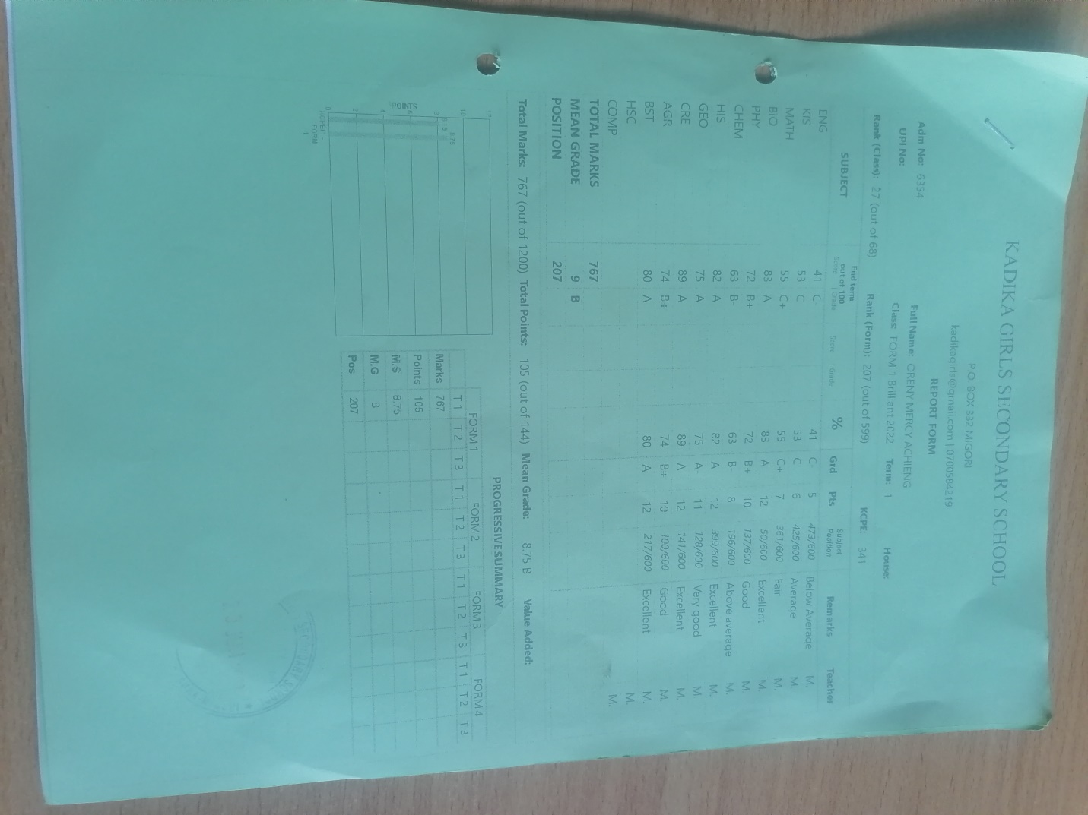
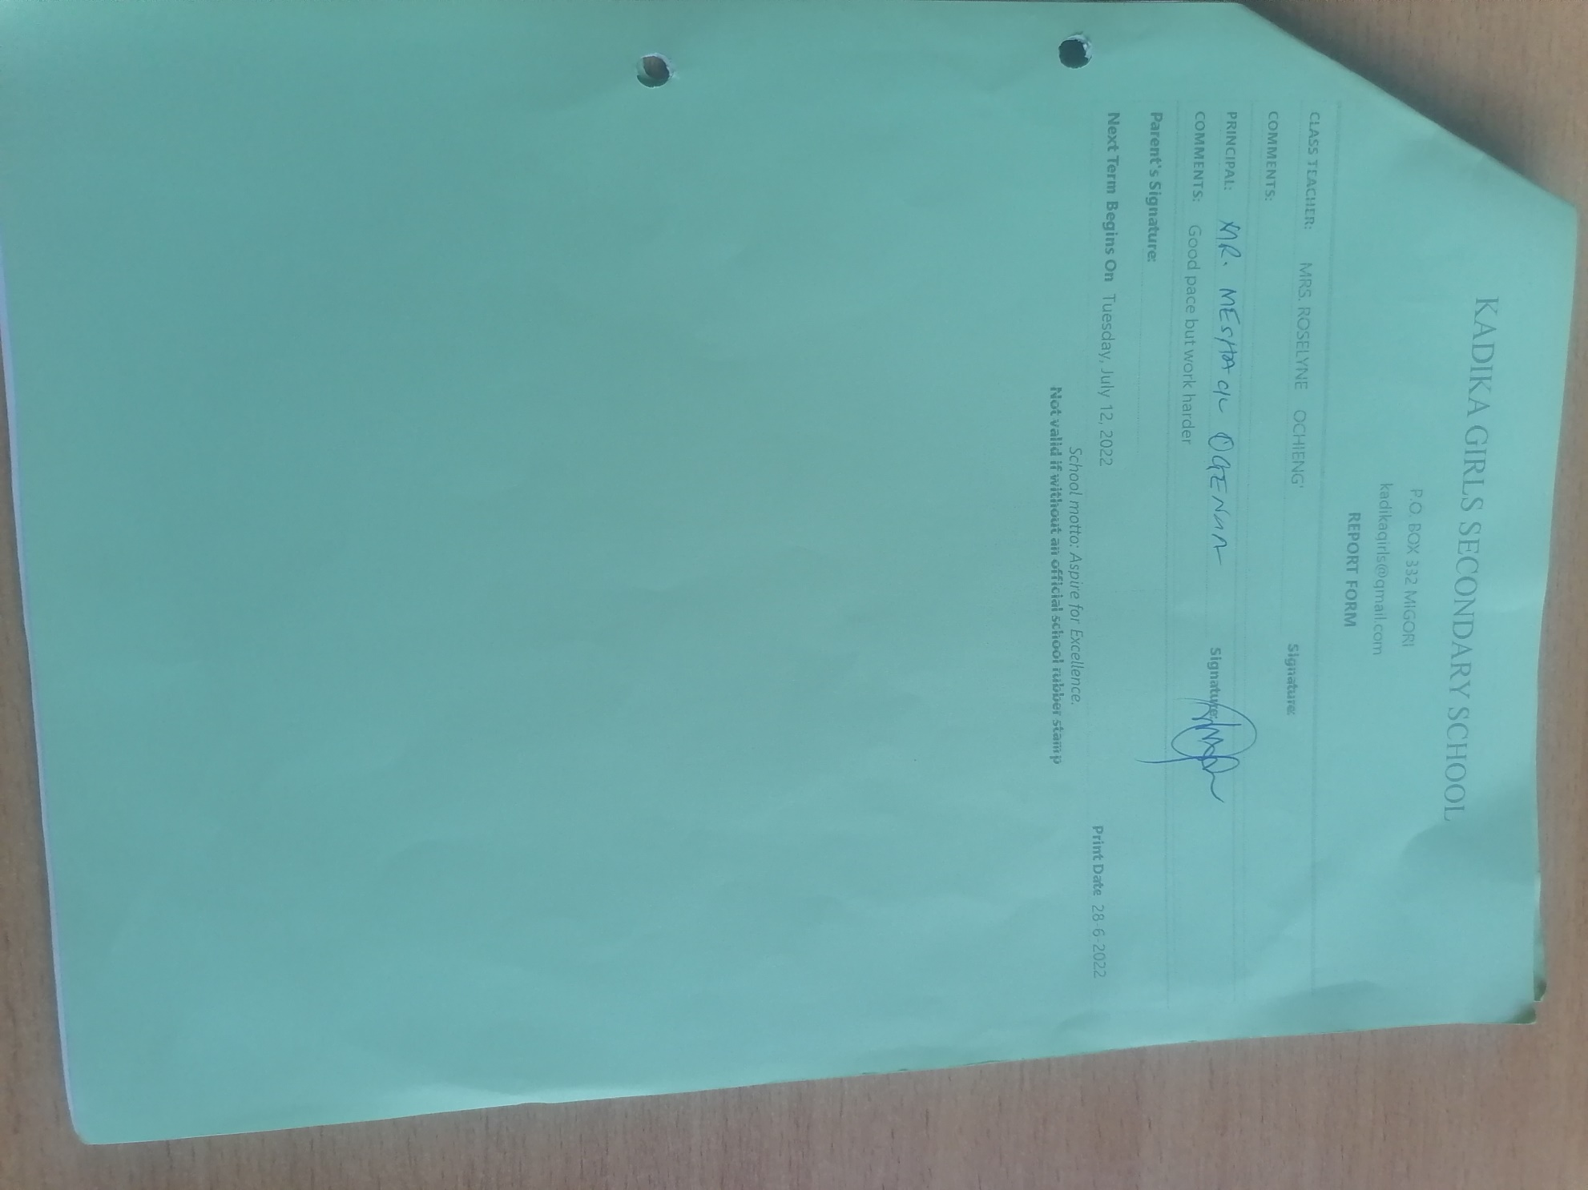
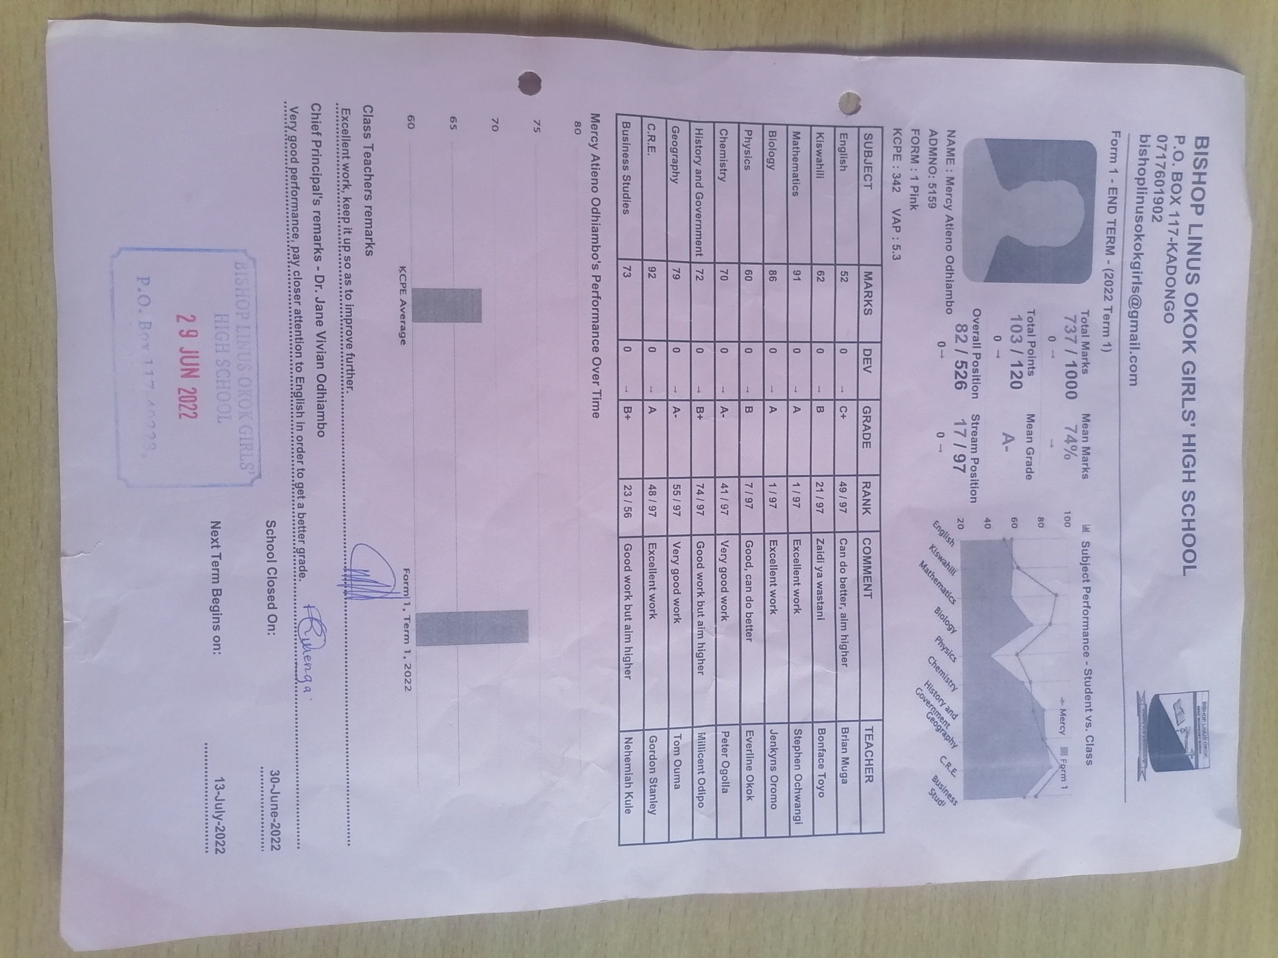
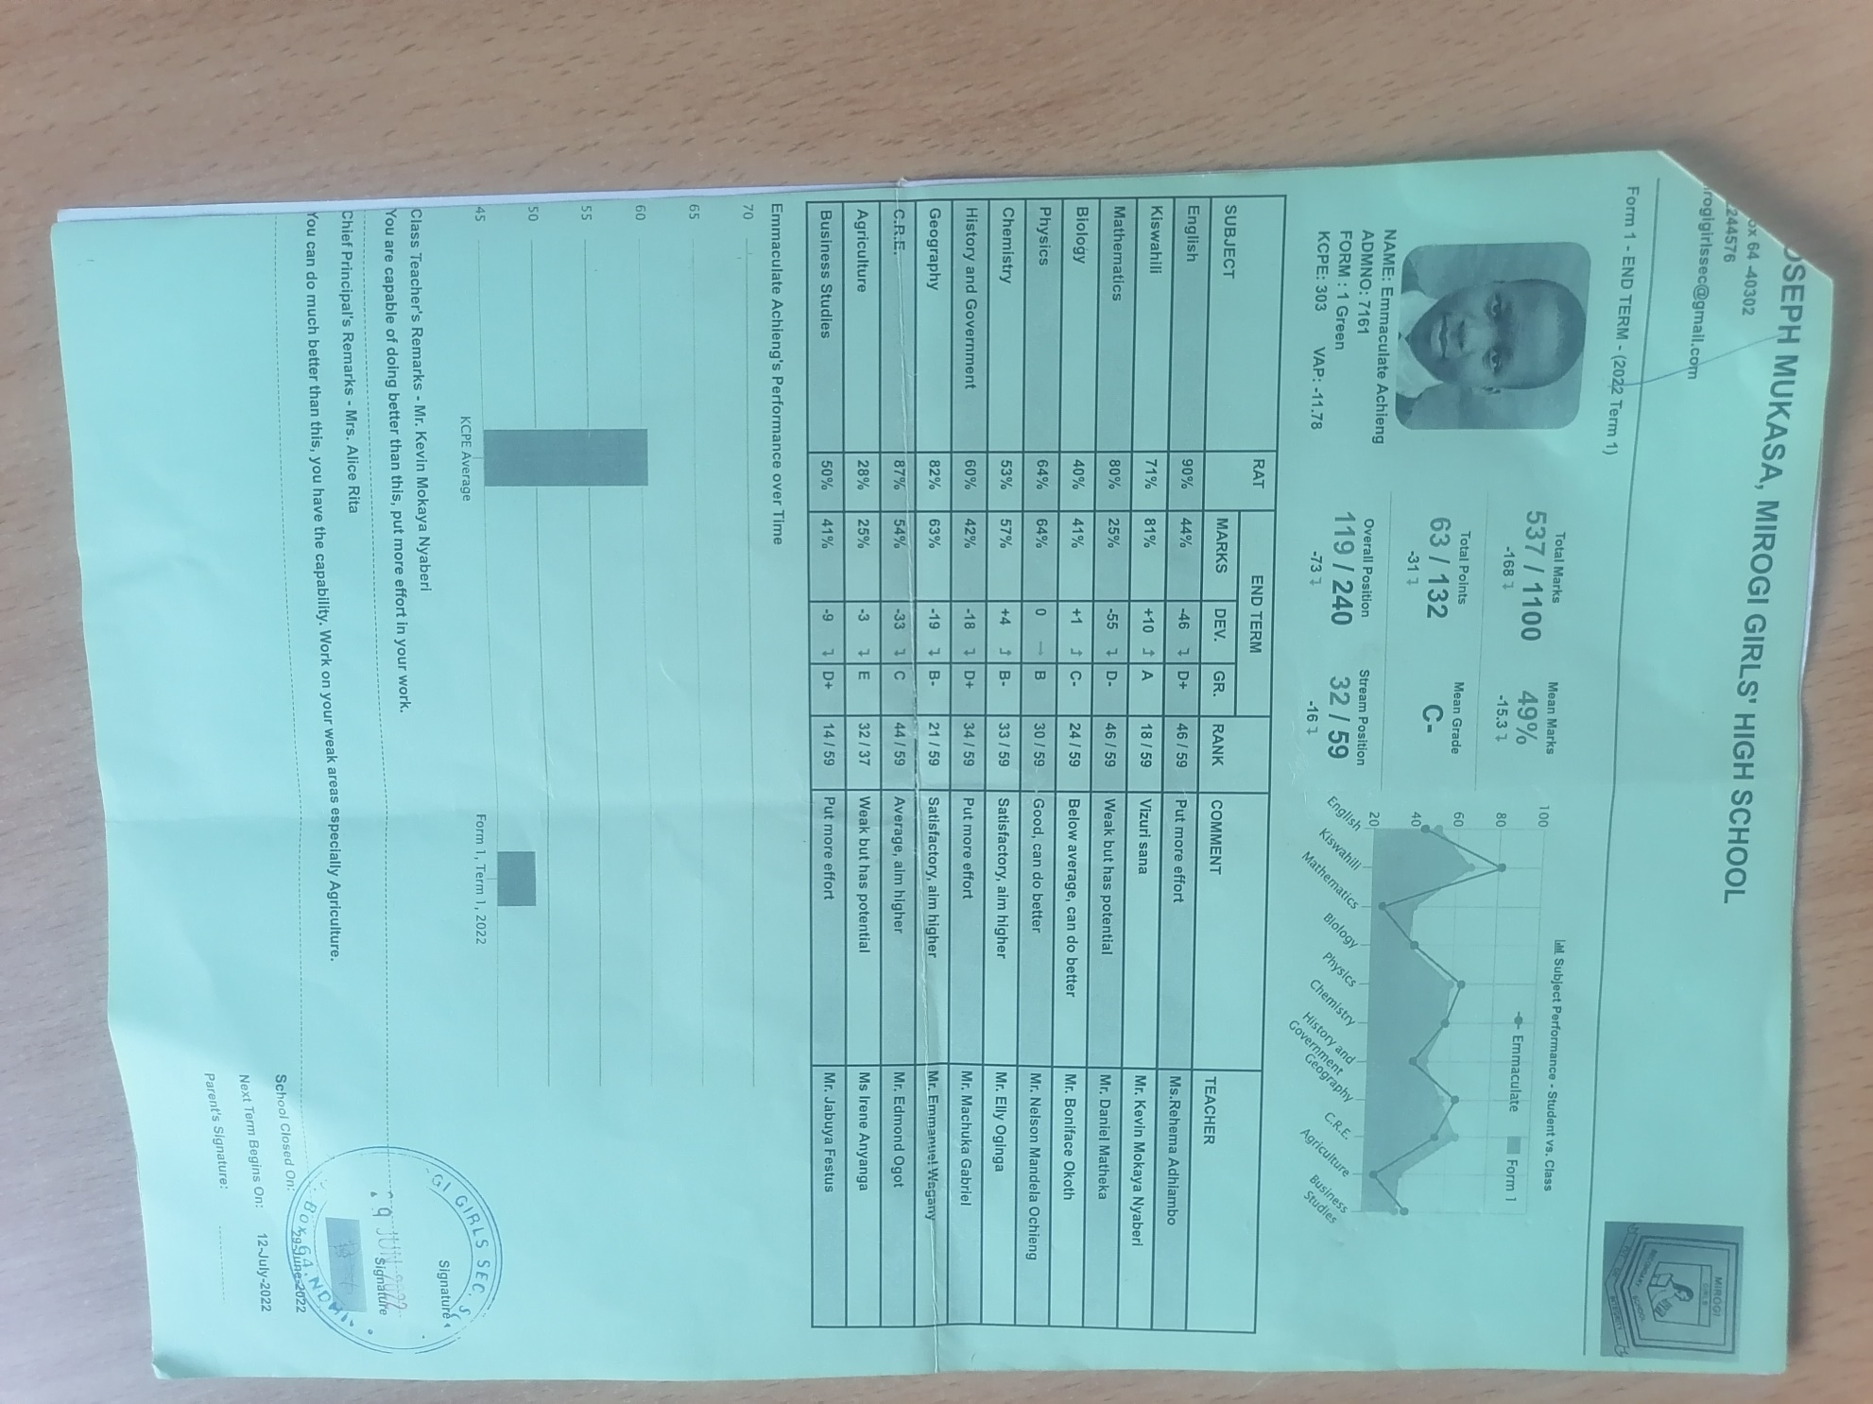
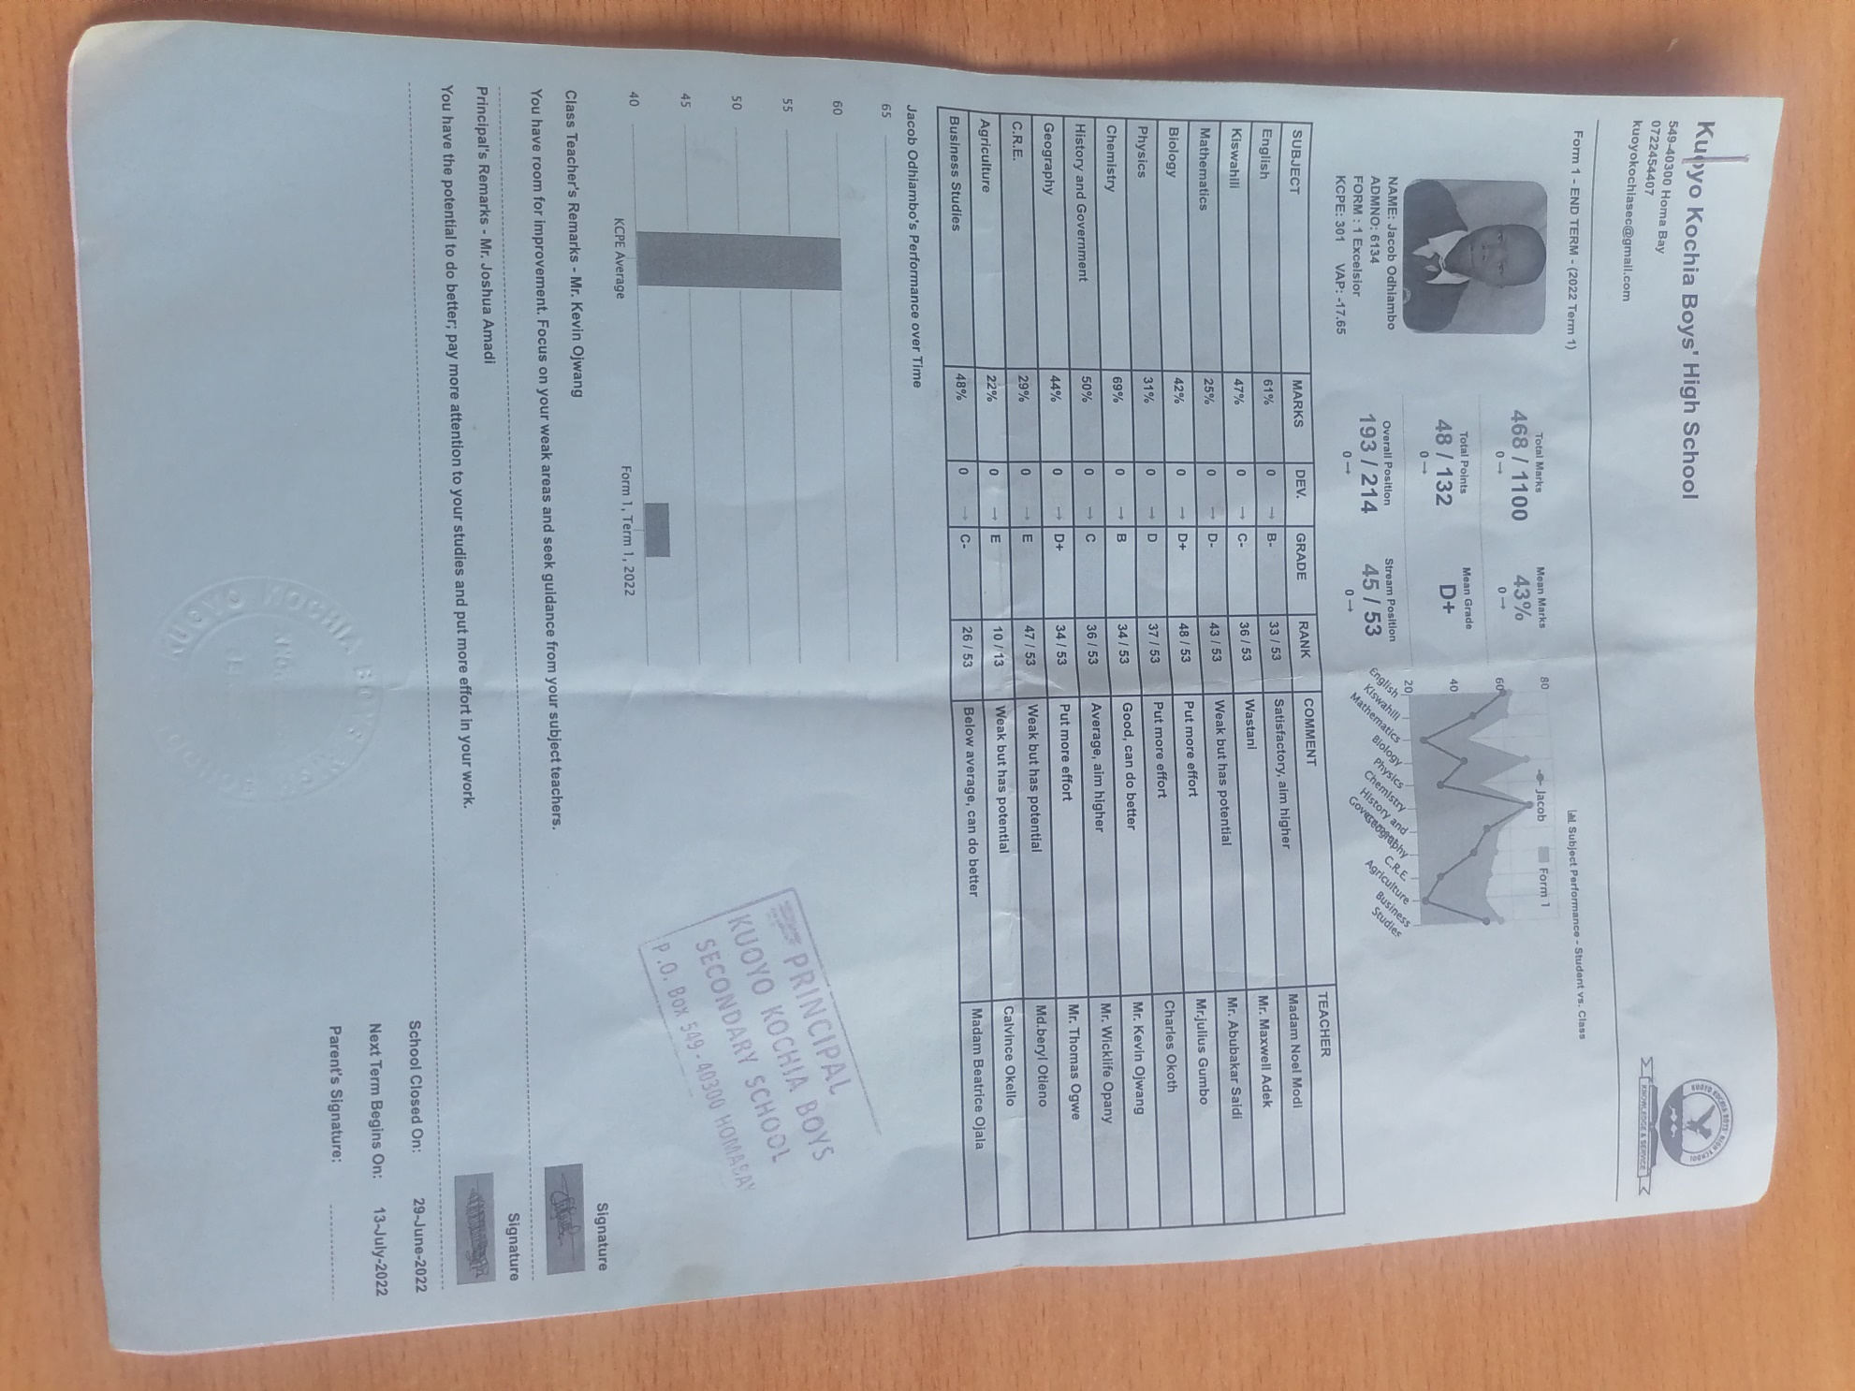
TFEC remains sincerely humbled by our donors and we appreciate each act of humanity shown. We promise to remain on our course to truly change lives of the needy children. This is our plea.
Thanks very much.
By Charles and Gonsag.

