
TOWNSHIP FOUNDATION EDUCATION CENTRE P. O. BOX 128-40303 RANGWE-KENYA MOBILE:+254 72858739 Email: Townshipeducationcenter@Gmail.Com
DONATION REPORT FROM JUNE 5TH- SEPTEMBER 1ST 2024
ACKNOWLEDGEMENT
Township Foundation Education Centre management acknowledges with great honor the receipt of donations worth $15000 disbursed on the 13th June 2024 as $12,750 from the Wilson Family Giving via Fidelity Charitable on the 5th June 2024 driven through GlobalGiving fundraiser platform. We admit that without this, TFEC would not have achieved quite a number of its goals. Thank you for being there for us; your donations have indeed changed lives of our children and community at large.
APPRECIATION AND ACHIEVEMENTS
We Township Foundation Education Centre do register our gratitude to the Wilson Family Giving for the support they continually give to our children and to the community. We truly recognize and appreciate the GlobalGiving for giving us the fundraising platform.
ANALYSIS OF FUNDS UTILIZATION
We have invested this money in farming for the season running from August-December 2024 by leasing 10 acre piece of land for maize and beans production. The produce we use in the feeding program and sell the surplus for income generation. We have already ploughed waiting to plant at the onset of rains
.
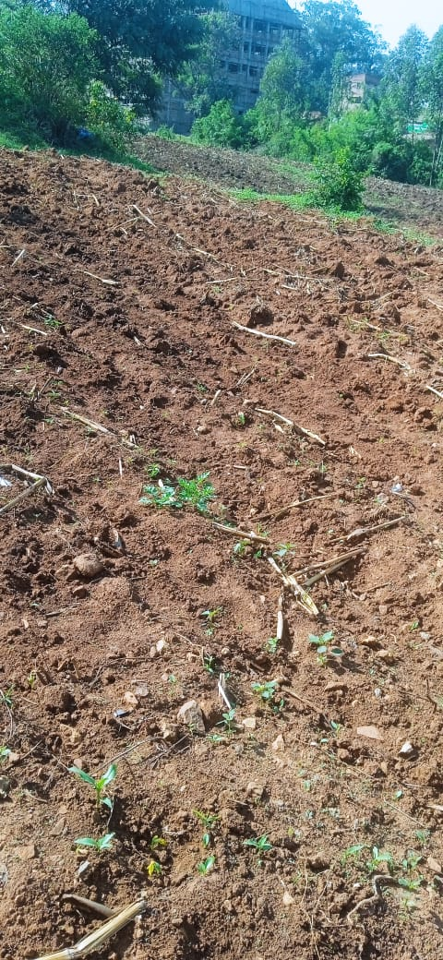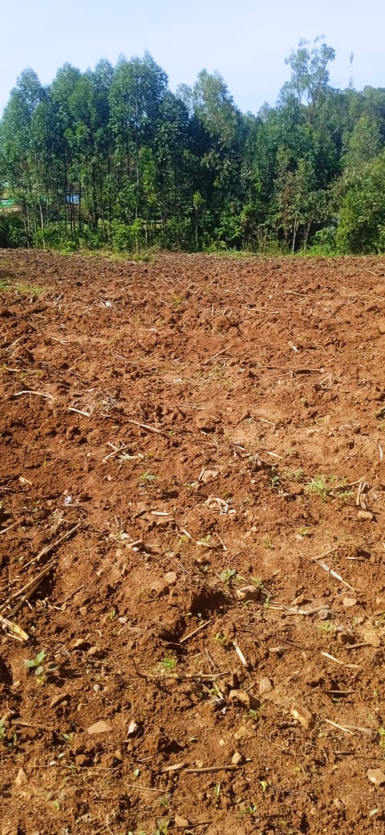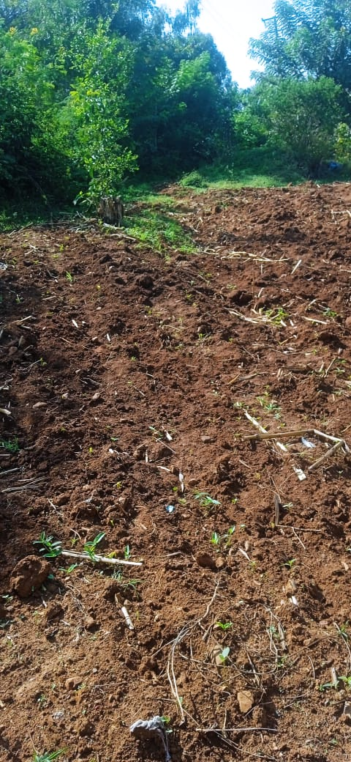

Funds utilization Table
sn | Item description | unit | Quantity | Unit cost($) | Total in USD
1 | Land leasing | Acres | 10 | 600 | 6000
2 | Tilling of land | Acres | 10 | 100 | 1000
3 | Seeds | Kg | 120 | 4 | 48
4 | Fertilizer | Kg | 500 | 0.96 | 480
5 | Labor | Acres | 10 | 400 | 4000
6 | Transport |  |  |  | 1222
7 | Total |  |  |  | 12,750

We continue to cherish our donors and hold high GlobalGiving for giving us this platform for fundraising. Surely you have given as a chance to put a smile on a numbers of faces which had initially lost hope.
Thank you and be blessed.
Prepared by;
Charles Odero,
Project Leader.

