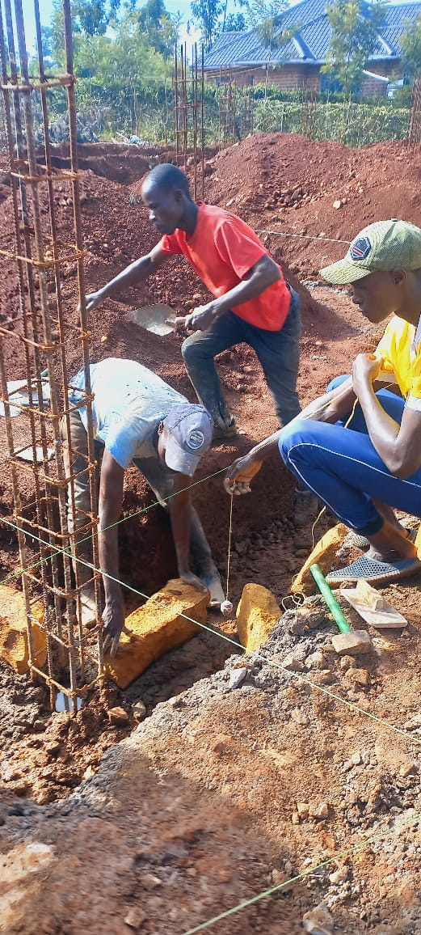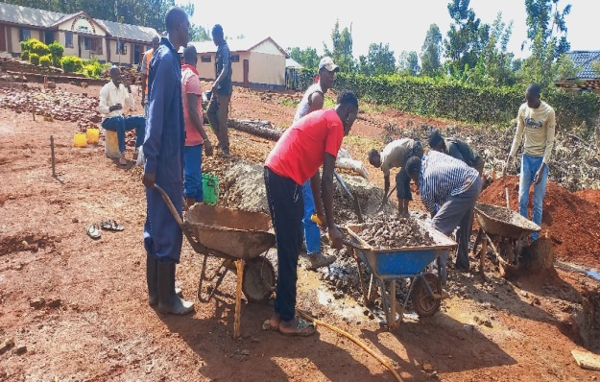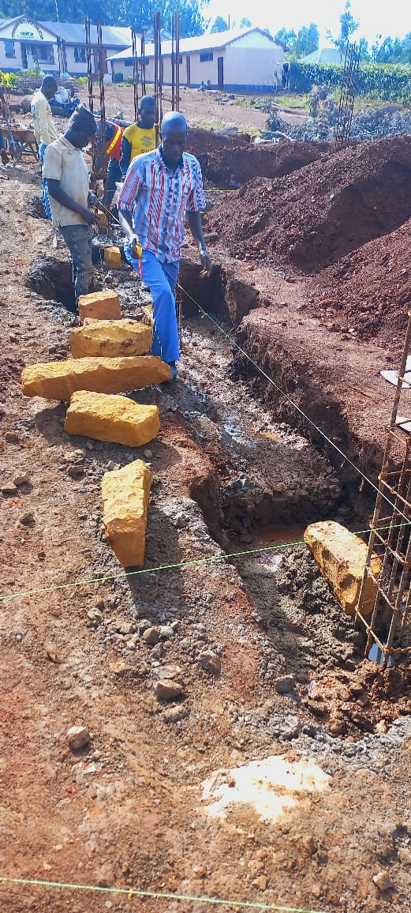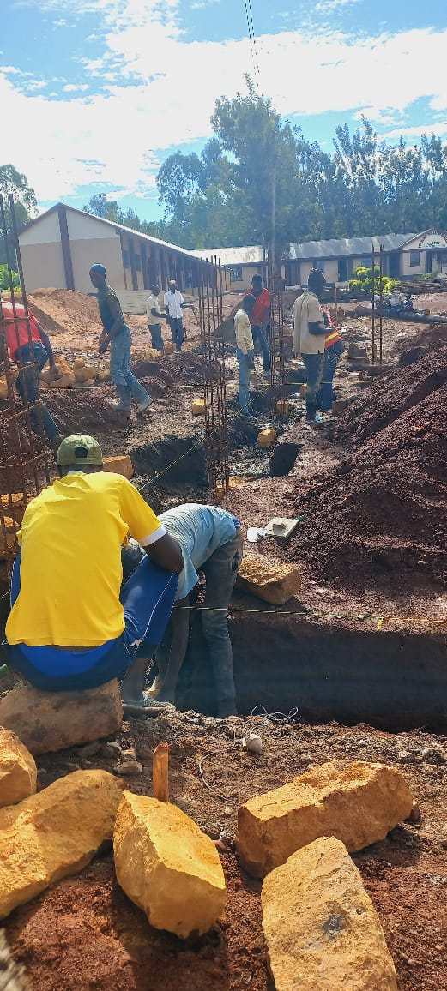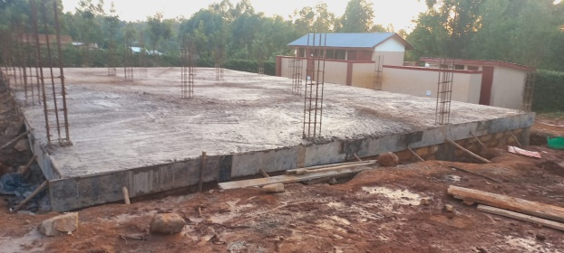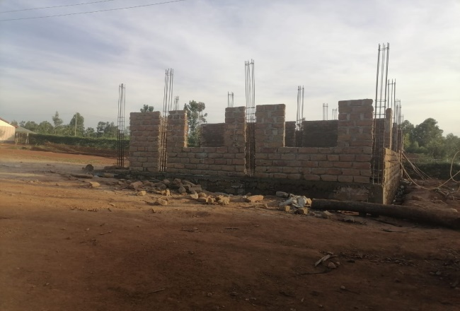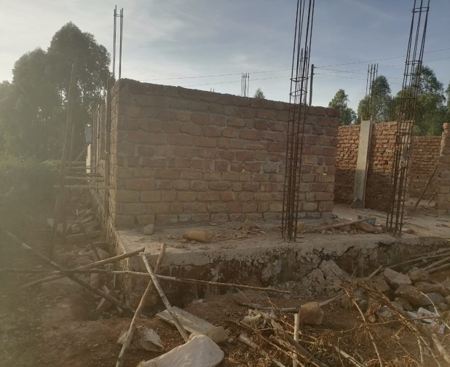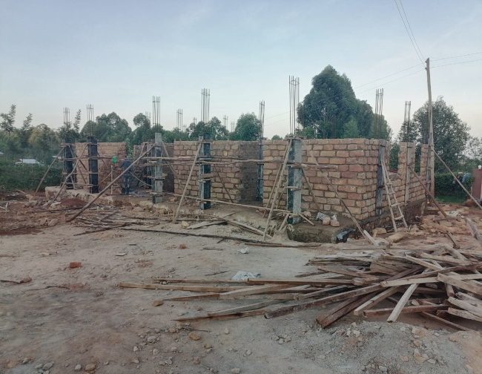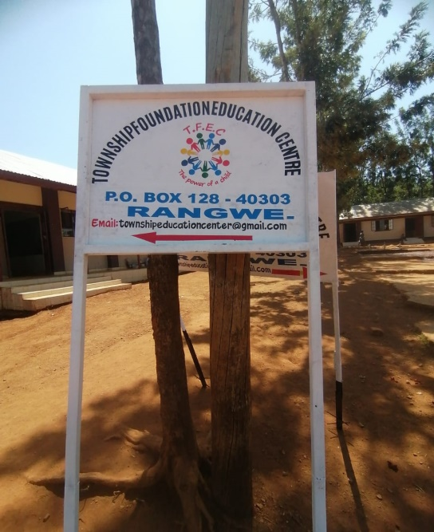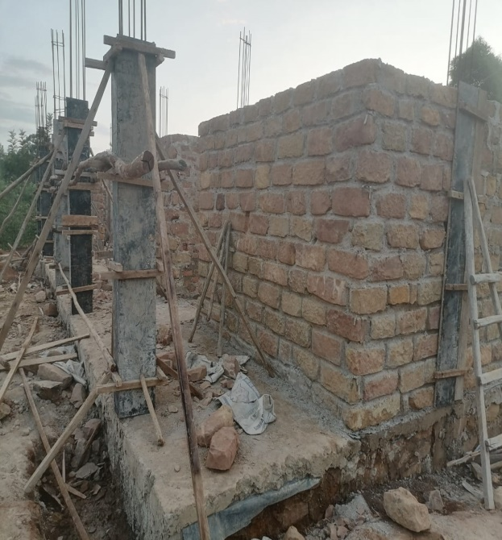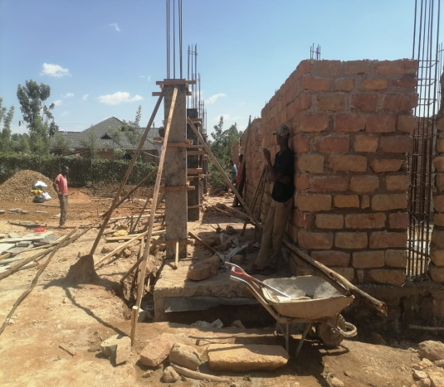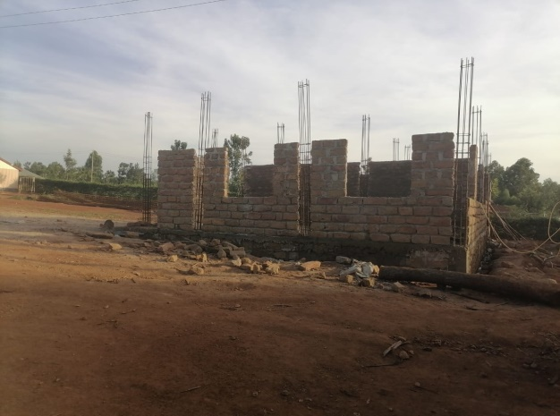

The above photos demonstrate the step-by-step progress of the 3 classroom storey building. The building is a section of the larger building only picking the left section of the shown plan which contains two classrooms, a staircase and a sickbay as indicated in the plan sent to you separately. We have managed to do base laying (foundation), lower slabbing, columns setting and walling to lintel level. We are not able to do the upper slab due lack of resources because we have exhausted the funds we had .We need $8,000 to do the upper slab and finishes of the ground floor indicated above so that the three classes can be in use.

ANALYSIS OF FUNDS UTILIZATION
DONATIONS FROM 28TH NOVEMBER 2023 TO JANUARY 24TH 2024
Amount Disbursed=$31,000
Construction Of 3 Classrooms To Lintel Level(Ground Floor)
No | Item Description | Qty | Unit | Unit Cost($) | Total Amount($)
1 | Sand | 100 | Tones | 15 | 1500
2 | Ballast | 60 | Tones | 20 | 1200
3 | Cement | 500 | Bags | 7.5 | 3750
4 | Foundation Stones | 1500 | Ft | 0.5 | 750
6 | Timber | 6 x1 | 1000fts | 0.27 | 270
7 | Timber | 3x2 | 1000fts | 0.27 | 270
8 | Hard Core | 40 | Tones | 10 | 400
9 | Bricks | 6000 | Pcs | 0.2 | On Site
10 | Walling Stones | 4000 | Ft | 0.6 | On Site
11 | Deformed Bars | 700 | Pcs | 18 | On Site
12 | Sand | 50 | Tones | 15 | On Site
13 | Round Poles | 600 | Pcs | 2 | 0n Site
14 | Muram | 60 | Tones | 10 | On Site
29 | Subtotal |  |  |  | 8,140
 | 35% Labor Cost |  |  |  | 2,849
 | Total |  |  |  | 10,989
Thunderstorm Prevention And Electricity Repairs
S/N | Item Description | Unit | Quantity | Unit Cost($) | Total Cost($)
1 | Thunderstorm Arrestors | Pcs | 4 | 36 | 144
2 | Copper Plate | M | 100 | 150 | 1500
3 | DC/AC 10 KVA Power Invertor | Pcs | 1 | 750 | 750
4 | Power Controller | Pcs | 1 | 180 | 180
5 | Automatic Change Over Switch | Pcs | 1 | 300 | 300
6. | Solar Batteries | Pcs | 6 | 230 | 2300
7 | Labour Charge |  |  |  | 720
8 | Working Period | Days | 14
9 | Sub Total |  |  |  | 5,894
10 | Scholarship Program |  |  |  | 14,000
11 | Total |  |  |  | 19,894
 | Grand Total For The 3 Projects |  |  |  | 30,883

We continue to appreciate the support we have received and continue to receive. Surely if it were not for your support Daniela, we would be nowhere near this level.
Thank you so much. We so are humbled.
Charles Odero
Project Leader

