**Progress report**

***MHO is women headed a non-governmental, organization established in 2011 with mission Empowering and changing the personal social and economic status of all women and children’s of Ethiopia who live in under poverty by giving the opportunities and supports which leads to development. MHO founded by a role model women, who long been served in Ethiopia Red Cross. She currently considered by many Ethiopian as 'mothers' to Ethiopia's most vulnerable and kid. . Since its establishment, the organization has implemented programs /projects mainly focusing on addressing the felt needs of targeted women and children.***

One pack for one child among currently active project implemented by MHO though Global Giving with support of special individuals and foundations like Corteva who provide the funds. Under this project, there are 5000 needy children. Since start of the project, One pack for one child project benefitted thousands children from poor families those who often missed out on school due to economic problem. This project enabled many needy children to properly attend their education as equal as their peers by providing nutritious food ,educational materials ,uniform , bags and etc .In this reporting period alone about 200 poor children Addis Abba and Southern People impacted by this project. Of 200 beneficiaries about 102 are girls benefitted in this reporting period. In this reporting period your financial support already created early childhood education opportunity for hundred’s Ethiopia Children from impoverished families On top of this there are 130 impoverished mother and 250 children presently sheltered and provided holistic services including, clothing, medical services, feeding service (school meal), and counseling and socialization services through MHO. Without you affording that care would be impossible. Individuals and foundations like Corteva generosity grant and partnership has enabled MHO to continue to serve our vulnerable children with mother

**We never missed my school again**

Children pictured here, is among other who has benefitted from the activities and programmes offered by the project. Theses Children’s are from poor families not able to pay school fees and provide the necessary and nutritious food and educational materials for their children. This beneficiary was selected by beneficiary committee and local district government official in this academic year. Previously these children were among children those who often missed out on school. Now they are attend their school without any problem as equal as their peer. This only possible because of the support of special individuals and foundations like Corteva who provide the funds to MHO project

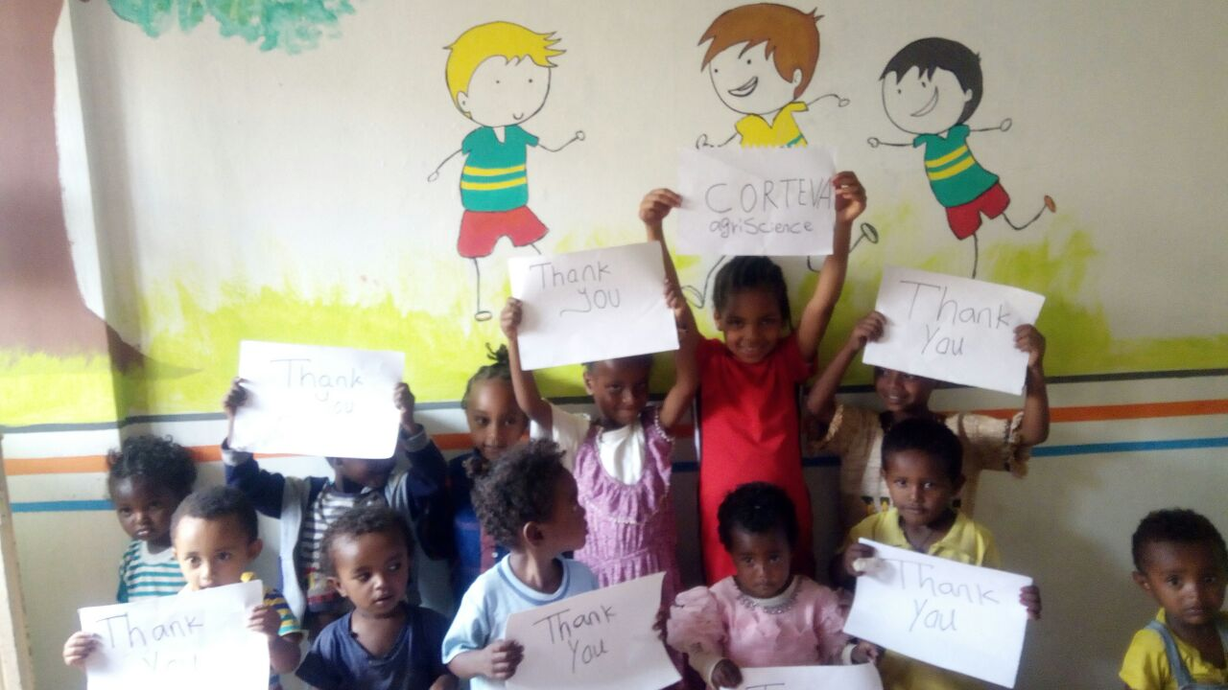

Figure Corteva thoughtful and generous donation and not only cultivate and building a strong foundation of our early childhood education but also enable us attend our school without any problem as equal as tour peers by fulfilling our

nutritional need

**Corteva thoughtful and generous donation and not only cultivate and building a strong foundation of our early childhood education but also enable us attend our school without any problem as equal as tour peers by fulfilling our nutritional need and provide educational material supplies**

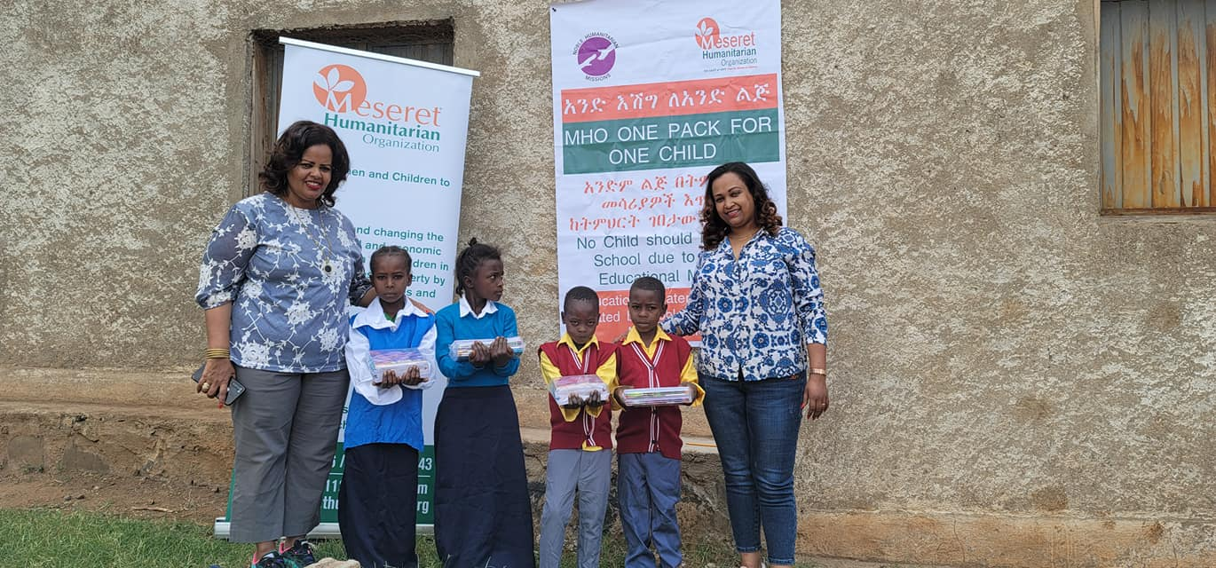

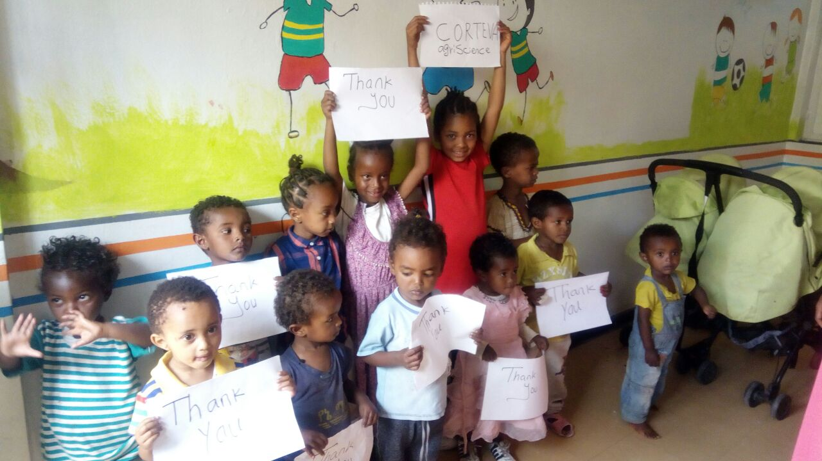

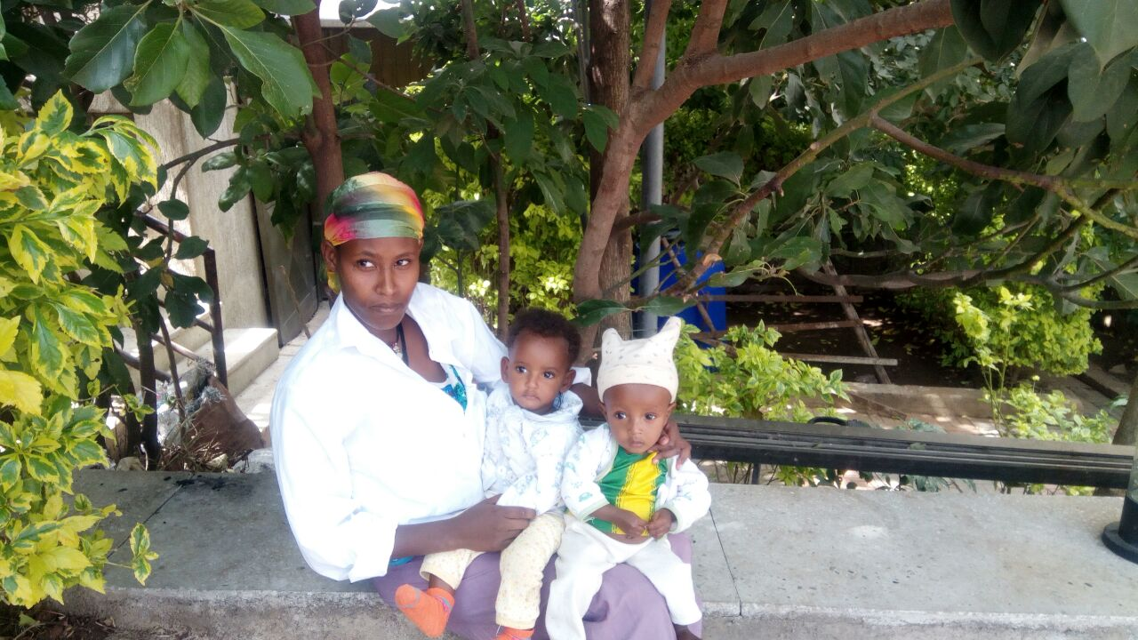

Figure My name is Haabtam .pictured here a mother of twin’s children in who has benefitted from life-saving food, nutrition, medical and hygiene supplies, nutrition rations to children and women whose you funded on the global giving . Because of the s your

Habtm mekurai pictured here a mother of twin’s children in who has benefitted from life-saving food, nutrition, medical and hygiene supplies, nutrition rations to children and women whose you funded on the global giving . Because of the s your generous donation my twin’s children in good health and saved .This only possible because of the support of special individuals and foundations like Corteva who provide the funds to MHO

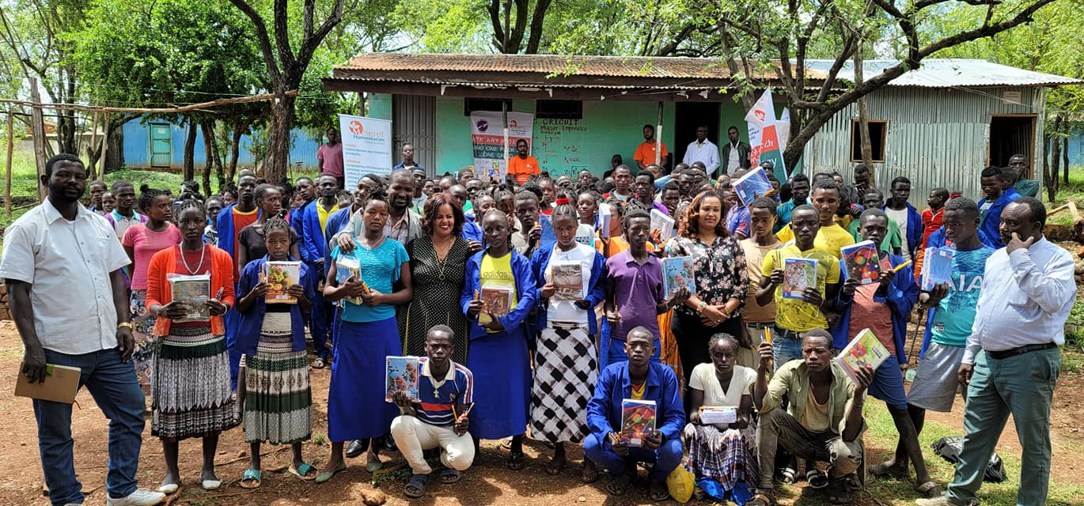

**Note: All the pictures and Name mentioned in the report real and MHO beneficiaries**

r