Program: Educate 10 Orphan Girls in Rural Nepal
Thanks to all our donors and supporters for continuing to support this project. The purpose of the campaign was to support Modern Model Residential School, our partner school in Naraharinath Rural Municipality in Kalikot district in Western Nepal to bring in 10 girls who are orphans or children in desperate need of support. Our campaign is fully funded now. Two girls in need, Nisha and Bismata are already being supported, whereas eight other girls and children in need will be supported in the coming months.
Children’s Update
Both Nisha and Bismata are settling well and doing well at our hostel facility and school. Their profiles have been highlighted in the last report. Both of them are in kindergarten this year. They are happy to be at our hostel and school with similar other children.
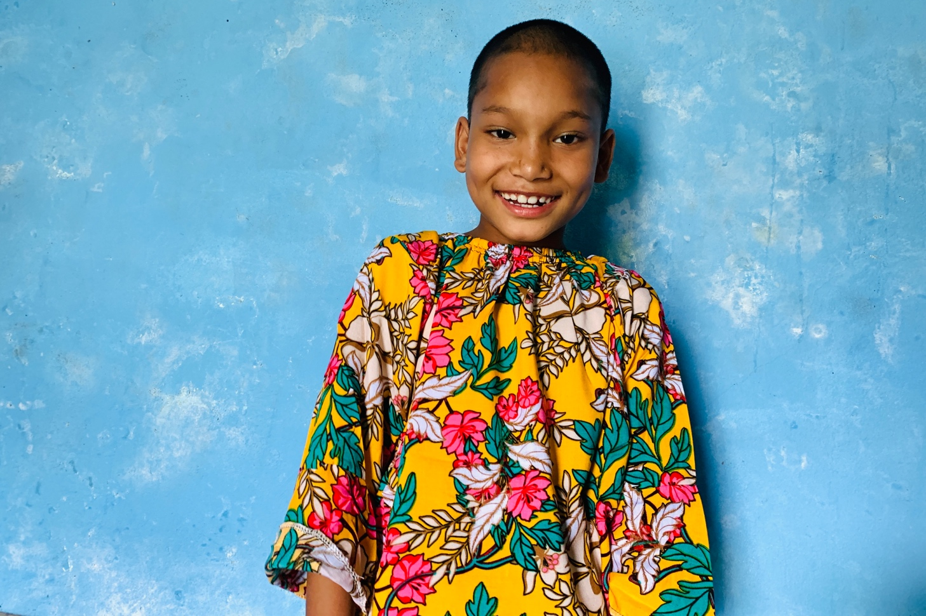
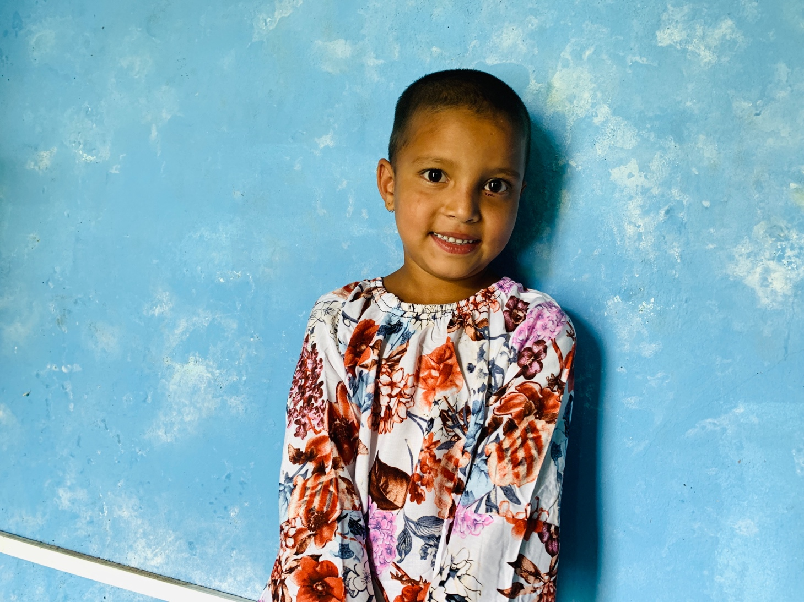
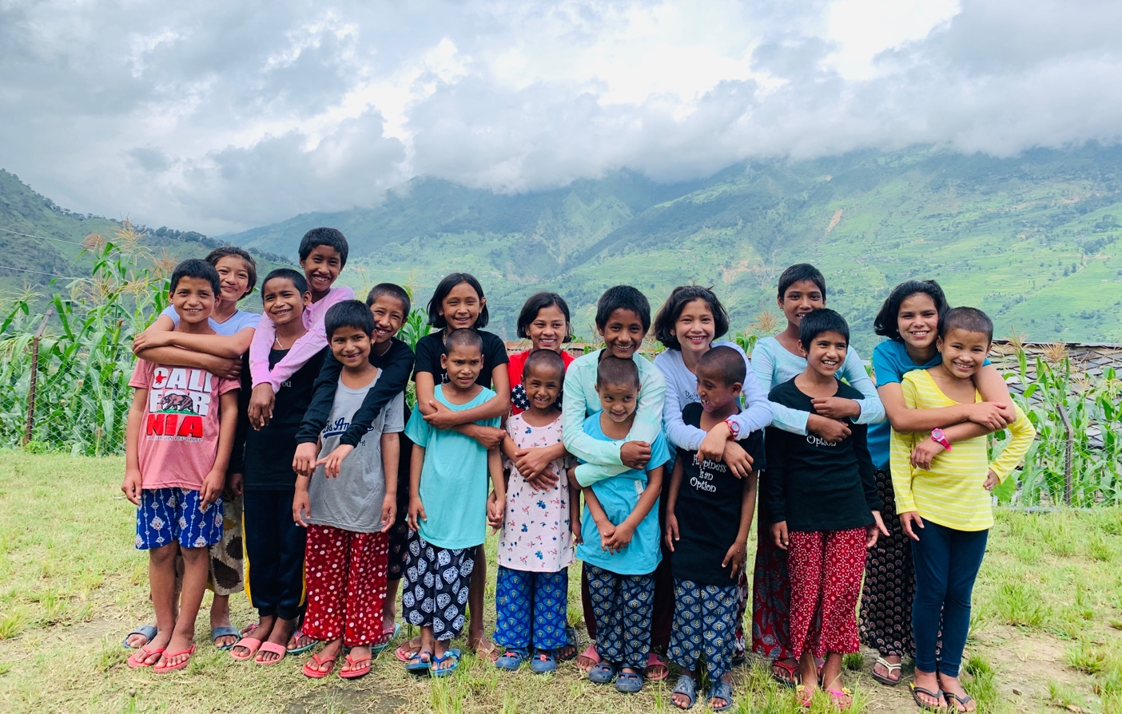
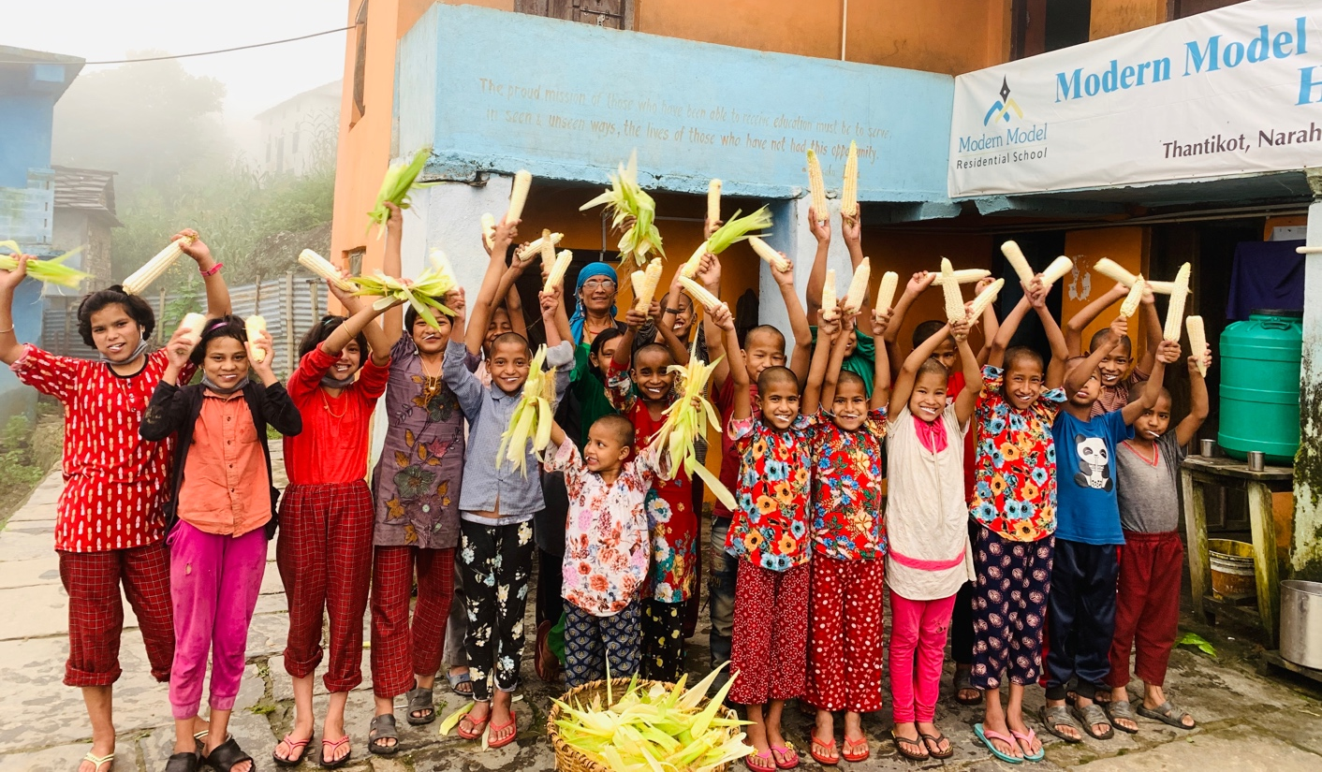
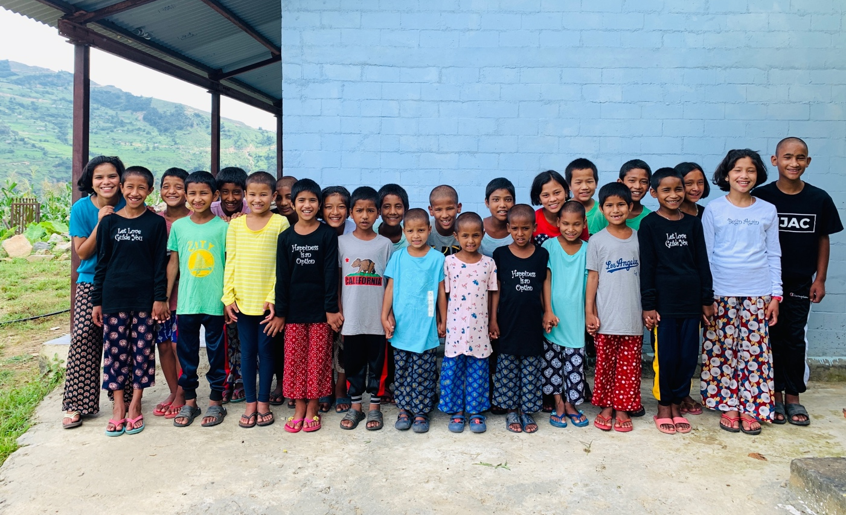
Thank you so much to all who have donated to our campaign to make a difference in the lives of children in need in the remote villages in Nepal.
Thank You

