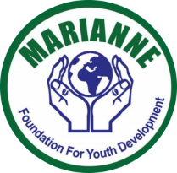
Proposal to Construct a Health Center

Submitted to
The Global Giving & Partners
March 2021
Website:www.mariannefoundation.com

Marianne Foundation for Youth Development (MFYDe) is a not for profit organization working with women. The Foundation also has a registered cooperative to help women in craft making.We use right based approach in our programming whereby communities identify their own challenges and through rural performance appraisal, we agree with communities what role they can play in solving their own challenges and we work to identify partners who can help us help these communities live better.In our work, we relate the challenges that affect communities and encourage the communities to believe that it is their right to get access to what they do not have. The communities are always encouraged to take the first step towards solving their challenges. This has created a bottom up planning for all our projects. Our projects are community driven.
Our Mission:
To empower rural youth to lead their communities in innovating appropriate solutions to their own challenges through mobilization, training, and expedient partnership development.
Our Vision:
Marianne Foundation envisions ‘an economically independent community sustaining itself through utilization and conservation of its own resources.’
Marianne Foundation is in partnership with The Big Hope Foundation Uganda implementing the Safe Motherhood Project.
About Big Hope Foundation:
The Big Hope Foundation Uganda is a non-governmental organization founded on 13th October 2010 by six members. It was officially registered on 11th September 2015 at Ishongororo Town Council as a community based organization Certificate No 041/2015 and on 14th September 2015 at the District Reg.No. 155/2015.
Mission:
To build medical centers for quality and accessible provision of health services
Vision:
Our vision is “to have an enlightened health community and self sustaining region”
Accomplishments for the Safe Motherhood Project:
- Distribute 9000MamaKits to mothers in 2022 to 2025
- 10000mothers receiving antenatal care by the end of 2025
- 600 women receive family planning services annually

With 70% of doctors practicing in urban areas, where only 20% of the population lives, the coverage in rural areas is much worse: one doctor for every 22,000 people. Programs are in place to train community health workers, forming Village Health Teams that operate at the local level, but coverage has been too limited to solve the problems. The Uganda Ministry of Health conducts annual surveys that assess health system performance, and these have shown significant shortcomings in availability and quality of service. Customers complain about poor sanitation, a lack drugs and equipment, long wait times, rude service, and inadequate referrals. This uneven service discourages patients from seeking out professional care, especially in rural areas with longer travel times.
--
In Uganda, mothers are dying at an alarming and increasing rate. Uganda's Maternal Mortality Rate (MMR) has consistently been one of the highest in the world with 440 deaths per 100,000 live births, according to UNICEF'S latest data. In Uganda, one woman out of every 49 will die of a maternal complication related to pregnancy or delivery.
--
Women in rural Uganda face multiple barriers to accessing critical routine and lifesaving maternal health care. The barriers fall into the Three Delays Model: delay in deciding to seek care, delay in reaching care (e.g. transportation and lack of road infrastructure), and delay in receiving adequate and appropriate care (e.g. lack of skilled birth attendants). In Uganda, the leading causes of maternal death are hemorrhage, eclampsia (high blood pressure), unsafe abortion, and infection. All of these causes of death are largely preventable. What makes the Three Delays Model so important is that with appropriate medical care, the vast majority of these deaths would not occur. This model addresses the barriers to accessing lifesaving treatment by outlining where each barrier may occur. Central to this model is the practice of encouraging women to seek care as soon as possible, in order to ensure survival.
The figure for the mortality rate may actually be higher since some birth are done by Traditional Birth Attendants (TBAs). Many rural women prefer TBAs due to their proximity and lack of costs associated with travels to hospitals.According to the Ministry of Health’s Reproductive, Maternal, Newborn, Child and Adolescent Health Sharpened Plan for Uganda 2016-2020, about 416,000 women annually are still not assisted by a skilled birth attendant.
The government outlawed TBAs in 2010 arguing they cannot handle hemorrhaging in women, which contributes to 42% of maternal deaths and is the leading cause of death in maternal mortality in the country.
The government said TBAs work in unhygienic conditions, which can cause infections and in situations where a baby is not lying properly in the mother’s womb -- a situation might call for a Caesarian-section, which they cannot perform.
The ban, however, has not eliminated TBAs. Many expectant mothers, especially in rural areas, say they prefer TBAs to skilled health workers because of their politeness, care and comfort during labor and child birth.But some women say the proximity to medical facilities prevents them from using TBAs, while for others it is the traditions and local customs.
As Marianne Foundation and Big Hope Foundation, we believe that no child is born to die and no mother should die while giving life.
Safe Motherhood Project will focus on the following:
The Health Center will focus on general health services, antenatal, pre and postnatal services, laboratory, in-patients, out-patients, HIV testing and counselling, immunization, public health services and family planning.
Project Objectives
- Reproductive health services such as family planning, antenatal, deliveries, postnatal care, post abortion care, cervical cancer screening and treatment and prevention and health education. This is a priority number one after realizing the five major causes of death in the reproductive age/pregnant women (identified causes of death are; postpartum hemorrhage, preeclampsia and eclampsia, sepsis, abortions and malaria during pregnancy). These causes are preventable and manageable.
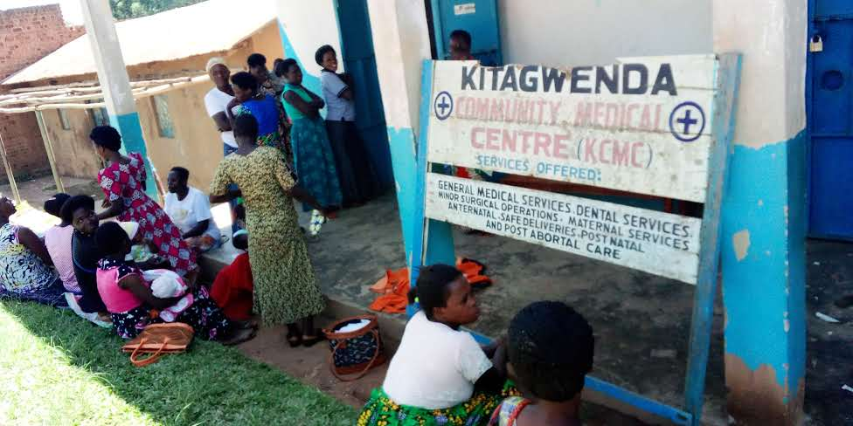
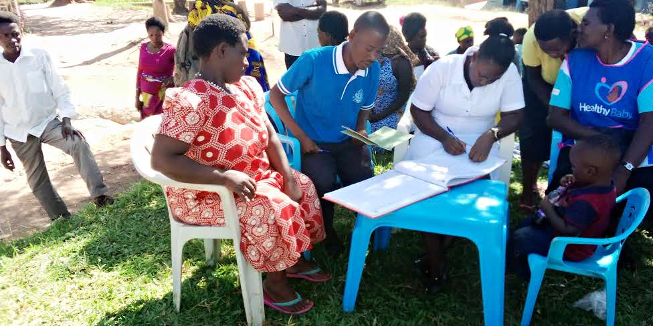
Above: Health work conducts registration in one of community outreach while in another photo woman line up at Kitagwenda medical center for antenatal services
The Grant will help to provide a bigger space to offer comprehensive health services.
It will serve 100 women and children daily from the districts of Kitagwenda, Kamwenge.
Services may include, OPD, Antenatal, Maternity, HIV counselling and Testing, Laboratory and ambulance services.

- To contribute to improved health conditions of women and children with a view to enable their households get out of poverty by increasing access to maternal and child health services as well as general medical services to the community.
Marianne Foundationand Big Hope Foundation seek to do the following activities:
- Construction of an outpatient department (OPD) building at the health center with a laboratory room, dispensing room and doctors’examination room. This will include placenta pit and incinerator and construction of two toilets at the Health Center. (66,610,400/)
- Procure an ambulance to facilitate real time emergence of transporting pregnant mothers from deep villages to the Health Center
Summary (BILL 1) | UGX | USD
Foundation | 31,383,600 | 8,967
Walling | 27,214,800 | 7,776
Columns & Beam | 6,687,000 | 1,911
Toilets (Stances for Women/ Men | 18,792,000 | 5,369
Shutting | 10,830,000 | 3,094
Finishing | 41,703,000 | 11,915
Purchase of Ambulance | 86,000,000 | 24,571
Sub total | 222,610,400 | 63,603
Big Hope Foundation & Marianne Foundation contribution(A) | 70,000,000 | 20,000
Requested from Global Giving | 152,610,400 | 43,603

(Detailed budgets attached)

