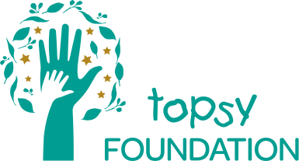

PROTECTING THE RIGHTS OF CHILDREN DURING THEIR CRITICAL, FORMATIVE YEARS TO FULL COGNITIVE, EMOTIONAL, SOCIAL and PHYSICAL POTENTIAL
in rural Dipaleseng, Mpumalanga

The Topsy Foundation, a registered Not-Profit and Public Benefit Organisation, has been serving the rural communities of the sub-district of Dipaleseng situated in Gert Sibande in the most southern part of Mpumulanga for 20 years. Whilst services provided have shifted over the years in response to community needs, they have always had at their core the focus of the wellbeing of the community, particularly vulnerable women and children. Since 2015, after consultation with the community, services focus on young children under 6 years of age as research indicates that investment during these early, formative years brings the most return in terms of a more educated and prosperous adult population in later years. The intervention has five child-centred components which together provide the basic support and tools that need to be in place so that vulnerable children can be raised in as optimal an environment as possible. The Topsy Health and Stimulation Centre in Grootvlei is home to our Play and Learn Centre, pharmacy, medical suite and community vegetable gardens. It is ideally situated to easily serve and be accessible to the surrounding communities of Grootvlei ext 1, Siyathemba and Nthorane.

The Topsy Foundation’s Early Childhood Development Programme supplies:
- Educational support and stimulation for early learning through close work with Early Childhood Development Centres within the community and our Play and Learn Centre situated in Grootvlei
- Primary level child health through medical support comprising health development screenings, provision of treatment, the dispensation of basic medicines, and referral for specialised attention
- Nutritional support through the establishment of food gardens and food donations
- Support for primary caregivers through home visits, counselling and parental skills training
- Social and income support through assistance with birth registration, accessing of child support grants and child protection.

By ensuring that all children within our reach get a package of essential early services, we can help to provide them with a more equal start to life.

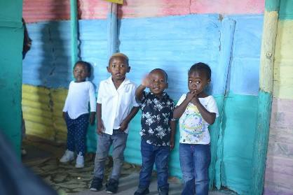
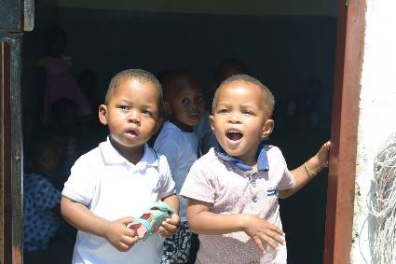
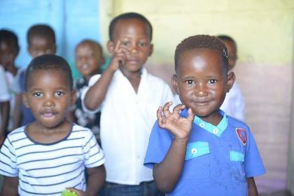

15 Sloane Street • Bryanston • 2152 • Johannesburg • South Africa
P.O. Box 131163 • Bryanston • 2021 • Johannesburg • South Africa • www.topsy.org.za
Tel: 27 11 709 6806 / 27 11 709 6623 • Fax: 27 11 700 3032 • topsyfoundation@ogilvy.co.za

Executive Directors: Sarah du Toit
Non-Executive Directors: Sandesh Singh (Chairperson), André Gilbertson, Zacharia Sethojane, Ayn Brown, Rodney Waldeck Reg. No. 2000/027675/08 • NPO 016-668 • PBO 130001720

