**I AM ABLE TO LIVE AN INDEPENDENT LIFE -STELLA**

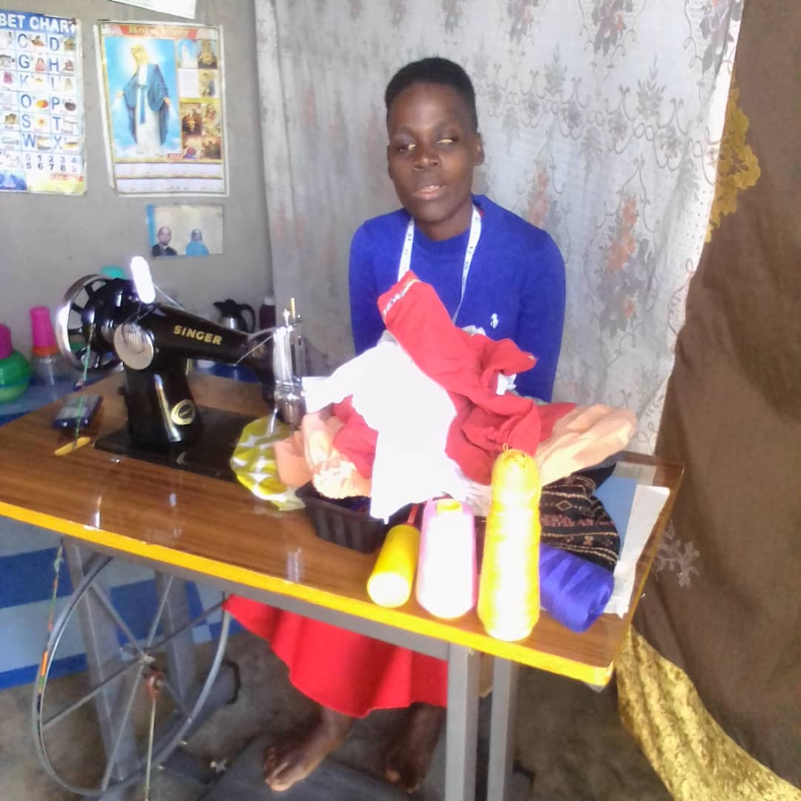

Stella is a woman with visual impairment, a single mother of one daughter aged 7 years, resident of Kayabwe Town council.

She received a sewing machine from MPWDA. She was also trained in tailoring.

She first worked with her boss but also later learnt how to look for customers. She rented a single room and partitioned it for bedroom and work space.

Stella is now operating a tailoring business at Kayabwe Town Council to sustain her life and her daughter. “I can now sustain my family on my pocket without begging. I know longer cry”. Stella

She is also emphasizing to her fellow women with disabilities not to underrate themselves in day today activities as well as reporting any case of abuse that is attached to them to concerned authorities. “I am greatful to the Global Giving donors, they have totally changed my life” Stella. She also thanks MPWDA for the support.