Report February 2021

Inclusion of women in community decision-making

Report of activities in LOS ALTOS DE CHIAPAS; at the Municipality of San Juan Cancuc and Chenalhó, in Chiapas, Mexico

At the beginning of 2021, despite the contingency, we managed to keep our attention to adolescents and young women. Through socio-emotional learning workshops, the young women were able to express their concerns about Covid-19 in their community and the lack of prevention by local authorities.
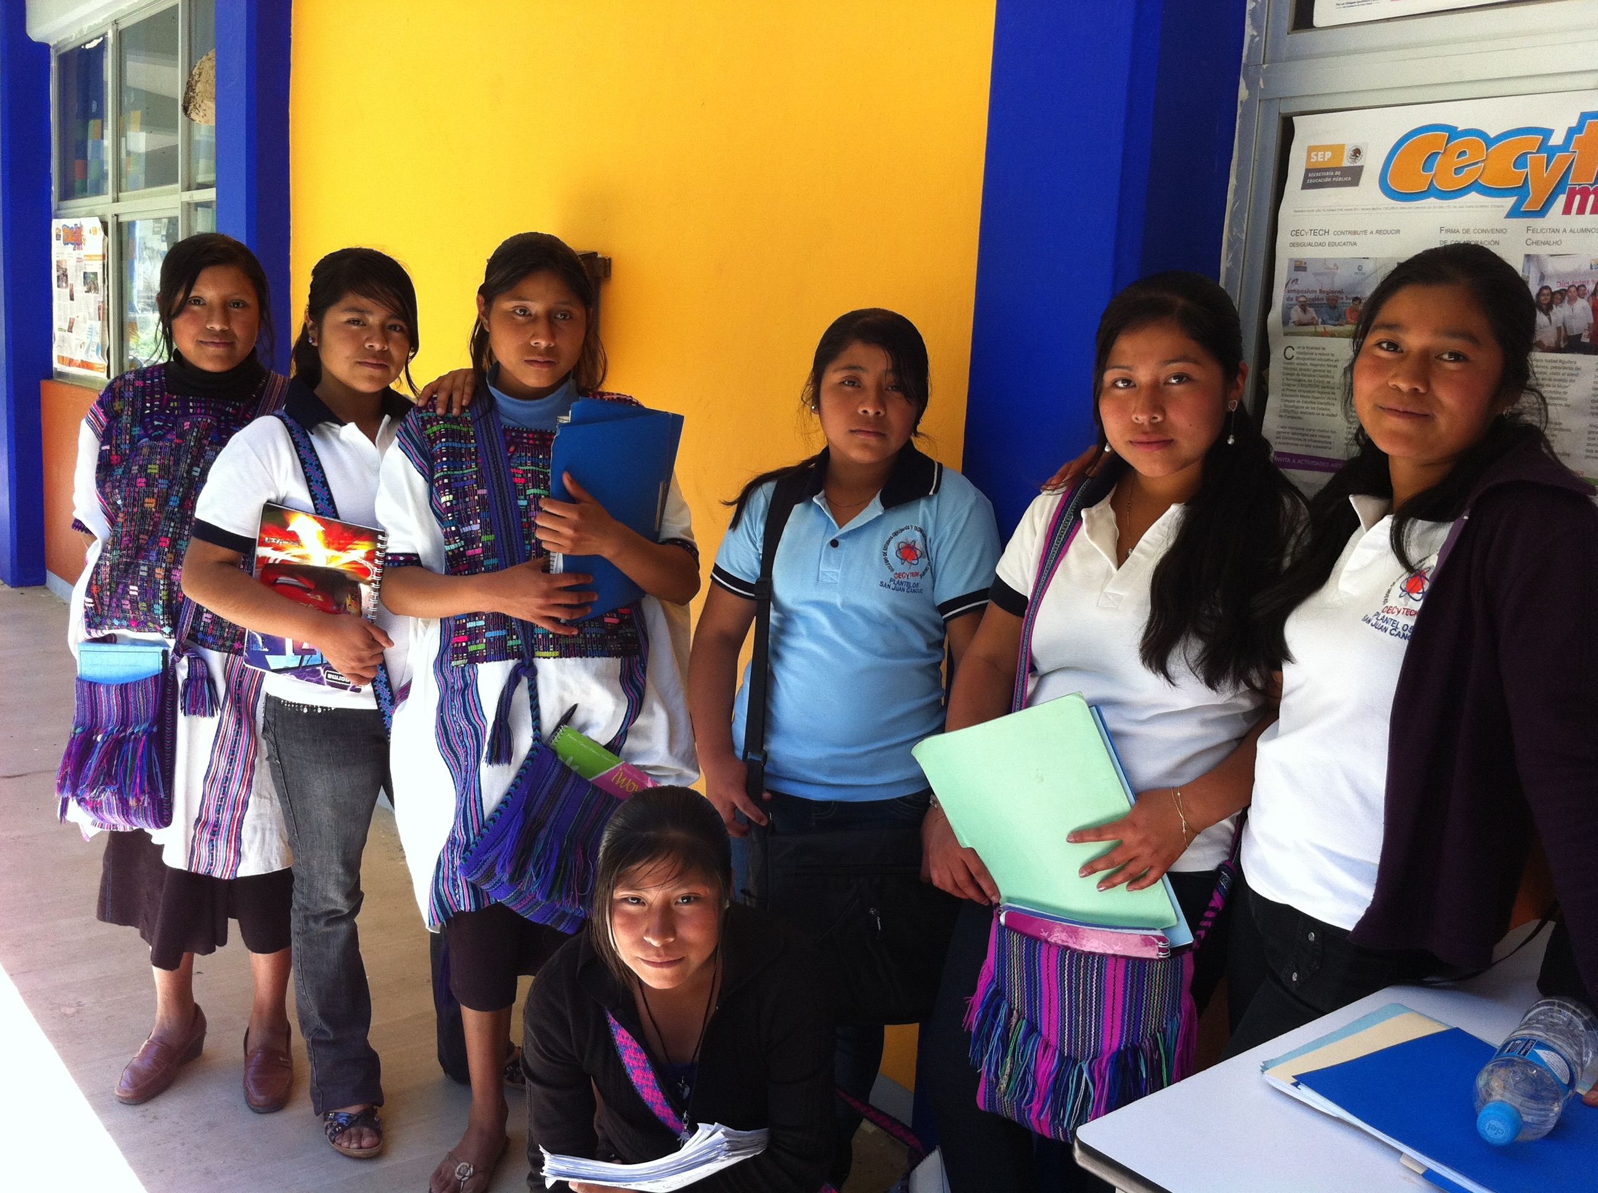

Together with Ch'ieltik, the participants developed a questionnaire addressed to community members about their perception of the disease. In San Juan Cancuc and Chenalhó so far about 180 citizens participated in the survey. Results will be released in April with the support of various organizations in Mexico to publicize the impact of Covid-19 on indigenous communities.

Girls from San Juan Cancuc

Thanks to this activity and the training that the participants receive, we can achieve the inclusion of adolescents and women in the next intersectoral roundtables in both communities. The health authorities have already supported this initiative and we are working both on the proposals that would be brought to the table and on the democratic designation of the spokespersons among the 60 most active participants of the program. This March we will continue with the workshops and training of the participants in order to be attended at the intersectoral tables at the end of the month.

Due to the relative indifference of men, Covid-19 can become a gateway for women from both communities to begin to speak and impact the decision-making of local authorities.

3 interviews were made in Spanish available on our social networks to exemplify latent machismo in indigenous communities.

