Application Global Giving

Training in:
Life skills: Personal Development, CV and Job readiness, Drug and substance abuse, HIV/Aids, Kitchen skills, Food and Nutrition, House Keeping, First Aid.
Home Based Care: Frail Care and Chronic illness management, Rights of the elderly, Feeding, Medication etc.
Baby –and Child Care: Child Development, Hygiene, Child Safety, Stimulating, Creative activities, Movement, Playroom and Music.

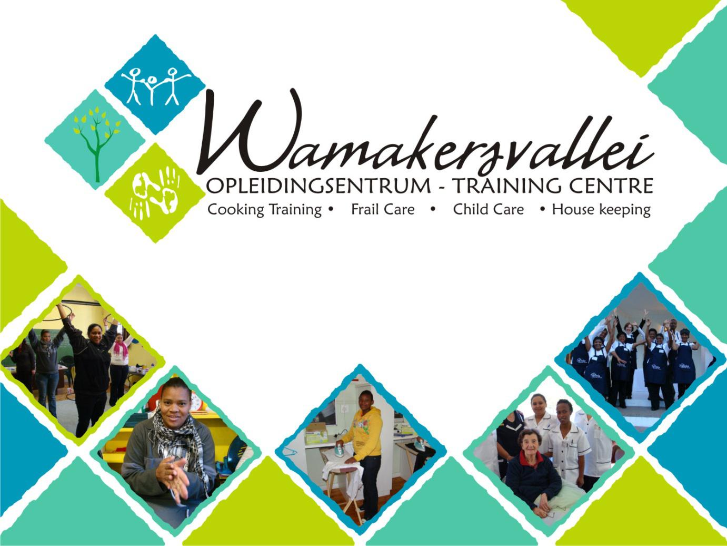

From: Wamakersvallei Training Centre
Contact: Elsabe Lintvelt
☎: + 27 21 873 5942
📲: + 27 83 630 8201
📧: elsabe@wamakerstraining.org.za
🌐: www.wamakerstraining.org.za

REQUEST FOR MONTHLY/ ANNUAL SUPPORT

INTRODUCTION

Wamakersvallei Training Centre NPC (hereafter “Wamakersvallei”) is a Registered 21 Company (NGO) based in Wellington in the Western Cape. The Centre opened its doors in 1998 to welcome the first group of students.

This year we are 23 years old!

Our community-based Centre provides training that is a much needed and affordable service, giving individuals who would otherwise never have had the opportunity, a new beginning in life.

Our main objective is to train unemployed people to become skilled workers or entrepreneurs in the field of Frail Care (“carer”), Child Care (“crèche teacher, nanny”), Home Management and Cooking and Hairdressing Assistants.

Not only do our students receive training in theory and practical experience, but also obtain valuable life skills and knowledge.

REQUEST

Wamakersvallei requires funding in order to:
- subsidize the tuition costs of R4 500.00 per Frail Care and Child Care student.
- assist with operational running costs of our centre - our financial reports can be made available in this regard.
- support special projects that we wish to undertake this year.

More general information is indicated below in respect to our request. Specific information will be made available.

IN RETURN
As a Donor organization, we undertake to print your logo on all our training manuals, workbooks, brochures, social media platforms and keep you informed of our progress and the impact of your support on our sustainability via annual reports.

We are however mindful of your requirements for a potential long term partnership and would wish to discuss aligned relationships between us.
ADMINISTRATION AND MANAGEMENT

- NAME OF THE COMPANY
Wamakersvallei Training Centre NPC

- PHYSICAL ADDRESS
10 Breedt Street
Wellington
7655
South Africa

- POSTAL ADDRESS
P O Box 479
Wellington
7654
South Africa

- TELEPHONE, FAX, EMAIL, FACEBOOK

☎: + 27 21 873 5942 or +27 21 873 3983
📠: 086 509 6509
📧: elsabe@wamakerstraining.org.za
FB: @wamakersvallei.opleidingsentrum

- CONTACT PERSONS
Chairperson: Pastor D Koopman 📲: +27 84 589 8863
Centre Manager: Elsabe Lintvelt 📲: + 27 83 630 8201

- BANK DETAILS
Absa Cheque account
Account Name Wamakersvallei Training Centre
Account Number 405 899 8558
Branch Code 334510 (Wellington)

- AUDITORS
BGR Chartered Accountants (SA)
Broodryk Kotzé Inc
3 Rose Street Wellington 7654
📲: +27 21 864 5180

📠: +27 21 864 5196
📧: bgradmin@fhbc.co.za
- ORGANIZATIONAL PROFILE
SPONSORS: Boland Printers
Valcare Funding Platform
National Lottery Distribution Fund (2016)
Quantum Foods

BOARD OF DIRECTORS *Board members work on a voluntary basis.
3 Members:
Chairperson Pastor Dennis Koopman
Centre Manager Elsabe Lintvelt

Birgit Westermann-Winter
Psychologist & Business Owner, Peoples Dynamic Development-Cape

📲: + 27 82 561 3965

📧: birgit@peoplesdynamic.co.za
Additional Members Retha De Jager Geratec

STAFF Centre Manager
Office Assistant
Student and Placement officer

- SKILLS WITHIN THE ORGANISATION
Voluntary Board of Directors
Community Participation
Registered Nurse
Training Experts
Cultural Diversity
Administration and organizational skills
Financial management skills

- TRAINING PROVIDED BY WAMAKERSVALLEI TRAINING CENTRE
(NOT CREDIT BEARING but the Home Based Care program is a Work in Progress in association with Geratec)

- Home Based Carers (Frail Care)
- Home Based Care Refresher Course
- Baby and Child Care
- Hairdresser Assistant
- 10-day Cooking Course
- Personal Development (Life Skills)
- Saving and Safety Course
- Food and Nutrition Courses
- Receptionist

- SERVICES
Facilitation of training
Placement of students

- SPECIAL PROJECTS 2021
- Presentation of the newly developed Receptionist Course
- Various Courses for crèche’s on Child Safety, Hygiene, Feeding and Nutrition
- Presentation of the Home Based Care Refresher Course in old age/ retirement homes
- Development and presenting of the Industrial Cleaning Course in collaboration with Geratec (Provider of full spectrum services to the care industry)
- Joint venture with Spescare Placements (Provider of a range of multi-disciplinary subakute and rehabilitation hospitals in South Africa and Namibia, specializing in physical and medical rehabilitation services).

- FINANCIAL STATEMENTS recent
Financial Statements are available on request.

- GOVERNANCE AND MANAGEMENT
Wamakersvallei Training Centre’s registration number is: 2004/033955/08 as an Association incorporated in terms of Section 21 (not having a share capital) under the Companies Act (Act 61 of 1973)

The following documentation is available:
Company Registration Certificate
Tax Clearance
Broad Based Black Economic Empowerment (BB-EEE) Certificate

Background and History
Wamakersvallei Training Centre is a registered section 21 company based in Wellington in the Western Cape. The Centre opened its doors in 1998 to welcome the first group of students.

This community-based centre provides training that is a much needed and affordable service, giving individuals who would otherwise never have had the opportunity, a new beginning in life.

Our main objective is to train unemployed people to become skilled workers or entrepreneurs in the field of Frail Care, Child Care, Home Management, Baking, Cooking and Hairdressing Assistants. Not only do our students receive training in theory and practical experience, but also obtain valuable life skills and knowledge.

Wamakers and Unemployment in SA
According to forecasting agency www.ceicdata.com: South Africa's Unemployment Rate is forecasted to be 35.313 % in Dec 2020 as reported by International Monetary Fund. It records a decrease from the last reported number of 28.700 % in Dec 2019.

Looking ahead, South Africa's Unemployment Rate is projected at 34.111 % in Dec 2021. Of particular concern is the high rate of youth unemployment. Unemployment in South Africa can lead to crime, poverty, depression, drug abuse, divorce, and homelessness to name just a few. The town of Wellington also has its share of these problems.

Wamakers - Part of the Solution
Wamakers’ vision is to provide training to the disadvantaged and marginalized community of Drakenstein.
Our aim is to empower individuals with the necessary skills to compete within the job market and generate their own income. By doing this we directly impact the employment rate in our country.
With our holistic approach we aim to educate individuals to enable them to take ownership of their own lives and lead healthy happy lives.
Apart from the formal training an important part of the curriculum of the Wamakersvallei Training Centre is to provide training to students with regards to Life Skills, HIV/AIDS, Drug and Alcohol Abuse and Pregnancy.
We also are privileged to have the services of a psychologist to assist the students. By doing this we equip individuals with the necessary knowledge to positively influence their families and communities.
We see our intervention as holistic, responding to needs and driven by community leadership.
Experience and skills are regularly donated by the Paarl and Wellington business community.

What we offer
Wamakersvallei offers a variety of courses. We offer 3 certificate courses of 8 consecutive weeks as well as number of short courses that only run for a couple of days. Courses are presented in Afrikaans three times a year and in English once a year. This is in line with the needs and preferences of the student community that we serve.

1. Certificate Courses (Course contents are available on request)
All students complete the BASIC HOME MANAGEMENT course of ten days (2 weeks) and thereafter elect one of below options, namely:
- Frail Care (6 weeks)
- Child Care (6 weeks)
- Salon Assistant (Hairdressing Assistant) (6 weeks)
- Cooking Class (10-days)

2. Short Courses
Courses run throughout the year for 1-2 days only. These courses include:
- Personal Development,
- First Aid Level 1
- Food and Nutrition
- Safety and Saving
- Receptionist Training
- Home Based Care Refresher Course
- Industrial Cleaning

Course fees
The Certificate Courses are R4500 per student including a R1500 deposit.

The Short Course fees are dependent on the course but in general we offer a course for R3500 per day for 12 learners.

Annually we train approx. 300 students, mainly from the Drakenstein area, but also from the surrounding rural towns of Ceres, Wolseley, Malmesbury, Tulbagh, Franschhoek, Stellenbosch and Riebeek Kasteel.

Although most of our students are currently female we would like to accommodate more male students and are currently in the process of researching opportunities to do so.

Placements
We play an important role in placing students with clients who are desperately in need of a Carer, especially when a parent or partner is terminally ill.

In general we do try to keep track of our students and aid them in finding a job, however we are not a recruitment/placement agency per se and do not have enough internal capacity to do this for every student. A re-occurring challenge is the fact that student’s addresses and contact numbers change regularly and makes this process very difficult. This however has not deterred us in making successful placements.

What we need
Wamakersvallei is a community centre funded by student fees, which is totally inadequate. We are thus also dependent on donations and sponsorships.

One of our core beliefs is that our training should be affordable to accommodate the marginalised community of the Drakenstein area. For this reason we keep our course fees very low.

Why Wamakers is successful?
Wamakersvallei Training centre is not only a platform where students receive educational and skills training, but it provides a safe developmental environment to the community.

Students report that they find hope at Wamakers, for their futures, families and wider communities.

While we are having a direct impact on the unemployment problem of South Africa we are also providing a holistic experience to the individuals coming to Wamakers.

We therefore encourage the Municipal Wards of Wellington to support the Centre in addressing the issues of the community but also playing a vital role in changing lives.

Compiled by
E Lintvelt
2021

