

PROPOSAL FOR CRECHES FOR CHILDREN OF CONSTRUCTION WORKERS IN BANGALORE

WHY CRECHES FOR CHILDREN OF CONTRUCTION WORKERS
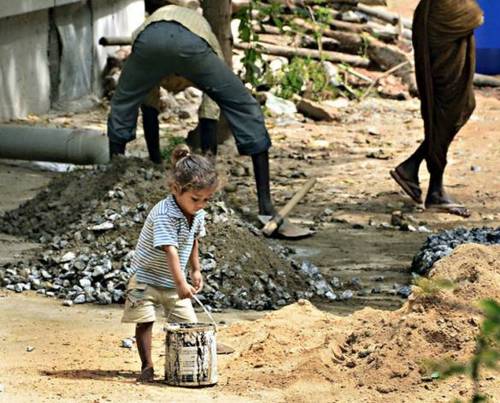
Today’s cities have become the hub of economic activities. With huge number of poverty struck migrant population moving to cities for income earning opportunities needs of their children are neglected. The vulnerability of migrant workers and safety of their children is less talked about and addressed. Construction sites are fraught with issues of safety that can adversely impact the lives of children. Absence of a social network to look after their children while both parents are at work creates a huge divide in the growth, health and education of children of construction workers. Absence of appropriate nutrition in the early years impacts the growth of the child. Early years are important as 90% of brain development happens within the age of zero to 3 years. Personality development happens between zero to 3 years and the child starts learning what is good and what is bad. Children need to be exposed to good learning environment to ensure good physical and behavioural development occurs.
The construction sector in India is one of the largest employers of labour in the country, and about 10% of the workers are women. The sector is heavily dependent on migrant workers, many of whom come to the city with their children. While the sector provides employment opportunities to migrant households, it has serious implications for the health and educational outcomes of children. According to the National Family Health Survey (2015-’16), 35.5% of children under the age of five in the country are underweight, 38.4% are stunted, 21% are wasted. In the absence of education and health needs and with no external adult support in the labour colonies, the children’s needs are neglected severely.
The “First 1000 Days” of a child are a period of rapid physical growth and accelerated mental development and offers a unique opportunity to build lifelong health and intelligence.

Children’s needs like health and nutrition, age-appropriate immunization, education and cognitive learning needs, interactive and social enabling environment and, above all, safe parenting care for children while their parents work are an essential need. In 2015, early childhood development was included in the Sustainable Development Goals, reaffirming its growing status in the global development agenda. Every Child has a right to develop to the “maximum extent possible”.

INTERVENTION
The proposed project is to run creches – day care centers for children of construction workers in the age group of above 6 months and under 6 years. The objectives of crèches are to provide a safe environment and to provide protection, nutritional and immunization support, and a stimulating environment for the all-round development of these children. Creches will provide a stimulating environment where children attend classes regularly and learn through fun stories, rhymes, games and art and craft activities in three languages English, Kannada and Hindi.
Crèches run from 9.30 am to 5.00 pm. Each crèche has 2 teachers and one helper. Children are divided into 3 sub-groups:
- Creche section consists of children from 6 months to 3 years
- Pre-primary/Balwadi consists of children from 3- 6 years
- Non-formal education (Bridge course) from 6- 12 years
Crèche section, which primarily focus on stimulation. Pre-primary (balwadi) section focuses on school preparedness and skill development. Non formal education enables the children to engage in learning activities as they have dropped out of school mid-year and will re-join in the next academic year. Across all ages, creches nurture children’s healthy development through nutrition programmes and medical check-ups. Creche children are admitted into Government schools every year. More than 100 children are enrolled into nearby government schools in Bangalore as they are considered in par with their peers in basic knowledge of languages, hygiene and school going discipline.
APPROACH
Sampark with our 30 years’ experience of development initiatives, have created a multi-stakeholder approach for the success of our interventions and initiatives. Creche also follows the multi-stakeholder model as it enables the children of construction workers to receive maximum benefits.

Linkages with a wide variety of stakeholders, helps in running day care centres (crèches). Sampark works not only at the grassroots level, but also at the policy level. Figure 1 on the left explains the same.

The Multi stakeholder model proves very effective in providing holistic benefits for the children of construction workers and ensures sustainability of interventions.

CRECHE TEACHERS
Teachers are the soul for the creches. Children of construction workers come from different states, different backgrounds and speak different languages. Teachers handling construction workers children must be more of a “nurture teacher” care giver than just imparting knowledge. Their role is one to ensure that they are fed and are given extra love, because there are children deprived of this. Teachers need to be patient and loving to understand the child’s issues, to understand their everyday moods and to handle them accordingly. Issues like poverty, alcoholism among parents are common in families of construction workers. Children of construction workers face nutrition and growth issues. These children need to be given special attention and ensure appropriate nutrition for them while they adapt to the new place without their parents. Teachers need to become children’s friends to ensure they attend the school every day. Ultimately, the teachers need to be a constant and caring force in the children’s lives.
Due to the specific nature of handling children of construction workers, teachers are provided different types of training to build their capacity.
12 days Initiation/Orientation Training
All newly appointed teachers undergo this rigorous 12 days training. This training orients the teachers into their new role. Training start from the beginning as to why Early Childhood development (ECD) is important and why it is even more important for children of construction workers. The changes and growth happen to children in their childhood are discussed and how the creche must provide a suitable atmosphere for the same. The needs of various age groups of children are discussed and explained as to how ensuring the same, has impacts on their future growth and intelligence.
Creche teachers are introduced the documentation methods and follow strictly the various ways in which the important data are recorded and monitored. There are various registers maintained to record the data regularly.
Training by Subject Matter Experts
Capacity building of teachers are seriously followed in Sampark. Teachers are trained regularly by subject matter experts. Subject matter experts are also approached based on the challenges faced by the teachers. For example, during the lockdown, teachers were all trained on how to handle Zoom calls, access Google sheets and documents to record the data. Teachers get trained on survey software and conducted surveys for a research. The topics on which they get trained are
- Fun methods and way to be a nurture teacher
- Physical development of children
- Language development of children
- Cognitive development of children
- Social and emotional development of children
- Pre- and Post-natal care for children and mothers
- Soft skills like digital literacy, making effective videos to communicate with children
These trainings are extremely helpful in building teacher’s confidence and commitment to their work.

CRECHE ACTIVITIES

CRECHES NEW NORMAL DUE TO COVID-19
Data collected by WHO, UNICEF showed that country lockdowns measures had substantially hindered the delivery of immunization services, putting approximately 80 million children under the age of 1 at increased risk of contracting vaccine-preventable diseases.

Sampark closed all 17 creches from 13th March 2020 to May 2020 due to the pandemic. With the recent update from the Education Department, creches are allowed to remain open for the first half of the day. Though children are not allowed to gather in the creches, early year children’s needs cannot be ignored. Neglect in the early years has long term impact on their health and growth. Children of construction workers are extremely vulnerable with poor nutrition and linkages for their immunization.
Creches have developed alternative ways to engage with children on an individual basis and to ensure their nutrition, health and education. These are explained under topics below:
HEALTH
Nearly 47% of India’s poorest children are not fully immunised. This makes them prone
to preventable diseases and has an irreversible impact. The burden of health costs is
82 children were immunized in Sampark creches (Jul-Dec 2020). 37 girls received their timely vaccination.
greater on low-income families. Timely health check-up, linkages to hospitals and immunizations are necessary to ensure that children grow healthy.
Creche teacher links the children to local Primary Health Centre for age-appropriate immunization. Identify pregnant woman in the labour colony and link to Anganwadi
centres for mother card and required immunization for child and mother.
Teachers monitor height and weight of children regularly. Based on the WHO standards
children are categorised as normal, undernourished and severely undernourished. Undernourished children are put on special diet. While distribution of groceries, dry
special diet nutrition is distributed to under- nourished children. Supplementary syrup
like multivitamin and iron syrup bottles are provided to parents to give the same to
children. Dosage and methods are guided by teachers to parents.
Teachers create videos on preventive measures to be safe during pandemic and share in
WhatsApp groups of the parents. Regular communication with parents ensures children’s
health is not neglected.

NUTRITION
Every second child in India suffers from at least one form of nutrition failure. Small food shocks can increase the burden of malnutrition. The nationwide lockdown and efforts to curb the spread of coronavirus can contribute to such food shocks. Malnutrition and under-weight children in India can increase by more than 4 million…
With loss of construction work and reduced days of work, construction worker’s income has reduced. The nutrition support provided by Sampark, helps the parents in providing the needed nutrition to the children. Groceries, eggs, bananas, and snacks are distributed fortnightly as a replacement for cooked meals provided in creches. Protein mix powder is also prepared by
77 Sampark creche children improved their nutrition grade during Jul-Dec 2020
teachers and distributed to children. Based on the WHO standards
children are categorised into nutrition grade as normal, undernourished
and severely undernourished. Undernourished children receive dry
groceries to follow their special diet.
EDUCATION
An assessment of the impact of Covid-19 pandemic on children from socio-economically vulnerable families shows that about 1 in every 4 mothers was not sure of their child going to school after the pandemic. The Unicef finding reveals how the outbreak has been calamitous for the underprivileged and it reflects in the digital divide also.
Sampark creche teachers in the constant search of new ways to take education to the children in their homes. have devised the below ways to bridge the divide in education:
- Learning materials such as toys for below three years old children and stationery kit for above three children are distributed. Stationery, worksheets, and colouring books are distributed periodically to engage them productively. Helpers in the community provide essential support to co-ordinate the activities in the community and ensure social distance and security protocol during distribution
- More than 100 educational videos made by teachers using flash cards, stories, songs in different languages are circulated to parents through WhatsApp groups created with parents. Children with no access to smartphones to watch recorded videos, teachers do house visits and provide gadgets to show the videos to children.
- Teachers guide parents to conduct topic-wise activities for children and follow up for their feedback. Teachers make individual house visits in the community to check with parents and motivate them to show the videos to children daily.
- Monthly parents’ meetings are conducted specific to crèche parents with whom issues relating to following the education activities is discussed and feedback are given.
- Importance of continuing education, linkages to government schools are re-iterated to avoid school dropouts in children. Currently government schools are offering online classes through TV and most of the migrant workers do not have TV and electricity. Teachers guide them as to how best they can follow the content through phones and other gadgets and continue their education.

Impact Stories – There are solutions – if the focus remains children and their well-being!

Bhagyalakshmi and Bhimappa migrated with 3 girl children from Yamawad village Yadagiri district 5 years ago. The couple were worried as with one income, they couldn’t send money back to native to repay their house loan. Bhimappa moved to T R Rajan construction site and enrolled their children at creche. This meant Bhagyalakshmi could also go to work with the satisfaction that children are taken care in a safe and secure place. They repaid their house loan Rs. 50000/- in one year and were very happy.
In March 2020, during the covid-19 lockdown, they lost their job and their situation got worse. They managed the lockdown times, with the support of meals and dry groceries offered by builder and Sampark. Though construction work started, jobs were available only for one person in a family. Hence the family depended on the dry groceries and snacks distributed by creches to feed their children.
Bhagyalakshmi was worried about looking after children when the creche was closed and how to keep them safe in the pandemic. With creche teacher’s regular guidance over phone, she received all information about the hygiene practices, social distance, health, nutrition, education and children overall development. Initially Bhagyalskhmi found it difficult to follow but with the help of multiple calls from teachers and their guidance she managed. During one of the house visits, teacher found that she did not have a smartphone and hence could not complete some activities. Teacher met with father of children and advised how he could show the videos to children on Sundays in his smartphone and also on weekdays when he is back from work. Bharati grew confident and started conducting activities regularly for her children and also neighbour’s children along with her kids. Bhagyalakshmi shared her own experience in one of the Focus Group discussion and she was acknowledged as “best participating mother” for the month.

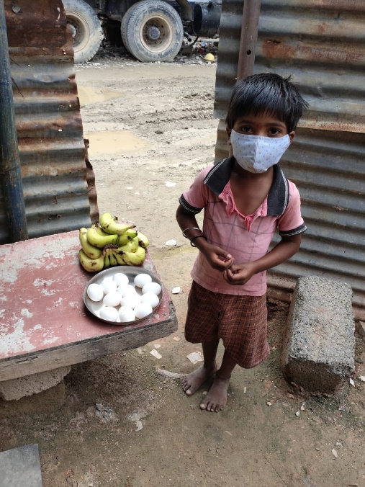
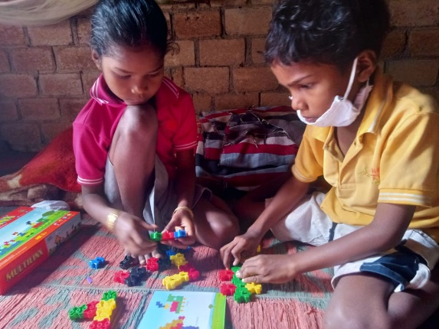
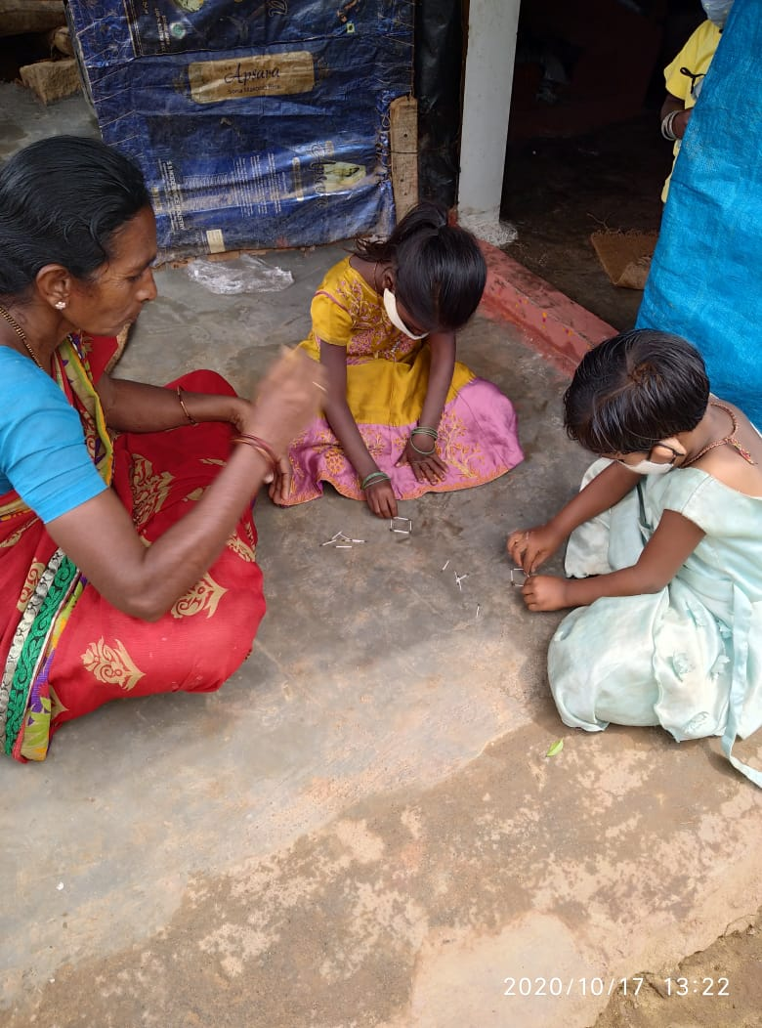
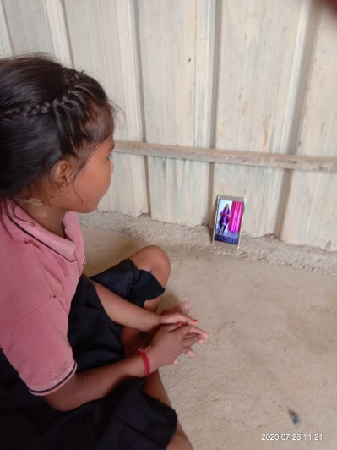
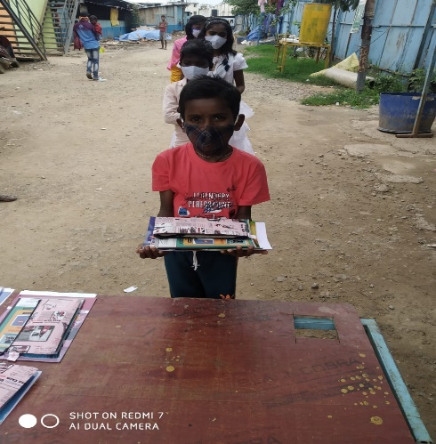
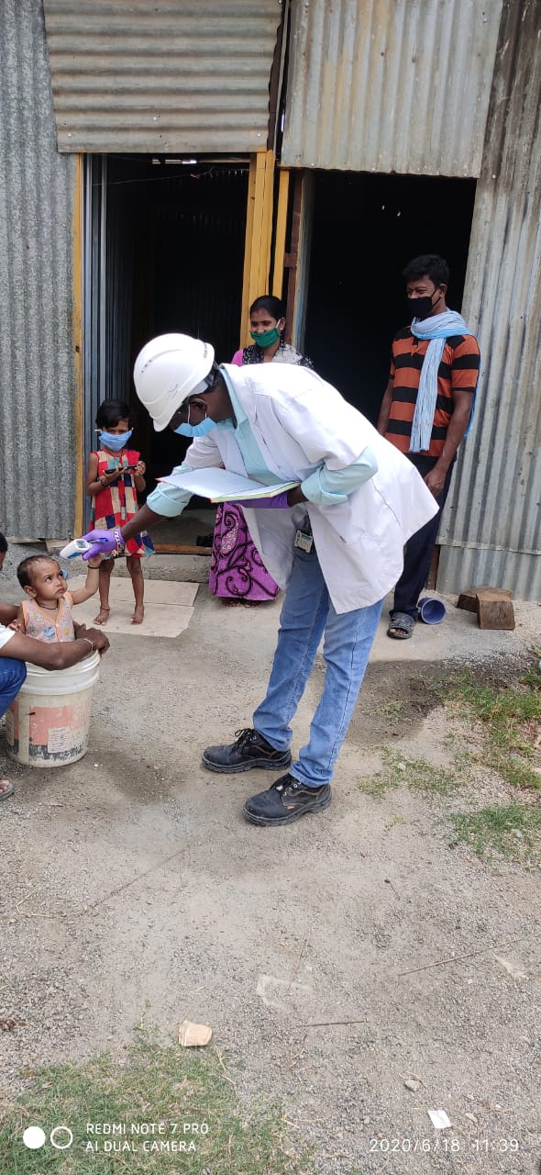
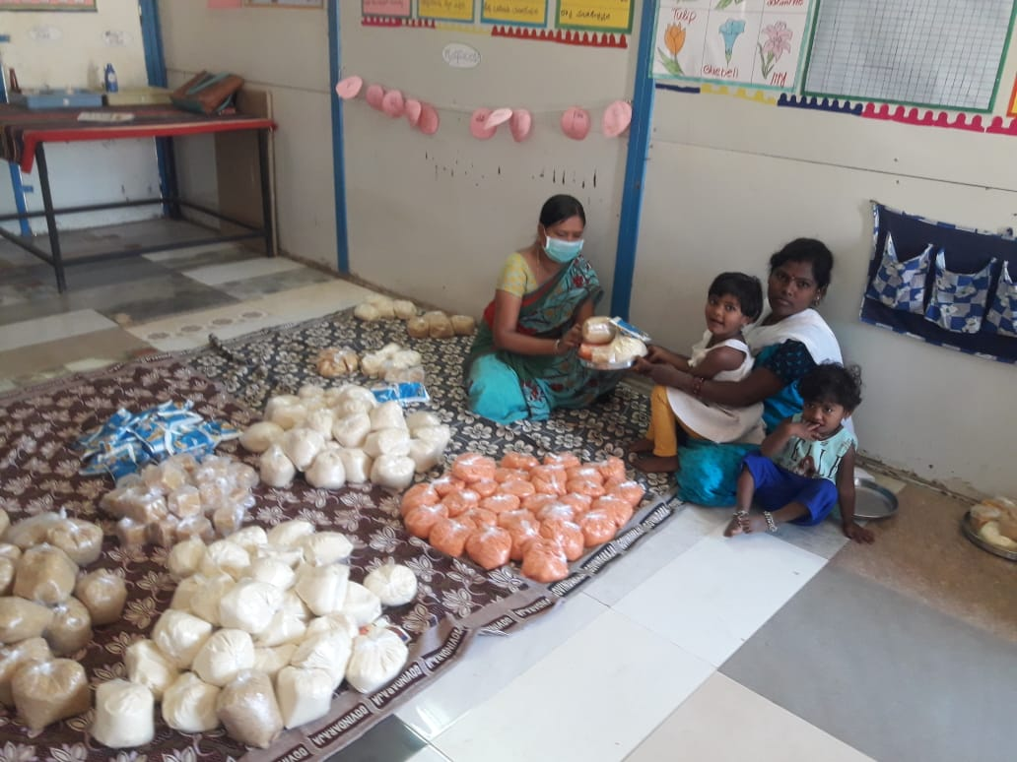
Distribution of dry groceries for children
Child watching videos sent by teacher
Parents entertain children at home with topic specific activities provided by teachers
Health camp conducted at labor colony
Stationery distribution
Child collecting nutrition
Blocks distributed keeping the children engaged at home

Sampark needs support of individual and corporate donors in our efforts to reach out to the needy and vulnerable. We are actively looking for funds for 10 of our creches. Corporates/Individuals could adopt creches for a year or more which will directly impact the nutrition and health of children of construction workers.
We look forward to hearing from you!

Do watch the video on our creche work!

https://youtu.be/_2kGtuBAM-Y

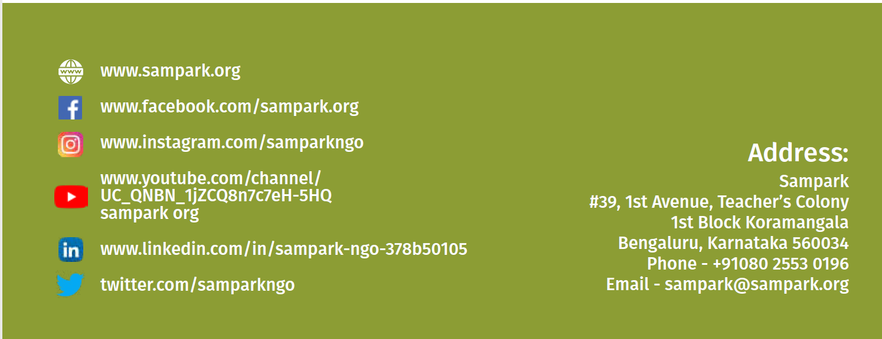

The study — by Sunil Rajpal, SV Subramanian and William Joe —titled Living on the edge? Sensitivity of child under-nutrition prevalence to bodyweight shocks in the context of the 2020 national lockdown strategy in India
Pandit.A, (2020). Unicef: 25% of schoolkids from Covid-hit families may drop out. Accessed on 16, Jan 2021 through Unicef: 25% of schoolkids from Covid-hit families may drop out | India News - Times of India (indiatimes.com)

