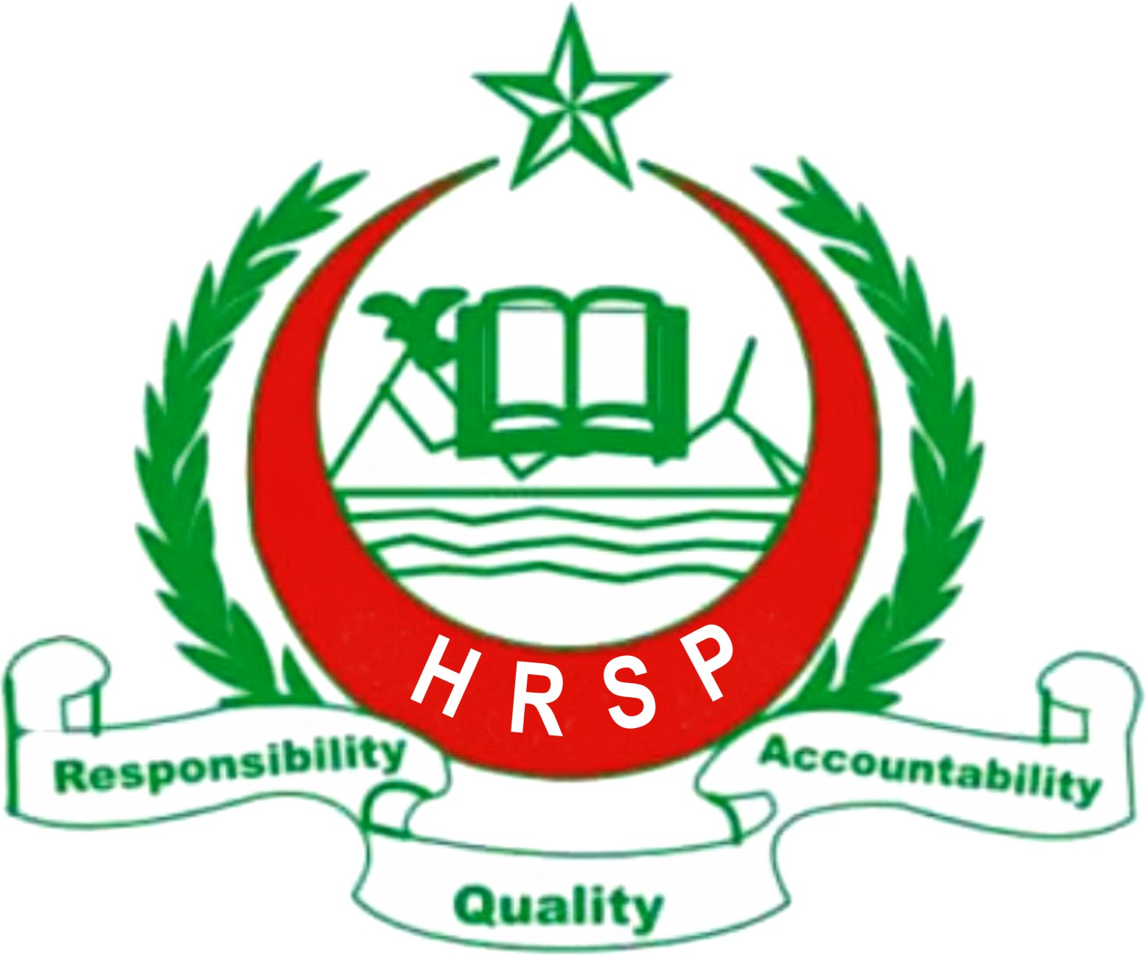
July - August 2011 Report
Project Report
Himalayan Rural Support Program HRSP

Project Title: Rain Water Harvesting for 100 Household in Union Council Degwar Haveli Azad Kashmir

Current Project Activity REPORT July-August, 2011
Himalayan Rural Support Program HRSP has worked with the selected beneficiaries after trainings on Rain Water Harvesting (RWH). Now the selected beneficiaries have identified the sites for water pond construction at their end with the available resources they have. But the capital they need is still awaited and it takes too much time to have funds for the response. It is like justice delayed, justice denied.
HRSP sub engineer Attique-uz- Zaman has selected all the houses with the minimum standard with all information required and justification of needs. Profile of all Villages of Union council Degwar namely, Rankary Khass, Rankary Chohan, Rankary Paeen, Hundi Pirran, Fatah Pur, Loi Dandi, Nari, Degwar, Akhori, and Danna has completed. During this period HRSP and community agreed on the following terms and conditions.
● Local Community will initiate a saving scheme for infrastructure work participation and record keeping.
● Local Community will construct more low cost latrines on self help basis to make the villages open defecation free.
● HRSP will Develop and disseminate the IEC material to facilitate the Project area beneficiaries particularly.
● HRSP and local community together will ensure the timely implementation of this project

iv) Project Proposed Activities

- Hiring of project staff
- Training of Masons and community volunteers
- Making 100 house’ roofs able to harvest rain water
- Construction of 100 water ponds
- Hygiene and sanitation trainings for the people especially mothers and fathers of children of age less than five

Project Potential:
The proposed Project area receives 1500 mm rain/year which can be stored and we want to modify house roofs which are made up of CGI sheet to store rain water and to construct water ponds it will be done by training of local people who will build such roofs. Some of them have already CGI sheet roofs to modify in Rain water harvesting enables. Sites for water ponds construction and the process of community mobilization has also been initiated and got a good acceptance and appreciation. It will bring the people out of grab of rare water. It is hoped to have the Project area open defecation free (ODF) by implementation of this Project and the health of women and children will be improved in particular and the general public as a whole. When we identified this need from Union Council Degwar the local community altogether were very thanks full upon, because they need water for vegetable growing, cattle raring, using in Toilets, washing clothes, Constructing houses and a good sanitation. Because this area is water scares. Local poorer communities are waiting for this marvelous response from the donors to meet the dire need and provide an opportunity to say thanks.

Syed Aftab Hussain Hussain Bukhari
Secretary General/ CEO
HRSP
www.hrsp.pk

