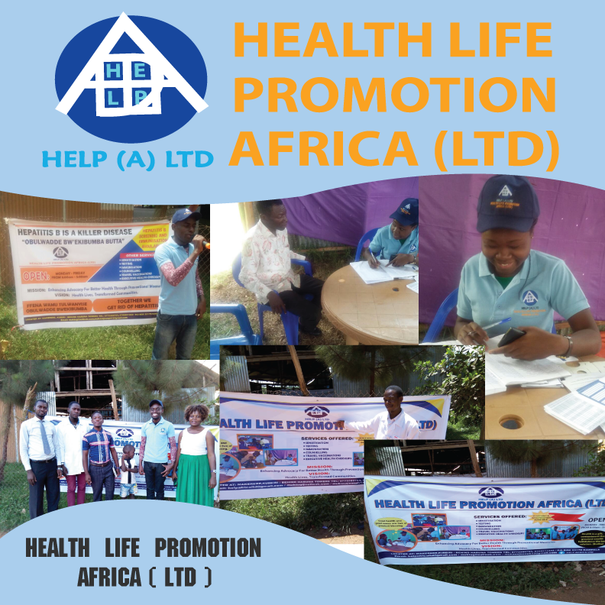
ORGANISATION
PROFILE

HELP (A) LTD is a non-profit making organisation limited by guarantee incorporated in October 2016 by medical team with a mission to enhance advocacy for use of prevention means to fight diseases as a way of promoting health among the people of Uganda and many other countries beginning with sub Saharan Africa at large.
It looks forward to transform the lives of people in communities through reaching out to them by means of advocacy for use of preventional means as a way of promotion of better health among all Ugandans which plays a big role in impacting the lives of people around and is a n affordable means.
It was formed to reach out to all people out there who can’t access medical services and reliable information how to live a healthy lifestyle free from diseases.
But this is done in form of organising community outreaches which involve mobilising the medical team to meet people in a certain area hence health promotion.

MISSION STATEMENT.
TO BE THE LEADING HEALTH ADVOCACY ORGANISATION IN THE AFRICAN CONTINENT REACHING OUT TO EVERY ONE THROUGH DIFFERENT FORMS OF MEDIA FOR COMMUNICATION WITH A MESSAGE FOCUSING ON EVERY ONE FOR BETTER LIFE.

VISION
TO SEE THAT IN 15 YEARS’ TIME THE PEOPLE IN EAST, CENTRAL AND SOUTHERN AFRICAN REGIONS LIVE A HEALTHY LIFESTYLE. FREE FROM DISEASES, HIGHER LIFE EXPECTANCY AND REDUCED MORTALITY RATES.
CORE VALUES:
-Professionalism.
-Quality.
-Integrity.
-Passion.
-Christian centeredness.
-Compassion.

OBJECTIVES.
-Ensuring health lives among the people of Uganda through creating awareness for ways how to prevent diseases
For example, the fight against hepatitis B infection in Uganda which is done in outreaches done in places like Kawuku in association with Case Hospital.
-Carrying out early screening, immunisations counselling and referrals to professional team for further management.
-Being a bridge between the public and the health service providers.
-Availing reliable information based on research to enable the people have in place strategies to fight diseases and live a better health life.
ACTIVITIES ON GOING.
-Massive immunisation of hepatitis B in schools, churches, markets, cooperate organisations and many others.
-Body Screening activities in many places like cooperate organisations, schools, markets, churches, and many others.
-Sensitisation massages about health on the media like T.V stations and other platforms including social media and
-Partnership health drives with many different Non-Government Organisations. Like the UGANDA KIDNEY FOUNDATION, UGANDA KIDNEY PSYCHOSOCIAL ORGANISATION, MY GRAND PAA MAA to reach out to people in communities.
STRATEGY.
-Use of all means to promote better health through advocacy for use of preventional means to fight diseases which may include Music Dance and Drama.
-Use of all influencing skills to reach out to people in communities aiming at promoting health through creating awareness by sensitisation.
-Carrying out all prevention measures against all diseases in the communities which include: consultation, blood Screening, immunisation and counselling.
-Use of talent and other personal skills to reach out to the people in the communities to entice them have love for better health.
-Working under a concerted effort with other professionals to bring hope and joy to affected members of different communities.

SCOPE OF WORK.
HELP (A) LTD is in place to ensure better lives of people through advocacy for use of preventional measures against non-curable diseases in Uganda, and Africa at large.
Uganda being a country with all sorts health challenges but with greater potential to find solutions for all health problems, leading to over spending of money and other resources to treat diseases.
STATISTICS OF DISEASE BURDEN IN UGANDA AND WORLD OVER.
As per the data released by Ministry of Health, 75% of all diseases affecting Ugandans are preventable. responsible for 63% of 57 million deaths which occur in the world annually. The leading risk factor globally for mortality is hypertension which is responsible for 13% of death globally, followed by tobacco use (9% ), diabetes (6%), physical inactivity (6%), overweight and obesity (5%), cardiovascular diseases(17.3%), cancers(7.6%), respiratory diseases(4.2%), the risk of developing these complications is higher in the presence of other cardiovascular diseases and their proportion increases with aging from one persons in their early 20s and 30s and also some 5 people in their late 50s
In Uganda by 2016, the total Non Communicable Disease death under the age of 60 was 53% and 38% for the females according to (World Health Organisation) WHO report in 2017.
Medicines to treat NCDs are available in low-cost generic forms but they remain in accessible and un affordable for many poor Ugandans.
There are 46% elders’ males and 54% elderly females with the majority living in rural areas where 80% of them are still actively engaged in crop farming whose common health problems include hypertension, stroke, diabetes, heart diseases and chronic kidney diseases which often reduce their incapacitation to generate income and socialization. These elders can hardly travel to health facilities for health services because of the long distances and long waiting queues plus the limited human resource capacity to manage their health conditions.
What we do.
-Screening for diseases like HEPATITIS B, Kidney disease, Diabetes, Hypertension, Sickle cell diseases, among others.
-Immunisation of the possible immunisable diseases like HEPATITIS B among others.
-Creation of awareness about diseases and their prevention.
-Referral of cases discovered in the communities to reliable and better health facilities with required medical personnel.
HELP (A) LTD is in place to look through all the health problems arising using its professional team, find out the cause why they exist then go ahead to deal with them through informing the public about them, why they exist, when to deal with them, how to deal with them and who should deal with them.
Expectation.
HELP (A) LTD is looking forward to make people in Uganda embrace the use of preventional means against diseases rather than waiting to go for curative means.
Preventional means are seen as cheaper and convenient to enable the people live healthy and happy lives.
It also looks forward to encourage Ugandans to go for early medical check up to enable them deal with problems which may escalate to become incurable diseases.
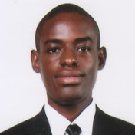
Previous activities carried out with different partners.
-Immunisation of hepatitis B in places like Kawuku Entebbe, Bwaise, Nsangi Secondary school.
-Organisation of World Kidney day celebration 2018 in Mityana hospital where screening for kidney diseases, hepatitis B, diabetes, hypertension among others where done.
-Organisation of World Kidney day celebration 2019 in the parliamentary premises where screening for kidney diseases, hepatitis B, diabetes, hypertension among others where done.
-Organisation of the 2nd National physical activity day on 14th July 2019 which was aimed to encourage Ugandans to embrace carrying out daily physical activities in a bid to fight non Communicable diseases like Hypertension, Kidney diseases, Cancers among others.
-Numerous sensitisation about kidney diseases and hepatitis B on TVs and radios where done.
-Numerus sensitisations in different communities was done.
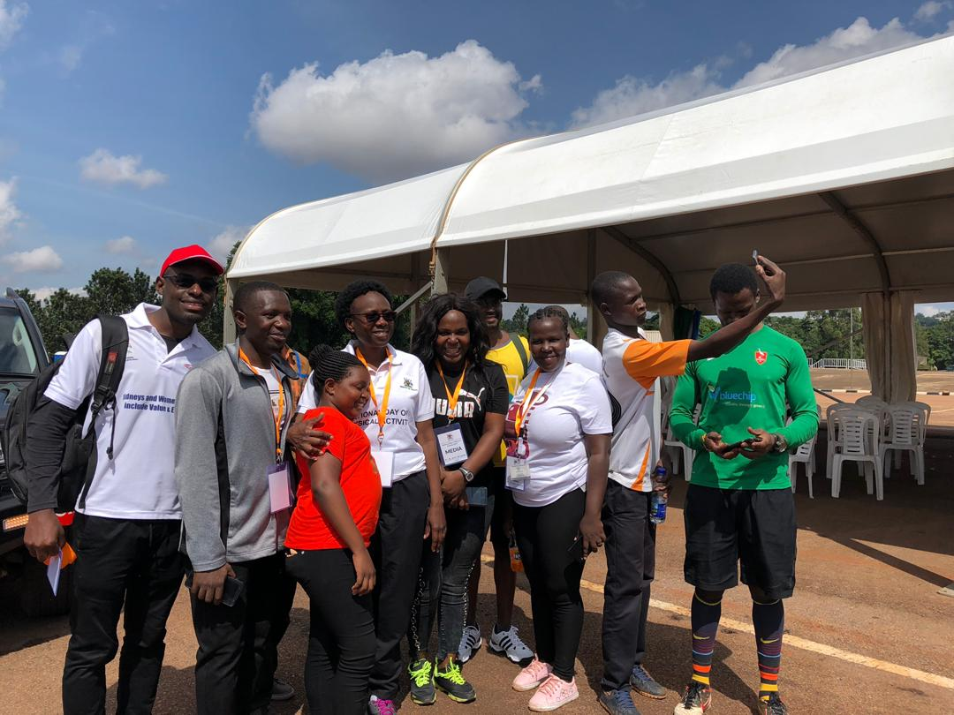

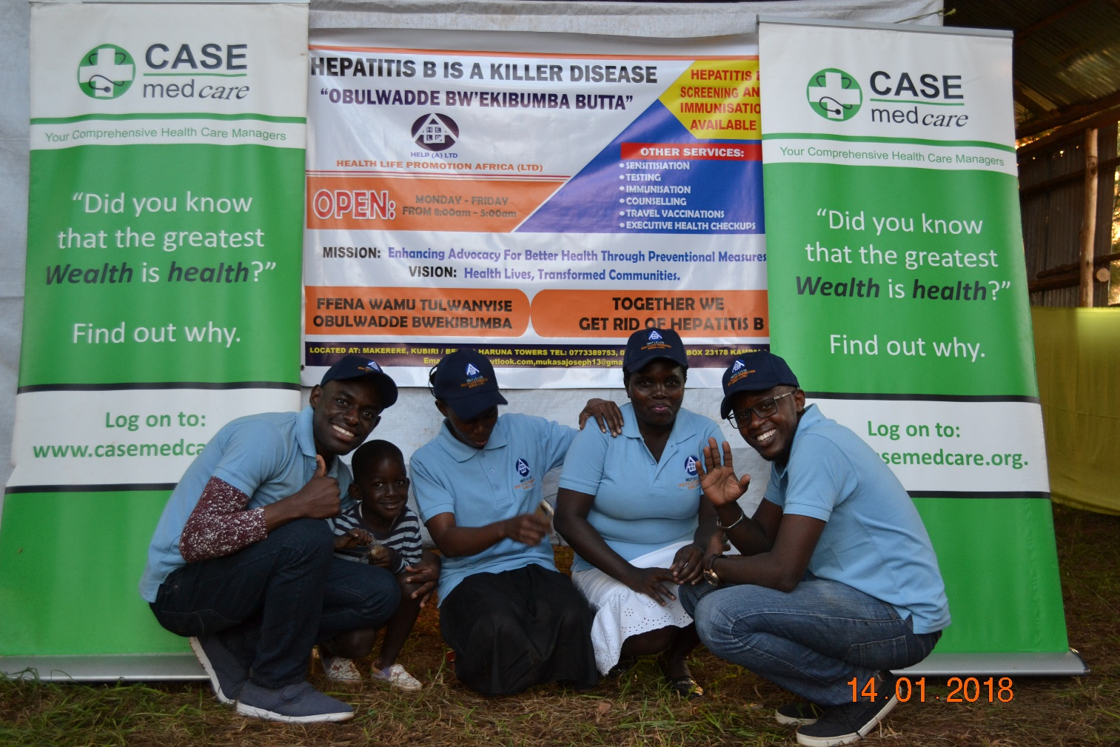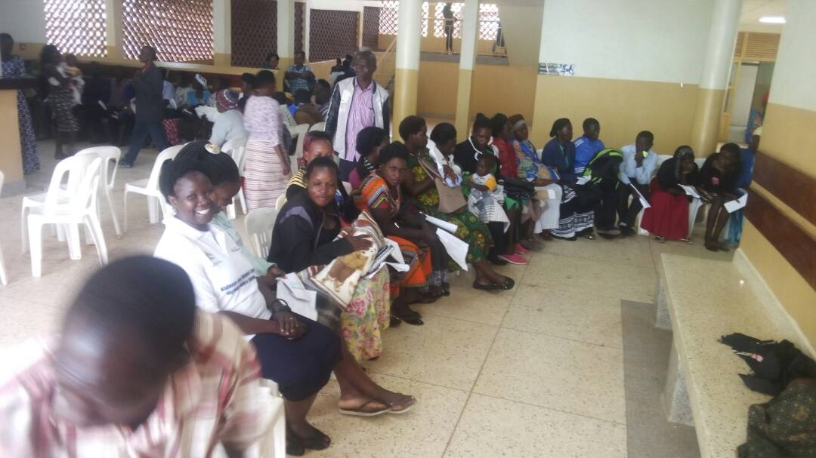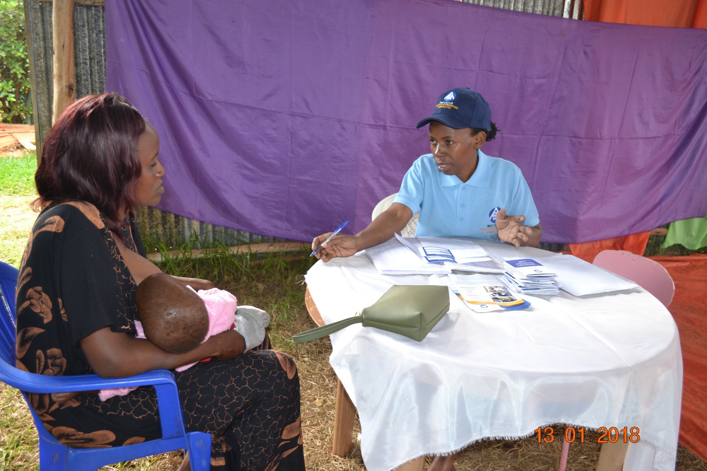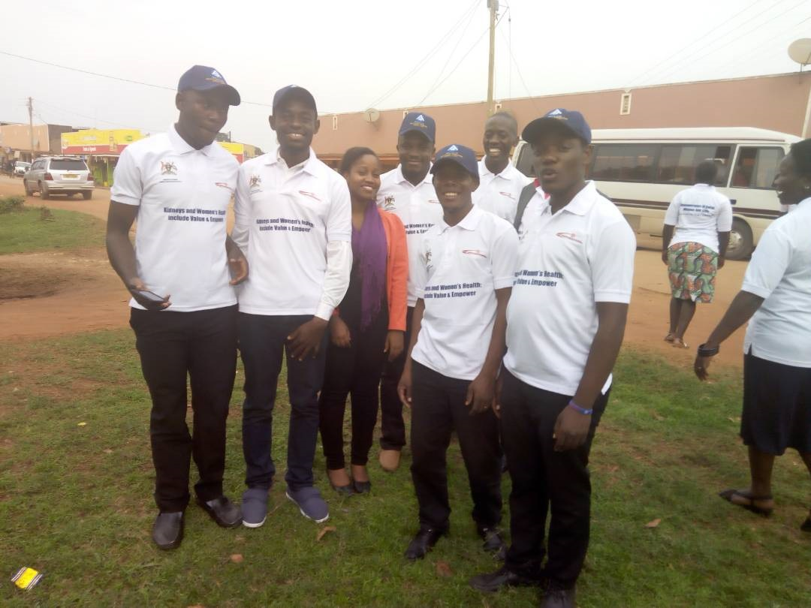
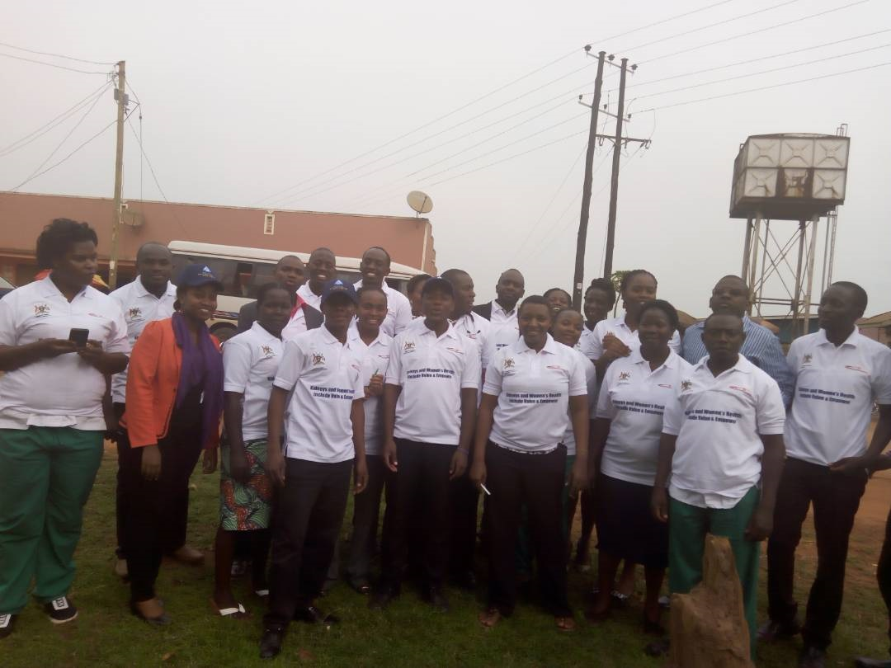
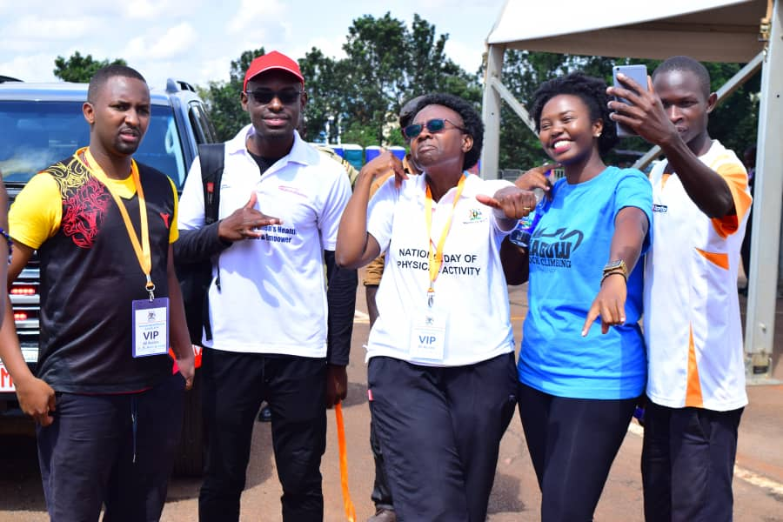
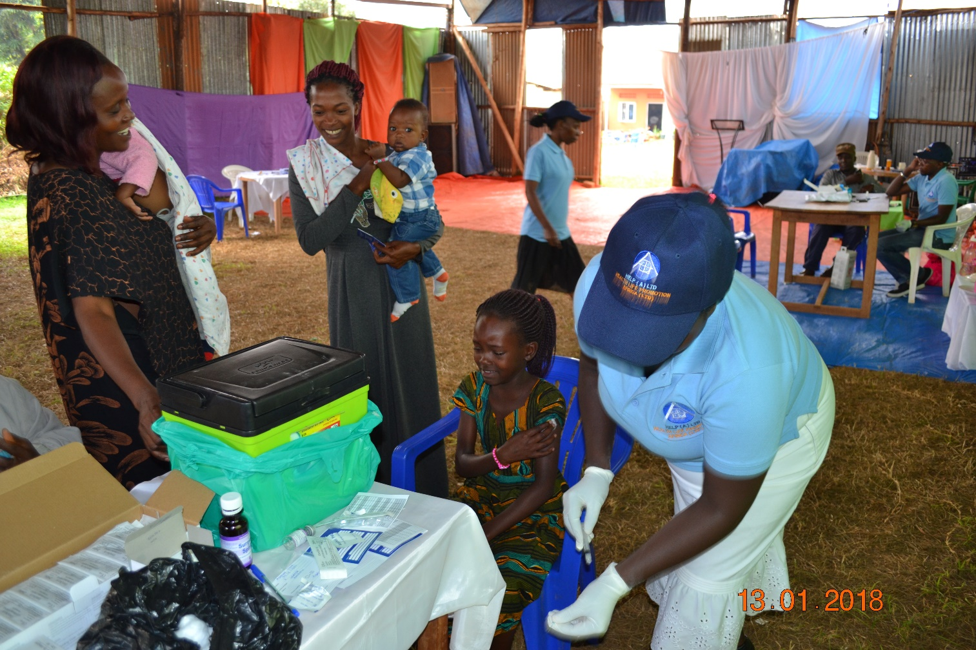
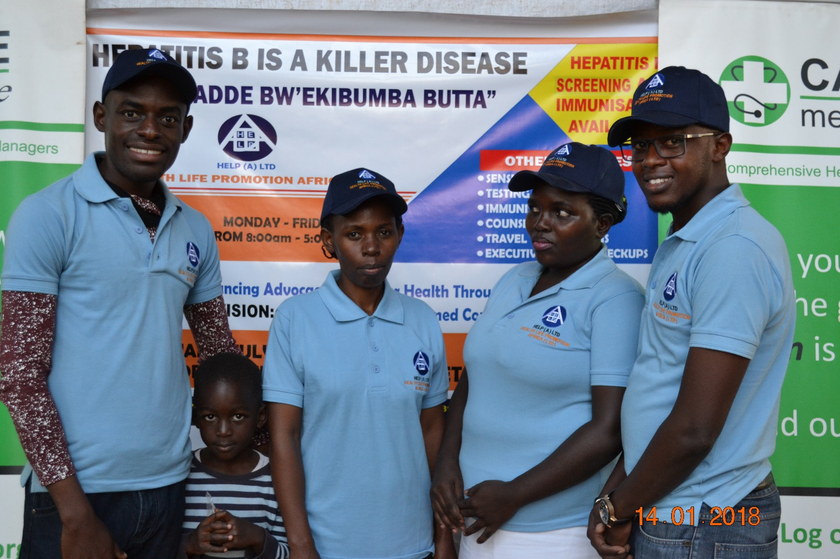
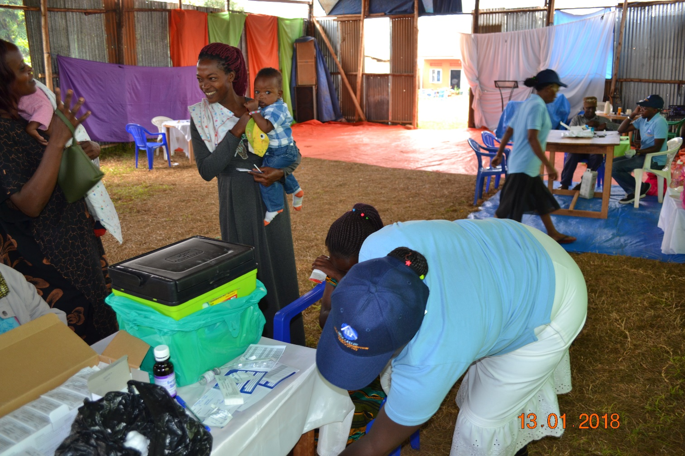

HEALTH LIFE PROMOTION AFRICA LIMITED.
P.O Box 23178 Kampala.
Uganda.
Bombo Road OPP Hass Petrol station
Behind Haruna Towers
Tel:256773389753/+256706511242
Email.mukasajoseph13@gmail.com

Cheaper is to prevent than to heal. Together we can have and live better and healthy lives. It’s not late.
Together rich or poor when we act early, we can have better and healthy lives

