Our Gratitude
10 Years Bringing a Project to Fulfillment
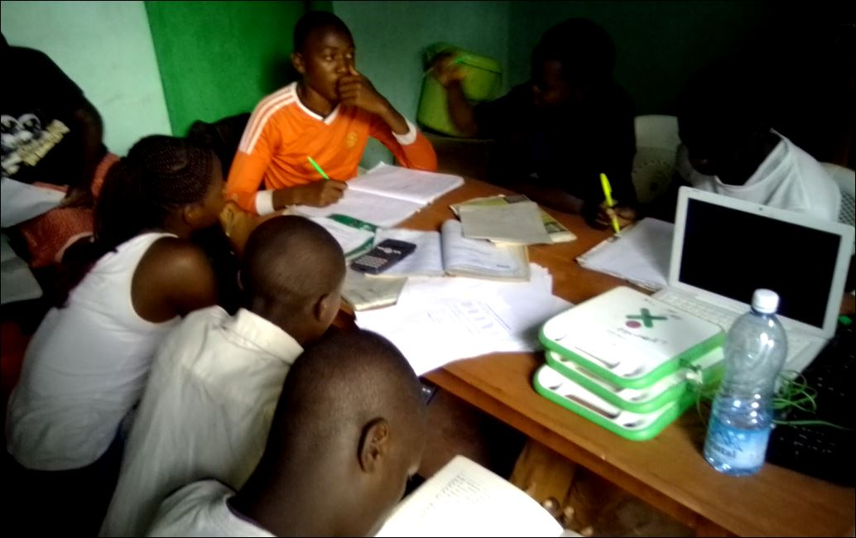
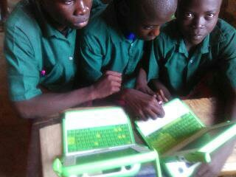

We are on our way: $3000 raised to meet out goal of $5000 for the second half of this year’s fundraising. We plan to replace the worn out laptops purchased in 2010.

- Our technology and learning center in rural Bungoma hosts recently up to 100 young students during the COVID Virus.
- When our center is open Saturdays and vacation days.
- We reach over 2000 students with our in school programs.
- We are proud of our 6 scholarships students, who are stepping up as the leaders in their community.
- Our center is open during all school holidays and weekends. Here are students at our center to study and encourage each other.
- We plan to purchase 50 this year laptops to replace those purchased in 2009.

We count on your support, this is our final push to get us funded for 2020, a year of forming a local Kenyan a self-sustaining team and designing their own center.
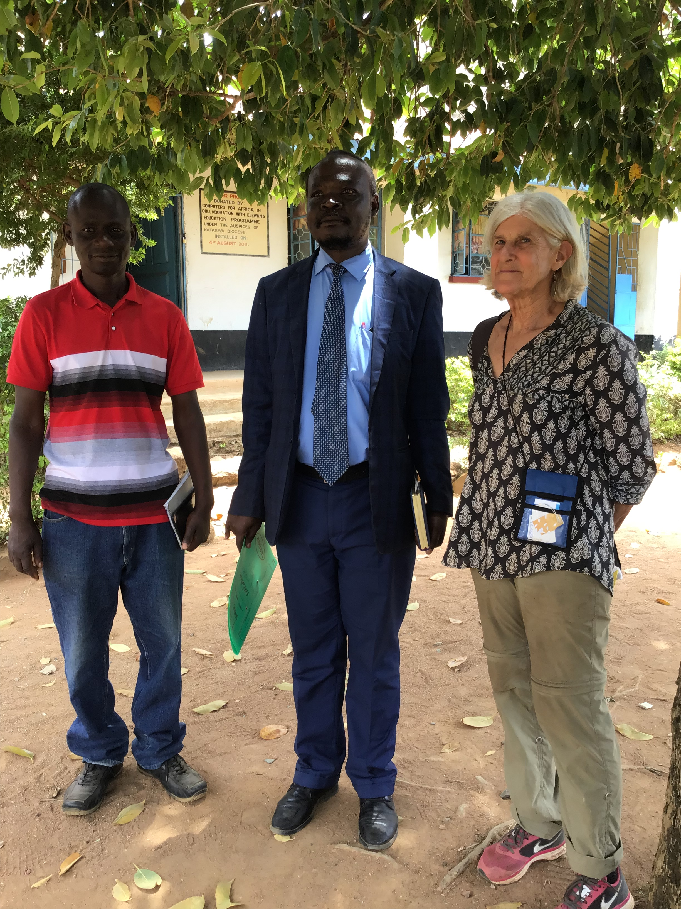

This year I will make my 13th visit, to work with the school leaders.
I stay in the community, with the teachers that make up the team
led by Bonaventure (on the left). We stay in the village and visit
with partner schools and spend time with the teachers reviewing
their progress and concerns.

Next year we hope to bring some of you to visit
these lovely people. Sandra, Annie, Jose, Maria-Jose, and Jane.

