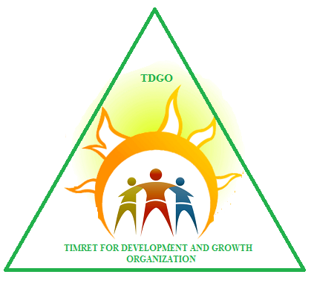

TIMRET FOR DEVELOPMENT AND GROWTH ORGANIZATION (TDGO)

SUPPORT SCHOOLS ON COVID-19 RESPONSES IN BATI TOWN

December 1, 2020 to July 31, 2021

Project Profile
Name of the project | Support schools on covid-19 responses in Bati town
Location of the project | Bati town, Oromo Special Zone of Amhara Regional State, Ethiopia
Types of beneficiaries | School Children, Teachers and Parents/Caregivers
Number of beneficiaries | 10,000 school children, all teachers in 5 schools 5000 Parents/Caregivers
Funding Agency (If any) /Source of Fund | Waiting for funding
Executing Agency | Woreda Health Office, Woreda Education Office, Schools
Implementing Agency | Timret for Development and Growth Organization(TDGO)
Contact person: | Ato Endris Seid Kassa  Position: Executive Director  Telephone: +251920144790  Email: abatuseid8@gmail.com  Bati Town, Head Office
Budget | Total project cost: Birr 709,000 (100%)
 | Direct project cost Birr 661,000 (93.23%)
 | Administration cost: Birr 48.000(6.77%)

Table of Contents
Acronym 3
1. Executive Summary 4
2. Project back ground & justification 5
3. Problem analysis 6
4. Goal 7
5. Objectives 7
6. Beneficiaries Selection Criteria 7
7. Target group /Beneficiaries 7
7.1. Direct 8
7.2. Indirect 8
8. Project Duration 8
9. Project Activities 8
10. Project Out put 8
11. Project Description 9
11.1. Location Region Zone – Woreda – Site 9
11.2. Project Inputs 10
11.2.1. In cash 10
11.2.2. In kind 10
11.2.3. Personnel 10
12. Organization & Management 11
13. Monitoring and Evaluation and Reporting Strategy 11
14. Project Cost (Estimated) 11
14.1. Program costs ≥80% 11
14.2. Administration costs ≤20% 12
15. Expected outcome 12
15.1. Short term 12
15.2. Long term 12
16. Risks and Assumptions 12
17. Sustainability and phase out strategy 12
18. Activity and Budget Breakdown for eight months 13

Executive Summary
The Corona Virus Disease (COVID-19) was first detected in Wuhan, China, in December 2019. On March 12, 2020, Corona-virus disease 2019 (COVID-19) was declared by WHO as a Global Pandemic. The next day, the Minister of Health announced that the Ethiopian Public Health Institute had confirmed the first positive CoVID-19 test result in Ethiopia. Three days later, H.E Prime Minister Abiy Ahmed ordered that all schools be closed across the country and banned all public gatherings including sports. Over 26 million students from over 47,000 schools have been affected by the closure.
The project aims to ensure continued learning and promote health, safety and wellbeing of learners, teachers and education officials during Corona crisis. This Project targets learners, parents and teachers in schools with a focus to most vulnerable and poor learners including learners with special needs and disabilities in Bati town of Ethiopia. It will be implemented for next eight months time period and offers the following objectives: support schools in the prevention of the spread of COVID-19 during the continuing the learning programmes, provide psychosocial support to learners, teachers and education officials, provide health, safety and well-being for learners, also for the marginalized and most vulnerable learners, and to strengthen the capacity of the human resource for effective and efficient response to the COVID -19.
This school COVID-19 response project requires an estimated budget costs for implementing the response and recovery activities is a total cost of ETB 709,000.

Project back ground & justification
The Corona Virus Disease (COVID-19) was first detected in Wuhan, China, in December 2019.
On March 12, 2020, Corona-virus disease 2019 (COVID-19) was declared by WHO as a Global Pandemic. The next day, the Minister of Health announced that the Ethiopian Public Health Institute had confirmed the first positive COVID-19 test result in Ethiopia. With the disease spreading, schools were seen as high-risk centre with potential of exposing both learners and teachers to opportunities of spreading the virus. Three days later, H.E Prime Minister Dr. Abiy Ahmed ordered that all schools be closed across the country and banned all public gatherings including sports.
26 million children who were enrolled in school are now at home due to school closures. This includes 3.2 million pre-primary, 20 million primary and 2.8 million secondary students. These have contributed to increased chances of gender-based violence within the homes. The children, especially those with disabilities are particularly vulnerable and the situation is likely to exacerbate rates of child labour, sexual exploitation, pregnancies, early marriages and incidences of violence within their living environments. The confinement at home and school closures have long-term consequences, especially for the most vulnerable and marginalized children who already experience barriers accessing education, or who are at higher risk of being excluded for a number of reasons. This equally applies to younger children who are vulnerable and depend immensely on parental support.
It is therefore imperative for learning to ensure that children do not lose out on essential learning times. Continuing education through regular learning pathways as soon as possible must therefore be a top priority. There is urgent need to support teachers, parents/caregivers. In view of this, this project will support for prevention of the disease and preparedness of learners, teachers and school communities. The rationale for this project is therefore, to support basic education in the overall response for COVID-19 to enable schools to continue the education system and to recover and transit smoothly post the COVID -19 pandemic.

Problem analysis
On March 12, 2020, Corona-virus disease 2019 (COVID-19) was declared by WHO as a Global Pandemic. The next day, the Minister of Health announced that the Ethiopian Public Health Institute had confirmed the first positive COVID-19 test result in Ethiopia. Three days later, H.E Prime Minister Abiy Ahmed ordered that all schools be closed across the country and banned all public gatherings including sports.
Over 26 million students from over 47,000 schools have been affected by the closure. These schools’ closure coupled with restricted movements with acute challenges around space among poor households may exacerbate cases of exposure to drug and substance abuse, increased rape, Gender Based Violence (GBV) including defilement of children. Children with disabilities and special needs face extra challenges because many encounter significantly higher chances of neglect, abuse, segregation leading to loneliness. This predisposes them to possible psycho-social challenges including depression hence need additional support.
Additionally, prolonged closure of schools could lead to increased loss of jobs and income for some non-teaching staff, teachers; high economic dependence ratio where those working including education staff and teachers are supporting wider community and relatives who have experienced loss of income as a result of the pandemic.

Goal
The overall goal of the project is to support schools in the prevention of COVID-19 and to provide updated information about all aspects of COVID-19, for school children, community members/parents in Bati town, Oromo Special Zone of the Amhara Regional State from December 1, 2020 to July 31, 2021 G.C.

Objectives
- Support schools in prevention of the spread of COVID-19 and ensure uninterrupted learning
- Provide psychosocial support to learners, teachers and education officials and also information to prevent transmission and spread of COVID -19;
- Strengthen the capacity of the human resource for effective and efficient response to the COVID -19 and post corona virus
- To raise public awareness and community engagement
- To strengthen screening capacity of schools to detect COVID-19 at points of entry
- To mobilize corona virus supplies, equipment and pre-position them.

Beneficiaries Selection Criteria
An independent need-based approach that are appropriate for the target beneficiaries will be used to ensure equitable access, especially for the most vulnerable, within the project areas.
The following guiding rules are used for beneficiary selection and targeting:-
- Independent selection and verification of beneficiaries through Woreda level responsible organisation and project specific needs-based selection criteria
- Prioritisation of the most vulnerable.
- Facilitation of access to assistance for all, especially the most vulnerable
- Taking into consideration pre-existing social, cultural and political system or practices that may marginalise or exploit certain groups is fundamental.

Target group /Beneficiaries
The project will cover in school children from 5 schools and parents/ caregivers of Bati town.

Direct
The project aims to reach 10,000 school children by creating a COVID-19 free school and an enabling environment.

Indirect
5000 Parents/Caregivers that live in the Bati town will be our indirect beneficiaries.

Project Duration
The project is an eight month project and will be implemented from December 1, 2020 to July 31, 2021 G.C.

Project Activities
- Support the operation of existing communal hand washing water points
- Provide hand washing soap and sanitizers to schools
- Support the establishment of sanitation and health clubs in schools.
- Develop and disseminate key messages and IEC materials to address the challenges from COVID -19
- Train youth groups to support schools in preparation of COVID-19 response
- Strengthen schools mini media through providing the required equipments
- Awareness-raising and sensitization of religious/faith leaders on COVID-19.
- Provide essential equipment and supplies for health screening
- Procure and distribute sanitary equipment and personal protective equipment
- Organize awareness creation sessions on COVID 19 control and prevention measures through open market public education once every month
- Organize dialogue sessions among children every month
- Organize workshops or conferences every month for key project stakeholders

Project Out put
Output 1: 10,000 school children, all teachers from 5 schools 5000 parents/caregivers get updated information on COVID-19 issues and capacity increased to effectively respond to the pandemic

Project Description
This project will support schools on the prevention of the spread of Corona Virus and response while reopening schools process with the COVID-19 crisis. It provides awareness and equipments to manage COVID-19 response and recovery efforts to ensure the continuity of learning during the crisis in the immediate, short term, medium and long term.
It is crucial to move quickly to support continued learning to ensure that the achievements realized through recent schools reopening. The project is directed to increase capacity for learning systems and options for children to mitigate the risk of school dropouts especially for the most vulnerable as schools reopen. The plan applies to all learners in basic education, teachers, caregivers’ education staff and parents/caregivers at Bati town.

Location Region Zone – Woreda – Site
The project is planned to be implemented in Bati town which is the capital of Bati Woreda. Bati is one of Woredas of Amhara National Regional State, administratively located under Oromo special zone of the region.
The Bati town is located at a distance of 405 kms from Addis Ababa and 540 kms from regional town Bahir Dar, and the Woreda was bordered by south wello in west and by afar in south, east and north. The Woreda has 26 rural kebele, and six health centers and 26 health posts with physical health service coverage is 100%.
In 2007 national census conducted by the Central Statistical Agency of Ethiopia (CSA), reported that this woreda has a total population of 107,387. The main ethnic groups in the Woreda are Oromo (92%), Amhara (7%), and Afar (1%). The main spoken languages are Oromiffa (88%) and Amharic (11.4%). The main religions in the Woreda are Muslim (97.3%), and Orthodox Christian (2.4%).
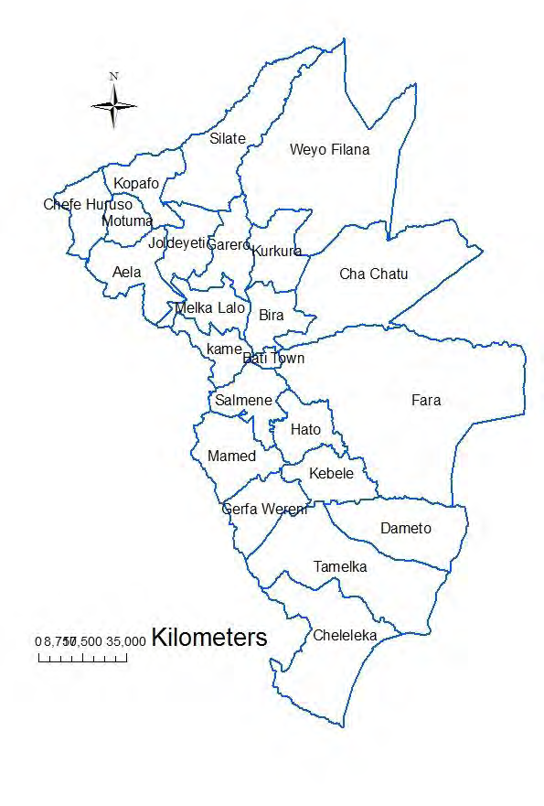
Figure 1: Map of Bati Woreda, Amhara region, 2016

Project Inputs

In cash
Birr = 709,000.00

In kind
Not identified

Personnel
      - Nationals -
      - Qualification
      - Experience
      - Salary
      - Quantity
      - Expatriate
      - Skilled
      - Unskilled

Organization & Management
Our organization is still at very early stages and the institutional arrangements for managing and coordinating activities are still in the process of being set up. The governing body of our organization will be the board which is the highest decision making body. The Board, which constitutes five members, is elected from among the founders and other members for a period of four years. The board appoints the Executive Director. Our organization has a volunteer Executive Director. The Executive Director will lead all of technical and administrative staff based in Bati town.
Board

Auditor
Executive Director

Financial Manager

Accountant
Others

Casher

Monitoring and Evaluation and Reporting Strategy
There will be a comprehensive monitoring and evaluation system developed as an integral part of the project design of which overall objective is to review progress against planned activities and to assess the achievement of objectives of the project. Project monitoring and evaluation will be carried out in accordance with procedures that are set by our organization. Monitoring and evaluation of project outcomes/results (both intermediate and end-of-project) will be coordinated by our organization and relevant stakeholders.

Project Cost (Estimated)

Program costs ≥80%
93.23% = 661,000 ETB

Administration costs ≤20%
6.77% =48,000 ETB

Expected outcome

Short term
- Increased awareness and knowledge and practice on COVID-19 issues among school children and their parents;

Long term
- Reduced spread of COVID-19 and continued learning by all learners in basic education during emergency and after the COVID-19
- Reduced numbers of potential drop-outs at all levels and reduced stigma of infected individuals
- Enhanced knowledge of personnel to implement and support education for all learners during the current and future outbreaks
- Enhanced health, safety and wellbeing of learners, teachers and education staff
- Reduced vulnerability and risk of COVID-19 infection
- Reduced incidence of GBV

Risks and Assumptions
Project risks can involve both external and internal factors. External risks are those that may occur outside the control of the project, and they represent factors of the project environment including political, economic, environmental, and social conditions. Internal risks are those that may arise from the management of the projects, such as inadequate human resources, and lack of clarity in accountability in partner organization.

Sustainability and phase out strategy
The project will be built on existing governmental and local community structures. The aware parents will work as community volunteers/ facilitators hence the acquired skills and knowledge will remain in the community and live beyond project period. The project will promote community participation and hence building of ownership to enable communities identify and solve own health program through the use of community action approach and this will ensure sustainability of the project. The COVID-19 pamphlets for peer educators and parents will be developed and published in both English and local language will be copied and distributed in schools.

Activity and Budget Breakdown for eight months
No. | Budget Category | Total budget  (In ETB) | Budget Allocation for 2020/2021( In ETB)
1 | Operational costs (≥80%) 93.23% |  | Decemb | January | Febr. | March | April | May | June | July
1.1 | Support the operation of existing communal hand washing stations | 100,000 | 100,000 | - | - | - | - | - | - | -
1.2 | Provide hand washing soap and sanitizers to schools | 80,000 | 10,000 | 10,000 | 10,000 | 10,000 | 10,000 | 10,000 | 10,000 | 10,000
1.3 | Support the establishment of sanitation and health clubs in schools. | 20,000 | 20,000 | - | - | - | - | - | - | -
1.4 | Develop and disseminate key messages and IEC materials to address challenges from COVID -19 | 50,000 | 50,000 | - | - | - | - | - | - | -

No. | Budget Category | Total budget  ( In ETB) | Budget Allocation for 2020/2021( In ETB)
1 | Operational costs (≥80%) |  | Decemb | January | Febr. | March | April | May | June | July
1.5 | Train youth groups to support schools in preparation of COVID-19 response | 60,000 | 60,000 | - | - | - | - | - | - | -
1.6 | Strengthen schools mini media through providing the required equipments | 25,000 | 25,000 | - | - | - | - | - | - | -
1.7 | Awareness-raising and sensitization of religious/faith leaders on COVID-19 | 40,000 |  | 40,000 | - | - | - | - | - | -
1.8 | Provide essential equipment and supplies for health screening | 10,000 | 10,000 | - | - | - | - | - | - | -
1.9 | Procure and distribute sanitary equipment and personal protective equipment | 240,000 | 30,000 | 30,000 | 30,000 | 30,000 | 30,000 | 30,000 | 30,000 | 30,000
1.10 | Awareness creation sessions on COVID-19 control and prevention measures through open market public education once every month | 8,000 | 1,000 | 1,000 | 1,000 | 1,000 | 1,000 | 1,000 | 1,000 | 1,000

No. | Budget Category | Total budget  ( In ETB) | Budget Allocation for 2020/2021( In ETB)
1 | Operational costs (≥80%) |  | Decemb | January | Febr. | March | April | May | June | July
1.11 | Organize dialogue sessions among children every month | 32,000 | 4,000 | 4,000 | 4,000 | 4,000 | 4,000 | 4,000 | 4,000 | 4,000
1.12 | Organize workshops or conferences every month for key project stakeholders | 32,000 | 4,000 | 4,000 | 4,000 | 4,000 | 4,000 | 4,000 | 4,000 | 4,000
Sub Total of Operational Costs |  | 661,000 | 314,000 | 53,000 | 49,000 | 49,000 | 49,000 | 49,000 | 49,000 | 49,000
2 | Administration Costs (≤20%) 6.77%
2.1 | Stationeries | 16,000 | 2,000 | 2,000 | 2,000 | 2,000 | 2,000 | 2,000 | 2,000 | 2,000
2.2 | Fuel for Vehicles | 8,000 | 1,000 | 1,000 | 1,000 | 1,000 | 1,000 | 1,000 | 1,000 | 1,000
2.3 | Vehicles for Maintainance | 8,000 | 1,000 | 1,000 | 1,000 | 1,000 | 1,000 | 1,000 | 1,000 | 1,000
2.4 | Vehicles Rent | 16,000 | 2,000 | 2,000 | 2,000 | 2,000 | 2,000 | 2,000 | 2,000 | 2,000
Sub Total of Administration Costs |  | 48,000 | 6,000 | 6,000 | 6,000 | 6,000 | 6,000 | 6,000 | 6,000 | 6,000
Grand total |  | 709,000 | 320,000 | 59,000 | 55,000 | 55,000 | 55,000 | 55,000 | 55,000 | 55,000

