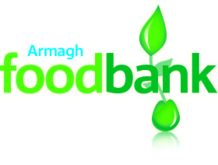
Armagh Foodbank
Armagh Elim Church
Drummanmore Road
Armagh BT61 8RN

T 07752 680805
E info@armagh.foodbank.org.uk
www.armagh.foodbank.org.uk

January 2021

Armagh Rotary Club

Thank you so much for your support of Armagh Foodbank during Christmas 2020 with your walkathon. Your amazing donation of £500 is very much appreciated.

2020 has been a very busy year for Armagh foodbank and has seen many challenges and blessings. Apart from all the practical challenges we really miss sitting and chatting with people face to face, but we have had many opportunities to chat on the doorsteps and via phone with many people facing challenges from all walks of life.

From we have opened on 18th July 2015 we have given out over 65 tons of food to people in need in the local Armagh area with around 25 tons of that in 2020.
During first lookdown we were distributing food via a council box scheme which we were distribution 320 boxes per week . None of the food distributed via the box scheme is recorded in our statics as we felt the need did not necessarily fall into people being able to afford food but rather were shielding and struggled to get access.

With one in five children living in poverty in the Armagh area, every day local people are forced to send their children to bed hungry.
Thank you for your continued support and being part of the solution.

Many thanks,

Richard Thompson
Armagh Foodbank Manager

