REPORT FOR THE PERIOD: August-November 2023

SUBMITTED TO GLOBALGIVING ACCELERATOR

BY REGINA N. MUHASA- Executive Director
“Menstrual Hygiene Management (MHM) is defined by the United Nations as the use of clean menstrual management products to soak menstrual discharge by women that are changeable in privacy as required, with proper access to water, soap, and disposable methods. If hygienic practices are not followed during menstruation like changing pads after every 4 hours, washing and drying our re-usable sanitary towels properly in the sun, and washing hands after handling the used sanitary pads, then the chances of getting Urogenital Tract Infections increases many folds. Menstrual Hygiene Management (MHM)is both a health and social issue that is increasingly gaining prominence on the global development agenda. Due to the increased recognition of poor Menstrual Hygiene Management in the country, and its negative socio-economic and health impacts to women and girls in reproductive age, the government of Uganda through the Ministry of Education and Sports, developed a National Menstrual Hygiene Management Strategic Plan. They also carried out a country-wide Situational Analysis where they sampled 14 districts on regional basis. These included; Wakiso, Gomba, Soroti, Kamuli, Moroto, Abim, Kyenjojo, Sheema, Bundibugyo, Kasese, Nwoya, Apac, Nebbi and Arua.” (Situational-Analysis-Study-on-MHM-in-Uganda-2020-eng.pdf (ungei.org))
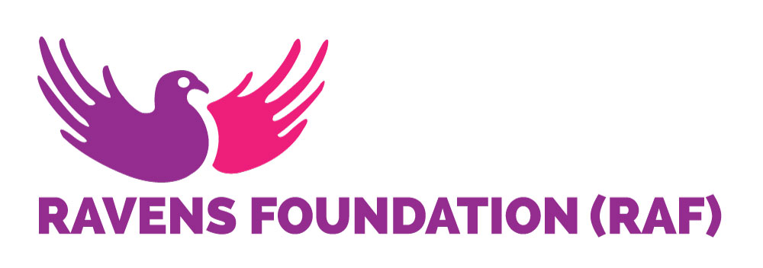
INTRODUCTION
RAVENS FOUNDATION (RAF), is an indigenous non-government organization founded in 2018, with the aim of contributing to the process of transformational development in the lives of adolescent girls, teenage mothers, other vulnerable women and entire communities.
VISION: Fanning the Wisdom of Motherhood and Nobility of Womanhood.
MISSION: RAVENS FOUNDATION (RAF) exists to develop and impact women especially young mothers with the love of Christ through sharing the word of God, counseling, life skills training and social services provision, hence enabling them to become women of noble character who continually build their homes.

BACKGROUND
Menstrual hygiene is essential to girls’ and women’s health and well-being. Unfortunately, millions of girls and women worldwide lack access to proper menstrual hygiene facilities and products. The situation is worse in developing countries like Uganda.
According to the UN Sustainable Development Goals (2015-2030), all nations should work towards ensuring healthy lives and well-being for all at all ages (SDG 3); and ensure availability and sustainable management of water and sanitation for all (SDG 6). In an effort to ensure dignity for women and girls, the United Nations in (2014), declared May 28th of every year a Menstrual Hygiene Day that aims to create awareness and highlight the importance of MHM to different stakeholders. The 2023 Menstrual Hygiene day theme was “Making menstruation a normal fact of life by 2030. The overarching goal is to build a world where no one is held back because they menstruate. But talking about this in a country like Uganda seems like a far-fetched dream that can never be achieved because of the difficulties that girls and women face in accessing clean water, sanitation facilities, and affordable menstrual products. These issues are further compounded by cultural barriers and stigmatizing attitudes, often leading to social exclusion and lack of education on menstrual health.
At Ravens Foundation, our goal is to grow the making of reusable menstrual products into a sustainable social business. We are intentionally building this entity with our focus on impact, and providing decent menstrual products to girls and women within the community at affordable costs. We believe that this will greatly improve their general health and also help to keep girls in school.

All our products will continue to be produced locally in Bukomolo village in Budaka district, by local Ugandan women. We plan to expand the project and diversify so that we produce various reusable products including the following;
- Reusable menstrual pads (is what we are making currently).
- Reusable schoolgirl kits.
- Highly absorbable, reusable, easy to wash and durable after labour pads to support new mothers after giving birth.
- Reusable washable, comfortable, affordable, easy to wash and durable baby diapers/nappies.

This report covers a period of four months, August to November 2023. As reported previously, one of the founders allowed us to use her premises to set up a skills training centre. Ravens Foundation still has a limited financial base and so we depend heavily on the good will of our founders. Renovation of the building has stalled because we run out of funds. We are still soliciting for the funds and the last four months have not brought in any changes as yet.
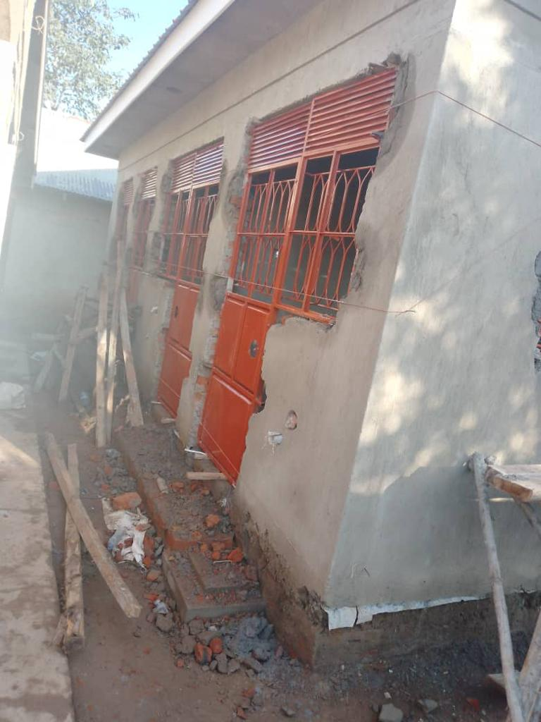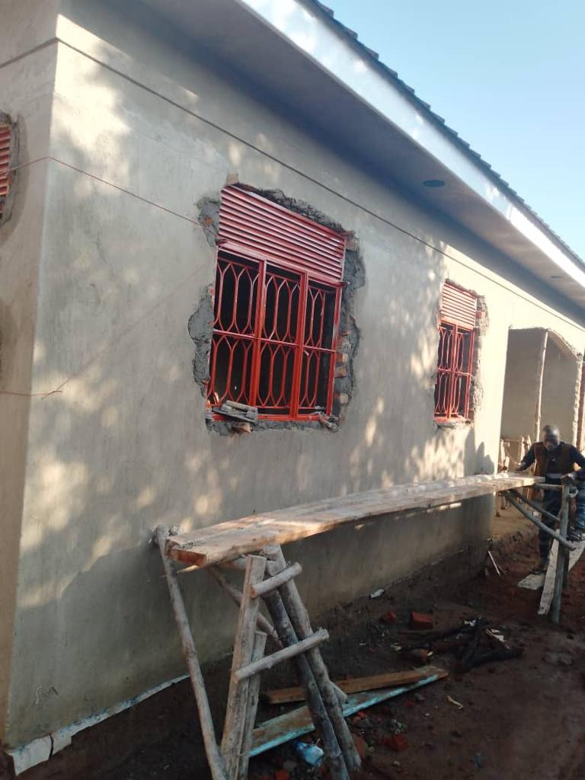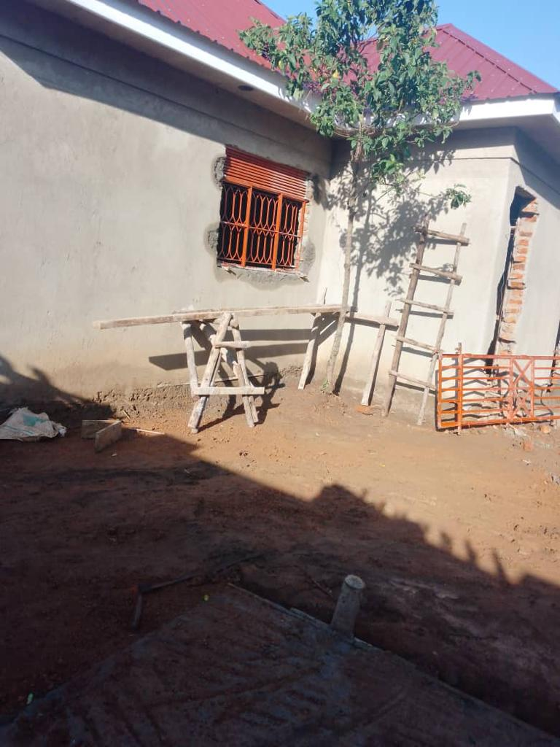Renovation work on the building
Making of reusable pads: The learning and making of reusable pads continues and the women/girls meet once every week. We still depend on volunteers to conduct the training sessions.

Training sessions for making reusable pads- one of the volunteer trainers is explaining to the younger women the process of making reusable pads.

CHALLENGES ENCOUNTERED
- The materials for making the pads are limited due to financial constraints but the trainees innovatively improvise by using old pieces of cloth.
- Lack of funding: due to the prevailing difficult economic situation, we hardly get donations from the founders because some of them lost jobs post Covid, and have since not been successful in finding alternative sources of income.

