QUARTER THREE REPORT (JULY-SEPT 2021)
  - SUBMITTED TO GLOBALGIVING ACCELERATOR BY REGINA N. MUHASA- EXECUTIVE DIRECTOR
Women and girls in Uganda still face significant menstrual hygiene management challenges, particularly in rural, low socio-economic areas. Strategies to manage their menstruation are largely influenced by available resources. Commercially produced disposable menstrual pads are available in rural areas but are prohibitively too expensive for most families. Hence, women and girls often resort to unhygienic, inconvenient and undignified materials such as old pieces of cloths, banana leaves and newspapers.
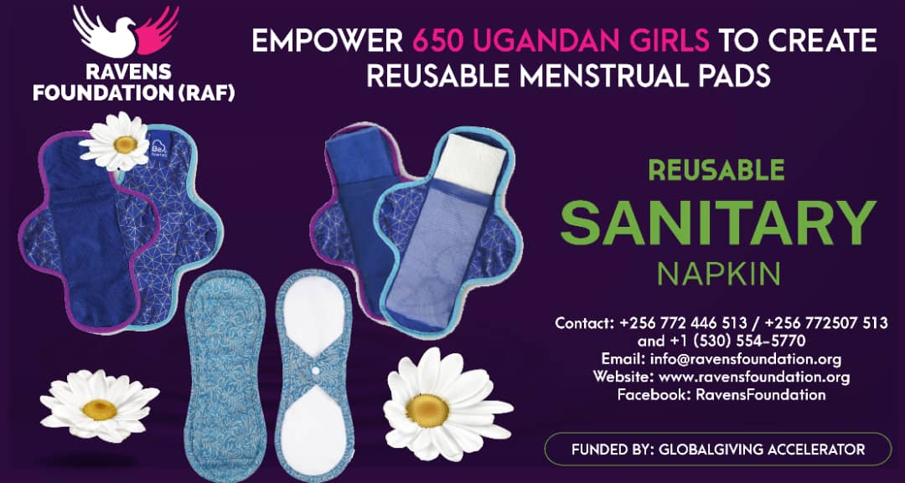
INTRODUCTION
RAVENS FOUNDATION (RAF), is an indigenous non-government organization founded in 2018, with the aim of contributing to the process of transformational development in the lives of adolescent girls, teenage mothers, other vulnerable women and entire communities.
VISION: Fanning the Wisdom of Motherhood and Nobility of Womanhood.
MISSION: RAVENS FOUNDATION (RAF) exists to develop and impact women especially young mothers with the love of Christ through sharing the word of God, counseling, life skills training and social services provision, hence enabling them to become women of noble character who continually build their homes.

BACKGROUND
Menstruation and menstrual practices still face many social, cultural, and religious restrictions which are a big barrier in the path of menstrual hygiene management. In many parts of the country especially in rural areas girls are not prepared and aware about menstruation so they face many difficulties and challenges in handling and managing their menstrual cycle. Girls and women have very little or no knowledge about reproductive tract infections caused due to ignorance of personal hygiene during menstruation time. In rural areas, women hardly have access to sanitary products or they know very little about the types and methods of using them or are unable to afford such products due to high cost. So, they mostly rely on old pieces of cloth which they wash and use again. Needs and requirements of the adolescent girls and women are ignored despite the fact that there are major developments in the area of water and sanitation.

In Ravens Foundation, our goal is to grow the making of reusable pads into a sustainable social business. We are intentionally building this entity with our focus on impact, not on profit. Our plan to see to it that 100% of any profits that will ever accrue from the sale of the reusable pads in future, will be reinvested in the work. Throughout our entire production process, we aim at creating employment and supporting the local economy.

All our products will continue to be produced locally in Bukomolo village in Budaka district, by local Ugandan women. We plan to expand the project and diversify so that we produce various reusable products including the following;
- Reusable menstrual pads.
- School girl kits.
- After labour pads to support the new mothers after giving birth. These are highly absorbable and easy to wash, lasting at least one year.
- Reusable baby diapers. These are washable nappies, cheaper, comfortable, easy to wash and lasting at least one year.
This report covers a period of three months, July to September 2021. Unfortunately for us, here in Uganda we were under total lockdown due to the second wave of Covid-19 that swept across our country right from June until early October 2021. Because of the restrictions put in place by our government to limit the spread of Corona virus, we could not conduct any trainings for our beneficiaries.
However, all was not lost because we used that period to build networks and mobilize more resources for the project. And as a result, we managed to get a donation of tools from TOOLS WITH A MISSION (TWAM) which includes the following;
1 | Sewing Machine Kit - Manual | Includes Sewing Kit
3 | Sewing Machine Kit - Electric | Includes Sewing Kit
1 | Sewing Machine -Treadle | Includes Sewing Kit
2 | Haberdashery Pack | Fabric, Zips, Ribbon etc for sewing m/c
1 | Knitting Machine Kit | Includes sack of knitting wool
1 | Knitting Wool Sack | Included in Knitting Machine Kits
1 | Knitting - Hand Kit
1 | Embroidery & Craft Kit

We hope to use these tools to start a skills training centre for women and girls. And we will still use our current place as the training centre until we are able to raise more resources to establish an independent vocational centre.
Our strategy will be as follows; we will ask the trainees to make things they can sell in the local market while they train. And as they do this we will encourage them to give half the money to the project to help pay for the costs of the workshop and keep half for them-selves. From the half they keep, they will use half to support their families and save the other half to help buy their own sewing machine at the end of their course.

CHALLENGES ENCOUNTERED
- Due to the covid-19 lockdown and restrictions we were not able to conduct the training sessions.
- The existing old structure at the training centre, which we reported about in the previous quarter, and were planning to renovate it, collapsed. We don’t have the money to erect a training shelter.

