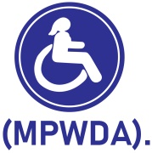 Mpigi Women with Disabilities Association

Project title: 150 disabled girls educated amidst COVID in Mpigi

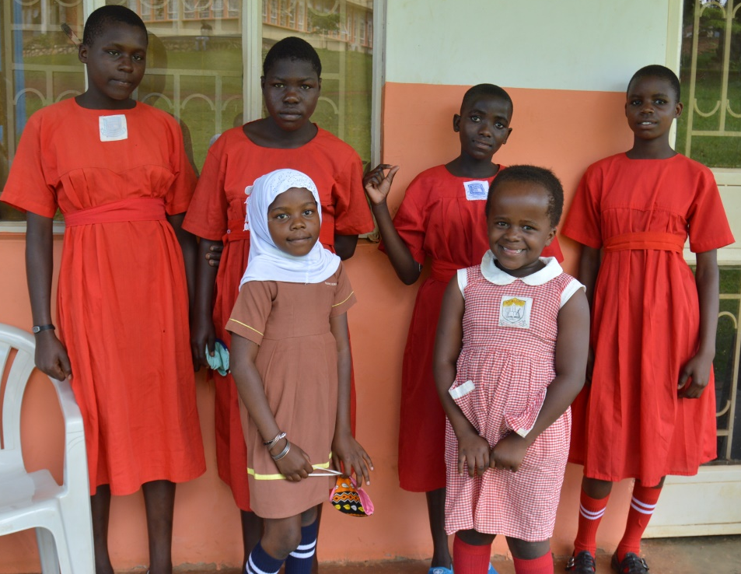
By: Mpigi Women with Disabilities Association (MPWDA)
Project summary: The project addresses Sexual Reproductive Health Rights and limited access to education among girls with disabilities amidst COVID 19. These violations are real despite the legal and social economic transformation in the Mpigi district (Having a Disability Inclusion Ordinance) and Uganda at large. Sexual violence is on the rise, By September 2020 four of our Peer Educators had married themselves off and we had received 10 cases of sexual abuse. Despite the government directive to take candidate students back to school and register for final examinations during COVID 19, many of the girls with disabilities have not been in position to go back to school due to a number of hinderances which are related to sexual violations and unavailability of school basic needs. This is an indication that even when all schools are opened, many girls with disabilities are most likely to remain at home. Provision of such basic needs is part of the solution toward enabling these girls with disabilities back to school and benefit like other learners without disabilities. These girls too deserve access to comprehensive sexual education and access to formal education for them to live happier and dignified lives in future. Due to many negative perceptions and discrimination, the only gift to a girl with a disability is a levelled environment for her to attain education
Funding amount: USD 17,169
Solution: MPWDA will support 150 girls with disabilities by providing education scholastic materials including school bags, pens and books, registration fees for those in candidate classes, school uniforms and sanitary towels. Hold Behavioral change, life skills, sexual reproductive health rights sessions with girls, parents $ care takers and hold community radio talk shows.
Long term impact: Confident, educated and healthy girls with disabilities with ability to pursue higher education and job opportunities in the fields of their choice. They will be pillars of support for their home, parents and the community.

Detailed Budget
10 | Buy pens and pencils for 50 disabled girls
25 | Buy geometry sets for 18 girls with disabilities
50 | Buy sanitary towels for 32 disabled girls
100 | Buy school uniforms for 12 disabled girls
1369 | Pay registration fees for 50 disabled girls
3424 | Conduct sessions on rights with parents and care takers and hold talk shows
4794 | Conduct session on life skills, rights and behavioral change with disabled girls
7397 | Buy schools bags, uniform, books, pens for 150 disabled girls
17169 | TOTAL

