Our traditionally trained midwife-turned-nursing student is entering the second half of her training. She recently communicated that she was nervous about starting her practical rotations in the hospitals. She actually will do quite well on rotation as she has an advantage over most new-to-rotation nursing students: she has been working as a midwife for at least five years, a front line clinical experience that no other nursing student could possibly have.

Where she is at a disadvantage is material resources. The pandemic has hit Guatemala hard, forcing her educational process to go remote. This is an inconvenience for most of us but not a true problem in first world reality. It doesn’t become a true problem unless you are impoverished, have no internet connection, and make use of an old laptop that is not able to easily handle the software needed to participate in a remote learning environment. Fortunately, through your donations, our student was able to buy a refurbished laptop and is able to access the internet in the birthing center where she works.

So, thanks to your donations, our first student is able to stay in school during the pandemic—and is now at a point where the addition of formal education to her already developed clinical skills will be powerful and useful combination.

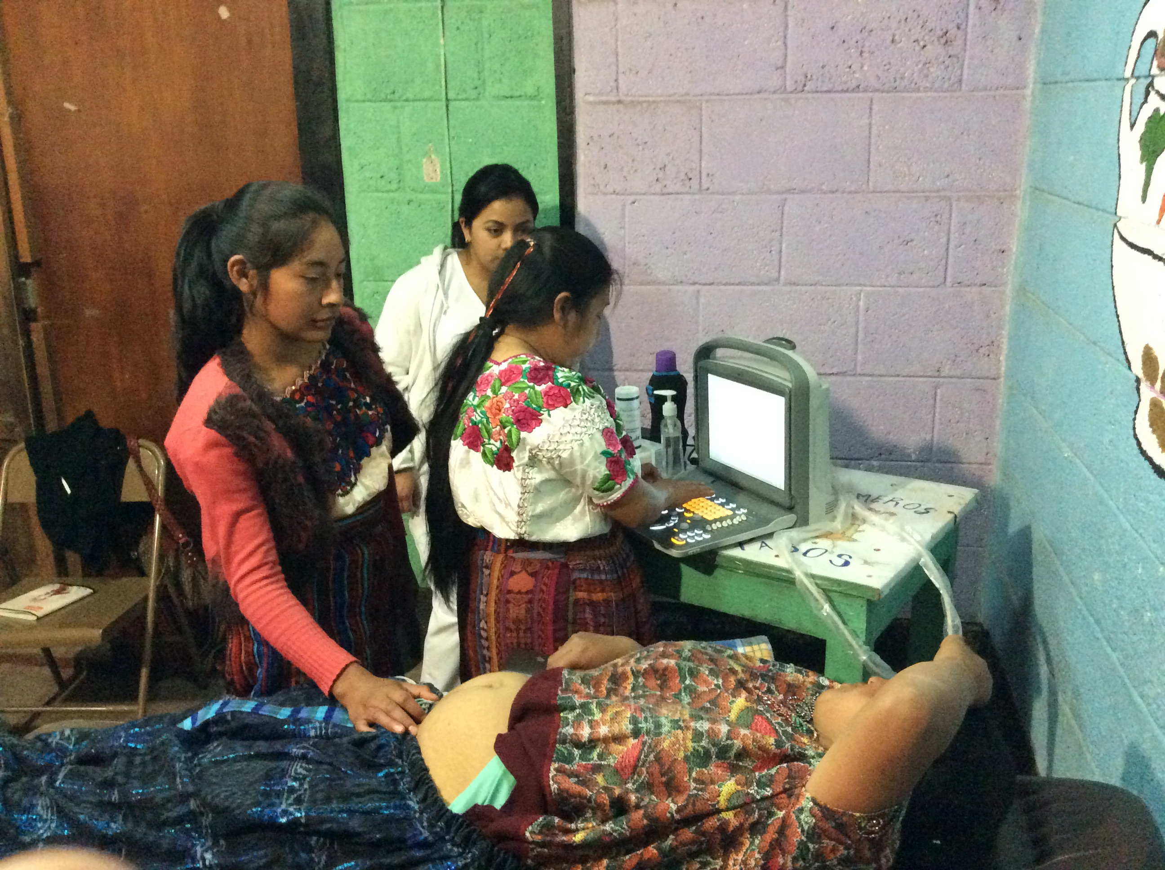
Ultrasound training

