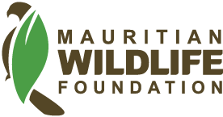
Updated report on Wakashio Recovery Plan
January 2022
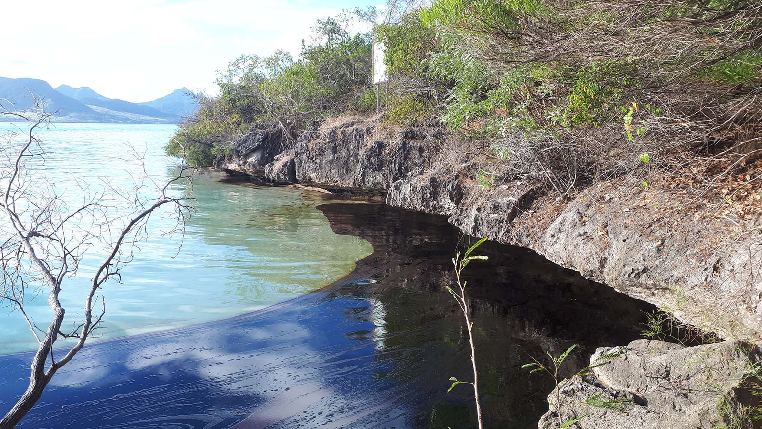
Photo: Oil spilled from the Wakashio at Ile aux Aigrettes (Aug 2020)
Background
On July 25, 2020, the MV Wakashio, a Japanese vessel registered in Panama, ran aground on the reefs of Pointe d'Esny, in the southeast of Mauritius, with more than 4,000 tons of fuel on board. 12 days after the impact, on August 6, 2020, the bulk carrier began to release oil into our waters. For days, nearly 1,000 tons of fuel and lubricants spread in the sea causing an unprecedented oil spill and gave rise to a wave of solidarity from Mauritians aggrieved by this ecological tragedy.
18 months after the ecological disaster
The Mauritian Wildlife Foundation has been actively working alongside the authorities and relevant actors to mitigate the impact and consequences of the tragedy on our most threatened species. We have learned from the incident and are planning new procedures following this catastrophe. For the past year, consultations with the government have been underway. Discussions and meetings have taken place on a regular basis to come up with an action plan to avoid similar disasters and to be prepared to react quickly should the country face another oil spill in the future. We have contributed to the development of a new National Oil Spill Contingency Plan, and staff have received training in oil movement computer simulation. We also participated in the Integrated Environment Monitoring Plan, which intends to continue monitoring the effects of the Wakashio oil spill on terrestrial and marine ecosystems. The Mauritian Wildlife Foundation, with its partner, Durrell, has looked at impacts on the biodiversity of Ile aux Aigrettes and other offshore islets of south-east Mauritius.
Progress noticed at the level of decision makers
‘The disaster gave rise to a lot of positive pressure and we recognize that there has been progress’, declares Vikash Tatayah, Conservation Director at the Mauritian Wildlife Foundation. Dr Tatayah highlights that the government's decision to recruit an international consultant with the help of the United Nations Development Programme to review the National Oil Spill Contingency Plan (NOSCP). A report which should be made public according to the Mauritian Wildlife Foundation, as a manual to be used in case of an oil spill. In its recommendations to the government, the foundation has also requested that Particularly Sensitive Sea Areas are identified so that these areas are better protected.
‘We made this request even before the Wakashio oil spill, since 2017. Nothing had been done but after the disaster, the authorities have proposed to declare some ‘Areas to be Avoided’. It’s probably not exactly the same thing, but we are satisfied with this step forward’, states the Conservation Director. The other measure which has been welcomed by the organisation has to do with the 1996 Protocol that the Republic of Mauritius intends to sign. Had this convention already been ratified, the country would have been entitled to a better compensation - (exceeding the USD 18 million that Mauritius is entitled to) in the event of an ecological disaster of this scale. In this context, the Ministry of Environment, Solid Waste Management and Climate Change has launched a tender to find a team of consultants to amongst other things, prepare a claim to the insurers.
The remains of the Wakashio were still on the reef where it ran aground and there have been delays in scuttling the ship. There was much progress towards the end of 2021, with the hope that most, if not all, of the ship would be cut up and the metal towed away to a recycling plant on Mauritius. MWF put in pressure so that the scuttling of the ship should not be delayed much further than it had already been.

The impact of the heavy oil spill on the protected species of Ile aux Aigrettes and other islets
The shipwreck happened just two kilometres from Ile aux Aigrettes, the nature reserve managed by the Mauritian Wildlife Foundation which serves as home to populations of Pink Pigeons, Mauritius Olive White-eyes, Mauritius Fodies and other endemic reptiles and plants on the red list of the International Union for the Conservation of Nature (IUCN). Despite rapid efforts to evacuate some species, some inevitable damage was observed.
Endemic cricket
One of the main concerns in the months ensuing the oil spill was the disappearance of an endemic cricket living on Ile aux Aigrettes. It has been found again in February 2021 by Souraj Dwarika, the warden of Ile aux Aigrettes but not as abundant as before.
In June 2021, the cricket, scientifically named, Makalapobius aigrettensis has been described as a species new to Science, with the most abundant population being from Ile aux Aigrettes. The accomplishment of a field work that has been carried out well before the shipwreck.
The foundation is awaiting the arrival of an expert to Mauritius to conduct the cricket survey, and confirm the extent of the decline. His planned arrival in December 2021, has been delayed due to the restrictions related to Covid-19.
Plants & nursery
The coastal trees on Ile aux Aigrettes were also contaminated by the black sludge. Martine Goder, Education and Flora Programme Manager at the Mauritian Wildlife Foundation confirmed that some of the trees next to the sea were covered in oil and had to be trimmed during the clean-up operations. These trees are recovering but they will take time to grow back to their original size. The affected vegetation is being monitored to investigate the long-term impact of the exposure to oil.
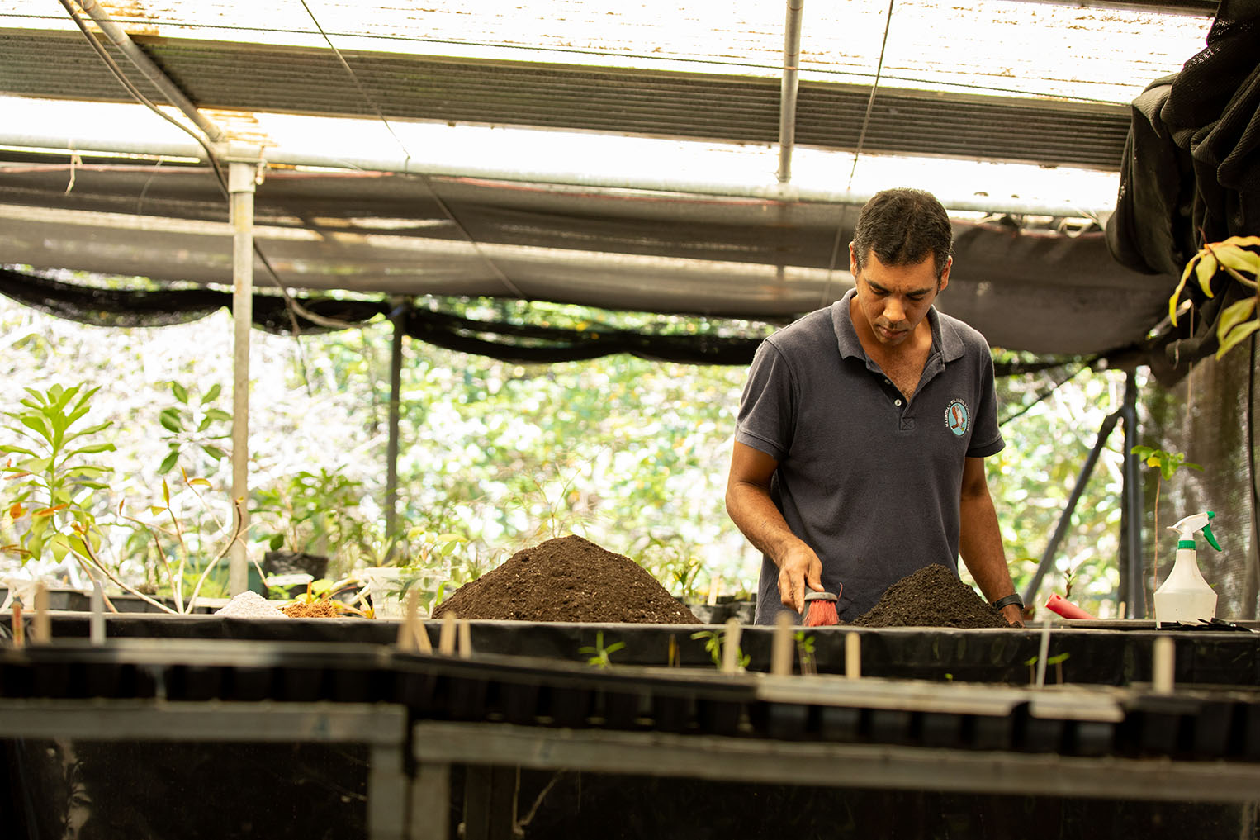
Photo: MWF staff at work in the Ile aux Aigrettes plant nursery
Martine Goder also explained that plants from the Ile aux Aigrettes nursery were transferred to mainland Mauritius during the oil spill as a precautionary measure to potential access restriction to the lagoon and Ile aux Aigrettes. August usually marks the beginning of the drier months, without daily care and daily watering, we would have had a high mortality of the endemic nursery plants, some of which are critically endangered. On the 9th of August, all the nursery plants (nearly 4000) were moved off Ile aux Aigrettes to the mainland and were transferred to the Forestry Service nursery in Mahebourg, where space was kindly provided to hold the plants until the situation improves. The plants remained on the mainland for a period of nearly 2 months, where our horticulturist Pascal, assisted by other staff took care of the plants. A lot of the plants had to be re-potted due to damaged pots during the transfer. All the plants were transferred back to Ile aux Aigrettes in the first week of October. The plant transfers required an enormous logistics effort and was possible with the help of the MWF staff, volunteers, and funders. Although we did lose some cuttings and very young seedlings due to lack of the appropriate facilities on the mainland, the great majority of the nursery plants are doing well.

Reptiles on the South East Islets
Following the oil spill, reptiles were rescued from Ile de la Passe, Ilot Vacoas and Ile aux Fouquets (au Phare) and Ile Marianne, to Jersey Zoo. Nik Cole, Island Restoration Manager for Durrell/Mauritian Wildlife Foundation managed the translocation process and reported that the animals are doing fantastically well with a high level of reproductive output for the Bojer’s skinks and lesser night geckos, although the Bouton’s skinks have taken a little time to settle in but have recently started to produce eggs.
‘The staff at Jersey Zoo have been so successful in breeding these rare reptiles, they have had to build and extend the biosecure rooms to house all of the hatchlings. A large captive assurance population under professional care at Jersey Zoo ensures that we have the buffer required to withstand any losses in the wild’, reported Dr Cole.
Since the rescue of the reptiles to establish the captive assurance populations at Jersey Zoo, the field team in Mauritius have been monitoring the impact of the oil spill on each of the four islets. To date, surveys have shown an overall decline in the abundance of invertebrates compared to pre-oil spill levels. The decline in invertebrate numbers has been most pronounced on Ile de la Passe and within the key dietary items for the lesser night geckos that inhabit the coastal rocks of Ilot Vacoas and Ile Marianne. Gecko body condition has declined compared to pre-oil conditions and the population size of geckos has also declined on each islet. Bojer’s skinks, which are omnivorous are not as sensitive to declines in invertebrate abundance and as such their body condition has not changed, although the population sizes on Ile aux Fouquets and Ilot Vacoas have declined compared to pre-oil spill levels. There has been no detectable change in the population sizes of the Bouton’s skinks on the islets, but these lizards are harder to monitor, and the data obtained may not be sensitive enough to determine change. Nevertheless, DNA samples have been obtained from each reptile species on each islet and once it is possible to get the samples to our partners at Cardiff University in the UK, it should reveal the full impact of the oil-spill and the need to bring animals in captivity back to Mauritius.
The bird population sizes, particularly the seabird populations on the islets remain similar to pre-oil spill levels.
Intensive monitoring of the islet populations of invertebrates, reptiles and birds is ongoing.
Endemic birds
Sion Henshaw, Fauna Manager, remains sceptical, as although our worst fears have not been realised, we still cannot be sure what damage has been done at this stage.
‘There has been no damage immediately visible to our birds on the island, but we do have concerns about bioaccumulation of hydrocarbons into the environment. This might take time, and if it does occur, effects might not be immediately detectable’, says Sion Henshaw.
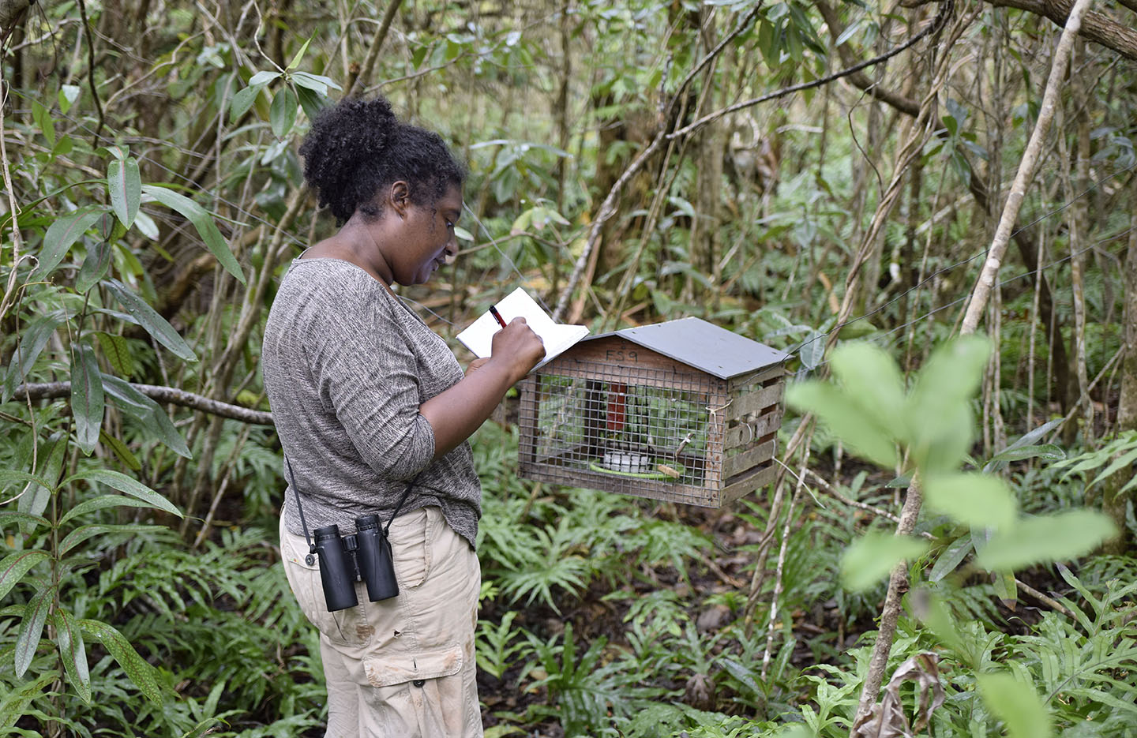
Photo: Monitoring feeding behaviour of the Mauritius Olive-white eye on Ile aux Aigrettes
A small number of birds were removed from the island immediately after the oil spill as a precaution if the Ile aux Aigrettes’ population would have been lost. Once the lagoon and the coastline had been cleaned, and there were no detectable threats present, these birds were brought back to the island. This process caused a change in the distribution of territories.
‘When the Olive White-eyes were released back on the island their territories had been taken over by other individuals. This caused a lot of fighting, and some individuals regained their territories while others lost theirs. In recent months the fighting has much decreased, and the population seems to have returned to normal. We continue to intensively monitor the population which will allow us to detect any potential secondary impacts of the oil spill in the future’, mentioned Sion Henshaw in his reporting.
Sion Henshaw also noted an increase in the mortality of Mauritius Fodies from the intensive monitoring. There appears to have been an increase in the average number of birds ‘assumed dead’ per month in 2020 and 2021. The impact of the Wakashio oil spill, if any, will only be detectable in the number of birds ‘assumed dead’ as from August 2021, and will require continuous monitoring.

Report submitted by
Jean Hugues Gardenne
Fundraising & Communications Manager
Mauritian Wildlife Foundation,
jgardenne@mauritian-wildlife.org

For more information on Post Wakashio Conservation Work, please contact
Dr Vikash Tatayah, Conservation Director
Mauritian Wildlife Foundation
vtatayah@mauritian-wildlife.org

For a video link on the subject: https://www.youtube.com/watch?v=0ZZxLJYCT3E

For news updates
Follow the Mauritian Wildlife Foundation on Facebook: https://www.facebook.com/MauritianWildlife/

