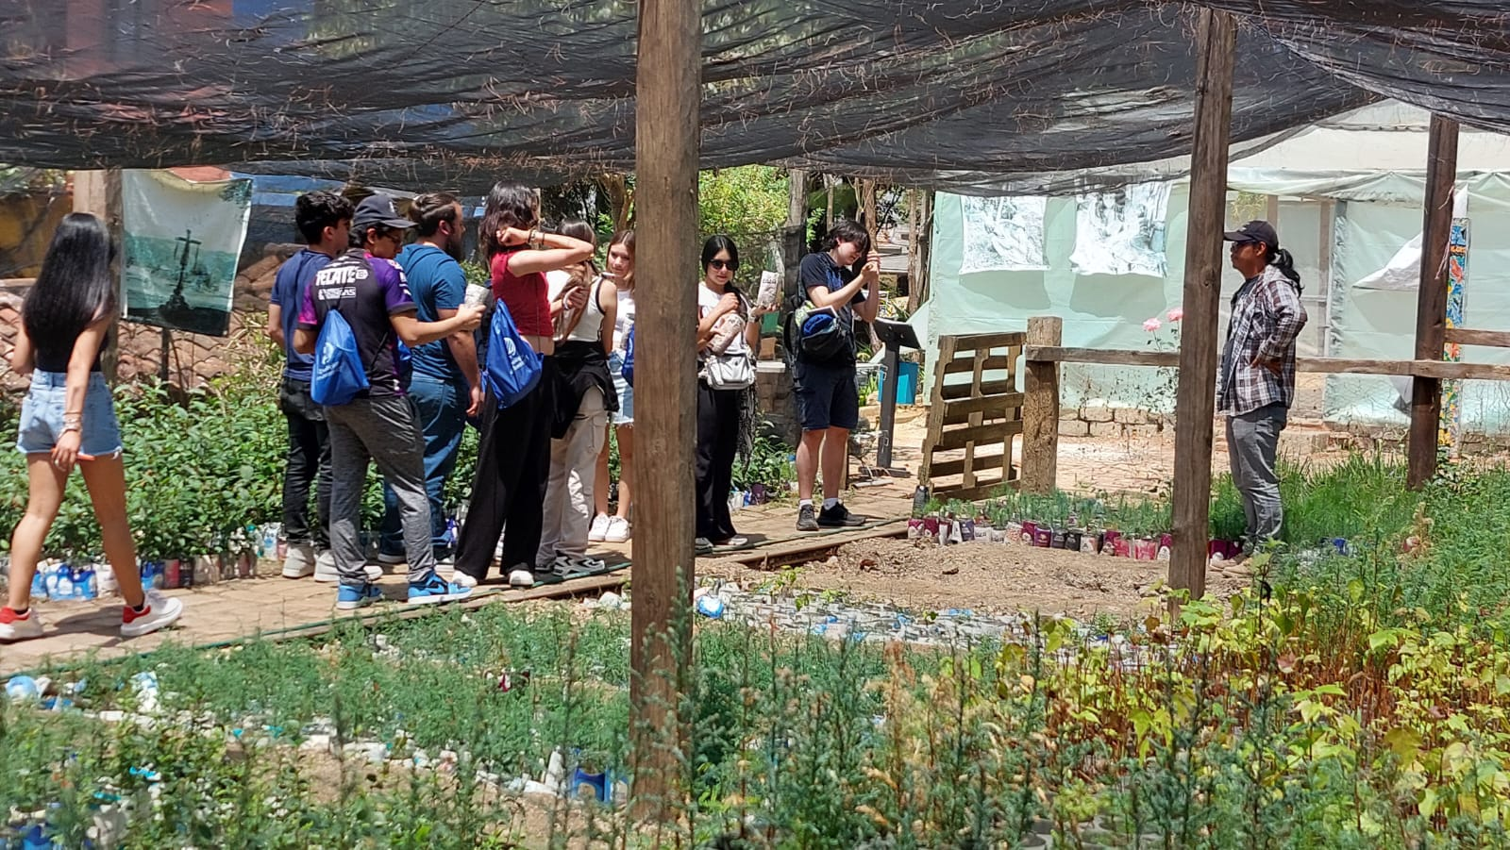

Experience report on academic collaboration with the climate change area of na bolom and the CIS.
This document collects personal experience regarding collaborations between the climate change area of the Na Bolom organization and the Center for Social Innovation (CIS) of the Tecnológico de Monterrey, although there has been a relationship for years between the CIS and Na Bolom, for more than a year they began to explore the possibility of making a link with the climate change area and its representative Víctor Hugo Sánchez Santiz and his work team, this with the purpose of carrying out a workshop practical community nurseries, and talks on environmental awareness, and climate change agency for students from the Tec de Monterrey high school.
From the first planning sessions with the management of the organization, the guidelines and interests for our purposes were defined, thus it was agreed to implement a first practical workshop to create community nurseries with a recovery fee for the change area. climate. After different planning and agreement sessions, the experiences achieved with the workshops and the talks we have had with Víctor and his team have been very satisfactory for our interests and our students.
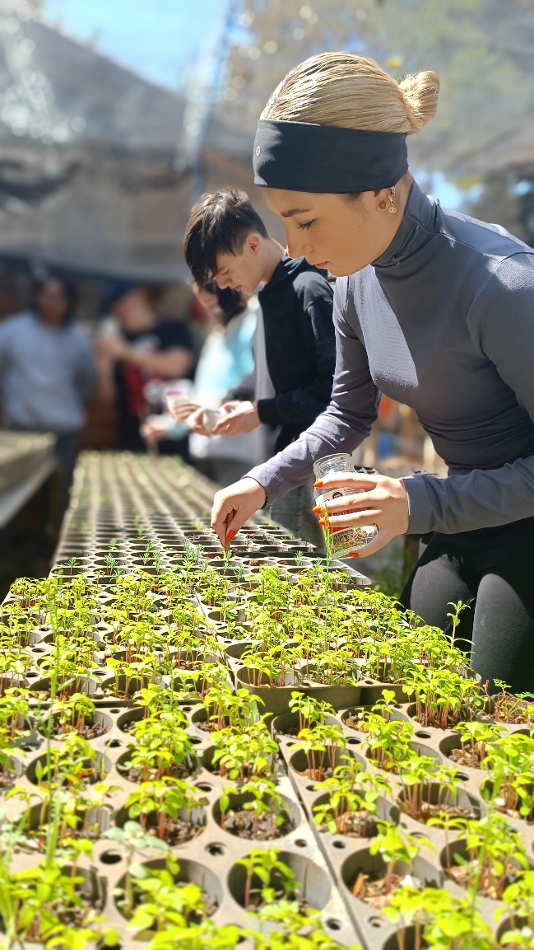
The activities carried out and the experience provided with the CIS are summarized in a horizontal dialogue that responds to the needs to emphasize and address topics such as the agency of change in our students, the community incubator workshop, the contextual and sensitizing talk on the part of the The Na Bolom team triggers reflection and meaningful and experiential learning in our students, as they report it in the internal surveys carried out at the end of our academic experiences.
One of the key findings that this connection has allowed us is that our students consolidate an openness of thought towards the generation of social and environmental awareness that, prior to the experience in Na Bolom, was non-existent or, in any case, distant from the social context of the students.
The interventions of Víctor and his team have allowed us an experience that provides us with valuable elements aligned with our institutional vision on human flourishing, in such a way that the passage of our students through the eco-environmental experiences of Na Bolom have been a great tool to achieve challenge-based learning, as well as the generation of skills necessary for the agency of change, such as teamwork, citizen responsibility, active listening, ethical commitment, etc.
Finally, I extend my gratitude to Na Bolom and the climate change area, for their participation in the generation of future agents of change as well as for their environmental and citizen work, committed to the environment as well as its preservation, rescue and awareness of urban and rural environments. Na Bolom and its climate change area continue to be a strategic ally to provide sensory experiences that provide great value in the community and whose importance transcends national and international borders, thank you for being allies and friends of our mission of using education as a means of social transformation.
Lic. Sebastián Hernández Jimenez.
Center for Social Innovation – Tecnológico de Monterrey.

