Hello, it's a pleasure to be able to tell you and share with you a little about the life of our team and the jungle projects. As you already know, to carry out our community process we have issues to address with different autonomy processes for each space.
The Na-Bolom nursery project(s) in the border mountain region (SELVA) have generated favorable results for the growth of this beautiful project. During these months, in particular, in our journey we were joined by a new space in the region, this community is called Quiringuicharo, in this new space young people between 11 and 13 years old join, with this space we reiterate that environmental processes, if they It matters to young people and educational spaces. In this journey we continue to observe that one of the activities that all young people are most proud of is carrying out reforestation in their places of origin and this empowers each young person in making decisions about their social environment. Each time the project reaches more areas, of which there are interests in having participation in the project.
Monitoring of nurseries in the jungle region
December 2023.
- December 1, visit to the Benemérito technical secondary school, to carry out a closing evaluation with the students.
- December 4, visit to the secondary school of the Quiringuicharo community, to learn about the dimensions of the new installation of the new nursery.
- December 5, visit to Roberto Barrios' Cobach, for end-of-year evaluation.
- December 6, visit to the Zamora Pico de Oro campus, for end-of-year evaluation.
- December 7, reforestation was carried out with the accompaniment of the students of CECyT campus 24.
- December 8, visit to Emiliano Zapata's Cobach, tree planting evaluation tour and end-of-year evaluation.
- December 9, Visit to the Tres Lagunas nursery, to generate an agenda with Pablo Chankin in addition to evaluating this year's results.
- December 12, the nursery of the Benemérito technical secondary school was visited to collect soil for the pending transplants.
- December 13, the nursery of the Zamora Pico de Oro campus was visited to present recognition for participation to the young people as motivation.
- December 14, Roberto Barrios' Cobach was visited to define the groups that would participate the following semester.
FOR THESE DATES THE NURSERIES WILL BE VISITED FOR MONITORING SINCE THERE WILL BE NO STUDENTS.
- December 22, visit to the Quiringuicharo secondary school for monitoring since the students are not there.
- December 26, visit to the Pico de Oro campus.
- December 27, visit to Roberto Barrios' Cobach.
- December 28 visit to Emiliano Zapata's Cobach
- December 29, visit to the CECyT and the Benemérito secondary school
The general activities carried out at each Cobach headquarters are the following:
- Seed collection.
- Soil collection.
- Sort the plants.
- Nursery maintenance.
- Watering and weeding plants.
- Collection trails.
- Weeding the nursery area.
- Assistance to service providers.
As you notice, the project is having an impact on a personal level, leaving traces of this project in the lives of young people who, when they leave their study centers, will take learning and experiences within their experiences.
Viki invites us to save the ancient mountains.
By Josefa Victoria Gonzále z Hernández - teacher in Zinacantán
December 12, 2023.
This year, with the development of the project, I learned many more things with the topic of balance and resilience of things and I understood that our space as a nursery is of great importance, which is why it has generated my new points of view. I still see my family and my people cutting down the mountains, using chemicals that kill the soil, but I know that in our space, although small, it is a preservation center. I give as an example a small animal that, although annoying because it moves our plants; This little animal is called yours; This takes refuge within our space below the ground, since more and more people put cement in their houses or use the soil too much with chemicals, but luckily for us today we are a point of balance.
That is why our task as a group will be to generate motivation with the people close to us so that they know about the production process that is carried out in our little school, in addition to valuing the work of the boys and girls , as well as knowing that their families involve in the participation of the nursery in addition to inviting people to plant trees to care for and protect them. With the support of my colleagues from Na Bolom, I began to propose new things in my house and I carry out what I learned in my personal spaces, in addition to paying part of it to continue my training through the results of the process.
In the process I have learned and shared my knowledge with the Na Bolom team. At Yo'onik we apply what we have learned to expand our tree production with the support of children. They already recognize seed collection dates and ways to protect, cultivate and transplant them. They have recovered their knowledge by naming them with our native language. Tsotsil town .
The children have committed themselves to adopting trees; each of them has taken a tree home with the intention that they have a memory of their effort.
In this journey with the project we have learned that not all of us are for everyone, we do this for the love of the environment, but this does not stop us or discourage us from continuing in our efforts to see our town green and with the intention of safeguarding our environment by preserving the traditions of respect for the environment as our grandparents did.
Viki is currently studying her bachelor's degree in which she focuses on participation and development of the rural context. Despite continuing her studies, she still continues to collaborate in the non-profit organization in her community, Zinacantán, where they help children complete their education by teaching them the things they do not learn in school. Yo'onik partnered with Na Bolom before the pandemic to start the tree nursery project. Since it was closed and the children started collecting seeds before the closure, Viki made her own project to take care of the seeds while the children were away. Today Yo'onik has a tree nursery and a seed bank. The children are collecting seeds from the surrounding area and producing trees to reforest their community.
Help Viki continue her dream of seeing her community full of trees.
You can continue to donate to the project through GlobalGiving and become a monthly donor.
Did you know that GlobalGiving gives extra donations to organizations with monthly donors?
GlobalGiving website .
Local actions, global impacts, moving towards community participation .

Jovenes sembrando/ Young people sowing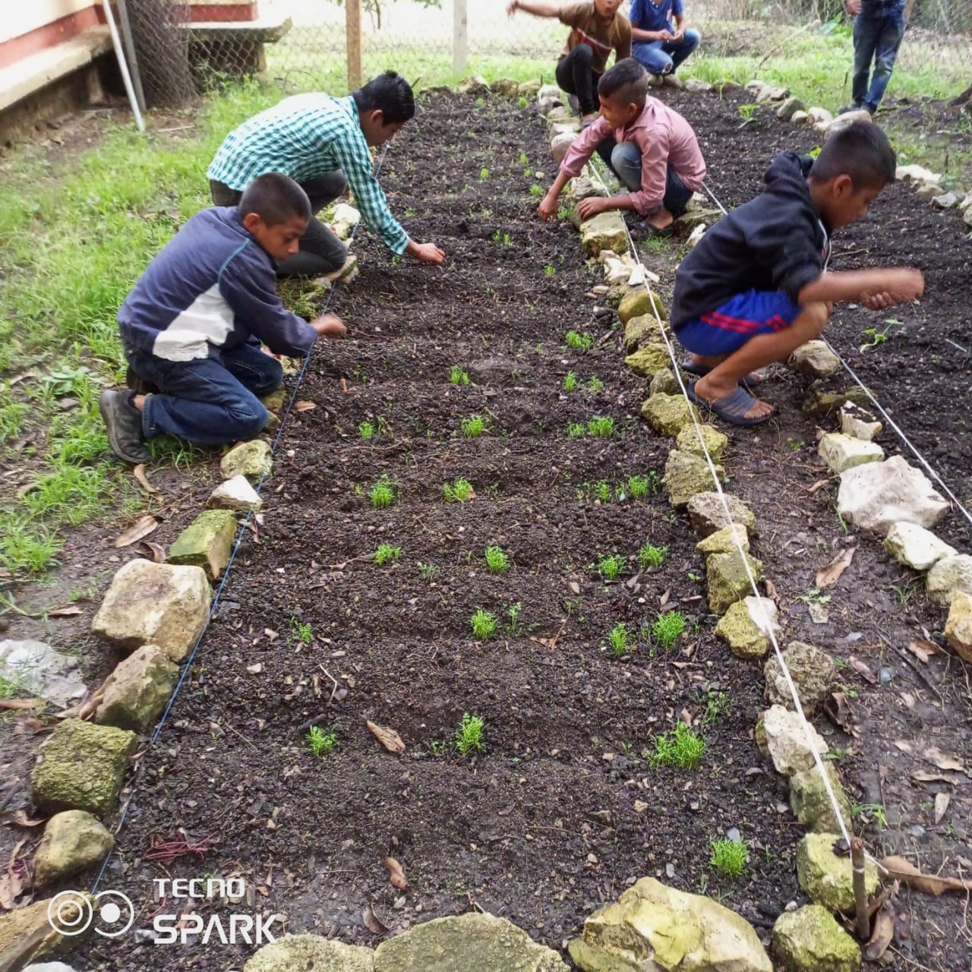
Niños sembrando / Children sowing
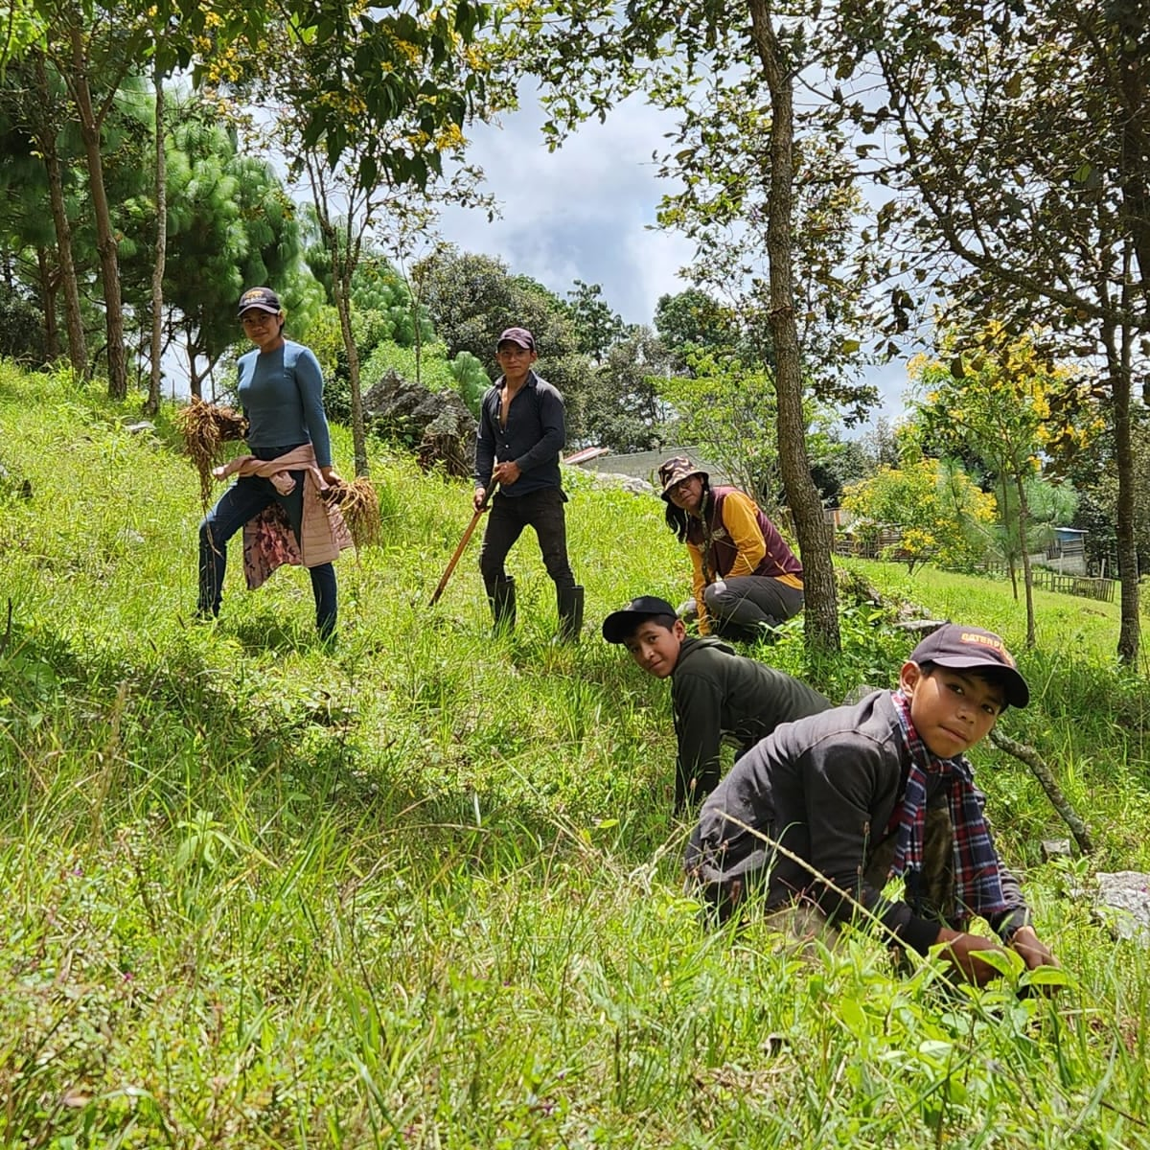
Elaborando curvas de nivel / Creating contour lines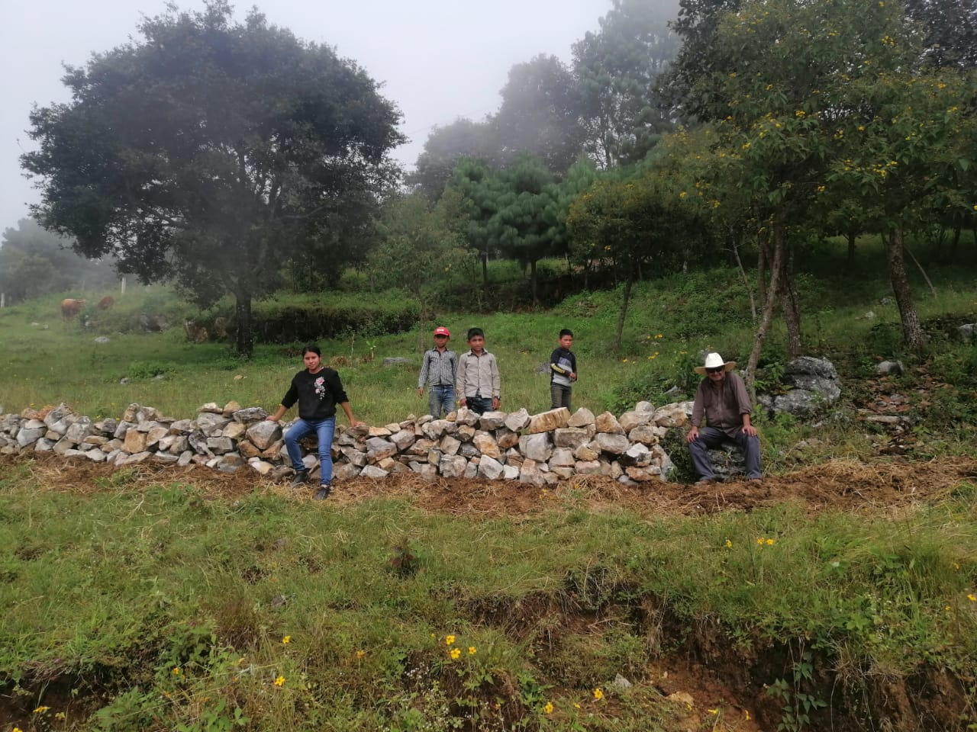
Elaboración de terrazas / Preparation of terraces
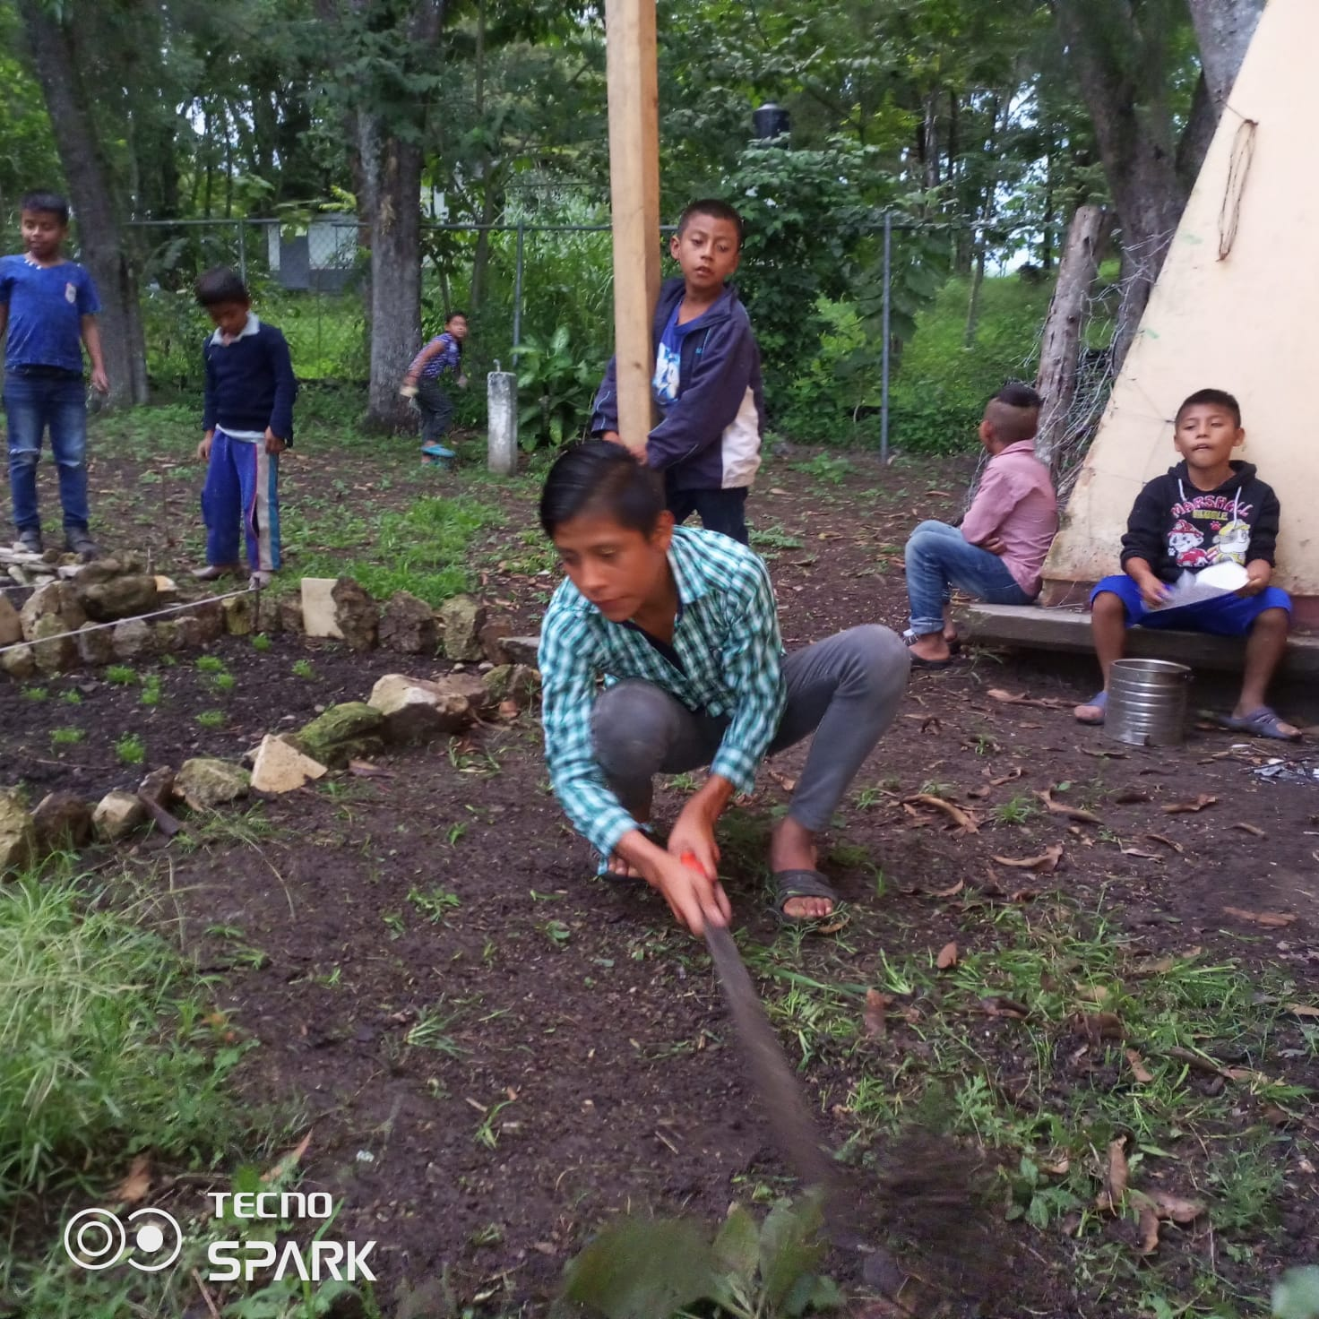
Niñez trabajando / Childhood working
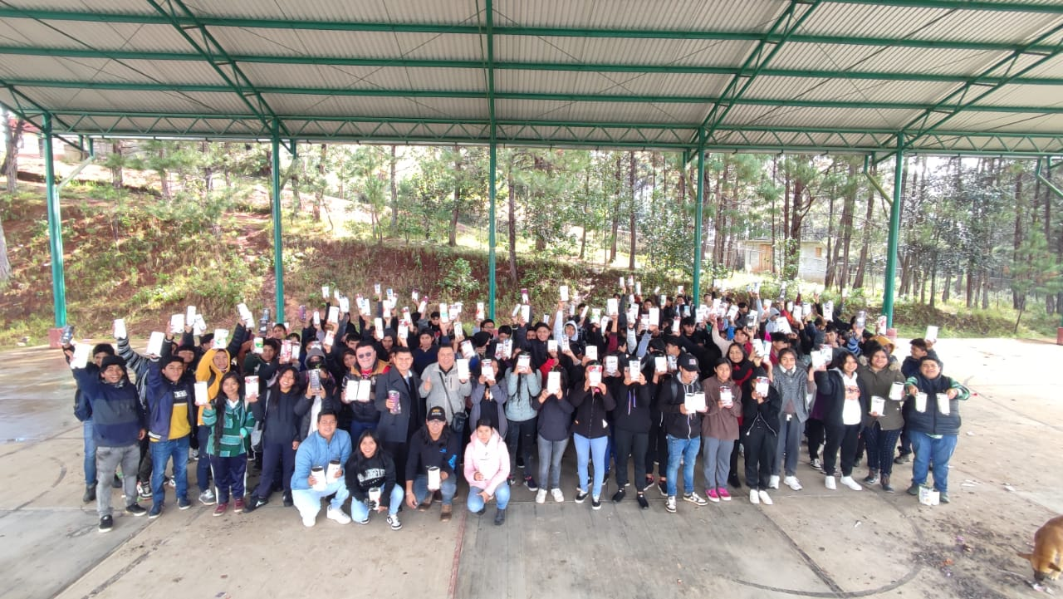
Todos trabajando por la vida / All working for life
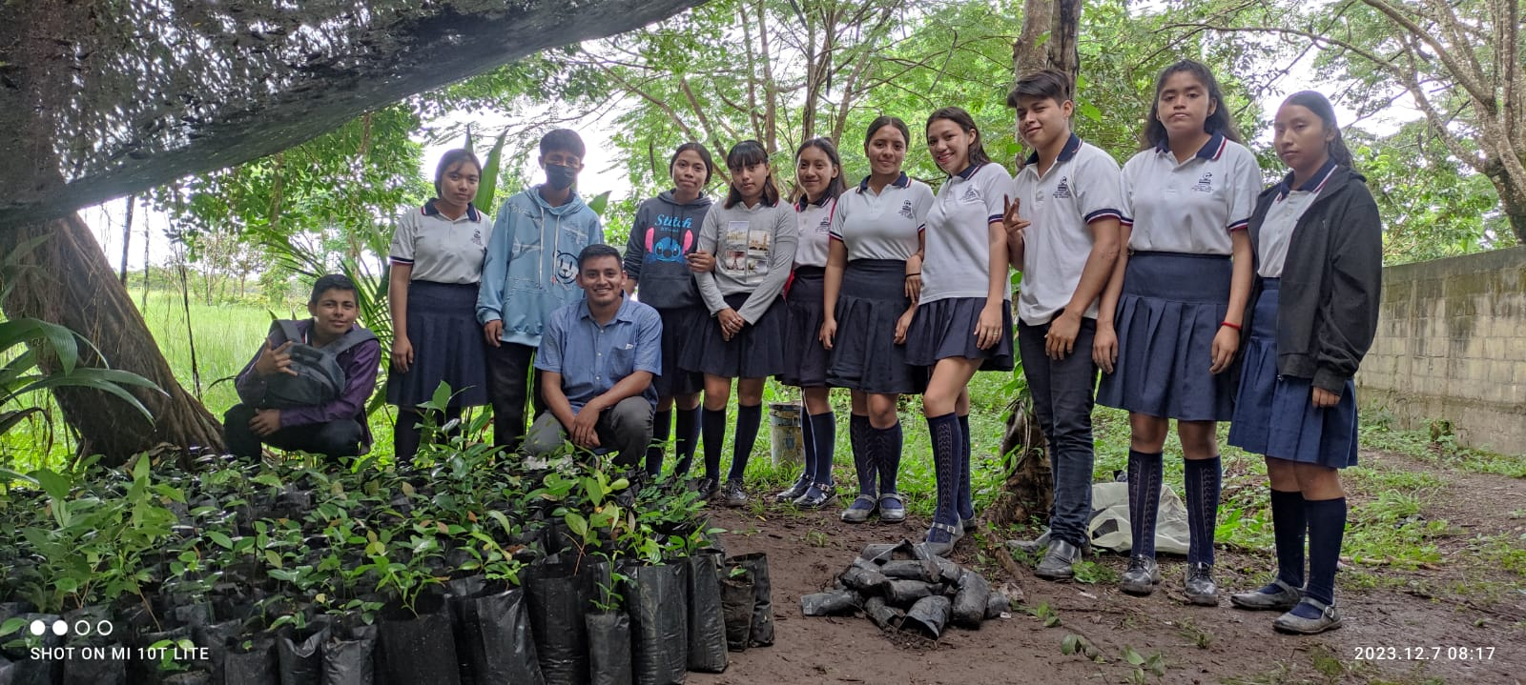
Marco en la selva / Marco in the jungle
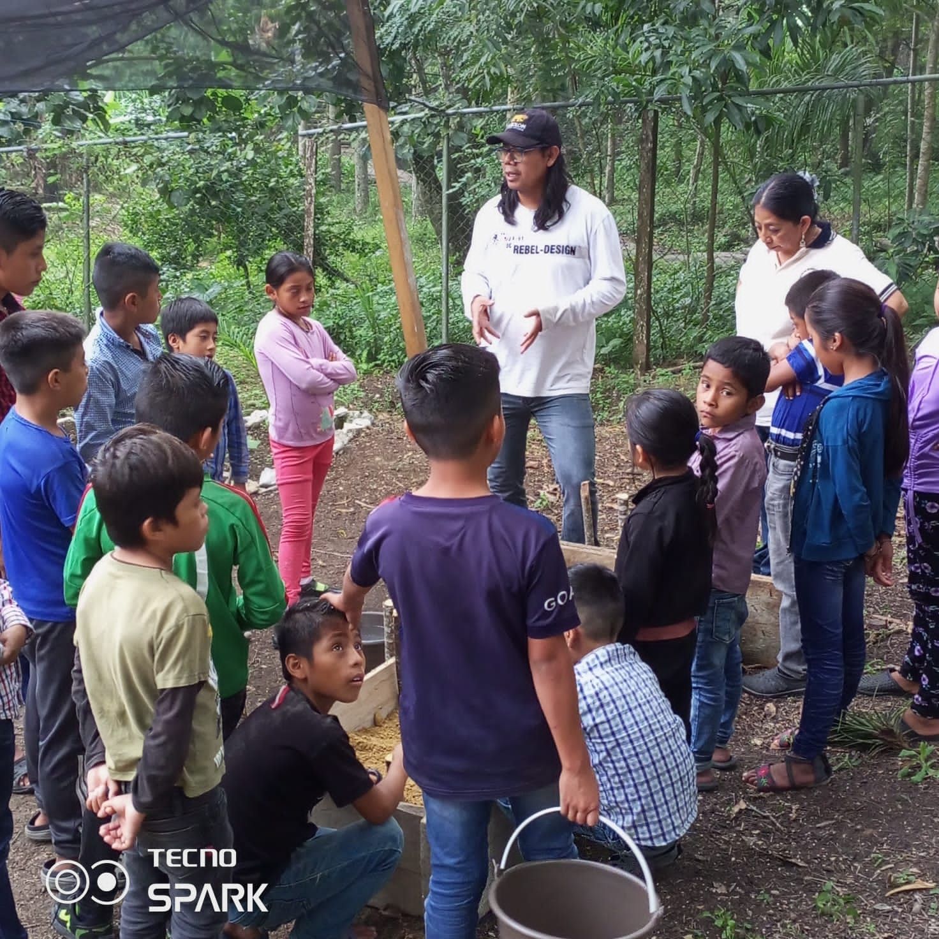
Víctor con niños de Ocosingo / Victor with children from Ocosingo
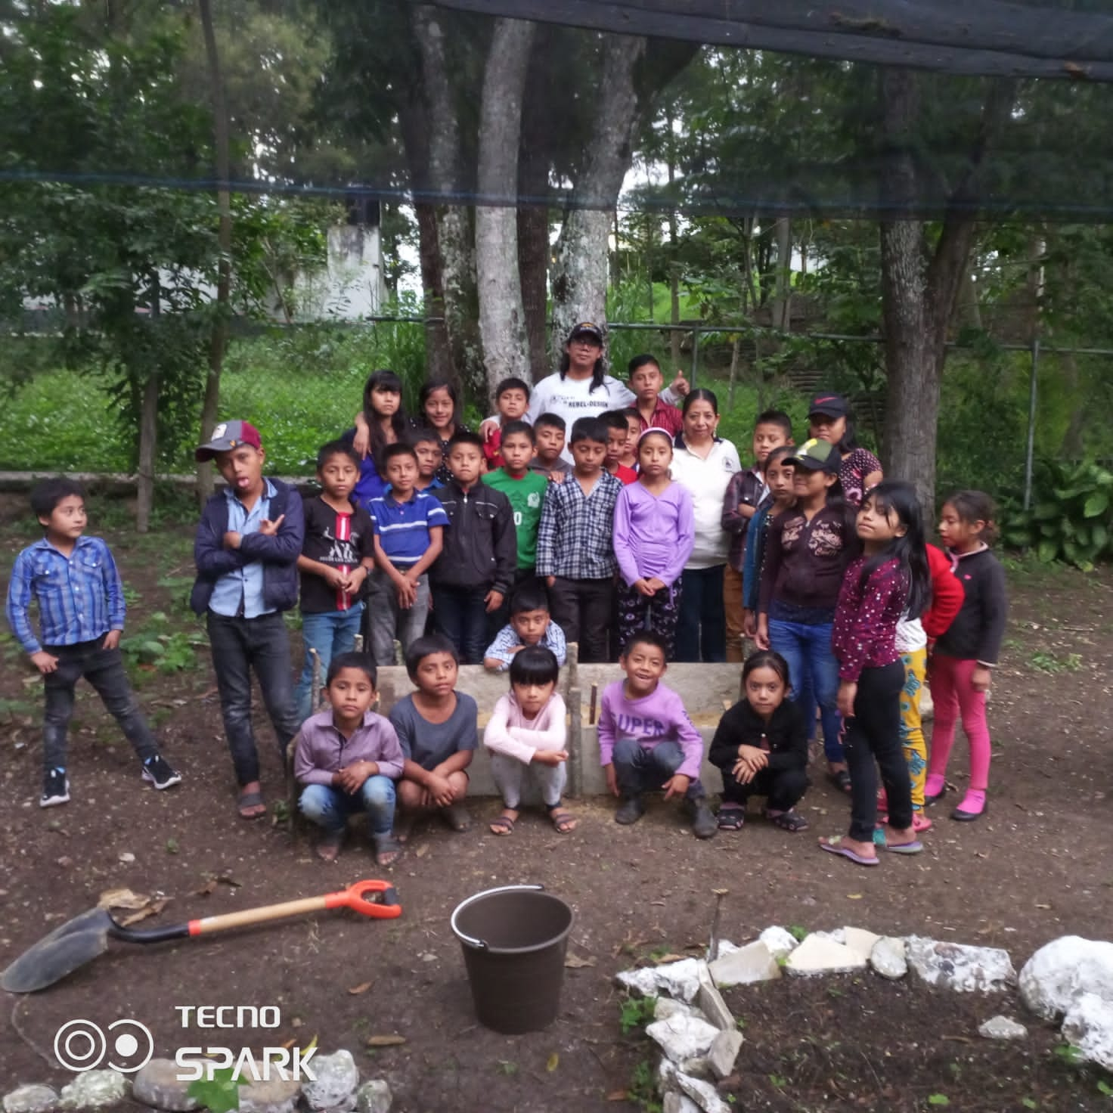
Terminando actividades en Ocosingo / Finishing activities in Ocosingo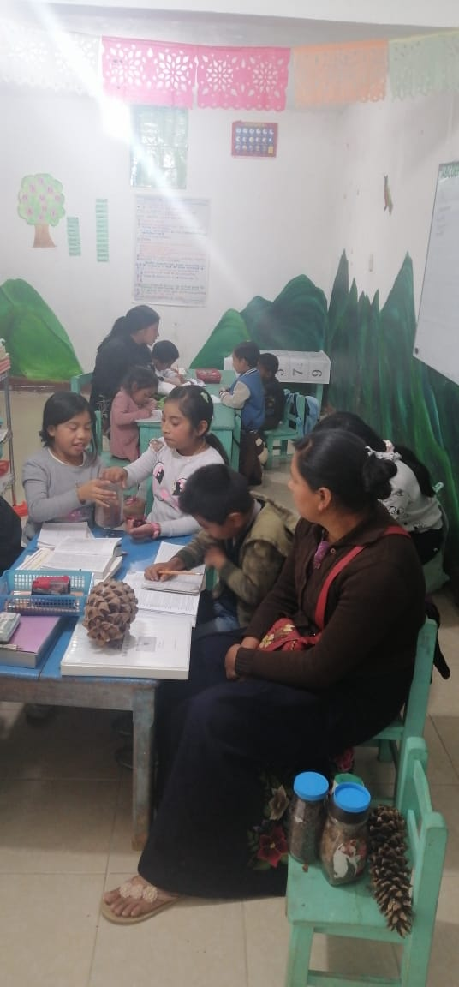
Viky con niños en Zinacantan / Viky with children in Zinacantan
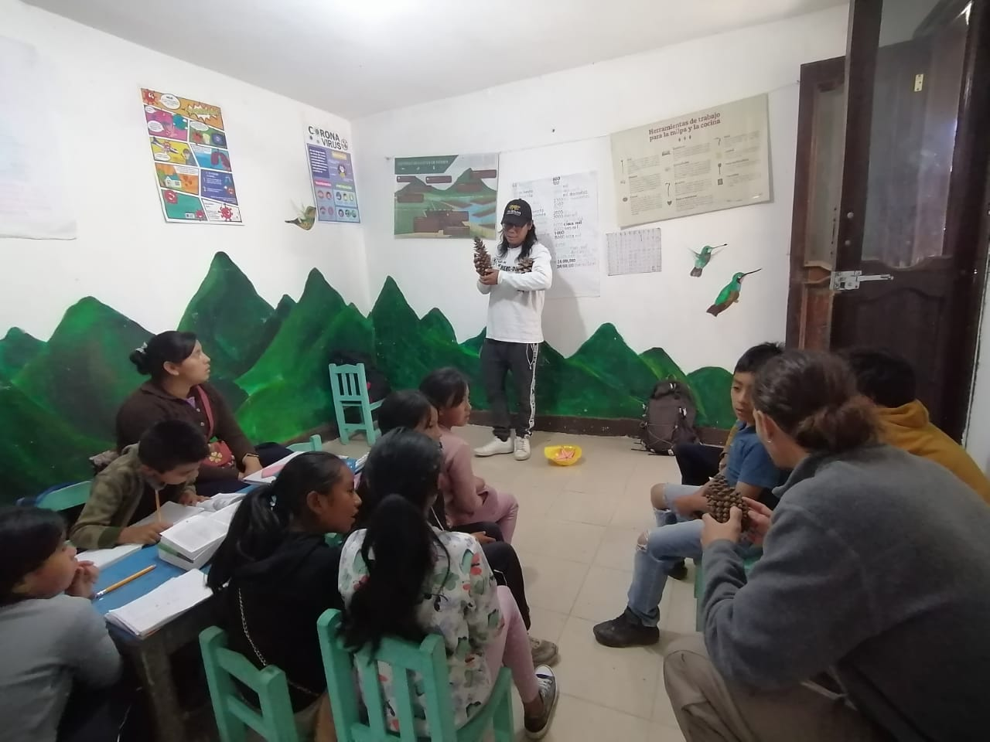
Explicación de semillas con niños de Zinacantán / Explanation of seeds with children from Zinacantán
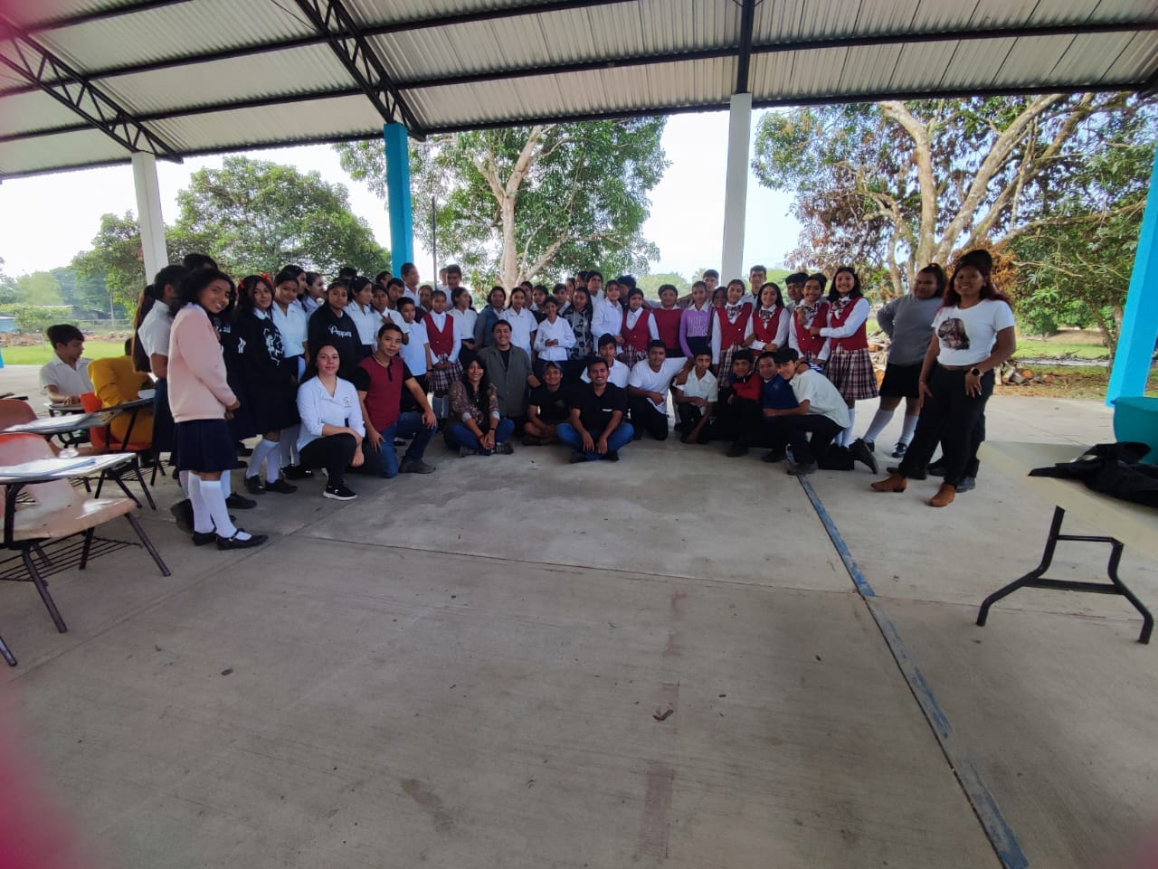
Foto grupal con jovenes de Quiringuicharo / Group photo with young people from Quiringuicharo

