How are you, we would love to share with you a month of our work as a team and let you know how the project is progressing. Unfortunately these months we have not been able to advance as we would like since donations have been slow, but even so the work and desire to work with the communities to achieve the achievements will continue without stopping us.

The Na-Bolom nursery project(s) in the border mountain region (SELVA) always gives us reasons to continue making efforts to promote the project. In these months we have managed to propagate trees of importance in the Lacandon Mayan worldview, which is the Ceiba, in addition to propagating fruit trees.
At the beginning of the semester, the high school groups prepare to collect seeds and prepare the substrate.

August 2023.
The days of visits and work were the following :
- August 1st visit to the nursery and sowing of seeds in CECyT.
- August 2 accompaniment to the Benemérito technical secondary school.
- August 3 accompaniment to Roberto Barrios' Cobach to remove and rearrange trees.
- August 4, spaces that donate tetrapack to us were visited.
- August 5th departure to three lagoons
- August 7, during the previous visit to the technical secondary school, they were told certain activities to carry out. On this date, I arrived to review the progress, but they did not carry out the activities in addition to the fact that the mesh suffered a tear.
- On August 8, the students of Emiliano Zapata's Cobach were visited in their homes since they protected the trees on vacation.
- On August 9, the CECyT was visited, during this activity the infestation of caterpillars in the beds was detected.
- August 10, accompaniment to Roberto neighborhoods' Cobach with Tamarindo transplant activities.
- August 11, the activity on this date is to remove and expel pests from the CECyT nursery.
- August 12 departure to three lagoons.
- August 14, the rearrangement and elimination of the pest that affects the CECyT nursery continued.
- On August 15, the Tres Lagunas nursery was visited, on this occasion Don Pablo was asked to donate land with the intention of giving it to other spaces.
- August 16 continue with the reception and collection of tetrapack.
- On August 17, the CECyT nursery was visited for irrigation purposes.
- August 18 accompaniment and documentation check to the social service provider.
- August 21, in the CECyT nursery, fumigant prepared by the institution's own students was applied.
- On August 22, the Benemérito high school nursery was visited for irrigation purposes.
- On August 23, the CECyT nursery was visited for the purpose of irrigation and pest monitoring.
- August 24, departure to Cobach de Zamora Pico de Oro for a meeting with the director.
- August 25, departure to Tres Lagunas for a meeting with Don Pabló to schedule reforestation.
- From the 28th to the 31st, the three Cobach plants will be visited with the intention of reinforcing the link and continuity of the school nurseries.
The general activities carried out at each Cobach headquarters are the following:
- Seed collection.
- Soil collection.
- Sort the plants.
- Nursery maintenance.
- Watering and weeding plants.
- Collection trails.
- Weeding the nursery area.
- Assistance to service providers.

Become a monthly donor and help us continue this work.

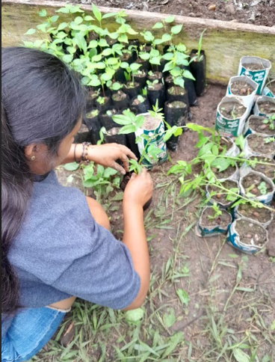
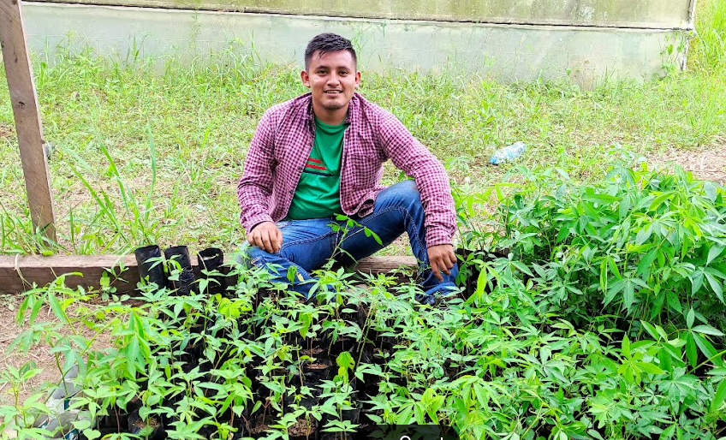
Antonio with ceiba trees
Young girl arranging seedlings
Plant a tree, resistance, and fight .
By Roxana Gómez - Na Bolom Climate Change Program.
September 3, 2023

I'll tell you what we went through during these months in our work within the Na Bolom nursery. As you know, the rainy season in Chiapas is in the months of June, July and August, which is why we generate reforestation campaigns on these dates with the intention that the donated plants can survive and persevere until the next rains.

Various communities approached us to request donations of trees, to mention: Chamula, Zinacantán, Huixtán, Oxchuc, Ocosingo, Chanal, among other communities. In total, more than 10,000 native and biologically important trees were delivered for the restoration and conservation of forests.
trees took place in the spaces established by the beneficiaries. The communities, as is well known, are always grateful and on each outing they welcomed us with great joy, sharing what they harvest from their plots.
Many of the reforestations focused on preserving their forests for future generations, and they also recognize that logging causes changes in climate and lack of water. This excites us because the need to have green spaces in communities is beginning to spread throughout the communities. regions where we managed to reach through this project of which you are part by donating.

But it is not the time to get complacent since the change in land use and the needs of the communities continue to persist and therefore our work has to be intensified, teaching and learning about sustainable forest management and the importance of reforesting forest areas. grades.

The best way to support us is to become a monthly donor.

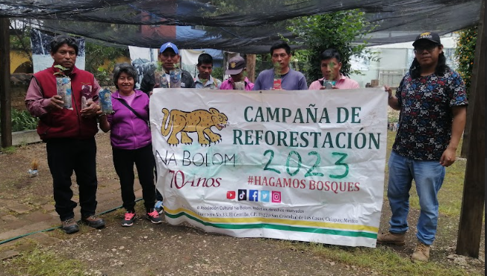
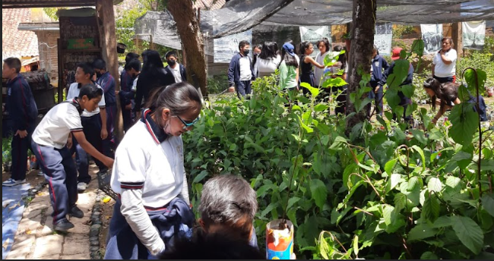
Teamwork with visiting children to deliver reforestation trees.
Donation to residents of San Juan del Rio Ocosingo, Chiapas
Let our volunteers tell you about the project
By Citlali Jaqueline Jiménez Cañada – Practitioner.
September 2, 2023

My name is Citlali Jaqueline Jiménez Cañada, and I will tell you that during the months of May to June I carried out several activities, where the result of what I learned in the area of the Climate Change Program (PCC) was demonstrated, in which Many people, but only three are responsible for this area, do everything possible to ensure that the objectives of (PCC) are met, since the objective has to promote environmental education, awareness through reforestation projects, creation of community nurseries. and school nurseries, rescue of endemic species, training, recovery of traditional techniques, recycling, all with a sustainability focus.
Through them I was able to understand that they have a very important value when planting each tree, since it takes a lot of effort, time, patience, perseverance and above all love for the trees, since it is considered that they also feel and perceive who touches them or They look in a good or bad way, care is not very different from one species of tree to another, the growth of each tree is different since it is observed that the pine takes a long time during its development stage; The aile is one of the most successful trees since its germination, a rapid development process and the ones that are most in demand when donated.
My arrival was achieved through the Universidad Tecnológica de la Selva, where they carried out several reforestation activities. It was also possible to observe that they collect the seeds either inside or outside the city and it is a task that requires a lot of time to find seeds. that they are ready for germination, not only do you choose seeds, you also choose stems to be cut into cuttings and can be introduced into the substrate. Regarding the preparation of the substrate, everything that is added must be of quality; such as the food waste that was added, that is, they are not malignant so as not to affect their growth, also adding worms so that what stimulates the activity of the microorganisms and the plants are successful in their growth. The activities carried out were fundamental for life on our planet, in addition to comforting our eyes with beautiful landscapes, they produce oxygen and clean the air, capture water, and help combat climate change.
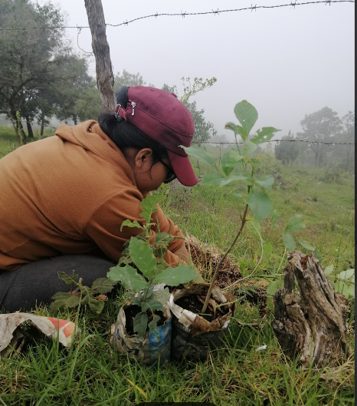

Jaqueline planting oak trees
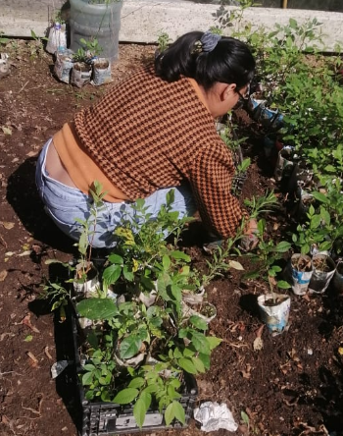

Jaqueline arranging trees
Challenges of a goal for a better future
By Victor Sánchez – director of the Na Bolom Climate Change Program.
September 3, 2023
Unfortunately, in this season that we are telling you about, the donations were not so frequent and this reflects that the established financing goal has not yet been achieved, but this has not stopped the continuity of the project.
On this occasion our arrival in Naha focused on recovering seeds from the copal tree, this tree is biologically and culturally important, with this we are diversifying the seed bank, in addition to generating bird watching transects, which is why your support is necessary to achieve greater results in the Naha seed bank.
Despite everything, the seed bank project continues to advance, unfortunately the needs are changing as the project progresses, in addition to the social situation of the environment affecting the desired goal, therefore with everyone's support we will be able to surpass these challenges.
Meanwhile, the Na Bolom nursery and seed bank and those in the jungle region continue to grow. And this is thanks to those responsible for the project; This is why we can move forward. And they always develop activities to strengthen the space. In addition, the nursery generates a space for sharing local and external knowledge for the benefit of the environment.
As in the previous quarter we worked in the communities of Zinacantán, El Carrizalito and this time Ocosingo and Chanal joined with different groups in each community. The participation of each work group motivates us to move forward in addition to emphasizing the difficulty of working with different ages of the population, it is not that easy; since each community need generates different ways of working and that one methodology is not the same as the one applied to another. For this reason, the project is changing and even more so when new spaces and new ideas come together.

Whats Next?
- Continue collecting seeds to proceed with germination and expand the types of seeds collected, generating greater preservation of local seeds.
- Build the new nurseries that the spaces are requesting from us
- Visit the communities of the Lacandon jungle to install an additional seed bank with warm climate plants and follow up on the one that already exists in the Lacandon Community of Naha. And generate new spaces surrounding these to generate more impacts in the region.
- Claim the local knowledge of the participants of the jungle seed banks held in the jungle schools.

To do this, we must guarantee employees' salaries and raise funds for travel and transfer expenses. We need to achieve our goal of $5,000 USD, otherwise the project will suffer and progress will be slower and we risk spoiling the seeds that have already been collected as well as discouraging processes with the working groups and we know that with you we can count on to achieve this new goal. Thanks to you we can achieve it. We are counting on you!

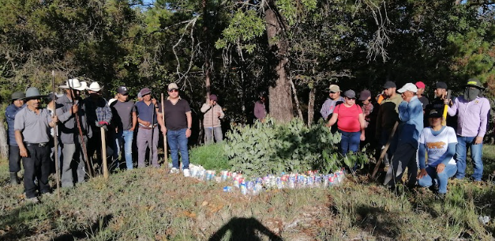
United for the same cause.

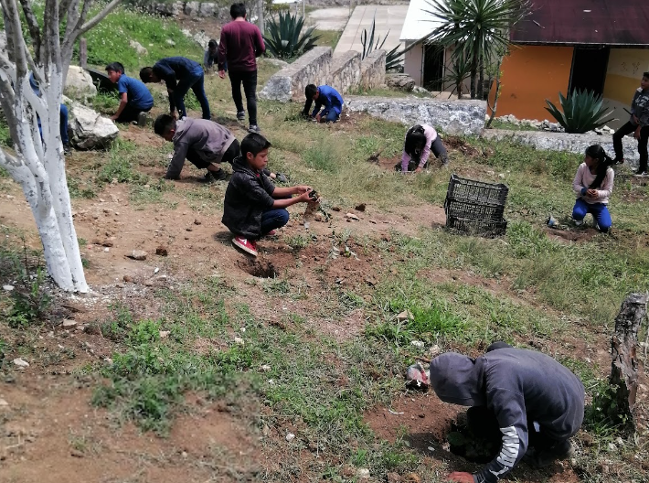

The new generations committed to the preservation of the community environment

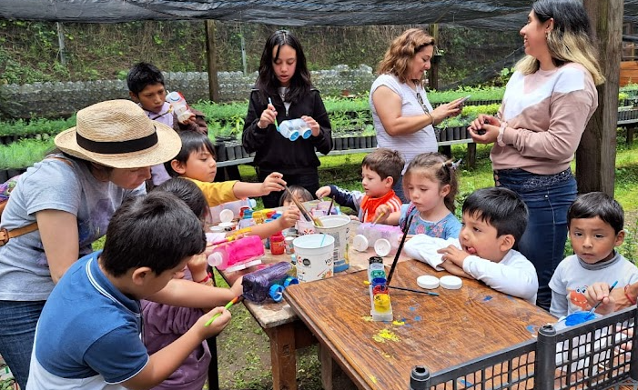
Toy workshop with recycling materials.

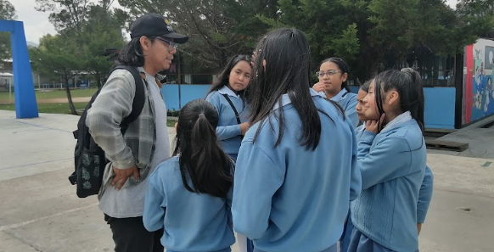
Dialogue and reflecting with girls about the environment.

