Covid-19 ---- A love story

“A horse, a horse, my kingdom for a horse.”
-William Shakespeare, Richard III

In uncertain times, what we need the most can change dramatically. In his famous last battle, fighting for life and kingdom, King Richard III knew the value of a horse….and so do we, and so do we…. let me tell you our story.

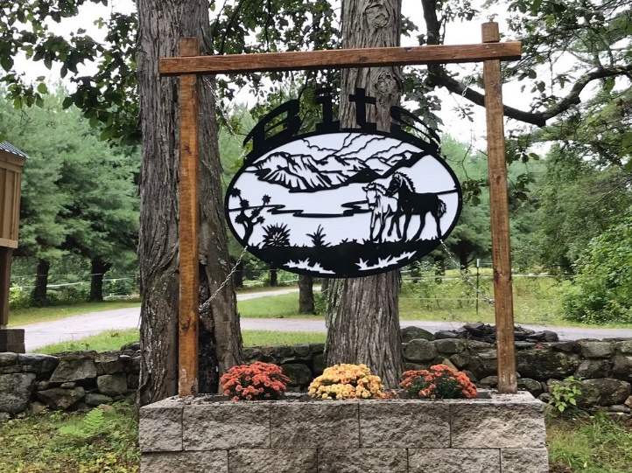
Back In The Saddle Equine Therapy Center (BITS ETC) closed in April and May, along with most of the country. A State of NH PPP loan and generous donations from the public allowed us to feed and care for 10 horses, affording us time to rewrite how therapeutic riding and equine assisted activities could safely continue during a pandemic.

“Courage is being scared to death and saddling up anyway.”
-John Wayne

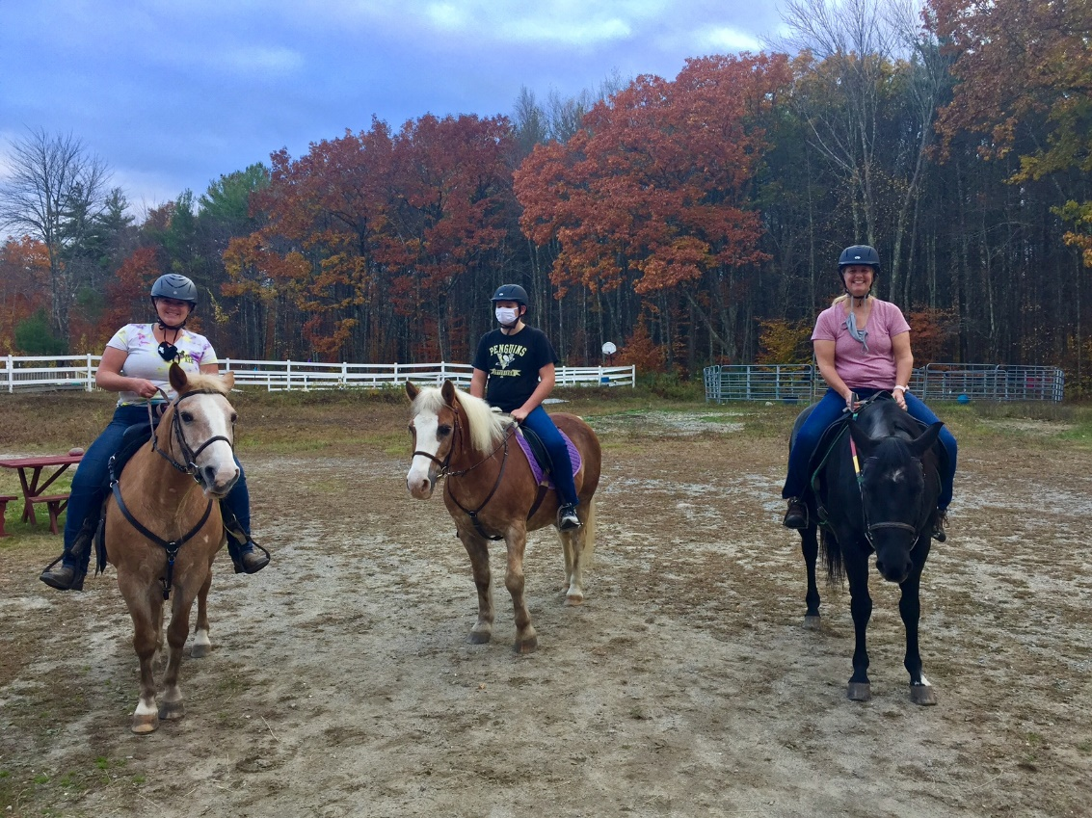
While closed we amended old protocols and wrote new ones: strict mask requirements, social distancing (one horse’s length, or two pony’s length apart), hand washing and sanitizing sprays for a barn, training of intrepid volunteers and staff, temperature checks for instructors and clients, and the list grew. We welcomed back independent riders in June.

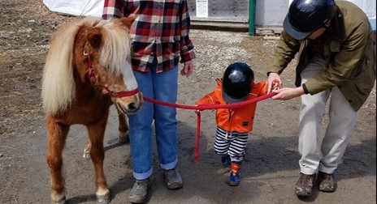

Walking at first, slowly and carefully finding the pace, we stayed open. July brought back those who ride with horse leaders, and then August found us trotting more confidently along, with the youngest supported by their newly trained parents as side-walker supports.

For some families, coming to BITS is the only activity their child has outside of the home.

Smiles undimmed by the masks they wear
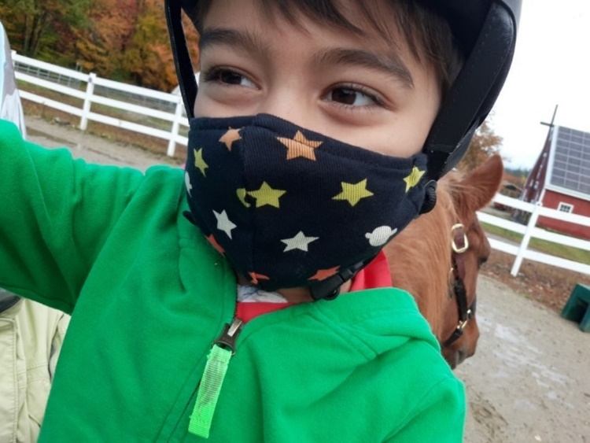

“There’s something about the outside of a horse
that is good for the inside of a man."
-Winston Churchill

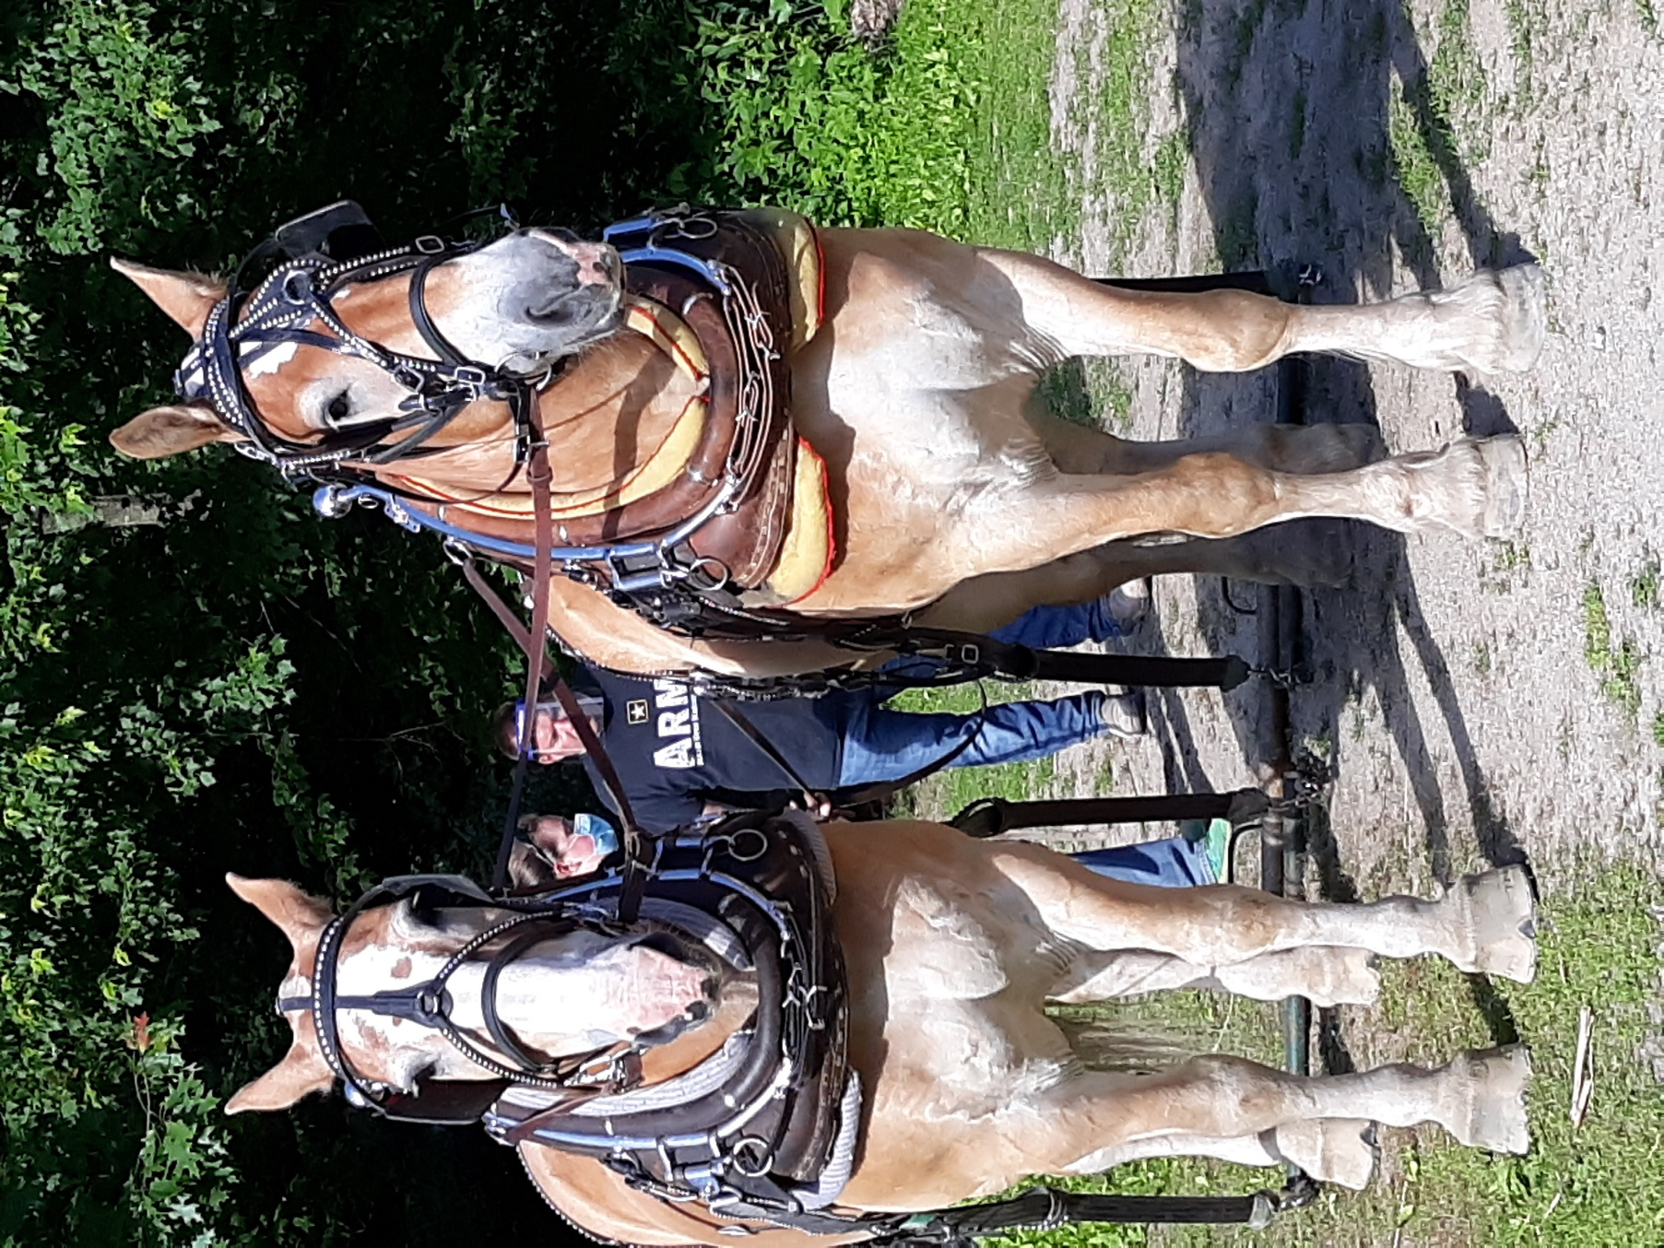

People have been in love with horses forever, it seems:
‘The horse has been with us ever since the Stone Age girl tamed her foal. He has been with us in the fields, on the battlegrounds, transporting us back and forth, helping and supporting us in all phases of our daily lives. He has been so natural for us that we have taken him for granted: He should just be there. Now he is not. He has been left to the domain of leisure time and only accessible to a few. For most of us, he remains something to be seen on television, in sport programs and American Westerns. It is now, when he is gone, that we start to realize that we are missing something more than just a piece of equipment… The horse was more than just a piece of equipment that became ineffective and produced too little. The horse was, as the old man said, a life companion. We all need life companions; nowadays, maybe more than ever. After an abrupt break in the knowledge chain of man and horse, we are now slowly regaining this knowledge.’ Sven Forsling, The Girl and the Horse

More horses died in the Civil War than did men. BITS horses stand ready today to answer the call. A horse carries your heart when it is too heavy to hold. Our horses heal Veterans and Front-Line Workers from their battles fought against depression and floating dread, a result of direct experience with war and the pandemic. Our service has expanded, extending to firefighters, Police, EMTs, and now to Hospital based RNs, RTs, and MDs, all fighting tirelessly and bravely in our communities.

“His hooves pound the beat; your heart sings the song.”
Jerry Schulman
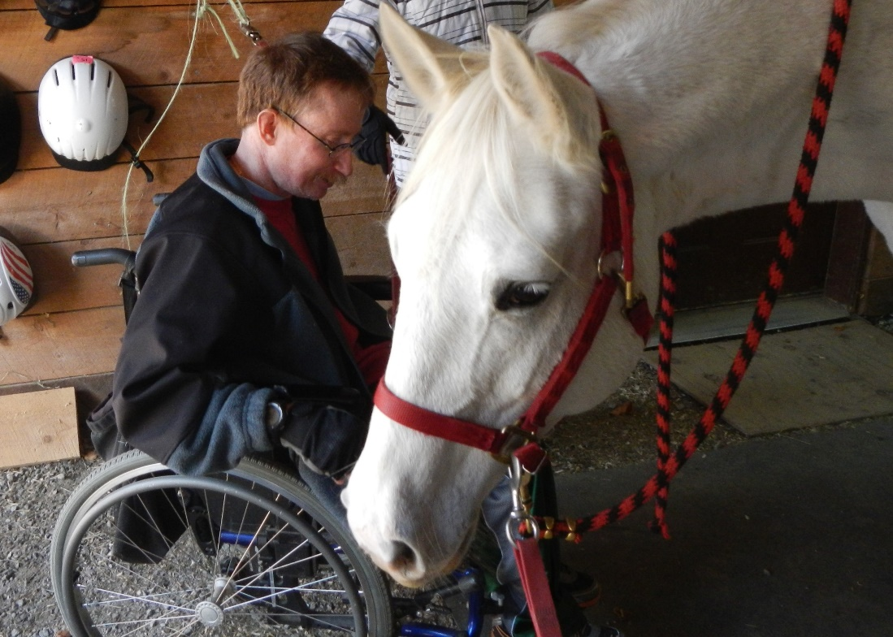

At times it feels like the rain won’t end.
At BITS there’s always a seat
or a saddle for those who need it.
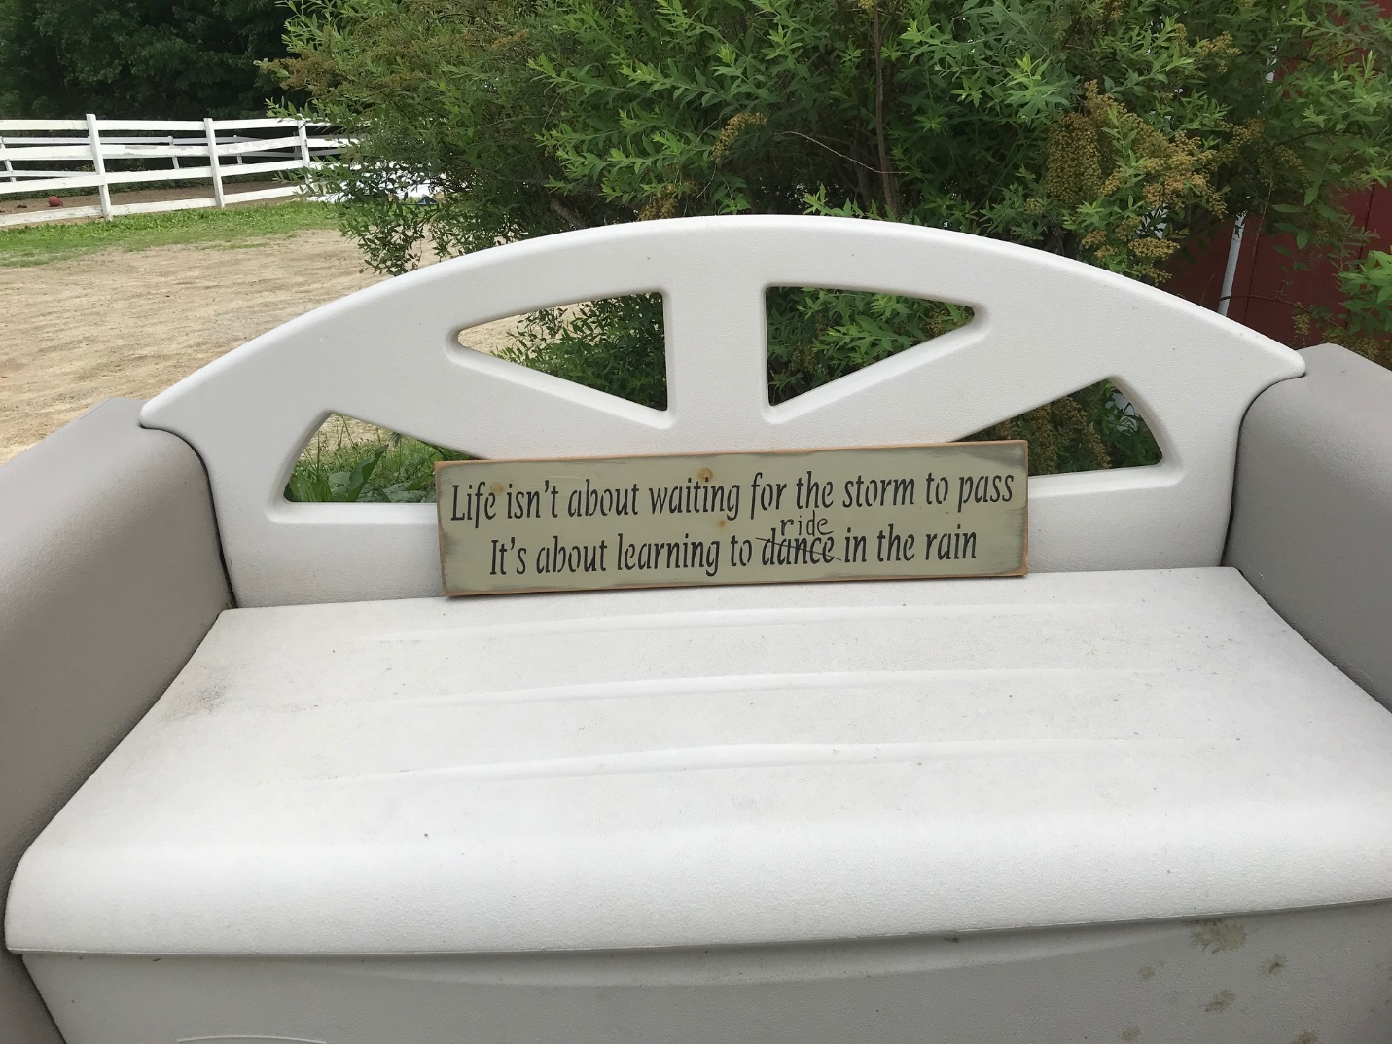

“Yesterday is history, tomorrow is a mystery.
Today is a gift, that’s why it’s called the Present.”
-Alice Morse Earle

Please join me and Invest in our PRESENT
with a gift to BITS ETC on Giving Tuesday

Pauline Meridien, founding Executive Director
November 2020

