Dear Donors
“We make a living by what we get. We make a life by what we give” (Winston Church Hill). I want to thank all of you who have donated generously to the Give safe water to 82 Ugandan orphans project. We can’t give back in kind, but we pray you are rewarded through work and life.
We thank God, who made us through the dry season, although it was tough on our side. When our rain-harvested water was done, we had to travel long distances looking for water. Our eyes are always pointed to heaven that the almighty may bless you entirely, and you bless us through financing this project. We know that when you are fine, we are fine as well.
Field Report
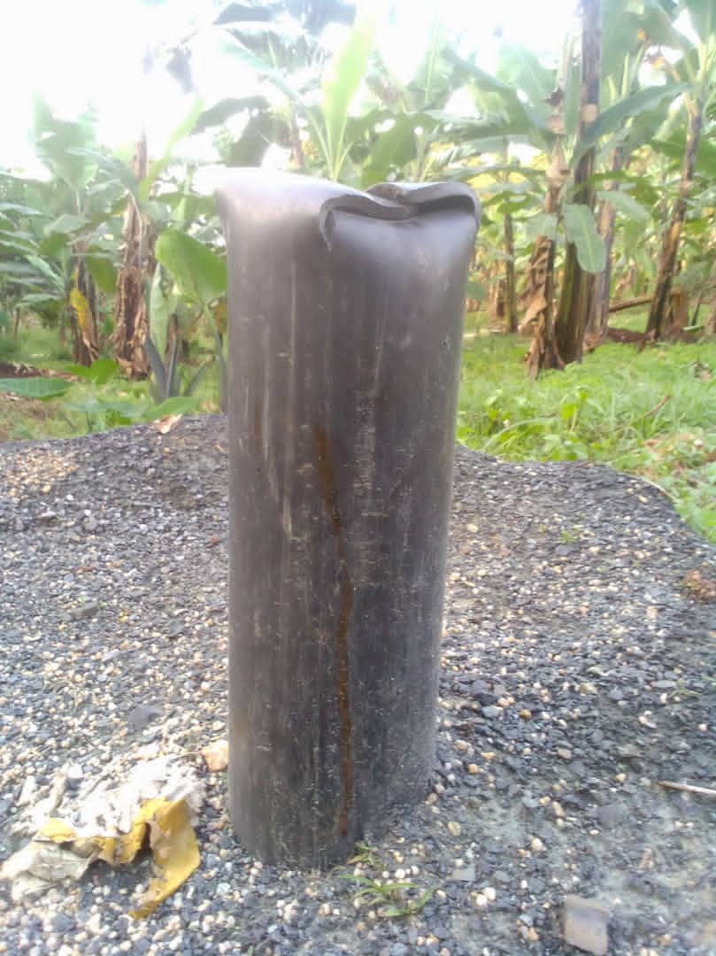
Our project is at a standstill as we continue collecting funds through this fundraising. Hopefully, with available funds, we hope to install a water pump powered by solar power. Step by step, we shall reach there together.
Activities of the project showing cost and status
- Hydro-geological survey $546 Done
- Drilling $6355 Done
- Solar pump installation $5,460 pending
- Tank and its accessories + Pipework $10,920 Pending
One more request, our dear donors, we request you to tell your friends and relatives to tell friends about this project. Amalgamation breaks the born is an African Proverb. We can’t thank you enough for everything you do for others and how you have. You are such amazing people. We are glad to call you our friends. Thank you for contributing to St. Mugagga Boys Home.
Your support is valuable to us. Thank you again! If you have specific questions about our mission, please visit our website https://stmugagga.org/
We sincerely thank you for the support and trust you have shown us in achieving your goals of providing safe, clean water to our communities without access.
Best regards
Bro. Nicholus Nuwagira
St. Mugagga Boys Home

