Dear Donors,
Happy New Year! Thank you for journeying with us in the previous year in collaboration to bring clean water to orphans and vulnerable children under the care of St. Mugagga Boys Home. In the previous year, we were able to drill the well something that was very big on the project. We thank everyone who has contributed to achieve up to that step
This year, our target is to get solar pump installed something that will lead to water production. Some of us we have already contributed but the journey is still big. As the African proverb say, “don’t stop when you’re tired, stop when you are done”, I do call upon you not to get tired.
Our major target is to purchase and install a solar pump which is estimated to cost us $4000. After installment, we can at least start using water a small tank available as our reserve tank as we fundraise for the big tank.
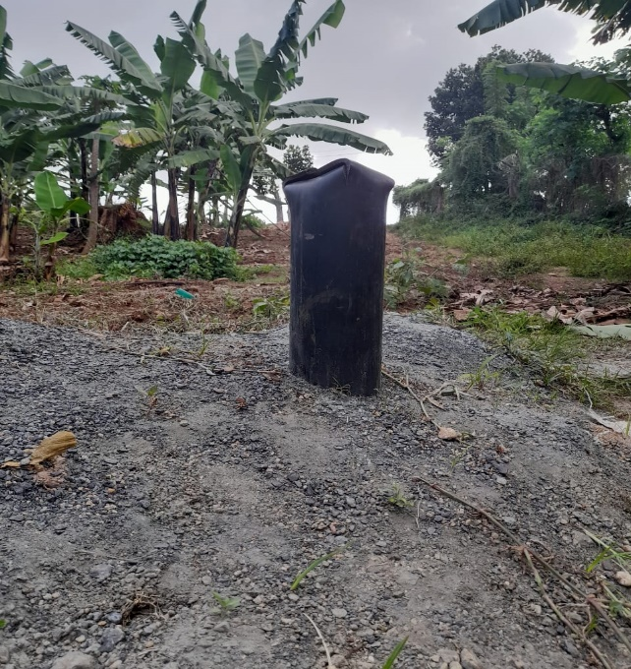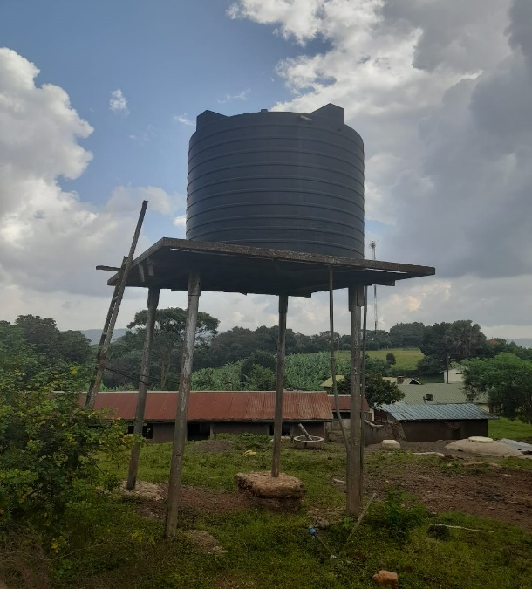
The available small tank that can act as our reserve tank as we fundraise to get finances for a big tank.
The drilled well waiting for the pump to start operating
FEARS
We are in fear of drought that has already shown a sign in some parts of Eastern Uganda where St. Mugagga is located. We therefore pledge for continual help so that we can achieve our goal of helping vulnerable and orphan children residing at St. Mugagga Boys Home get enough and clean water.
We pray for abundance in whatever you are doing and we wish you a prosperous new year 2023
Best Regards
Bro Nicholus Nuwagira. (BSCL)
https://stmugagga.org/
https://www.facebook.com/stmugagga

