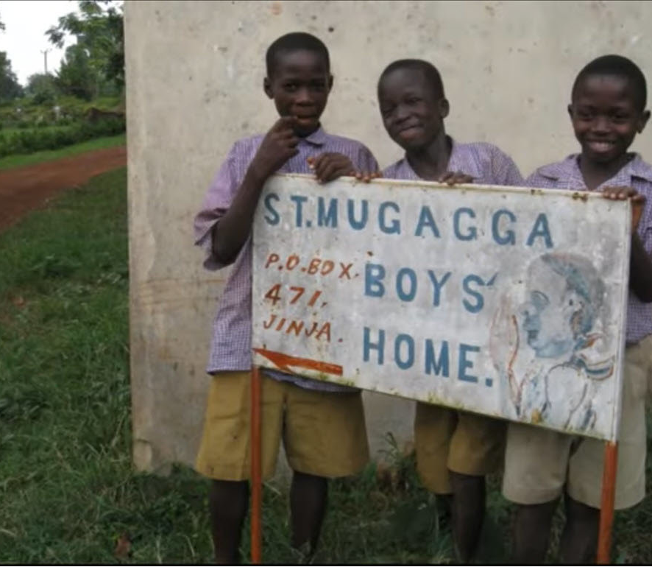
Give safe water to 82 Ugandan orphans

Br Nicholus Nuwagira | 2/26/21 | St Mugagga Boys Home

Dear Friends,
We cannot thank you enough for your generosity to support the St Mugagga Boys Home Clean Water and Sanitation Project. Through your efforts, we were able to raise $5,879 out of the $22,000 goal. Thank you very much for your generosity towards the vulnerable and orphan children who directly benefit from this project.
We have made progress putting your gifts to work and make good progress already on this project. We just completed the geological survey to help us know the availability of safe underground water. The survey discovered we have safe water 80 Meters below the surface which is excellent news.
See the attached Geological Survey with the research and pictures of the proposed well site.
Our next step is to start drilling and putting the pump installation. We hope to begin this work very soon. Now our need is greatest during the dry season when we have the most water scarcity. The drilling company cannot start work to dig the well until their labor gets funded, and we are eager to begin this next step soon.
The remaining steps remaining for the water project and their costs are below:
Activity steps | Cost | Status
Hydro-geological survey | $546 | Done
Drilling | $7,644 | Pending
Solar pump installation | $5,460 | pending
Tank and its accessories + Pipework | $10,920 | Pending
Thanks to your support, we feel hopeful for the progress so far. We can and will bring clean, safe water to these children.
The power of a seed is not in its size but the quality of its product. May the investment you have made yield multiple blessings for the children in our care. Thank you again for your support.

