Safe Spaces, Healing Journeys

Thanks to the continued commitment of our donors and partners, Remar Casa Hogar Occidente remains steadfast in restoring the rights and dignity of 70 girls who are survivors of various forms of abuse. This quarter has been a period of continuity and growth, strengthening existing programs while expanding opportunities that support the girls’ holistic development.
Every step we take is focused on healing, protection, and empowering each girl to grow in a safe, nurturing, and hopeful environment.
Continuity and growth of formative workshops
During this reporting period, we continued and strengthened key workshops that have shown a positive impact on the emotional, creative, and practical development of the girls:
- Jewelry-Making Workshop:
This workshop continues to grow steadily, allowing the girls to develop fine motor skills, creativity, and concentration. It also fosters self-esteem, patience, and consistency, while introducing productive skills that may support future independence.
- Community Garden (Vegetable Garden):
The garden remains a central educational and therapeutic space. This quarter, the girls learned how to produce compost, gaining knowledge about organic recycling and environmental care. The compost is now used to nourish the garden, reinforcing sustainability and responsibility.
- Connection with nature and creation of a safe bond:
We continue encouraging meaningful interaction with nature as a path to emotional healing. The garden and green areas have become spaces of protection and recreation, where the girls build a sense of safety, calm, and trust—essential elements for emotional recovery.
Early childhood stimulation and inclusion of younger girls
As part of our ongoing growth, younger girls in the home were incorporated into early stimulation activities, designed specifically for their developmental stage. These activities strengthen sensory, motor, and emotional development, promoting care, affection, and learning from early childhood.
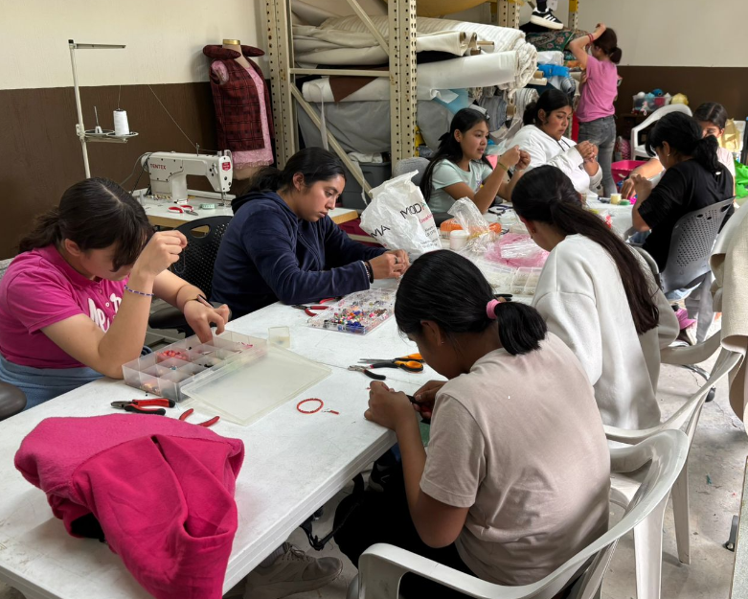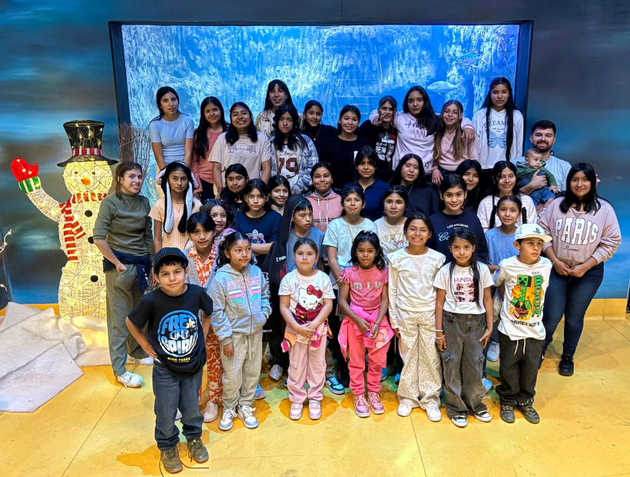

Recreational activities and community celebrations
Thanks to the invitations and collaboration of supportive community members, several recreational activities were carried out this quarter. During the holiday season, the girls participated in festive celebrations that brought joy, connection, and hope, reminding them that they are supported and valued by a caring community.

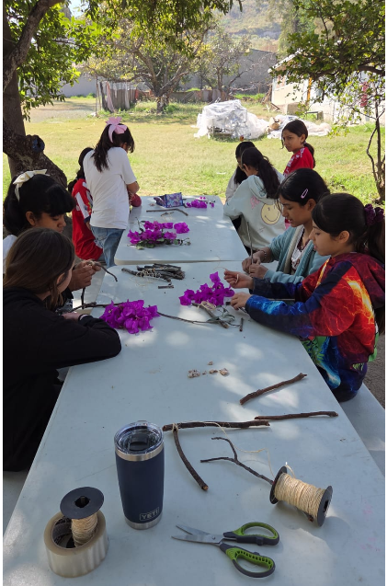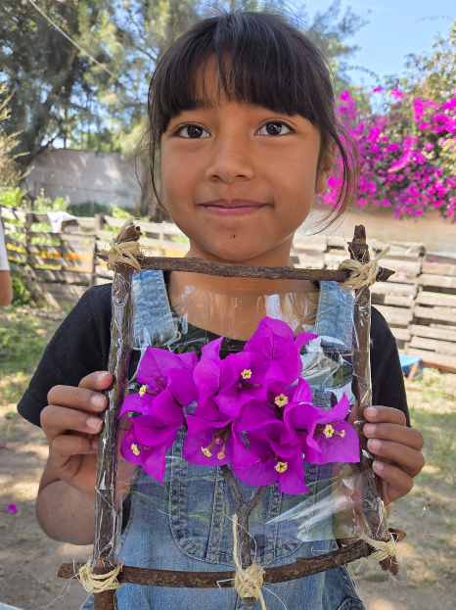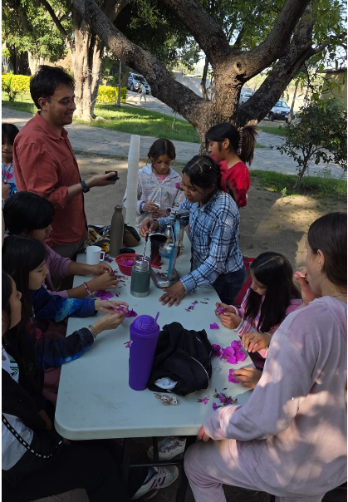

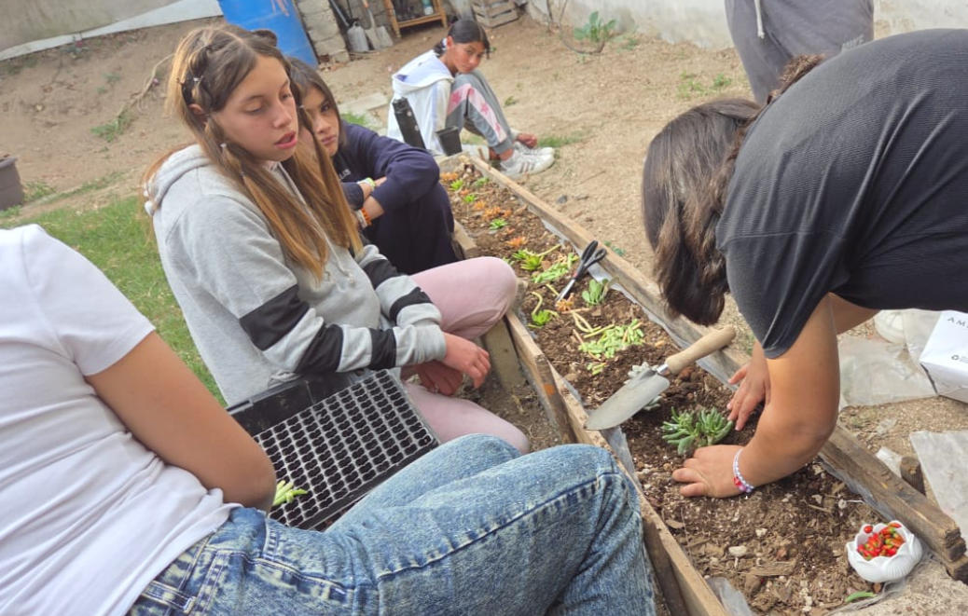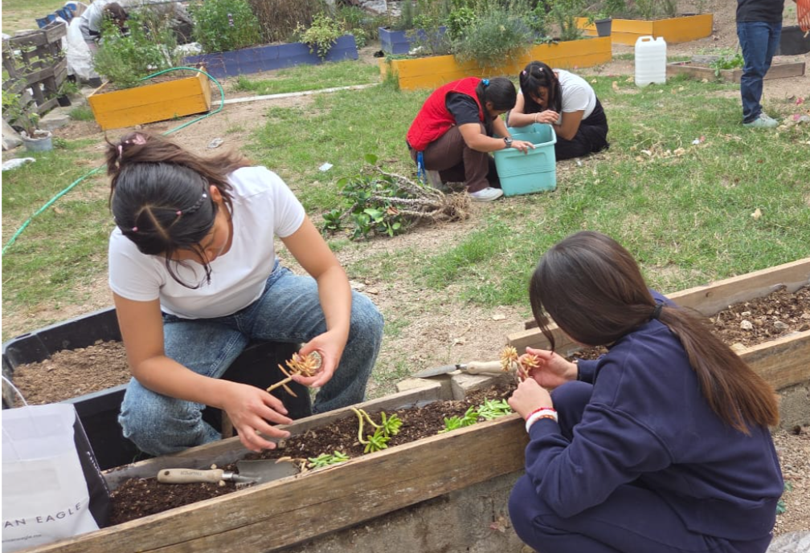
Moving forward—together
Every workshop that continues, every new skill learned, and every moment of joy restored is made possible by the generosity of people like you. Your support does more than meet basic needs—it helps create spaces for healing, learning, and protection.

At Remar Casa Hogar Occidente, we reaffirm our commitment to continued growth, strengthening our workshops, and walking alongside each girl as she rebuilds her life.
Thank you for believing in our mission.
Thank you for extending your hand.
Thank you for being part of this transformation.

