Rebuilding Dreams

As part of our ongoing efforts within the rights restoration program for 70 girls who have been victims of abuse, we are pleased to share with you the recent progress we have made thanks to the continued commitment of our donors and partners.
Our focus remains on strengthening the comprehensive development of each girl by providing them with a safe and loving environment where they can build a resilient life project, with clear goals and the skills needed to pursue a future full of real opportunities.

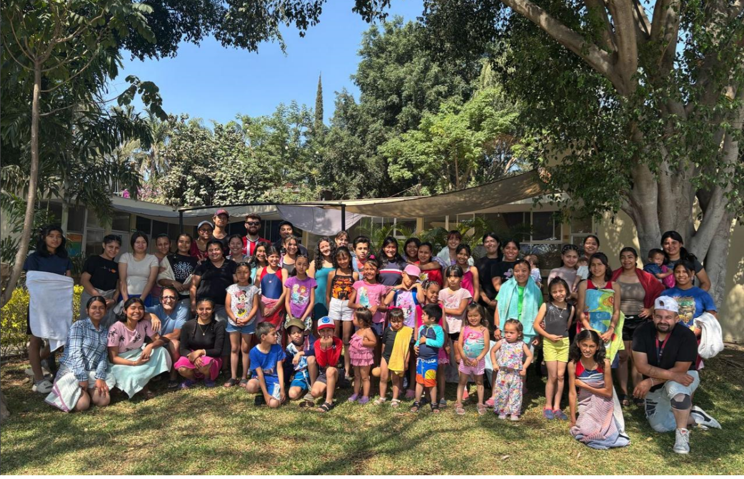

New Actions and Progress
1. Academic Support and Formal Education
Over the past few months, we have enhanced our academic support efforts. We are currently in the process of enrolling the girls in vocational beauty courses.
2. Critical Reading and Emotional Expression Workshop
Our reading workshop has evolved to include oral and written expression activities, allowing the girls not only to improve their comprehension skills but also to strengthen their emotional intelligence and ability to communicate assertively.

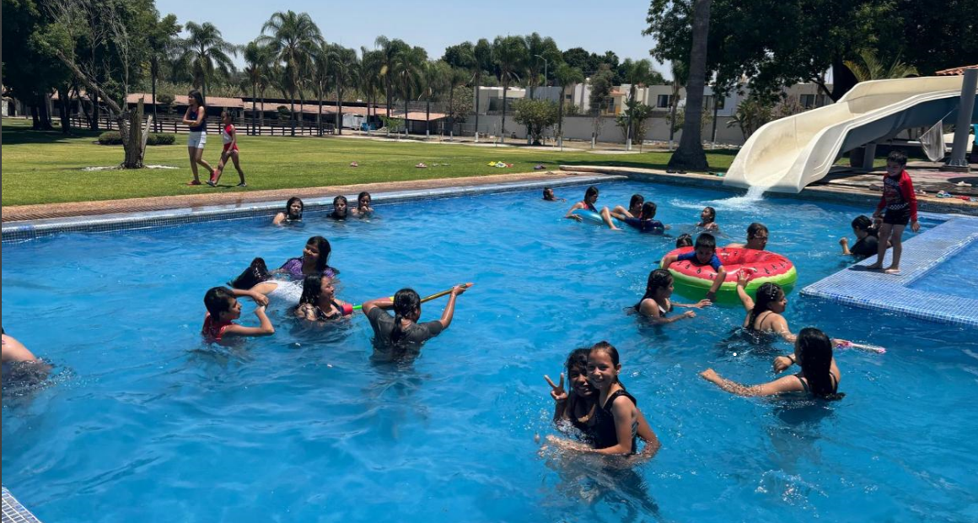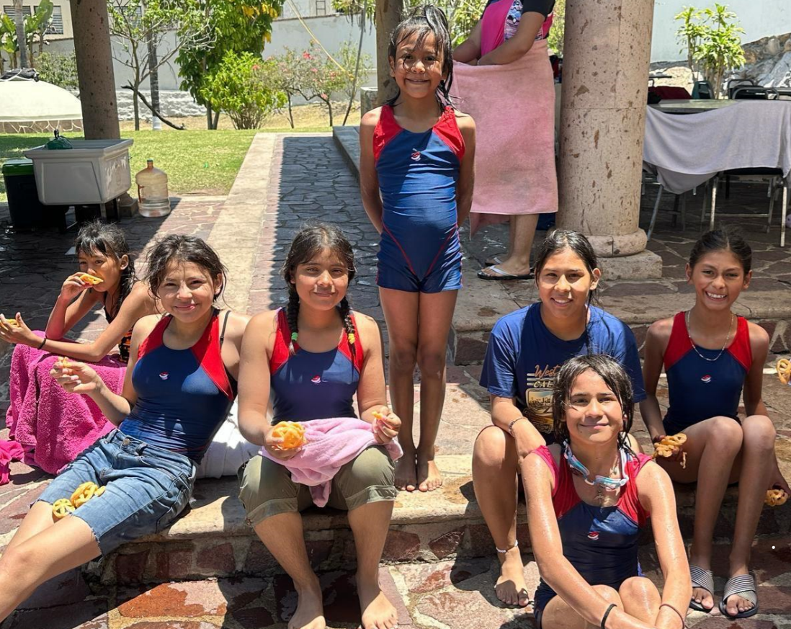
3. Recreational and Holiday Activities
During the Easter holidays and recent long weekends, we organized recreational outings to natural and cultural spaces. These experiences have contributed to the girls' emotional well-being and have helped strengthen their sense of belonging, self-esteem, and positive outlook on their surroundings.

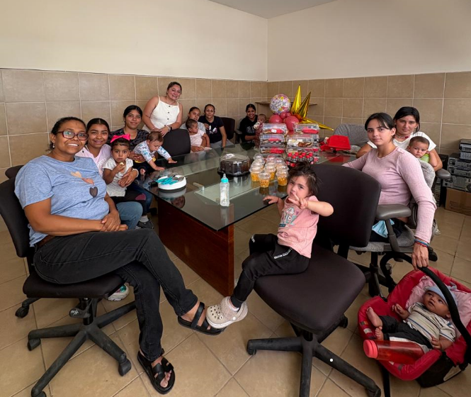
4. Psychological Support and Resilience Building
We continue to offer regular emotional support sessions, focusing on topics such as resilience, self-esteem, emotional regulation, and the development of secure bonds. This approach has been key in helping the girls heal their emotional wounds and find meaning in the new stages of their lives.

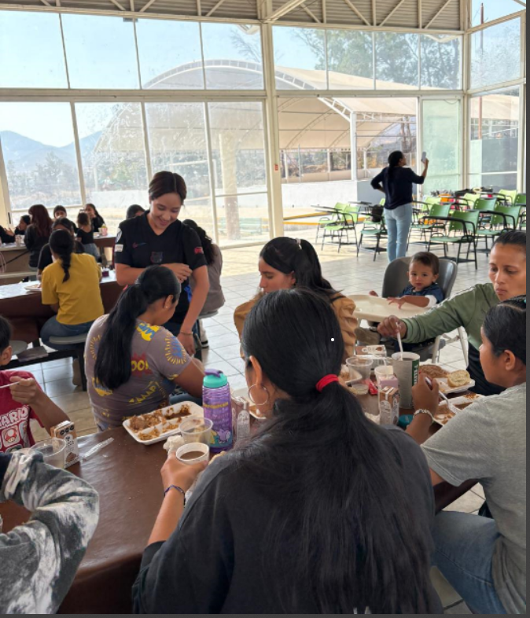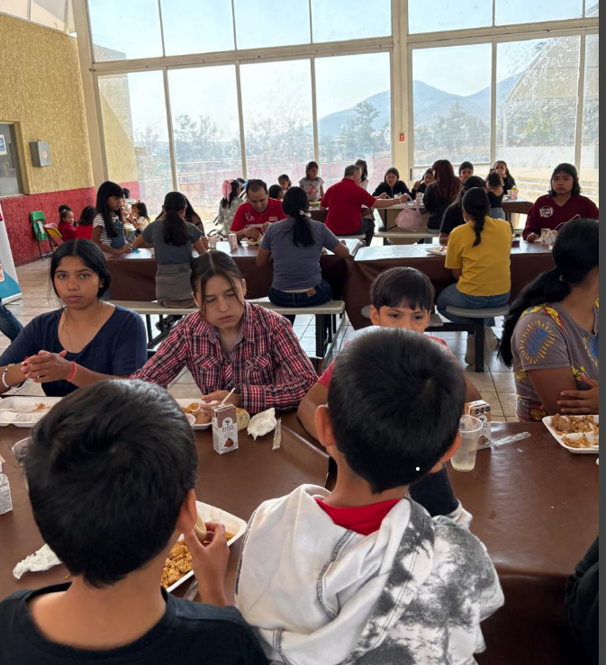

5. Special Celebrations: Children's Day and Mother's Day
This quarter, we placed special emphasis on creating joyful and celebratory spaces. We organized a fun-filled event for Children's Day, including games, activities, gifts, and moments of laughter and happiness.
We also held an emotional celebration for Mother's Day, where the girls actively participated in creating symbolic gifts to honor the maternal figures in their lives—such as educators and caregivers—thus fostering gratitude, recognition, and affection.
This progress has been made possible thanks to the generous support of our donors. Your contribution represents not only financial backing but also a gesture of solidarity and hope for each of the girls in this program.
We remain committed to working with dedication and responsibility so that every peso donated transforms into opportunities, learning, joyful moments, and new beginnings.
We deeply appreciate your trust and invite you to continue being part of this transformative mission.

