LISTEN, LEARN AND EVOLVE
CONSCIOUS EDUCATION

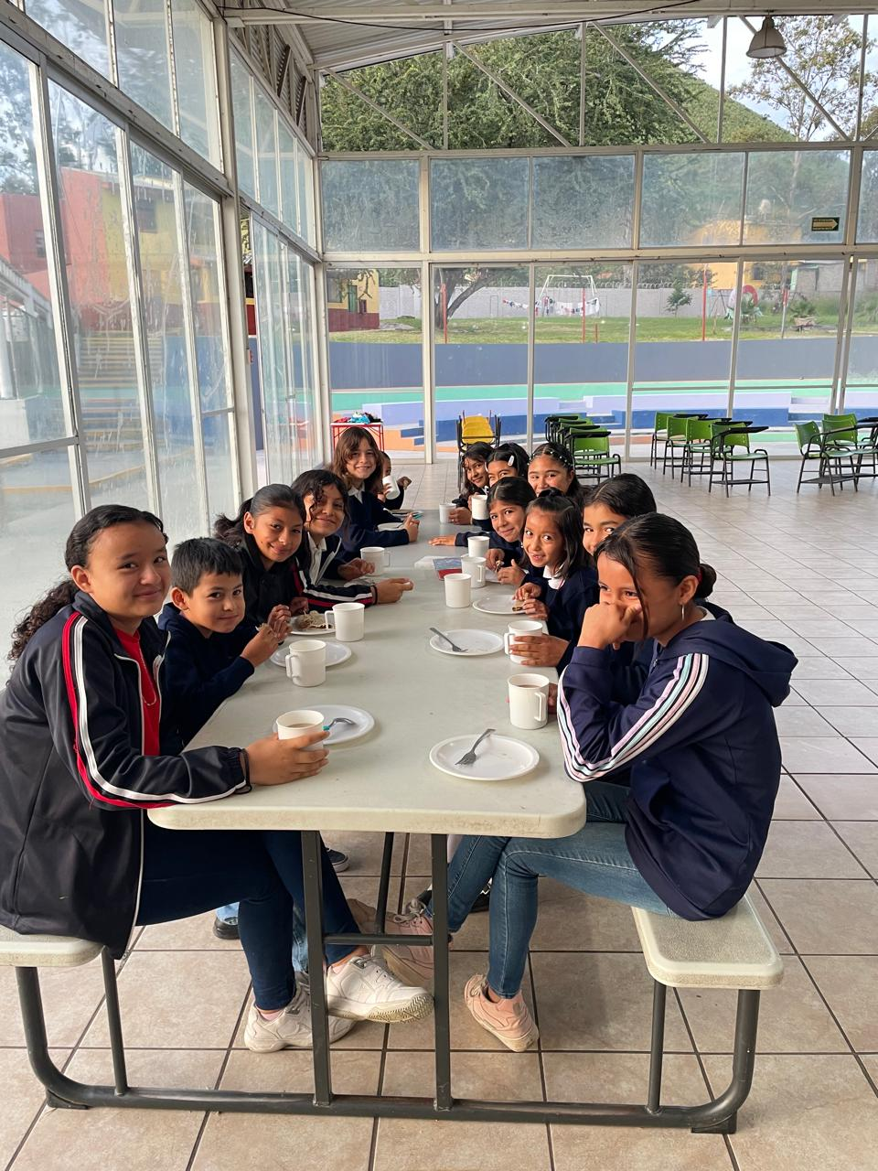

Within the Care and Education program for 70 vulnerable girls in Mexico, we are committed to the comprehensive development of each of our minors, which is why we reinforce proactive and empathetic participation at each of their stages.

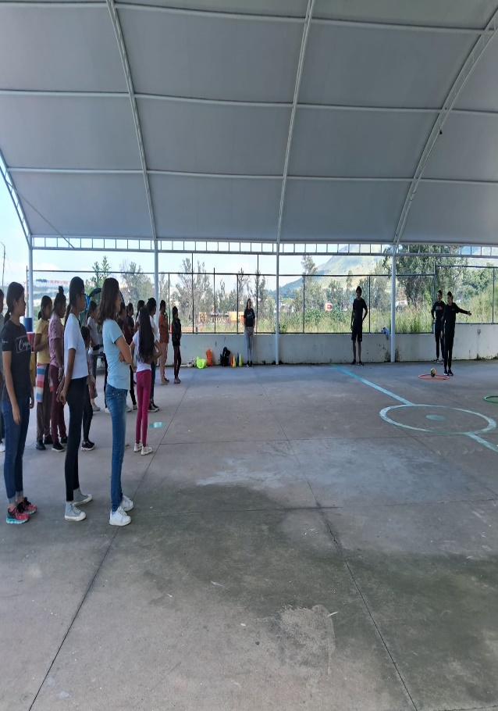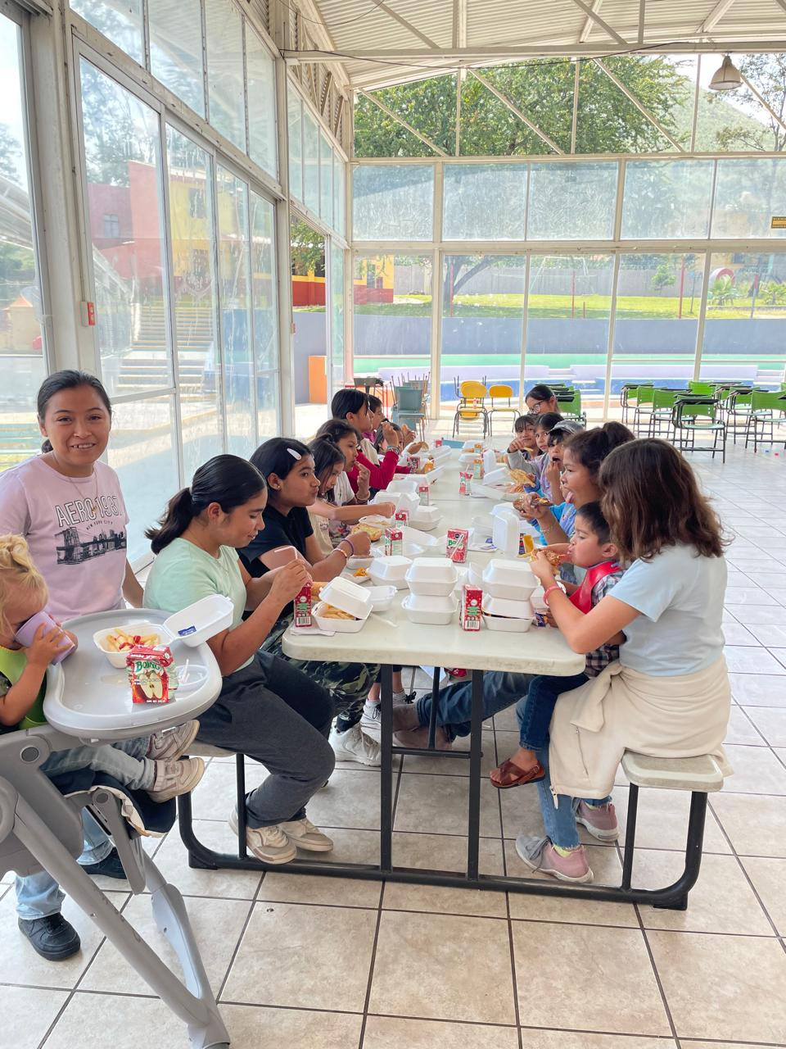

Not only do we work to provide them with decent and warm spaces, food security, recreation and leisure, but we also implement workshops on self-discovery, reflection, thought, feelings and emotions, generating permanent changes for a more resilient future.

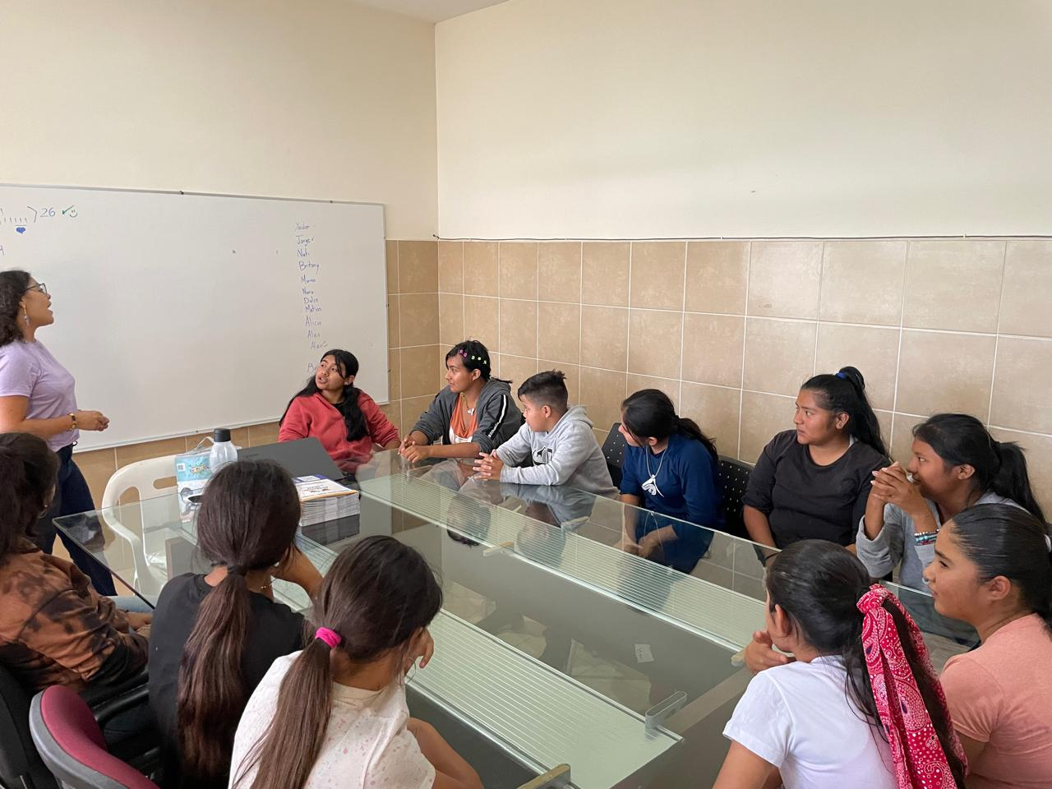

Through the conscious education program we show our girls, adolescents and young people alternatives to difficult situations by encouraging critical thinking and informed decision-making, promoting skills to face challenges, without causing stress, anxiety or depression, empowering them and connecting them with their environment, keeping them away from crime or prostitution.

We thank everyone who made this transformative project possible.

