Healing Hands, Creating Hands
By Nathali Pérez Córdoba | Operations Director
Thanks to the ongoing commitment of our donors and partners, at Remar Casa Hogar we continue advancing in the comprehensive restoration of rights for 70 girls who have been victims of various forms of abuse. Every step we take is an opportunity to heal, to learn, and to build a life filled with dignity and real possibilities.
Our approach remains focused on holistic development: we care not only for their formal education and physical well-being, but also for their emotional world and the practical skills that will allow our girls to build their own paths with confidence, resilience, and joy.

New Workshops: Creativity, Teamwork, and Connection to Nature
In recent months, we’ve enthusiastically launched new hands-on and therapeutic workshops that not only teach useful skills but also provide spaces for self-expression, self-care, and emotional growth:
- Artistic Plaster Workshop
The girls participate in creative plaster activities, where they learn to mold, decorate, and express themselves artistically. This workshop helps them develop manual skills while also strengthening their self-esteem and focus.
- Garden Creation and Maintenance
Connecting with nature is a powerful tool for emotional healing. That’s why we’re cultivating our own garden. The girls are learning how to care for plants, work as a team, and take on responsibility — all while experiencing the joy of seeing something they planted grow with their own hands.

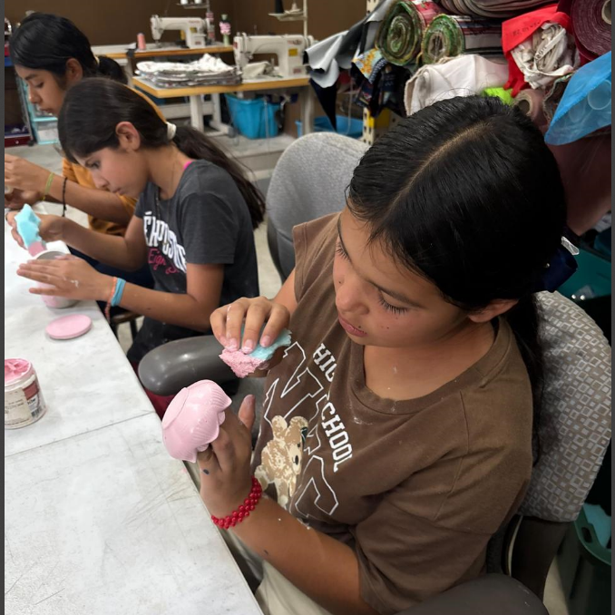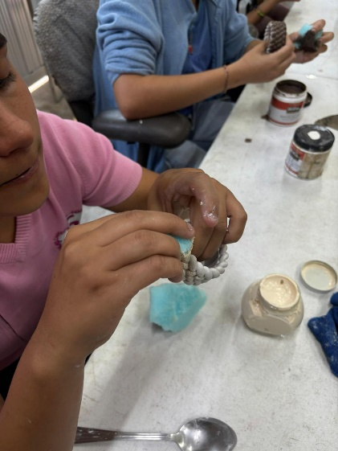

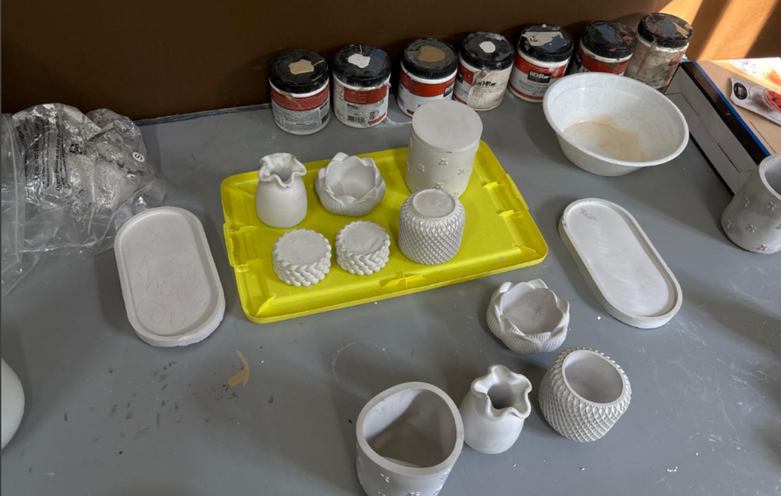
Continuing to Strengthen Emotional Well-being
Psychological support remains a fundamental pillar of our work. We conduct individual and group sessions focused on resilience, emotional regulation, self-esteem, and building healthy emotional bonds. These safe spaces help the girls understand their emotions, heal deep wounds, and develop life skills.
We also continue to promote our critical reading and emotional expression sessions, where the girls explore stories that inspire them and reflect on their own experiences — helping them strengthen both communication and critical thinking.

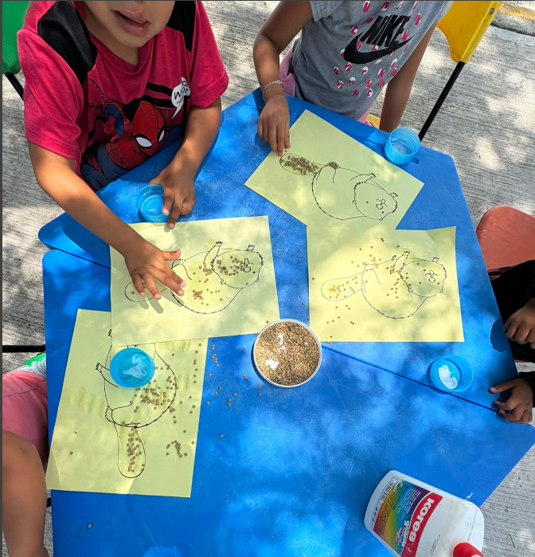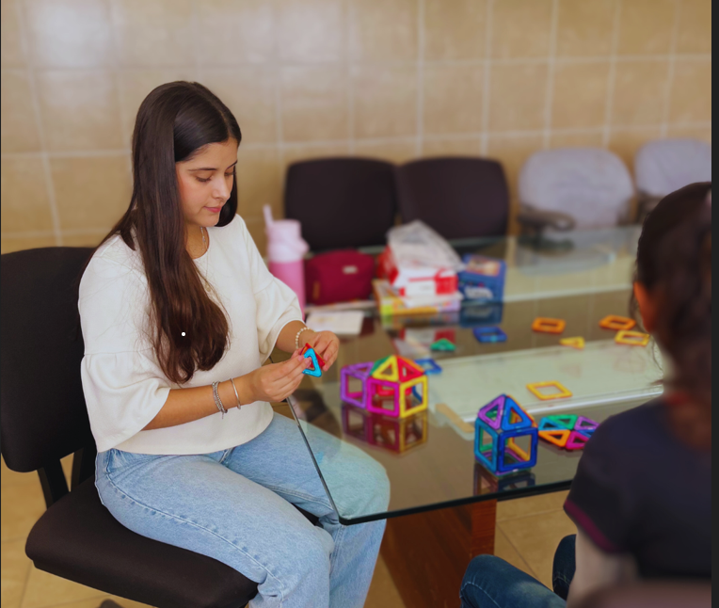

Education and Recreation: Building the Present, Dreaming the Future
In terms of education, we’re working hard to expand their academic opportunities. Several girls are currently enrolling in vocational training programs (such as beauty courses), which open new doors for their future.
We also prioritize recreational and emotionally enriching activities. On weekends and during special seasons, we organize cultural outings, nature trips, and celebrations that promote joy, a sense of belonging, and the enjoyment of childhood.

Thank You for Being Part of This Transformation
Every milestone we reach is possible thanks to the solidarity of people like you. Your donations not only help us meet basic needs — they become tools for healing, learning, and empowerment.
At Remar Casa Hogar, we remain deeply committed to every girl, every story, and every dream waiting to be rebuilt.
Thank you for continuing to believe in them. Thank you for being part of this change.
