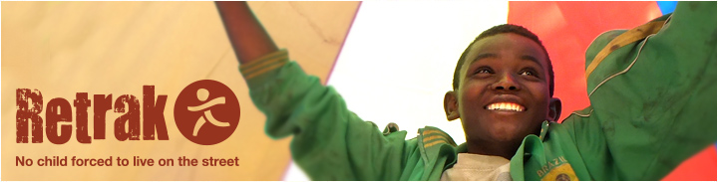
Reaching out to Street Children in Ethiopia

About Us:
Retrak has been working with street children for 20 years. Our vision is a world where no child is forced to live on the street. We work to transform highly vulnerable children’s lives; preserve families; empower communities and give them a platform for their voices to be heard. Today Retrak provides support to children and families in Uganda, Ethiopia, Kenya, Zimbabwe, Democratic Republic of Congo, Malawi and Brazil. In 2015, Retrak worked with over 24,000 beneficiaries in Africa, providing children living on the streets with food, temporary shelter & accommodation, catch-up education, medicines and medical treatment, vocational training and counselling in our transition centers. In addition, Retrak works to deinstitutionalize children from government orphanages and remand homes.
Retrak works with families and children to reintegrate children back into safe family care. This involves working with and following-up families to build their capacity to protect and provide for their children through parenting skills training, income generation activities and community work with vulnerable families to prevent children coming to the streets. Retrak also seeks to help build the capacity of local organizations, working in tandem with local partners on topics of Family Reintegration and Monitoring and Evaluation. Retrak can be seen to work beyond the national level, sharing valuable lessons learnt internationally through its dissemination of research findings through networks such as the Better Care Network, Child Protection in Crisis working group, Family for every child and the Consortium for Street Children. As a leading figure in global advocacy on Family Reintegration, 2015 saw Retrak become a key member of the Global Agency on Family Reintegration. This relationship has led to the agency’s use of Retrak’s Standard Operating Procedures to create global guidelines on reintegration.
Project Title: Reaching out to Street Children in Ethiopia
Project Summary:
Across Ethiopia, Retrak will identify over 800 homeless children sleeping on the streets, listen to their needs and problems, and offer them support at our transition centers. Children will visit our transition center and access safe overnight shelter, medicine, food and be protected from abuse. Children will have access to education and the counselling needed to overcome past trauma suffered whilst on the street. Ultimately, Retrak’s aim is to reunify these children in a safe family environment and give them a better alternative to life on the street.

What’s the Problem?
Increasing poverty, limited resources, natural disasters and HIV are all factors which affect family breakdown and drive children to the streets. Street children are amongst the most vulnerable children in the world. They have often suffered abuse and are likely to suffer further trauma, especially as they lack many of the coping skills necessary to establish a safe and secure life. Increased exposure to disease and malnourishment can impact their development and ability to learn. Life on the streets often denies access to education and consequently the skills and experience to earn a sustainable and formal income.

In the capital Addis Ababa, this problem is severe with an estimated 11,000 children living unaccompanied on the streets. Retrak is one of only eight NGOs/CBOs providing support to full-time street children in the capital city. The total capacity of these agencies is currently just over 1,000 children per year. This represents less than 10% of the total figure of 11,000 street children identified in the UNICEF headcount. Across the whole of Ethiopia, Retrak is one of the few agencies that is working exclusively with full time street children.

Project Goal:

Our goal is to reduce the number of children on the streets in Ethiopia, helping them make the transition from street life back to their home families and communities. In doing this Retrak helps protect vulnerable street children from sexual abuse, violence, gang crime, exposure to drugs and susceptibility to disease. Our program seeks to change attitudes and behaviors towards street children, reduce stigma, and to respond to and prevent further abuse and exploitation of children in target communities.
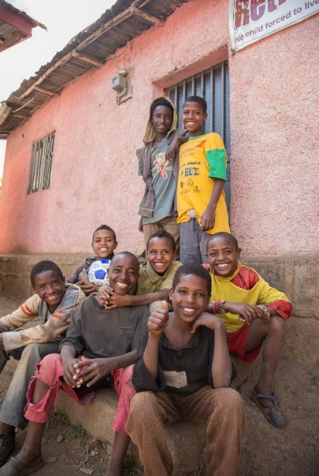
What will your support deliver?
With your support we will drastically transform the lives of these children, providing a safe and hygienic space to sleep and providing the children with the advice and support they need to begin to move away from a life on the streets. This includes:

Outreach
- Over 800 children will be visited by our outreach team, who invite them to open feedings, sport activities and open clinics in order to build trusting relationships.

Transition center Services
- Across our transition centers, 620 children will access safe shelter to protect them from harm and have the opportunity to receive medical attention to ensure medical needs are tested, addressed and treated.
- Children will receive catch-up education (which is taught in line with national curriculum). This allows them to catch-up on learning that they have missed and supports reintegration into formal schooling once they are back with their families.
“I was placed in a loving and caring family by Retrak social workers” – Brian, aged 14
- Children will also receive counselling and life skills sessions in order to overcome the trauma of street life and develop trust with their peers and adults. Life skills sessions will teach the children about healthy decision-making, drug and disease awareness, issues regarding gender and discrimination, and values in general.

Skills Training
- Business Skills. Retrak will also offer young people who are unable to go back to formal schooling, business skills for them to learn a skill or a trade and start up a small business that they would like to run. The small business startup includes a full week of training provided by one of our social workers during which time the children design and cost a business plan with a budget. They then receive an Income Generating Activity (IGA) grant to start up the business. These children usually return to their communities in rural areas (but not necessarily to their family) and are financially independent. If they do return to their family then they usually provide some economic support to their family. This is particularly popular with the older boys who don’t want to return to their family but do want to return to their home area.
- Vocational Training. Retrak will also facilitate formal vocational training to allow older children to gain skills which can lead them to formal employment and independent living in the community. Independent living mentors are recruited from the local community to help the young people with this transition into independent living.

Reintegration
The ultimate goal of Retrak is to reintegrate the children into a family unit either in their own family or a foster family.
- Over a 12 month period, 310 children will be supported into a family placement with over 380 caregivers supported during the placement.
- These caregivers are supported by parenting skills training and psycho-social counselling to ensure that the child receives the best care possible when back at home.
- Selected families are provided with an income generating assistance grant to boost family income.
- Retrak follows-up these families for a period of two years to ensure that children stay within families.

Your donation to this project could help drastically improve the lives of the street children that will be reached by this project. We are grateful for any support that you can give us.

This is dependent on the needs of the family.

