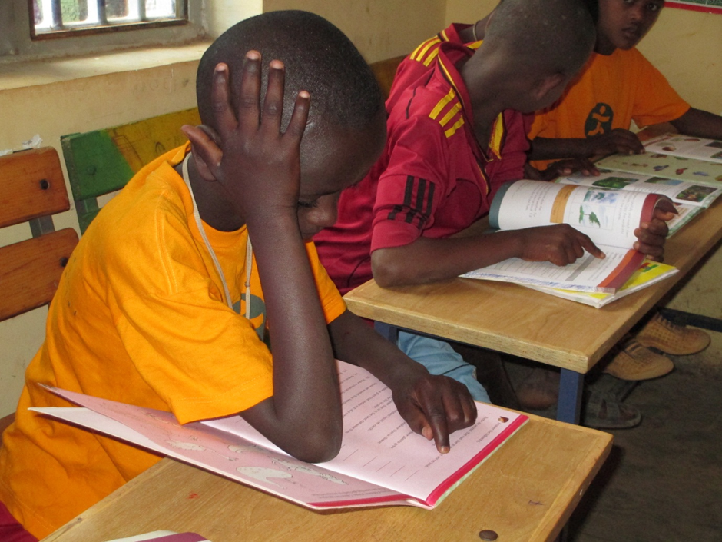
Loma in a catch-up education class at the Lighthouse

