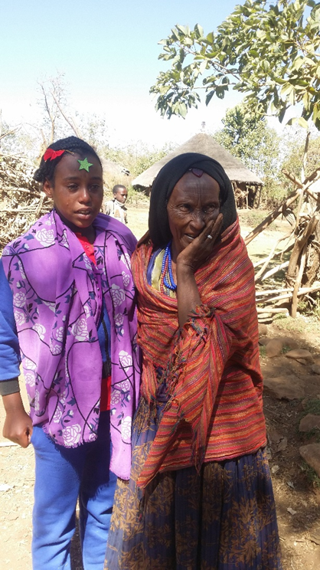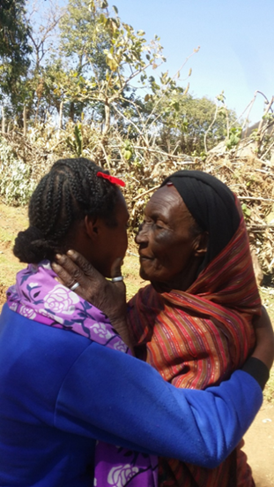

**Fozia reunited with her grandmother**

**Overjoyed to have Fozia back home!**