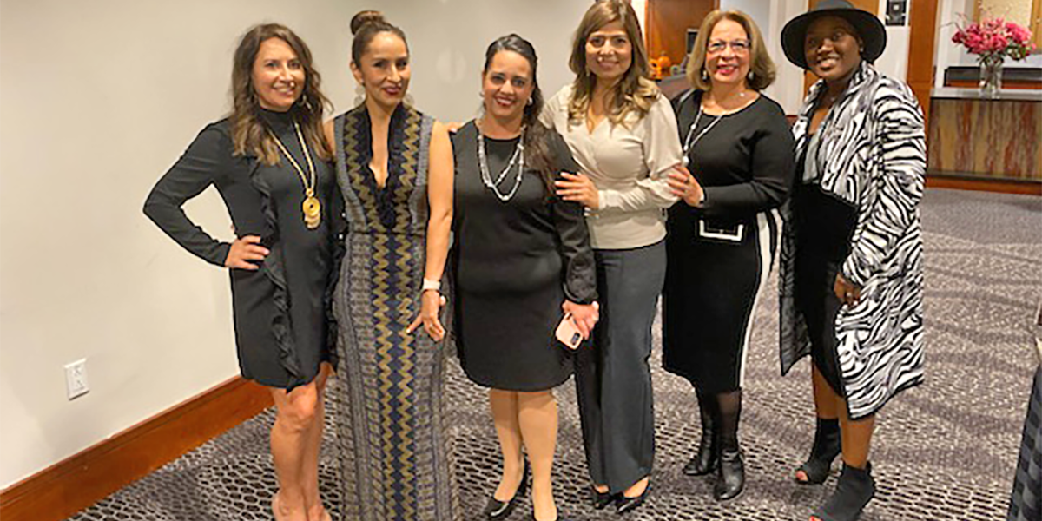
Contact: Nancy Baker, Communications Director, 540-533-7490, nbaker@inmed.org

Another Outstanding Report Card for Healthy Families Loudoun
STERLING, VA (February 22, 2022): INMED USA’s Healthy Families Loudoun continues to be a top Healthy Families Virginia (HFV) programs to prevent child abuse and neglect, according to a recent quality assurance assessment.
Healthy Families Loudoun is a three-year child abuse and neglect prevention program that helps at-risk, first-time parents build a foundation for self-reliant families and raise children who enter school ready to learn and succeed. The program includes intensive case management, regular home visits, parent education classes and support groups, access to critical resources and mentorship. INMED USA has facilitated the program for 24 years, improving the lives of thousands of families throughout Loudoun County.
The evaluation, conducted by a representative of HFV and Prevent Child Abuse Virginia, examined family files, supervision documentation, training records and outcomes for healthy births, well-baby care and parenting skills development. In addition, group discussions were conducted with home visitors, assessment workers, program management, and a host agency representative, as well as a home visit of a participating family.
“The INMED Healthy Families Loudoun team is a group of highly professional, competent and committed individuals, each determined to give their all in serving families and maintaining a culture of excellence,” said Hope Schutte, who conducted the independent assessment.
The team and participating families achieved a 100% success rate for babies having medical providers and up-to-date immunizations and a 90% success rate for well-baby visits. The HFL team also scored high marks for expanding access to vital resources for struggling families.
Thanks to INMED US Programs Director Jennifer Lassiter Smith’s outstanding program development and community collaboration skills, “the resources available to HFL parents and community members at large have also grown significantly since last year—from diapers and non-perishable food distributions, to personal hygiene items, baby strollers, perishable as well as non-perishable food distributions, free refurbished and new computers, and even rental assistance for ‘non-traditional’ renters, such as families with no signed lease,” noted Schutte.
Through a partnership with Inova Cares Clinic for Women, at-risk pregnant women and new mothers are referred to Healthy Families Loudoun for free critical support to ensure healthy birth outcomes and prepare the way for optimal child development. The HFL team also supplies clinic staff with diaper bags to distribute to families willing to be referred to HFL—with a 94% acceptance rate.
Yeny Ventura is one of those women referred by the clinic to the Healthy Families Loudoun program. A single mom of newborn twin boys, she was overwhelmed, but INMED Family Support Specialist Yesenia Abrigo was by Ventura’s side to help her build parenting skills and confidence.
“[Yesenia] showed me how to believe in myself as a single mother and to ask for assistance. She taught me how to spend quality time with my children and has given me the tools and ideas to continue working on their development,” Ventura said. “She also gave me an opportunity to learn about finances. I am very grateful to be part of this great program.”
INMED USA also has expanded its Parent Education Group program at its Family and Youth Opportunity Center in Sterling--facilitated by Healthy Families Loudoun and free for all Loudoun families. The program helps parents practice good physical, mental and emotional health via workshops on COVID prevention and treatment, weekly Zumba classes and wellness and support groups for mothers. Last year, INMED USA introduced a basic computer skills class to help parents access community resources, including their children’s teachers and online
“I am extremely proud of our Healthy Families Loudoun team and the hard work of the program participants. This has been a flagship program for INMED in Loudoun for decades,” said Dr. Linda Pfeiffer, Founder and CEO of INMED Partnerships for Children, the parent organization of INMED USA. “Complying with the national and state-wide program standards is highly complex—with intensive case management, rigorous record-keeping, tracking of processes and outcomes, extensive training requirements and regular reporting and accreditation.”
For more information about Healthy Families Loudoun and other INMED USA programs, visit https://inmedusa.org.
For more information about Healthy Families Virginia, visit https://www.familiesforwardva.org/.
Photo caption: Pictured left to right: HFL Program Manager Gester Pino, Tania Frias (Family Support Specialist), Paula Callaghan (Community Educator), Yesenia Abrigo (HFL Supervisor), Nancy Ordonez (Family Support Specialist) and Tanisha Cox (Program Development Coordinator).
-30-

