HOPE FOR TOMORROW CHILDREN AND WOMEN INITIATIVE (HTCWI)
……………………………………Committed to helping the helpless CAC/IT/NO38499

(logo)

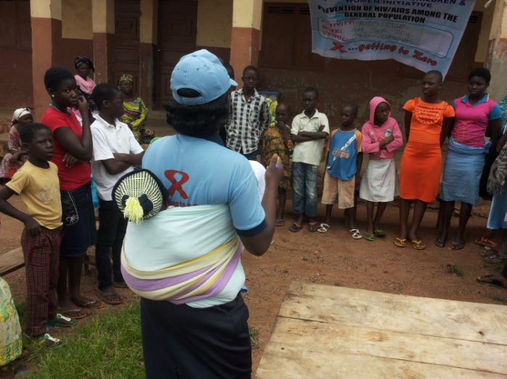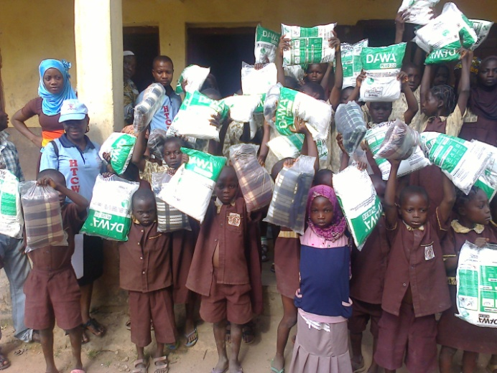
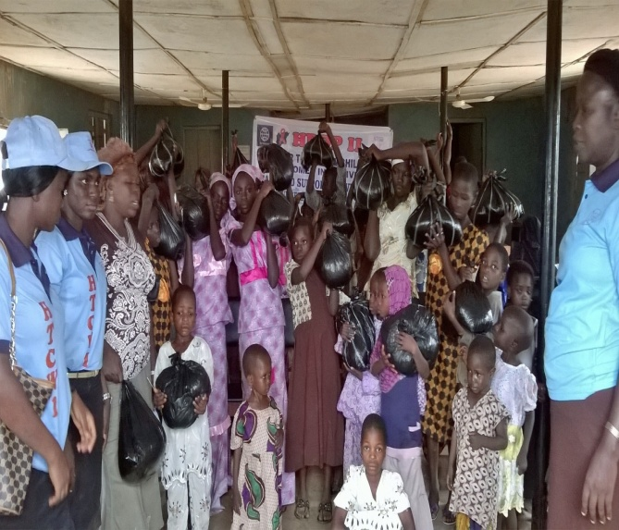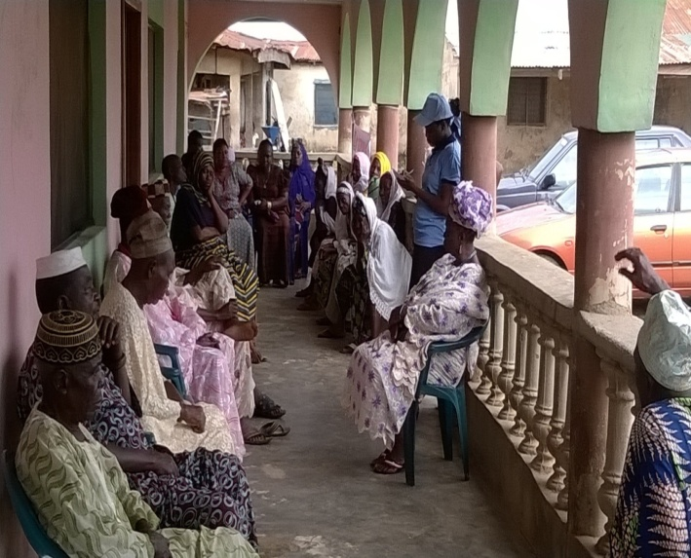
Headquarter: Opposite Winners Model College, Tinumola Estate, Technical College area, Osogbo, Osun State, Nigeria.
Contact Office: Near Nigeria Civil Defence Office, Behind Owode Market, Owode-Ede, Osun State.
08064259784, 08034680421. floveachild@yahoo.com www.tomorrowhope.org
HTCWI………………To establish a community where all orphans, vulnerable children, widows and marginalized women in the society have access to basic needs of life

Who we are:
Hope for Tomorrow Children and Women Initiative is a non-governmental, non-profit making organization established in 2006 as an initiative to improve the lives of the vulnerable in the society. It was formerly known and regarded as Love a Child Foundation, before its incorporation with the Corporate Affairs Commission. After the incorporation, the organization (Love a Child Foundation) was re-named as Hope for Tomorrow Children and Women Initiative.
Hope for Tomorrow Children and Women Initiative (HTCWI) was registered with the Corporate Affairs Commission in the year 2010. The operational headquarter is located in Osogbo, Osun State, Nigeria, with the head office along Kajola Road, Owode-Ede, Osun State.
The organization work with Orphans and Vulnerable Children (OVC), Widows, marginalized and under-served women and people living with HIV with the view of promoting their chances of survival and protecting their rights in the society.
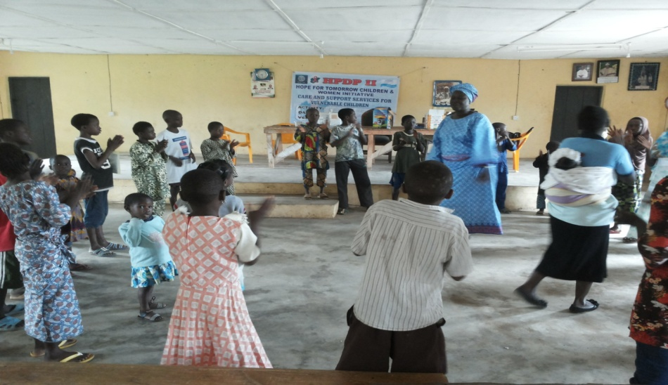

- Our Vision:
To establish a community where all orphans, vulnerable children, widows and marginalized women in the society have access to basic needs of life

- Our Mission:
To form a functional organization (non-governmental), committed to addressing the issues of the orphans, vulnerable children, widows and the marginalized women; in terms of provision of education, healthcare and social support

- GOAL:
To ensure the survival, development and protection of orphans, vulnerable children, widows and the marginalized women in the society

We are set to achieve our set goal through the following strategic objectives:
- To support and educate (scholarships and other personal effects) the orphans, vulnerable children and women in the society
- To discourage violence against the defenseless children and women in the country
- To protect the health of the orphans and vulnerable women through provision of or assist in accessing healthcare services
- To provide social and welfare support for households where these orphans and vulnerable children are found. e.g. provision of food stuffs, household materials and other daily needs.
- To improve the standard of living of vulnerable children and women in the society by providing capacity building
- To provide psycho-social assistance through counseling, acquisition of life skills and adequate monitoring.
Our scope of work………………….
HTCWI since its operational inception in 2006 has been working in the thematic area of care and support to OVC, PLHA, widows and other vulnerable in the society. The organization has carried out several activities on care and support to OVC, community awareness on HIV/AIDS prevention and PMTCT campaign in the community. HTCWI also support and strengthens chains of marginalized women support groups on entrepreneurial empowerment, life skills development and counseling for improved living standard.
The organization is currently working with over 100 marginalized women and over 200 OVC enrollee in the state of Osun. HTCWI collaborate with individual stake holders, Groups, NGOs and local authorities in providing care and support services to target beneficiaries in the society:
Our PROJECTS:
- CARE AND SUPPORT SERVICES for Orphans, Vulnerable Children, Children affected or infected by HIV, People Living with HIV and Widows
- HEALTH/MEDICAL OUTREACHES: HIV, Prevention and Control services for Viral Hepatitis, Malaria, Tuberculosis, and cancer, Sexual, Reproductive and Health Rights Services for Girls and Women
- TOTAL SANITATION AND HYGIENE PROMOTION through Community-Led Total Sanitation Programme(CLTS), Hand washing promotion/ campaign, etc
- LIVELIHOOD PROGRAMMING AND VOCATIONAL TRAINNING SERVICES for target beneficiaries in the communities of operation
- SUSTAINABLE AGRICULTURAL AND COMMUNITY DEVELOPMENT SERVICES in form of Agricultural Extension Services, Advisory Services, Site Mapping, Geo-Referencing and Promotion of Sustainable Land Management System
Our strategies……………………..
- Registration and enrollment of Orphans and vulnerable children, under-served and marginalized women and widows in the communities of operation
- Advocacy and community dialogue meetings on child protection and child rights in Osun state.
- Provision of educational, nutritional, medical and psycho-social support services to the enrolled beneficiaries
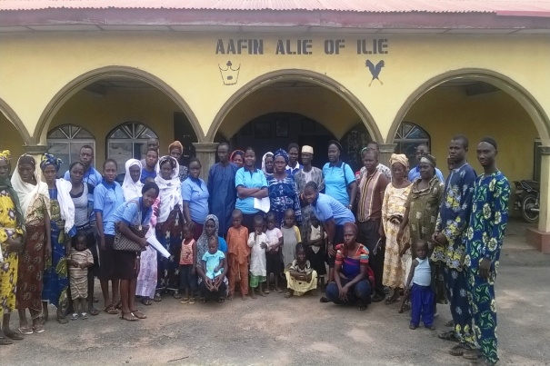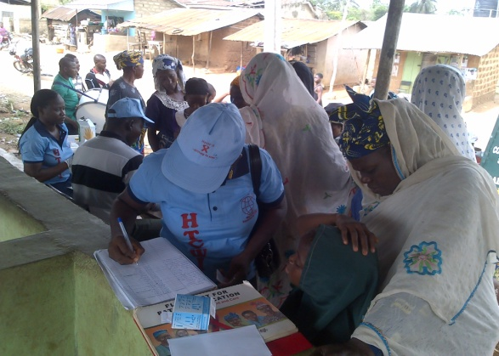
- Community sensitization, awareness campaigns, school and community outreaches on HIV/AIDs prevention and control, Malaria Prevention and control, Hepatitis and Tuberculosis prevention, management and control .
- Formation of support groups of under-served women and girls experiencing sexual or domestic violence with the provision of empowerment schemes (micro-credit facilities, income generating activities and skill acquisition programmes).
- Shelter and care giving support services to ensure that the Orphans and vulnerable Children (OVC) have safe, dry, and warm living conditions.
- Food security and nutrition services through nutritional assessment and counseling for OVCs and their families, training for caregivers and families on diet and food preparation, referral and follow up assistance for other health and nutrition interventions (e.g. school and after care feeding programs)
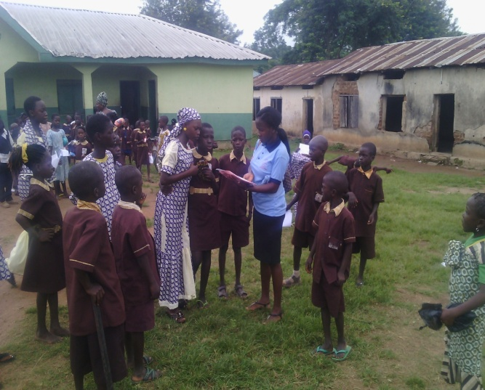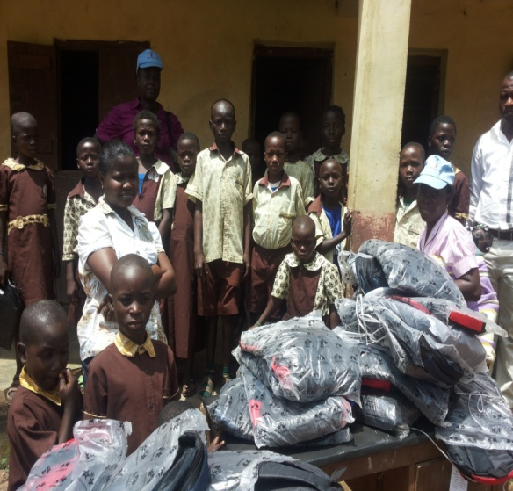
- Education and Vocational Training support to actively promote the value of education, and serve as a bridge between OVC families and schools. Regular monitoring of school attendance and progress of the enrolled vulnerable children as well as support for issues that arise with school enrollment
- Economic strengthening services support to OVCs and their families in a relatively short period of time to improve their means of livelihood.
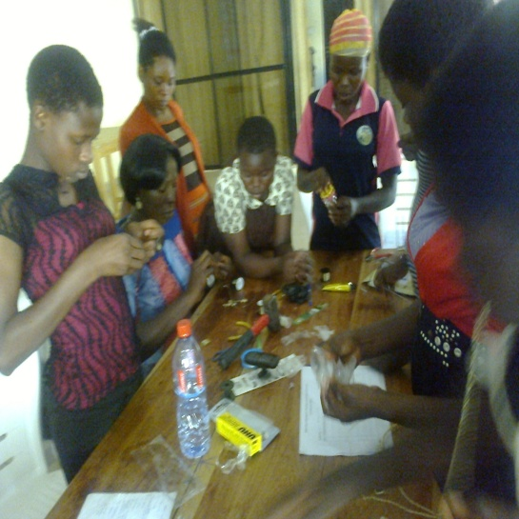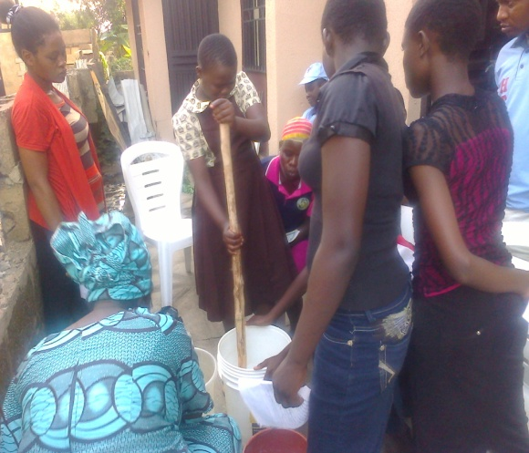

- General Health support to ensure that the OVCs receive routine growth and development monitoring, immunizations and physical check- ups and as well as referral and follow up for clinical care when required
- Psychosocial, social and Spiritual support interventions, in terms of linking the OVCs to social, mental, emotional and spiritual care.
- Innovation platform on Sustainable Agriculture
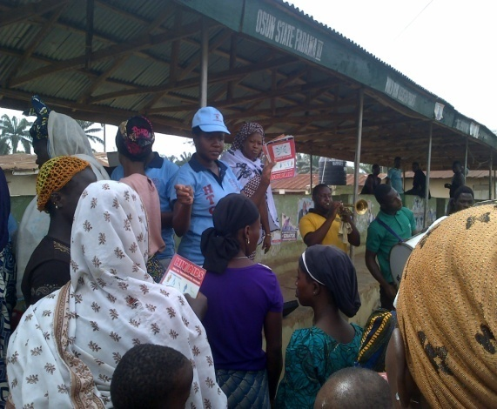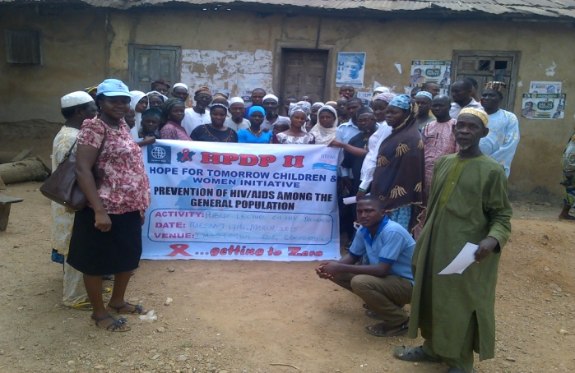
- School Outreaches and sensitization campaigns on Child protection, Child Rights and Hygiene Promotion
- Community-Led Total Sanitation (CLTS)

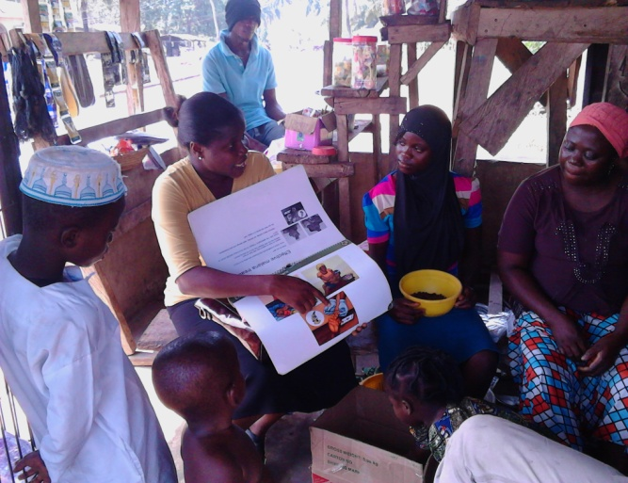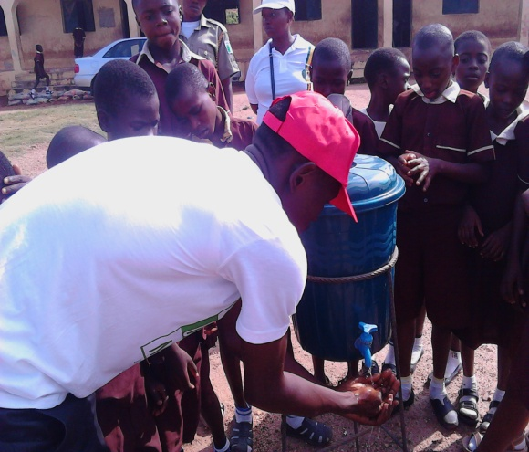
Our intervention programs have focused on grassroots communities across the State.
Our staff…………………
HTCWI is adequately equipped with key professional staff which include the Programme Manager, Project Officers, the Monitoring, Evaluation& Learning (MEL) Officer, Accountant, Finance Officer, Community Mobilization Officer and other support staff (project volunteers who serve as community care workers, MIS officer and medical consultants).
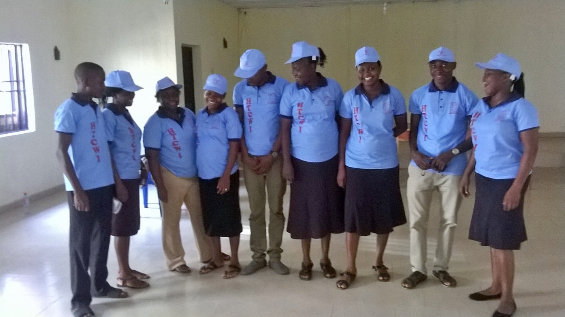

The Organization banker
- Unity Bank(current Account):
Account Name: Hope for Tomorrow Children and Women Initiative
Account Number: 0023250730
- FCMB( Savings Account):
Account Name: Hope for Tomorrow Children and Women Initiative
Account Number: 2856101017
Hope for Tomorrow Children and Women Initiative is always willing and ready to collaborate with individual, Groups, NGOs who are willing to assist them in the service they render to the community/ society.

