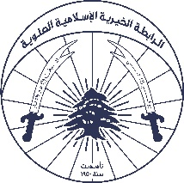

Quarterly Report | Beirut Explosion response

|  |  |
| --- | --- |
| Organization Name | Alawite Islamic Charity Association |
| Project | Kermalik Ya Beirut – Health Assistance |
| Contact person  *Name, email, and phone* | Youssef Aouli  Phone Number : 03041125 Email : Youssef.Aouli@aica-lb.org |
| Reporting period  *From – To* | First of April 2021 to 30 June 2021 |
| Submission date | 15 July 2021 |

# Context

In Response to the Beirut Blast and as an Emergency Response Action plan, AICA implemented a project providing primary health care services for people in need of a wound change, health aids and referral for people who need other specialized services to nearby centers. AICA also distributed acute and chronic medications for patients suffering from chronic diseases. Below is an aggregation for the reached figures within the last quarter covering April till June:

|  |  |  |  |  |
| --- | --- | --- | --- | --- |
|  | April | May | June | Total/Nationality |
| Lebanese | 202 | 167 | 164 | 533 |
| Syrian | 759 | 831 | 787 | 2377 |
| Other Nationalities | 9 | 22 | 15 | 46 |
| Total/Month | 970 | 1020 | 966 | 2956 |

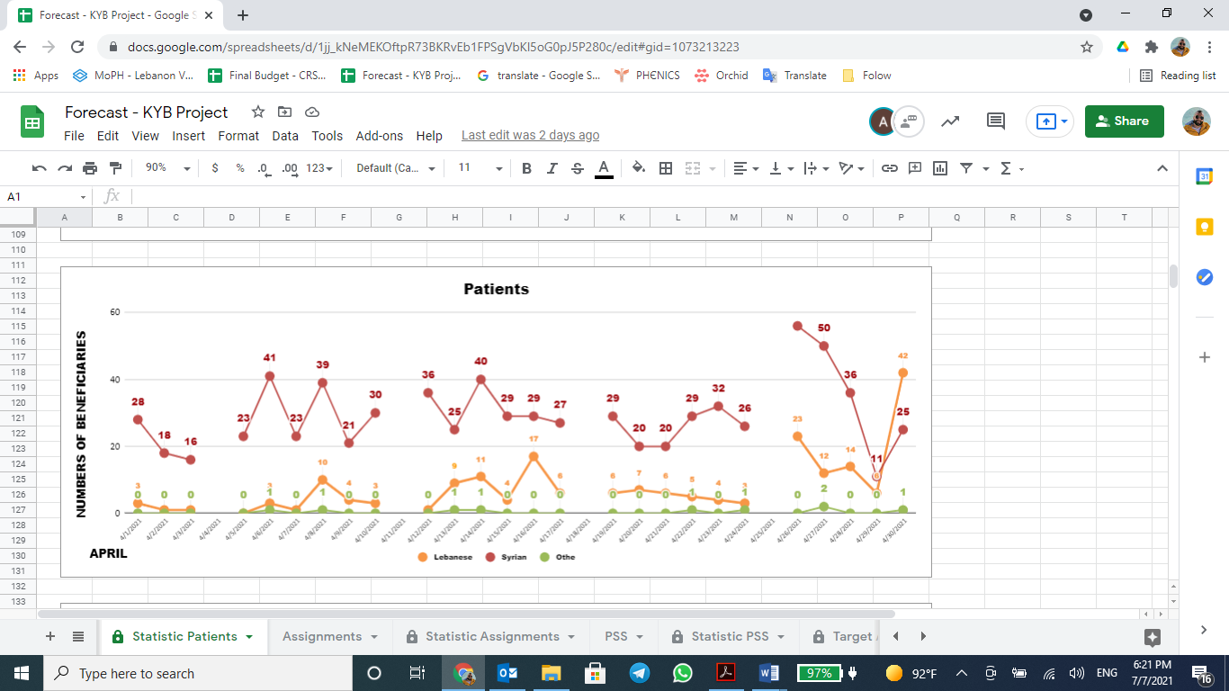

*Nationality Aggregation of visiting patients in April*

# 

*Nationality Aggregation of visiting patients in May*

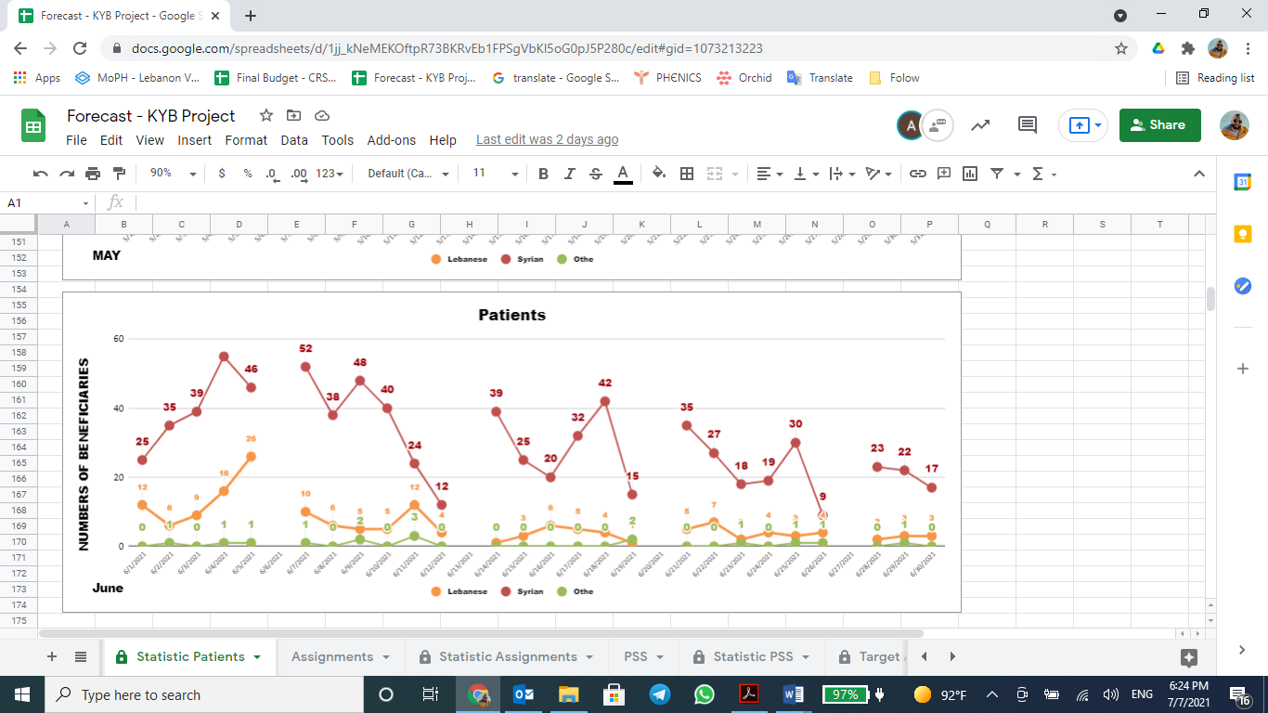

*Nationality Aggregation of visiting patients in June*

# Activities implementation

* Patients’ reception: The admission process was organized by the receptionist who used to assign numbers in order to track the entry of each beneficiary. After receiving it, the beneficiary’s temperature was checked, and questions related to Covid-19 symptoms were asked. At that point, the beneficiary received a corona leaflet, sterilized his/her hands and provided a mask. All patients were treated equally regardless of their nationalities. It is worth highlighting that the center’s visitors were from 6 different nationalities.
* Patients’ preparation: The reason for each patient’s visit was identified through asking several questions. The diagnosis was given according to the answers where he/she was referred to either a general doctor or a specialist, depending on the condition. The patient’s profile was filled with all personal information, such as: copy of ID, weight, height, drug allergies if any, current medications, and any family history of particular genetic diseases.
* Urgent cases: Urgent cases such as bleeding, unconsciousness... were served immediately. All people with disabilities’ entrance and exit was facilitated by AICA’s staff using a wheelchair.
* Patients’ examination: Once the patient entered the doctor’s room, the nurse addressed him/her with a series of questions to further diagnose the need. Each patient was served a half hour consultation where a full explanation of the illness, treatment process and any further inquiries were provided in detail. In case the required drug was not available, the patient was handed out a prescription request.
* Assignment: People who needed x-rays, lab analysis, special treatment, and surgeries were referred to other primary health care centers providing such services.
* Patient’s follow-up: Post referrals, patients were contacted by AICA Staff and informed that they can return for any needed medical advice related to the recently conducted tests or X-rays.
* Chronic medication distribution: Each written prescription to the patient, was then handed to the pharmacist in order to be prepared and delivered after approximately 1-week post request. Every received medicine was labeled with the correct usage, dosage and appropriate timing. Patients were visiting the center on a monthly basis, coming from different areas like Tarik Jdidi, Achrafieh…
* Home visits and assessments: With assistance from the “Emergency coordination unit” established by the government and administered by Lebanese army, AICA was able to identify 30 families who were direct victims of the blast. AICA staff coordinated home visits for 23 families with an average of 2 visits/day. The remaining 7 cases were either relocated to other areas or refused to be visited due to Covid-19 situation. The case assessments were conducted by AICA’s social workers, case workers and some other cases were handled by the Monitoring officer and project manager. The key findings were the need for: food, cash, construction and health assistance (medicines and medical machines per example: walker, air or water mattress, oxygen machine ….). below is a chart aggregating the results:
* Pharmacist’s role in assessment: AICA’s pharmacist double checked at the end of each visit, with the case worker that the delivered medication was compatible with the prescription. In addition to that, all data was documented and recorded in a database for future follow up and referrals.
* Medications Procurement: Due to market deficiency and shortage, some of the requested medications were substituted by alternative generics. AICA’s pharmacist reviewed these medications and confirmed that they match the requested ones and are safe to use
* Medications and medical supplies distribution: As per the findings of assessments, door to door visits were conducted by AICA staff (Case worker, pharmacist, project manager) to distribute the needed medications and equipment. Below is an aggregation of distributed items:

|  |  |
| --- | --- |
| Item | Quantity |
| Oxygen Concentrator With Nebulizer (5-10 L ) With Remote Control | 2 |
| Water Mattress | 4 |
| Air Mattress | 4 |
| Thoracolumbar Corset | 1 |
| Cervical Collar | 1 |
| Commode Wheelchair | 1 |
| Walker | 3 |
| Stick With 3 Leg | 2 |
| Mask - cpap / bipap | 1 |
| Stick | 1 |
| Walker With Wheels | 2 |
| Catheter | 1 |
| First Aid kits | 23 |

* First Aid Kit’s content:

|  |  |
| --- | --- |
| Description | Quantity |
| Non-Contact Infrared Forehead Thermometer | 1 |
| Glucose Machine With Test Strip | 1 |
| Sphygmomanometer Digital | 1 |
| Oximeter | 1 |
| Bandage 5cm | 1 |
| Bandage 7.5cm | 1 |
| Bandage 15cm | 1 |
| Surgical Tape 2inch | 1 |
| Surgical Tape 3inch | 1 |
| Betadine Swab | 8 |
| Alcohol Swab | 8 |
| Bandage Elastic 7.5" | 1 |
| Bandage Elastic 5" | 1 |
| Non Sterile Gauze 5*5 cm | 1 pack of 100 Pcs |
| Sterile Gauze 7.5*7.5 cm | 4 |
| Sterile Gauze 10*10 cm | 4 |
| Surgical Scissors | 1 |
| Gloves Nitrile Pair | 4 |
| Wound Dressing 10*15 cm | 1 |
| Transparent Dressing 15*25 cm | 1 |
| Transparent Dressing 15*30 cm | 1 |
| Emergency Box | 1 |

Action Plan Table:

|  |  |  |  |  |
| --- | --- | --- | --- | --- |
| Activities | Description of the activity | Modality  (Value, frequency…) | Location of activities | Number of individuals and number of households (if HH is relevant) |
| Activity 1: Medical care and drugs PHC | Affected people having traumas were treated by a general practitioner, assisted by a nurse, referred to Case Management and followed in coordination, upon need. | Daily from 10 AM to 3 PM | Bourj Hammoud | Estimate of 3000 during 3 month |
| Activity 2: Coordination with Emergency unit | The project manager & Monitoring officer visited the emergency room to acquire contact numbers of families affected by the blast. | 18 March 2021 | Bourj Hammoud | N/A |
| Activity 3: Case Management assessment | Home visits to those directly affected by the Beirut Blast to determine the services needed | Door to door:  1 or 2 visits per day | Beirut and its suburbs | 30 cases affected by Beirut Blast |
| Activity 4: Medications procurement | The supplier provided the medications as per the pharmacist’s confirmation of the excel sheet | N/A | N/A | N/A |
| Activity 5: First Aid kits | Some savings occurred after past report so AICA suggested to liquidate this sum through provision of first aid kits to families injured from the blast. | Door to door distribution:  1 kit / HH | Beirut and its suburbs | 23 HH |
| Activity 6: Medicines, medical supplies/devices, first aid kits’ distribution | Providing affected people with medical equipment, supplies and medications | Door to door distribution of medicines and medical devices for assessed and eligible families as per the need.  1 first aid kit/HH | Beirut and its suburbs | 23 HH |

COVID-19

In response to Covid-19 situation and in order to ensure safety of visiting patients, AICA’s staff installed signs within the center in order to organize the entering and waiting process of the patients. Since the distance between marks was two and a half meters, the staff were keen to measure the patients' temperature, sterilize his/her hands, and pose medical questions. It is worth noting that the center was being sterilized on a daily basis as a precaution measure.

## Challenges

*Overview of any challenges encountered during the reporting period and how they were tackled*

|  |
| --- |
| Challenge(s) Response(s) |
| 1. Ramadan challenge: Despite fasting and more than 2 hours’ drive, the team’ socializing spirit with the beneficiaries was not affected and all beneficiaries were served with empathy. |
| 2. Electric power : The unstable electric supply formed a limitation, the team was forced to use flash lights in order not to halt operation and let the patients wait till the power is back |
| 3. The diesel fuel crisis: The shortage in fuel within the market was a real challenge, AICA’s logistic team made sure to provide the needed fuel quantities in order to avoid a scenario where staff are not able to reach the intervention area. |
| 4. Shortage of medication: Not all the medications were available in the market which caused a delay in medication procurement and hence provision for beneficiaries. AICA’s team was keen to provide alternative generics which were compliant with the original request and approved by pharmacist. |

## Monitoring

The number achieved during the reporting period is the sum of all targeted participants that have been reached in previous reporting periods and those that were reached during this report’s reporting period.

The progress towards target is a percentage calculated as follows = (Number achieved during the reporting period) ÷ (Overall target) × 100

|  |  |  |  |
| --- | --- | --- | --- |
| Indicators | Number achieved during the reporting period | Overall target | Progress towards target |
| Health activity 1:  # of medical consultations completed | 9444 | 9467 | 99.75% |
| Health activity 2:  # of Individuals (without duplication) who benefited from medical consultations | 6590  individuals(4165 females & 2425 males) | N/A | N/A |
| Health activity 3:  # of individuals who benefited from Pharmacist version chronic Rx | 411 individuals  (227 females and 184 man) | N/A | N/A |

|  |  |  |  |
| --- | --- | --- | --- |
| Monitoring tools used (satisfaction surveys, discussions with beneficiaries…) | Sample size | Primary findings from these tools | Actions taken/to be taken in response to these findings |
| Complaints Box | N/A | No complaints were recorded |  |
| Hotline | 314 | 75% of the requests are for chronic drugs, neuroprotection | AICA was able to secure a part and worked on securing the rest of medications, except for nerves medication since they require medical prescription as well as their expensive cost |
| Individual interviews. | 1073 | 80% are satisfied with the service but need more medication | 1301cases Referred to other associations and 153 cases followed up by AICA  The reason is that there is only one Staff |
| Beneficiaries Satisfactory | 627 | Center service satisfaction The COVID-19 prevention measures 158 (100%)  26 people/ Need specialist Doc  12 people/ Need to renew project |  |

## Coordination and communication

*Please list any coordination meetings or communication with national response actors (Government of Lebanon, municipalities, local community, FGOs, INGOs…)*

|  |  |  |
| --- | --- | --- |
| Date [dd/mm/yyyy] | Response actor | Type of coordination [meeting, email, phone call][1] and purpose |
| From 18 till 25 June 2021 | Caritas | Email and phone call to provide food assistance for the beneficiaries |
| From 18 till 25 June 2021 | Orthodox | Email and phone call to provide MHPSS for the beneficiaries |

AICA’s field team relied on Activity info and other mapping exercises in order to identify who is doing what and where in order to refer beneficiaries in need accordingly. The identified cases

# Budget

*Annex A  
*

# Annexes

## Annex I: Pictures, videos

AICA launched the "Kermalik Ya Beirut" campaign when the implementation of the project began, sharing 2 videos to introduce AICA and the project about public health and the support sessions that will be presented sequentially.



## Annex II: Success Story

Annex III: Other supporting documents

|  |  |
| --- | --- |
| OUTCOME | |
| *STAFF LEVEL* | *PATIENTS LEVEL* |
|  | The patients gained trust after the services provided by AICA, so they gave their full personal details without any complaint.  Patients reached a sense of belonging shown in the increased number of visits to the center. |
| The nurses have become more patient with their interactions with a new society and with people who have been exposed to trauma, which is new of its kind. | Patients appreciated every single service even if it was a single sachet of drugs. |
|  | Beneficiaries’ awareness level increased about the COVID vaccination’s efficiency and this was proven when they let AICA’s vaccinated team go inside their houses despite the previous fear . |
|  | Beneficiaries’ satisfaction and relief was raised after receiving their medications despite the shortage of supply and increased cost . |



1. Refer to annex email communication with response actor in other supporting documents