The sweethearts Foundation Project UpdatE

Background

The sweethearts Foundation aims to help underprivileged people receive the gift of movement by recycling plastic Tops and Tags which are sold, and the proceeds used to fund wheelchairs. It takes approximately 450 kg of bottle Tops or 50 kg bread Tags to fund a standard wheelchair. Against incredible odds, we managed to collect enough plastic to hand over our first wheelchair on Valentine's Day 2013.

Our beneficiaries come from the most marginalized communities in South Africa and something as simple as a wheelchair is often out of their reach due to financial issues and long government backlogs.

The foundation is driven completely by volunteers, who we endearingly call “sweethearts”. They are the ones who make the magic happen and help change the lives of our beneficiaries, as well as their families. It is thanks to our enthusiastic, energetic and absolutely awesome sweethearts, like you, who continue to help us, support us and motivate us to give all that we can to those who need our help.

12 Days of Christmas Campaign
Wheelchairs do not have a one-size-fits-all solution and providing the “wrong” type of wheelchair can do more damage in the long run. We made the important decision to ensure that every beneficiary should receive a wheelchair that is suited to their specific needs. Unfortunately though, these specialized wheelchairs often come with a big price tag and the plastic recycling funding does not cover all the costs – as a result we’ve created 12 Days of Christmas which aims to help 12 beneficiaries with extra special needs.
Our 12 Days of Christmas: Wheelchair Edition campaign was started in 2016 and in 2020 it really blossomed! We were completely overwhelmed with support and received donations from all around the world.
Whilst we always aimed to select 12 beneficiaries for this project; in the past we were not successful; however, this year we were able to pre-select 12 beneficiaries for this project!
Considering the pandemic, we found ourselves in 2020 32% of donations made towards our annual fundraiser were made on Giving Tuesday and match funding from GlobalGiving helped raise another 10% of our funds! We raised a grand total of R97 881.66 which was distributed between 12 beneficiaries.
Thanks to the generosity of everyone who contributed to the fundraiser, we were able to fully fund Amahle, Gontse, Boitumelo, Siyabonga, Reathabile, Banele, Lisa, Sindile and Boikaelelo wheelchairs and partially fund Nambitha, Caleb and Tiishetso’s wheelchairs. Over the course of 2021 we continued fundraising the remaining funds and together with Tops and Tags revenue we hope to fund the remaining wheelchairs.
These wheelchairs would not have been possible without each and every sweetheart, who have given in such a generous way – thank you sweethearts!

Rethabile’s Wheelchair Handover
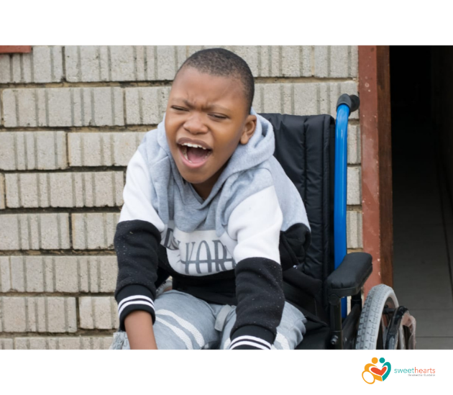
Rethabile is 9 years of age and he is currently enrolled in the Paballo Day Care in Meloding, Virginia, in the Free State in South Africa.
Rethabile was diagnosed with Hypotonia Microcephaly at birth, as such, he cannot speak nor walk although he is able to communicate using gestures and making simple sounds. He enjoys the company of his parents and siblings and being the center of attention.
Rethabile’s dad, Pitso, is the only person in the family who is working and has not been able to afford a wheelchair for his son. Currently, the family and daycare use a baby pram to move Rethabile about. Pitso believes a wheelchair will help him provide Rethabile with a better quality of life.
We had the privilege of handing Rethabile’s wheelchair over on 1 April 2021, with Covid-19 restrictions in place we did not have a big handover, but it was indeed a very special one. Rethabile immediately fell in love with our volunteers handing heading this handover and had such a warm happy jump in his new wheelchair when he was first placed. His wheelchair which was custom-fit for his special needs and designed to last a couple of growth spurts – perfect for a growing boy!
It was truly a blessing to have been able to help Rethabile and his family.

Amahle’s Wheelchair Handover
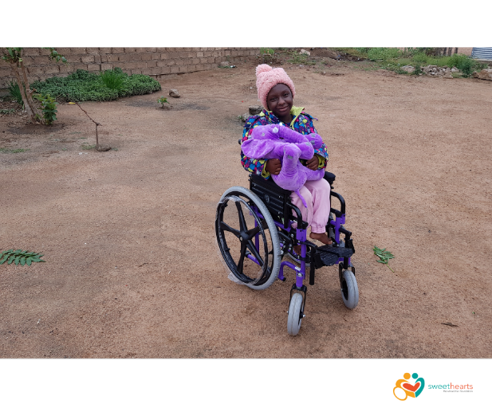
Amahle is 12 years old and has been waiting patiently for her own wheelchair since 2018. She lives in Hammanskraal, Pretoria, South Africa with her mother and two siblings. Amahle is a very active young lady, loves drawing and playing with her friends although she struggles to keep up with them due to a disease that affects her bones.
Amahle is currently not at school, mobility challenges, school fees, and transportation costs are currently a stumbling block. She needs a standard wheelchair but one that is correctly sized as she is quite small with wider wheels (Tuffee Wheels) to help her with the rough terrain around her home.
Amahle told us, "If I receive a wheelchair, I will be happy because I can move around very well, especially when I meet my friends."
Her, mom, Philiswe, has a wish of putting her back to school and she believes a wheelchair will be a starting point to providing a better future for Amahle.
On the 7th of April 2021 we were honored to bless Amahle with a forever life changing specialised wheelchair. When we arrived at her house – this sweet, bouncy girl was all smiles and excitement – and immediately tested her wheelchair in the yard.
Both Amahle and her family was so excited that going to church on a Sunday is possible again and the search for a school suited for Amahle is well under way!

Banele’s Wheelchair Handover
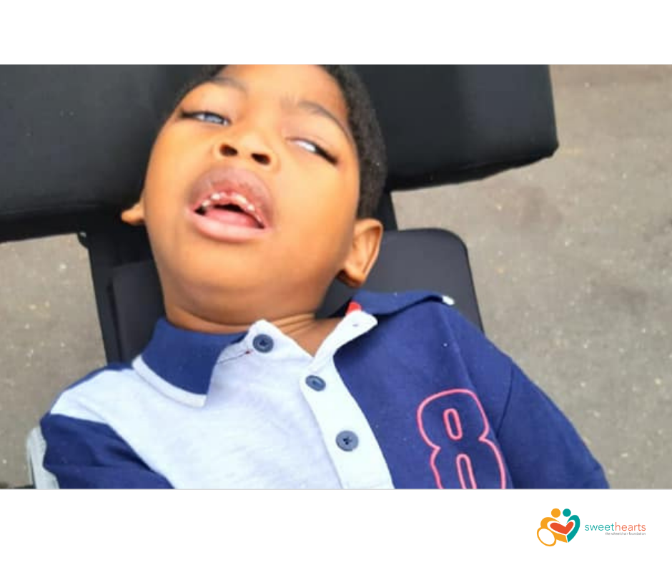
Banele is 6 years old and lives in a rural village in the Inanda Valley in Kwa-Zulu Natal, South Africa. During a severely complicated and tough birth, Banele suffered oxygen deprivation which led to permanent brain damage. Banele is subsequently 100% reliant on his mom, Nomthi, who has to do everything for him as he is unable to move and eat on his own. Banele's dad is absent from his life leaving his mom with the responsibility to support him and his four siblings on a meager government grant and with help from friends and family. Nomthi had to make the hard decision on whether to place Banele in a state-run home...in the end, she decided against it as she believed that they would take proper care of him. Looking after Banele requires constant care and supervision and has turned into a full-time job to which has dedicated her life.
Banele's needs are financially demanding, his diet is limited as he cannot eat solids and will have to wear nappies for the rest of his life. Nomthi takes Banele for physiotherapy sessions as much as she can but this is not regular due to the rural setting where they live, the cost of transport, and difficulty in physically moving Banele.
On the 4th of April, Banele received his wheelchair!
Such a happy exciting event.

We are so grateful that Banele and his family have been blessed by this gift of mobility, they are so deserving.
Thank-you so much to All of you. 
Theresa and Friends of KZN Valley Dogs took time off from work to fetch Banele and his family from the Inanda Valley and take them to Durban, so Banele could be assessed and measured, ensuring a wheelchair was made to fit him correctly, to make him as comfortable as possible. Thank-you.
An endless amount of thank you’s to every special sweetheart who fully funded Benele’s wheelchair.

Gontse’s Wheelchair Handover
Gontse lives in Hammanskraal, Pretoria, South Africa, and is 16 years old, blind, and was born completely disabled, the exact reasons are unknown. She has NEVER had access to a wheelchair and is confined to her bed, or is dependant on being carried on someone's back to go anywhere. Getting a wheelchair will be the best thing ever and would make life easier for her parents and help them move her around easily
On the way to the handover, I found the cutest little Pink Elephant – once I met Gontse I rubbed the soft fir against her arm and the screams of pure delight was something that will forever remain in my heart!
During an emotional handover on 7 April Gontse received her new wheels and the family made sure to tell everyone in attendance they better collect Tops and Tags!
Initially she was uncomfortable and unsure of the “unknown” but she was very brave and allowed a little ride. There have been many more happy rides since then in her wheelchair which was custom-fit for her special needs and designed to last a couple of growth spurts.
The Family further when to say “Sweethearts, for you we will forever be grateful and will never know how to express our gratitude – you have not only changed Gontse’s life, you have changed the lives of every family member and each person in our community!!”

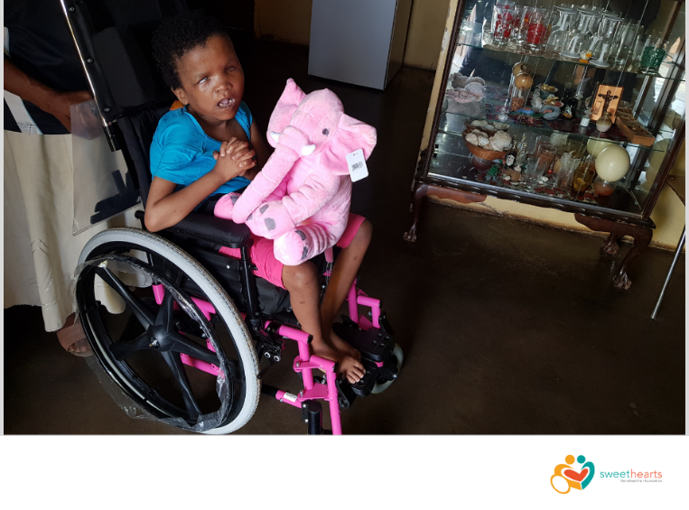


Here is a sneak peak in some of our other 12 Days of Christmas beneficiaries

No words exist to convey our sincere appreciation in helping our beneficiaries receive the gift of movement!
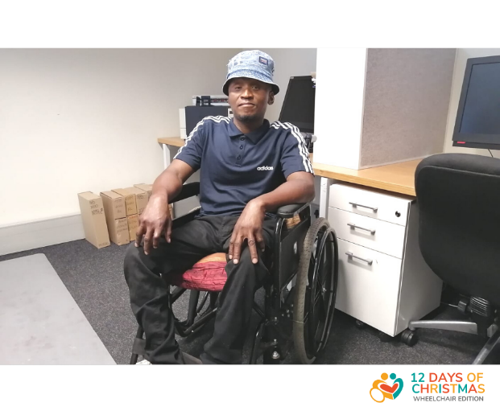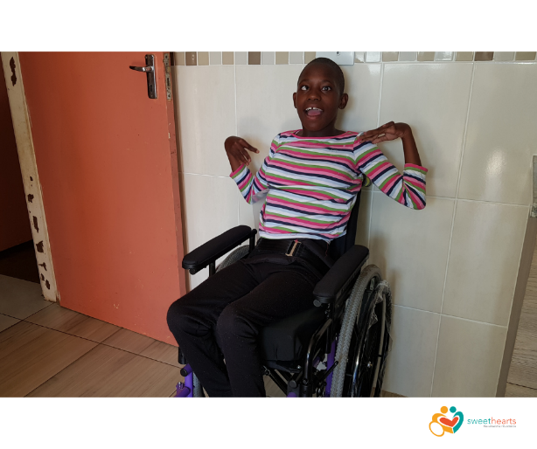
Boitumelo
Sindile

- Siyabonga Lucky is currently away at school and his family asked us to return in May (when he’s at home) to hand over his wheelchair
- Lisa & Boikaelelo wheelchairs are still in manufacturing and a special handover will be arranged once they wheelchairs are ready
- Please help us raise funds for the remained of our 12 days of Christmas beneficiaries:
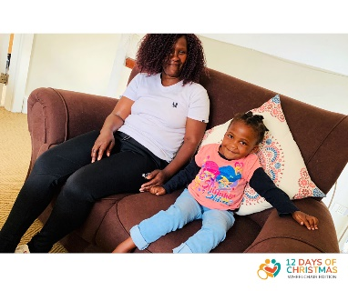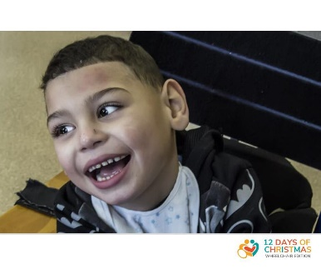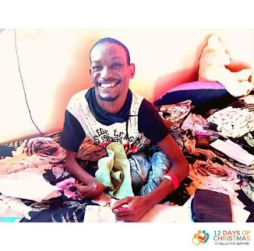
- To follow all the action, subscribe to our Facebook Page www.facebook.com/sweetheartsfoundation. This is our primary method of sharing all our updates.
- Please consider donating again in future to help us continue changing lives
- We’d love to hear what you think of our journey so far, please let us know by emailing us on sweethearts@sweetheartsfoundation.org.

