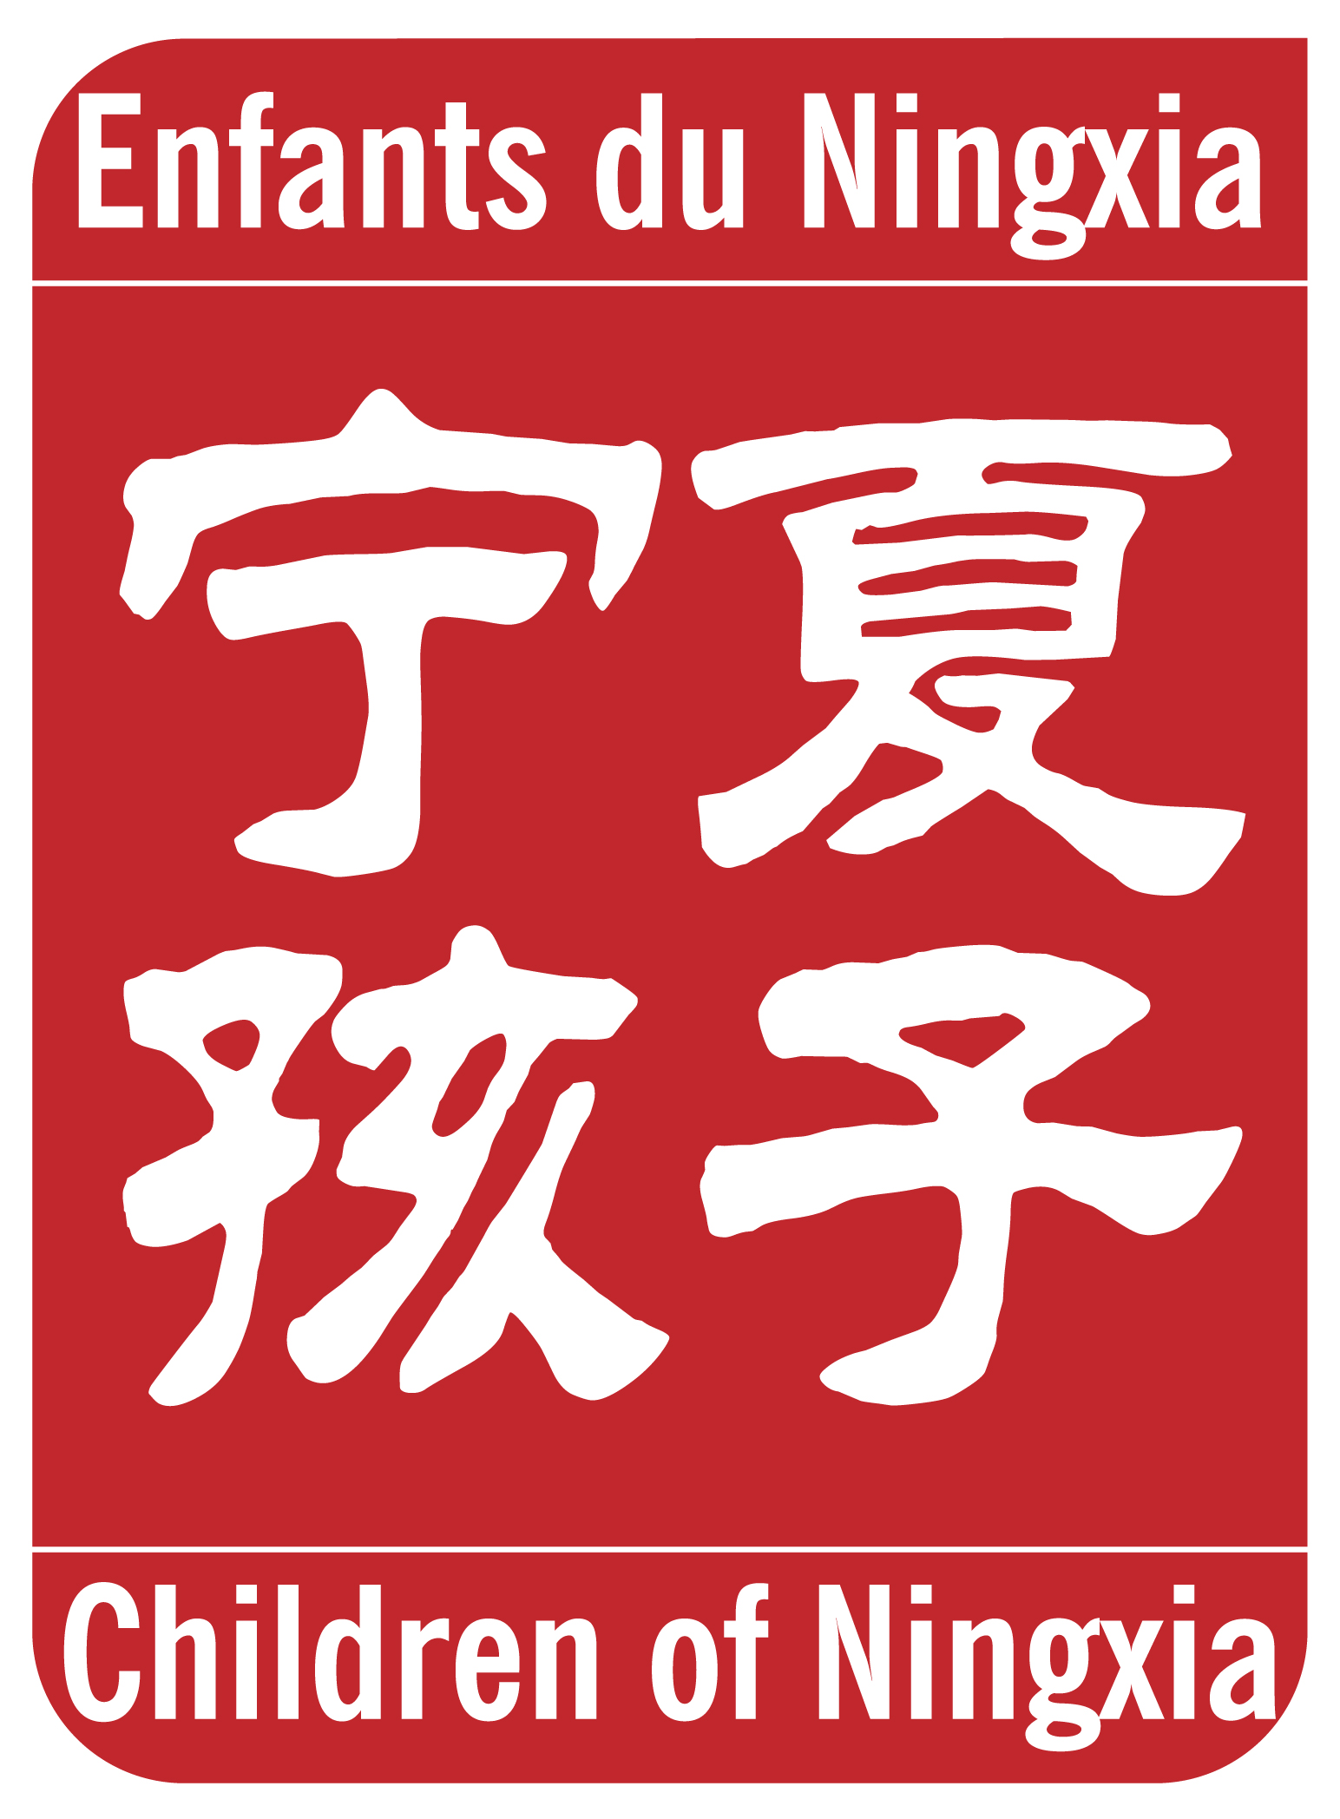

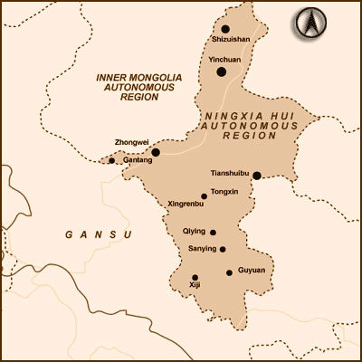
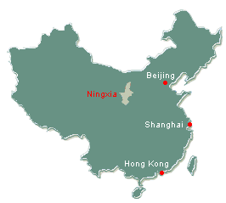

Ningxia, one of China’s poorest regions

Ningxia is located north-eastern part of China bordering Inner Mongolia on the arid steppes of Central Asia. One of the People’s Republic of China’s five autonomous regions, it also ranks as China’s third-poorest rural region.

The principal causes of poverty are drought and desertification. The rainfall is on average less than 200 mm per year. More than 65 % of the land area in Ningxia suffers from desertification, which affects 90 % of the population.

Poverty and drought damage health, particularly that of women. Based on starchy food, their diet does not include dairy products, and fruits and vegetables are rare.
Families cannot often afford medical fees.

Tongxin county: a poor rural population

The majority of the activities of Enfants du Ningxia take place in the villages of the county of Tongxin: one of Ningxia’s counties officially recognized as “poor”.

The county of Tongxin includes 237 villages with a total population of 322 600 people. 82 %
belong to the Hui minority group. Illiteracy is still widespread and income per capita very low: between 50 and 120 euros, representing a daily income of 14 to 33 eurocents.

Tongxin county is situated at an altitude that ranges from 1 240 to 2 625 m.

Canyons, hollowed by erosion due to rare but heavy rain showers, alternate with narrow plains. Only a third of the 4 445 km2 total surface is arable. Nevertheless, agriculture represents the principal livelihood of the inhabitants. Consequently, some 77 000 farmers migrate each year towards Inner Mongolia, Xinjiang, Gansu, Qinghai, Pekin or the Yiwu region of Zejiang to look for other work.

OUR STORY

“I want to go to school!”

This was the desperate cry of Ma Yan, a 13-year-old girl living in Zhang Jia Shu, a little village in Ningxia, one of the most deprived provinces in China. Her parents, poor farmers raising three children, could no longer pay the tuition for their daughter’s schooling. Everything she had dreamed for was now impossible. So she wrote of her revolt and her dashed hopes in her diary and in a letter addressed to her mother.

This was in 2001. Pierre Haski, then Beijing bureau chief of the French daily newspaper, Libération, was reporting on the Ningxia region and had stopped in Ma Yan’s village. Seeing this foreigner, Ma Yan’s mother made the spontaneous decision to give him the letter and her daughter’s diary. She herself didn’t know what they contained as she was illiterate. Back in Beijing, Haski published extracts of the diary in the newspaper. There followed an immediate and heart-felt reaction from a number of readers. How could we leave this girl in such distress? The subsequent donations and offers of help allowed Ma Yan to return to school. But what about the other girls Ma Yan’s same situation?

Ma Yan’s fate was far from unique. Her story is the hidden face of the Chinese economic miracle. While the East Coast of China enjoys dazzling growth, entire swaths of society are far from benefiting from it, especially in rural regions.

In the province of Ningxia, which is mined by chronic drought and populated by an ethnic majority unconstrained by the one-child rule, the little girls of poor farmers are doubly discriminated against. Even more than by poverty, their gender condemns them to ignorance. And to early, sometimes forced, marriage.

When they are able to afford sending a child to school, parents prefer sending their sons who, in a country where retirement pensions don’t exist, represent their future support. Girls, educated or not, will bring a dowry paid by the family of the husband, as tradition has it.

The Diary of Ma Yan, co-written by Pierre Haski and Ma Yan, was published in October 2002. It was a best seller in France and then elsewhere in the world (19 different countries). It was awarded the “Outstanding International Book for 2006” by the United States Board on Books for Young People and the Children’s Book Council. The book brought numerous reactions of solidarity.

Thus, Enfants du Ningxia (EDN) was born in October of 2002. At first, Enfants du Ningxia was able to help 30 children by providing school scholarships; many more followed. Ma Yan remains the symbol of the association. She passed her university exams in September of 2007 and came to France to continue her studies at the Sorbonne.

ENFANTS DU NINGXIA’S GOAL

At the beginning, the priority was to provide school scholarships for girls excluded from the education system. However, EDN felt it would be unfair to neglect the boys, the younger and older brothers, because they also were in situations of distress.

In 2005, the Chinese government decided to pay the tuition of all children in primary and middle school, but some families still cannot pay other costs connected to educating their children: boarding fees, cafeteria, transport, clothes, books, etc.

The only condition is that the scholarship recipients promise to keep the association informed of their progress in school. Each one of them sends a letter at least once a semester (along with their school certificate at the beginning of the school year).

The number of scholarship students increases every year. However, EDN is very careful not to take on too many children because when the association has decided to help them, it commits itself to help them until the end of their studies.

Thanks to EDN’s support, in 2005 the young Yang Xia was the very first girl from Ma Yan’s village of Zhang Jia Shu to be accepted at university.

Along with providing scholarships, it seemed evident to propose other projects that would benefit all of the people of the community.
In September 2003, the luxury company, Hermès, organized a sale to benefit the association, the proceeds of which provided a computer room for the middle school in Yuwang (Tongxin county, Ningxia). In 2006, the sale of a limited edition of Hermès scarves with the Enfants du Ningxia logo allowed the association to rebuild a primary school which was falling down in the village of Liumiao (Tongxin county, Ningxia). In the fall of 2007, Hermès also participated in the financing of scholarships.
Since 2004, students from the Lycée Français in Hong Kong have been making an annual trip to Ningxia during which they contribute school supplies to local schools. Thanks to these donations, a library was set up at the middle school in Yuwang.

Today, according to EDN estimates, 2,000 children have been helped through our scholarship program or our other projects. And five of our scholarship recipients have finished their studies: 2 girls, Ma Na (Arabic studies) and Ma Shilan (Law) and 3 boys, Ma Yongbin (Chemistry), Ma Chenglong (Literature) and Ma Quanwen (Education). Ma Shilan has found work in a lawyer’s office and Ma Chenglong in a dictionary publishing house. Furthermore, three of our female scholarship students and one male are presently pursuing advanced degrees. They are Yang Xia (Chemistry), Hu Yufeng (Medecin specializing in surgery) and Ma Xiaomei (Computer programming in a very good university). And Zhou Hai is in Law school specializing in jurisdiction.

ENFANTS DU NINGXIA’S ACTIONS

EDN’s priority remains the distribution of school scholarships.
The selection of new scholarship recipients takes place during an annual visit in the summer. A criteria chart was drawn up in collaboration with the local inhabitants to direct us in selecting the children whose need was the greatest.

In the past, Enfants du Ningxia financed its actions entirely upon spontaneous donations from individuals. The association also benefited from 25% of Ma Yan’s author’s royalties for her co-authorship of her diary and half of Pierre Haski’s. It was Ma Yan’s idea to donate part of her profits to the association, the seed for our continuing efforts to involve our scholarship recipients in actions of solidarity with incoming students.

In 2008 however, in order to ensure the payment of EDN’s university scholarships, which were increasing in number thanks to the success of the students on their university entrance exams, EDN solicited the help of private foundations. Happily, in 2008 EDN received three generous donations from The Pelicans Foundation (15,000 euros), the ELLE Foundation (7,500 euros) and the Total Foundation (5,000 euros). All three donations were renewed in 2009. In addition to its donation, the Pelicans Foundation offered the help of a consulting firm to elaborate an economic model to achieve EDN’s goals. But in 2010, the Association needs new donors to continue its actions. Below is a chart detailing our current students’ levels and the costs of their scholarship.

School Level | No. of students | Cost per year per scholarship | Amounts paid for school year  ’09 - 10
Primaire | 8 | 40 | 320
Collège | 18 | 50 | 900
Lycée | 47 | 140 | 6.580
Université | 50 | 600 en moyenne suivant l’université | 30.000

Total | 123 |  | 37.800 €

