A camp for refugees in Burkina Faso
A camp for refugees and displaced persons is founded on the suburbs of Ouagdougou, the capital of Burkina Faso. There are 450 of people with children. They came from the north of the country escaping from terrorist attacks.

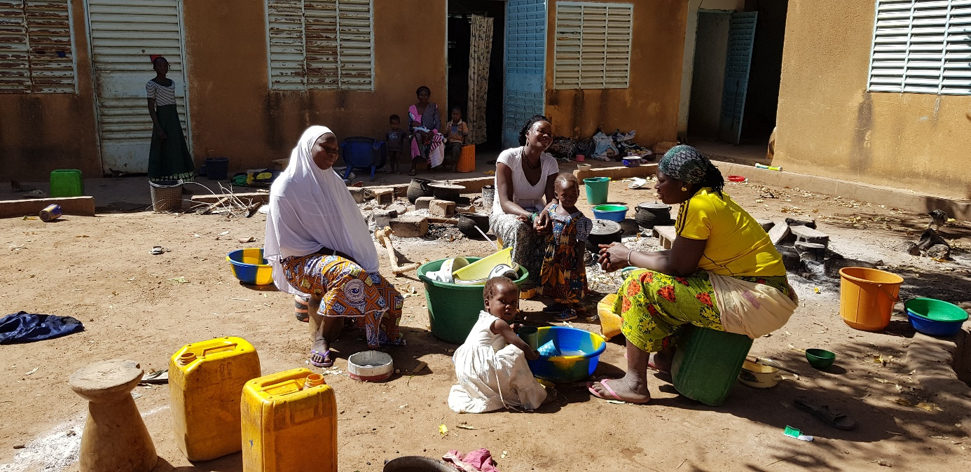

The refugees need food, hygiene mesures and dessinfectants.
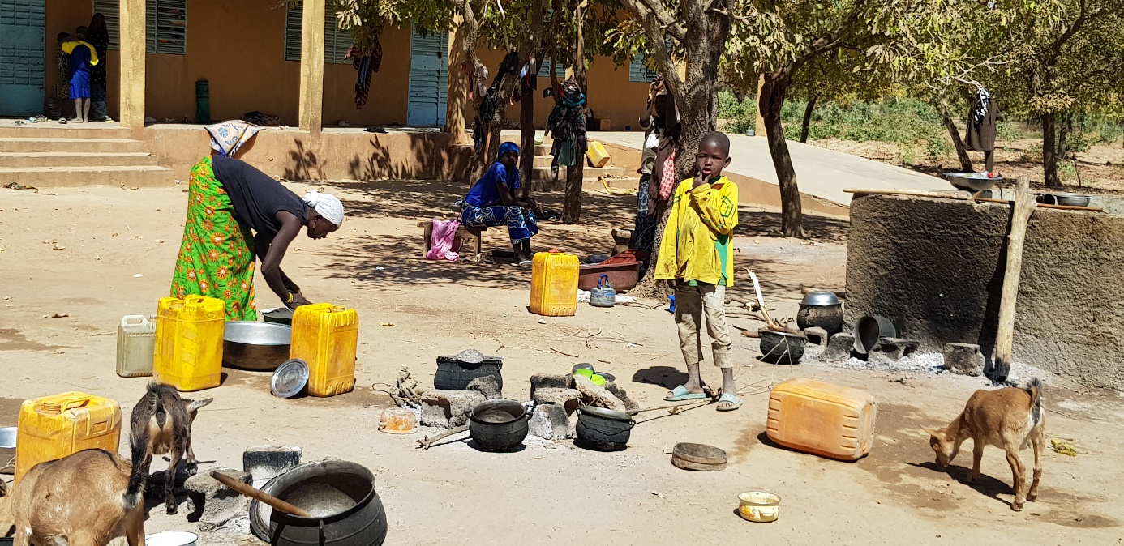
Their children need school!

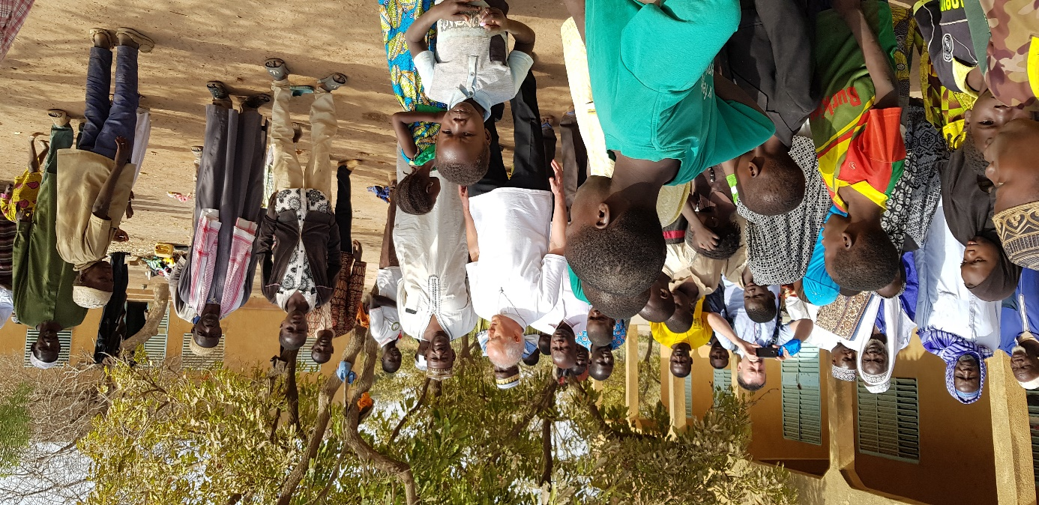

So far we have gained 10 000 dollars to help them, but it is not enough.

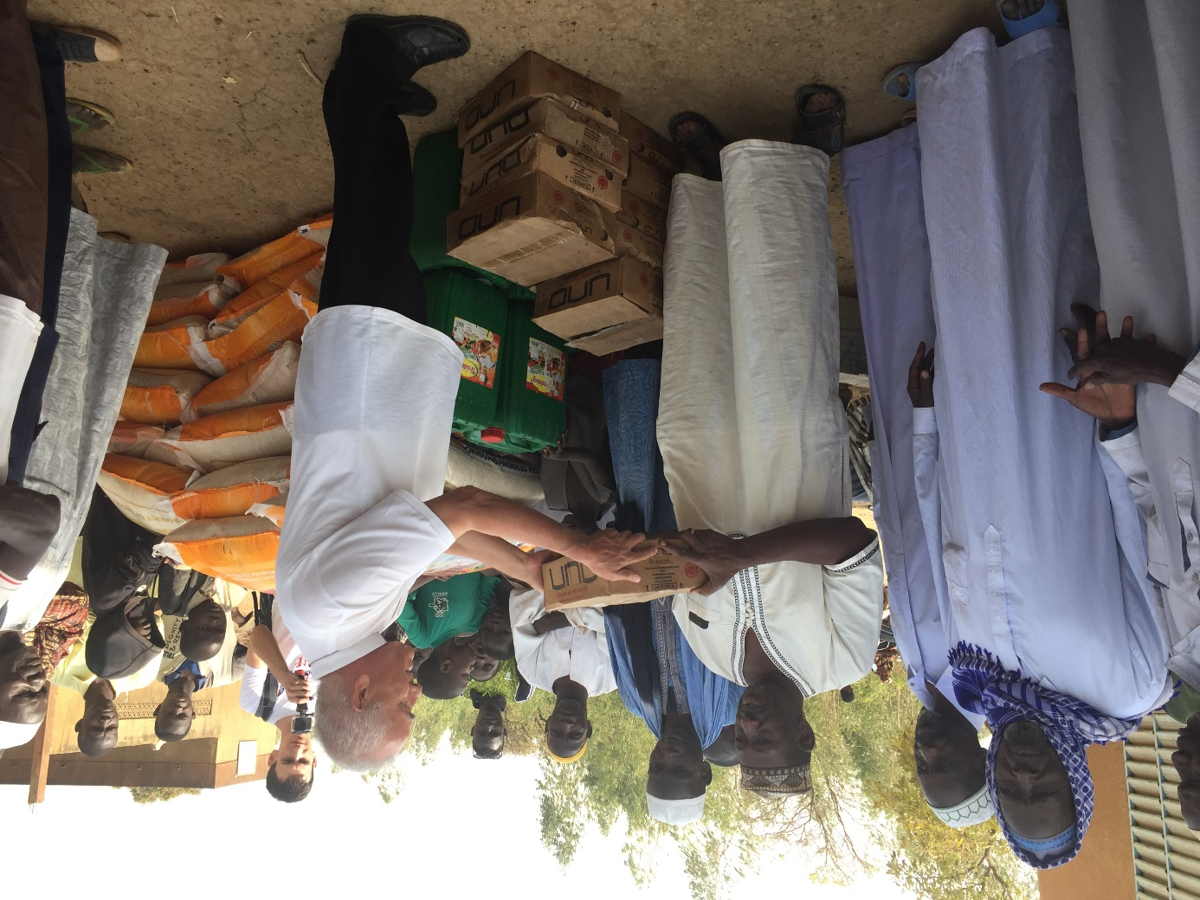

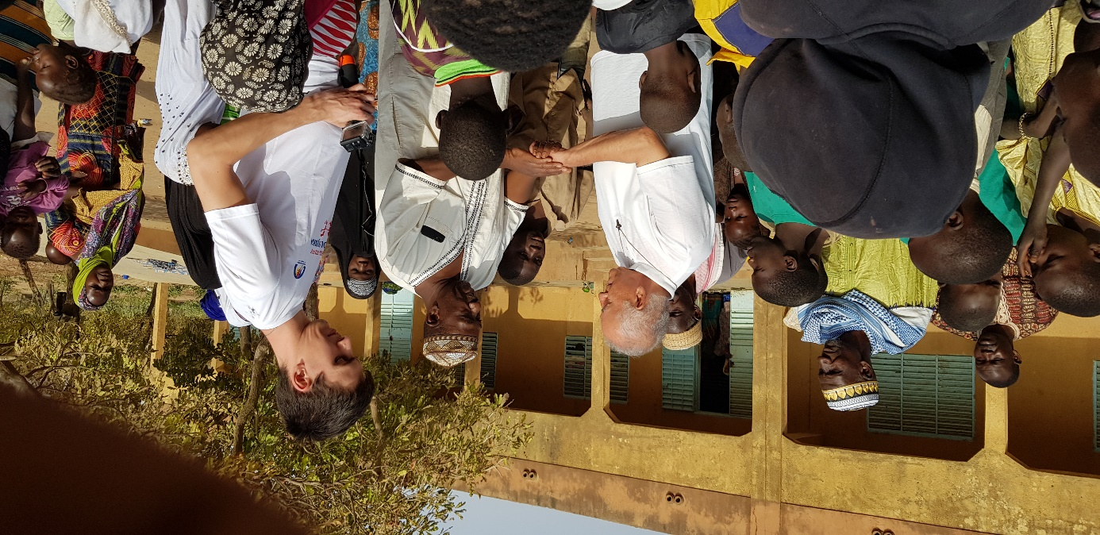

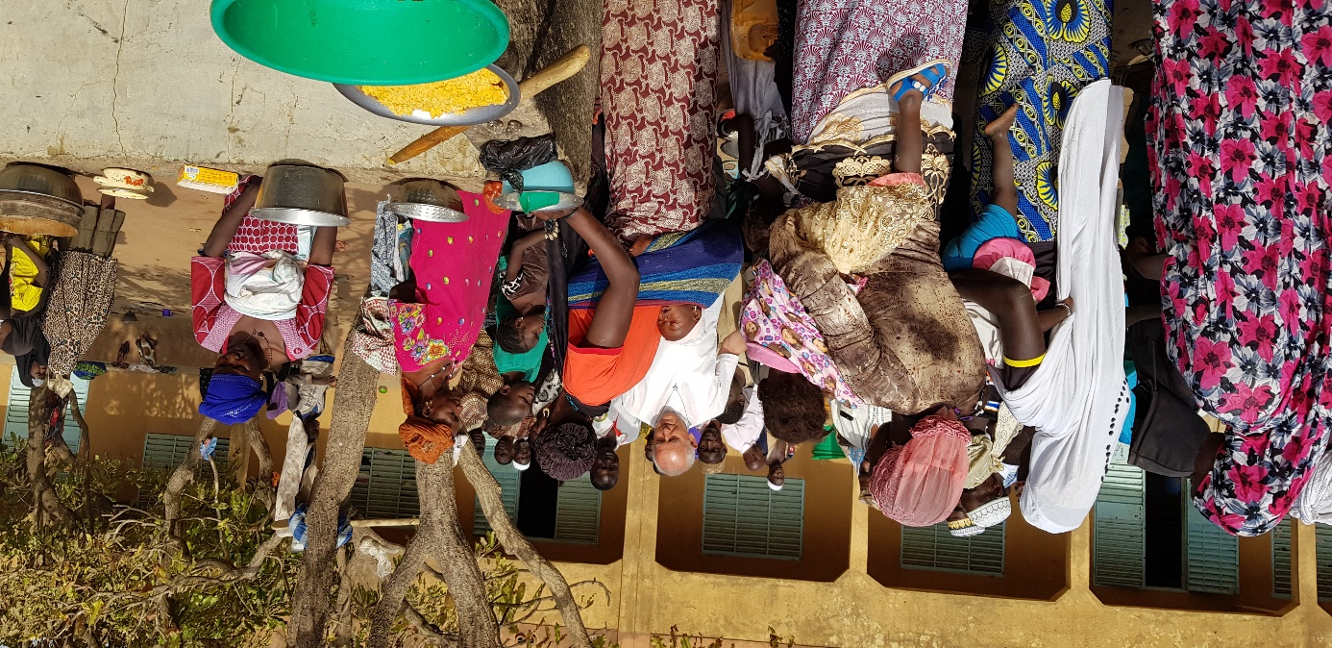

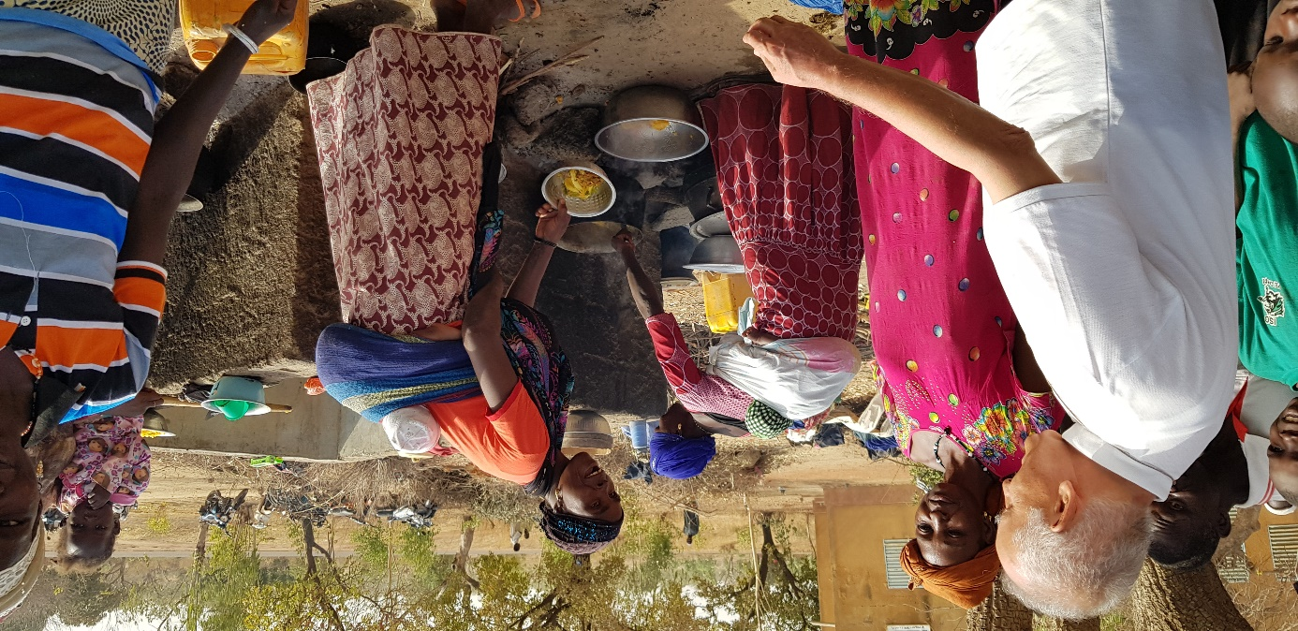

We want to support them for the first six months to allow them to live in human conditions, to protect them from infections, to ensure hygiene. Thanks to that they will be able to look for a job, to find for them and their families a place in new environment.

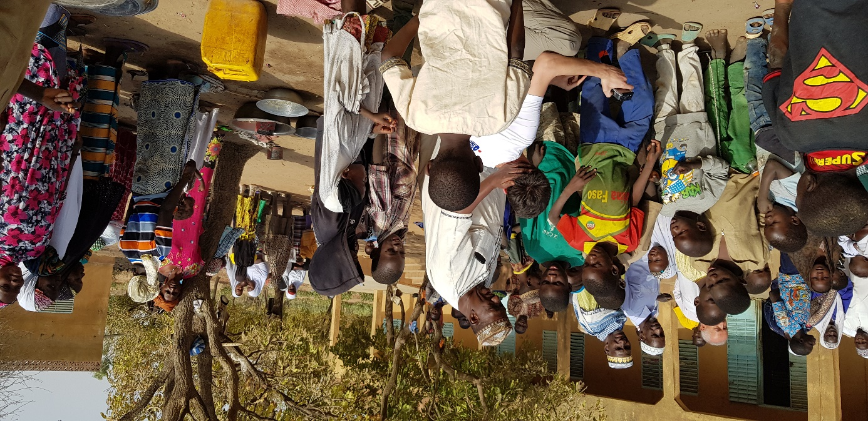

The children need school to gain education and to be able to change the world in the future.
