Planting the seeds for a better future
- Report 1, March 2021 -
Our project partner in Huista (Department Huehutenango, Guatemala) was very happy when he learnt about the funds raised via GlobalGiving in December. The head of our partner organization ADSOSMHU, Rubén López Herrera - right in below picture - sends his thanks to all donors and guarantees that they are eager to start and implement project goals.
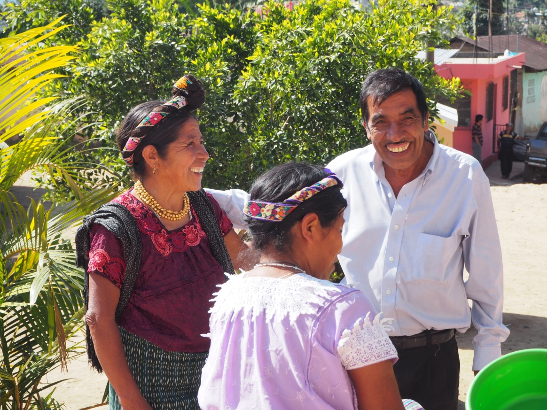
The project is located in Huista with main town San Antonio de Huista close to the Southern-east border to Mexico with a median altitude 1,260 meter over sea level. The main goal of this project is to plant seeds to provide food for the poorest Mayan families in the region - i.e. income less than 2$/day. An additional objective is to teach them how to best treat the plants using biological treatment methods, the use of herbs for natural medicines, selection and preservation of seeds for the next planting period and to organize workshops on reproductive health.
The dry season in this area starts in December and lasts until April. The rainy season begins in May with the heaviest rainfalls typically in October. Mayan agriculture in addition is governed by a sacred ancient calendar with the name Chol Q’ij (Kiche dialect) therefore planting will start in June with results seen three months later. Since this region is also part of the dry corridor in Central America the project will be managed in order to have the lowest risks for the seeds.
Currently, a series of activities are ongoing including the family selection and teachers who will run the training. All training will be in San Antonio and the participants will be taken to town by bus. The participants’ selection is done together with local groups in ten villages in the Huista region. Below is a picture from a meeting of one such local group. Each group proposes the members that should be part of the project. In addition, other members of the organization select the best local seeds (corn, beans, herbs), trees (lemon criollo, orange) and native birds (chompipollos) in order to be ready when planting starts.
