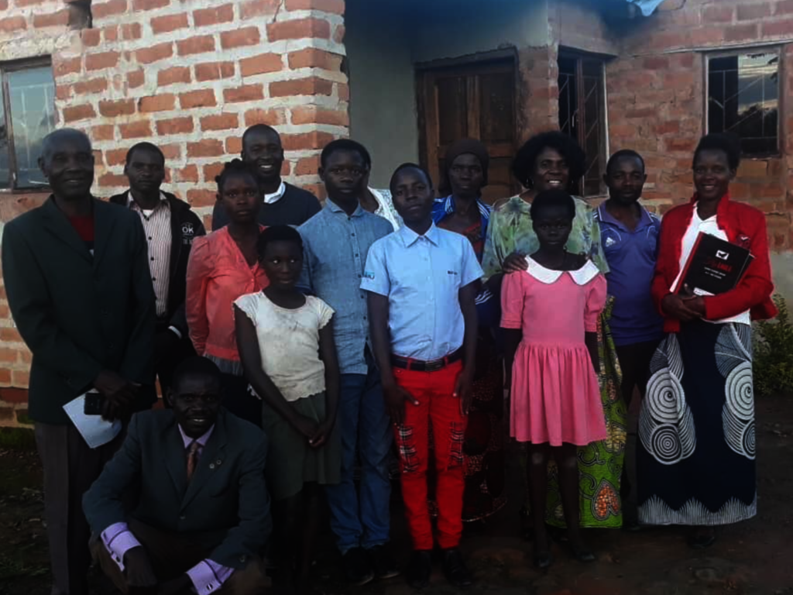

UPGRGRADING COMPASSION ORPHANAGE IN ZAMBIA

Summary

One of the steps taken to alleviate poverty and avoid an orphan become a destitute, was to upgrade the community based orphanage called Compassion Orphanage in Saili community which is situated 3.5km along the Luwingu-Mansa Road in Northern Zambia. However, the facility accommodation has challenges which include power, water supply and sanitation. The orphanage is currently accommodating 8 children comprised of 5 boys and 3 girls respectively. 32 others are being kept by their relatives because there is not enough space at the orphanage to accommodate all the enrolled orphans. However in special occasions they are invited to come and share good moments together with their colleagues if any support is given to the orphanage by well-wishers.

Members of the community have come up with a committee that looks at the affairs of the orphanage whereby some members have devoted their lives to take care of the 8 children that are currently living in the orphanage house. The members of the committee are all volunteers

Aim

The aim of the project is to improve the lives of 40 orphans and vulnerable children who could have lost hope due to being an orphan, by providing care, support and protection through food, and clean water and sanitation and decent accommodation.

Problem statement
In the urban and the rural community of the Luwingu district in Zambia most orphans and vulnerable children, are about to drop out of school due to lack of financial support Some don’t even have a chance to go to school at all and end up as street children or engage into criminal activities just for them to have a meal for the day. Others begin to work in the fields as child labour for little money. Most girls choose early marriage. High rates of HIV play a role in exacerbating poverty in Zambia. Statistics show that, 1.5 million million children out of 8.4children are orphaned as a result of the disease. However, some children showed willingness to continue with school should the situation improve.
Solution

The orphanage has identified orphans and vulnerable children, provided good and enough accommodation, food and boarding facilities, medical care and medicines.
The orphanage provides quality education for all the children by sending them to nearby schools, pay school fees, provide uniforms and books and meet all the school related costs. The project provides counseling and guidance to all the children regardless of their backgrounds.
The Zambian Association in Belgium plans to help the orphans to realise that there was still hope of them becoming a responsible citizen.
Project Goal: (What are we achieving with this project?)

The main goal of this project is to improve the lives of more than 40 orphans in the district of Luwingu Northern Zambia. However, this goal will and can only be achieved through different objectives that have been identified as direct key drive to the goal. These objectives are in line with the National agenda and this is according to the Zambian government 7th Development Plan. The Agenda emphasizes the need to provide clean and safe drinking water in order to prevent water borne diseases. It also encourages to diversify the economy by not depending on copper mining which is the main Zambia’s economic driver, but to get into agricultural activities.
And these objectives are:

Objective 1: Providing a descent accommodation for all the orphans;

Currently, the orphanage has the bed space of the 12 Children while the rest have gone back to their relatives who cannot even afford to take care of them. The idea by our organisation was to bring all the 40 orphans to live under one roof. This will help these children feel they belong to a family and also help them grow under one voice of command, learning same principles of life together as one family. Therefore, providing enough descent accommodation will be a great mile stone for the orphanage.
A kitchen will also be built.

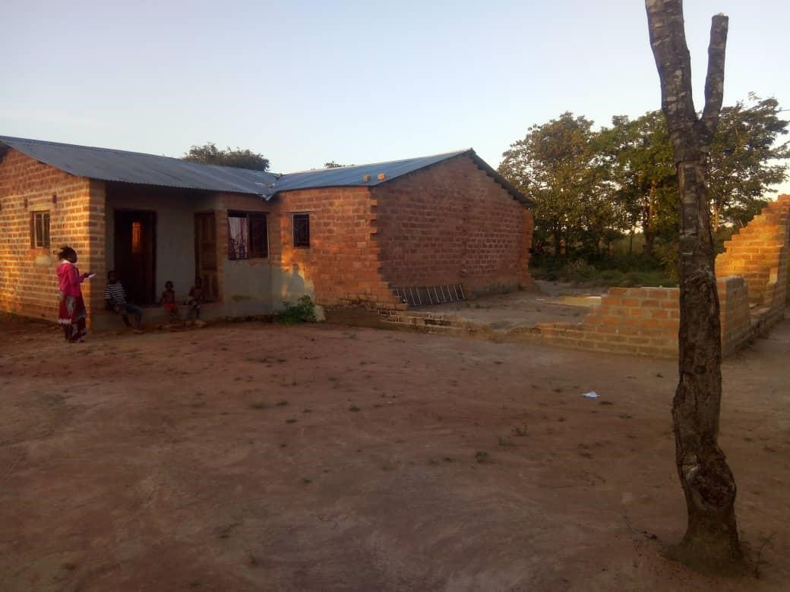

The front view of the unfinished orphanage house that needs to be completed to provide the much needed accommodation to all registered orphans under compassion orphanage

Objective 2: Water and sanitation

Good or descent accommodation goes along with the good and safe drinking water “A healthy generation is believed to be productive generation” The institution will accommodate many children of different backgrounds, beliefs, and age groups, hence water and sanitation will be considered too. This will lead to reducing mitigating the spread of waterborne diseases.

Therefore, Installation of a submersible pump and erecting 2 x10000 liters tank and construction of a modern ablution block with two segments males and females from the foundation level to completion will be inevitable.

Objective3: Providing quality education and closer to the learner

Education is the key to eradicate poverty and if a child is not given quality education, then the foundation of that child not having a bright future is compromised
The current situation at Compassionate orphanage is that orphans are enrolled in nearby schools.
However the children are made to walk a distance of 5km in order for them to access education every day for 13 weeks in a term. The long distance covered has an adverse effect on their education because they are always tired.
In reality 5km is not that long a distance but the fact that the children walk through a thick bush, they face a danger of being kidnapped or killed for ritual practices and child molestation especially girls. Therefore, constructing a 1x3 classroom block within the premises of the orphanage will keep the younger orphans safe.

Which activities will the project carry out?

Activity 1: Completing the unfinished orphanage house
Roofing, completing the wall, electrical wiring, plastering both inside and outside, grazing, painting

Activity 2: Construction of a kitchen equipped to prepare meals for 40 children

Activity3: Installation of safe and clean water and construction of a modern ablution block respectively.

Constructing a modern ablution block from the foundation stage to the wall plate, this structure will have two segments for boys and girls, and it will comprise of 2 toilets and two showers both sides. It will also have two attached toilets for male and female members of staff.
Activity 4: Installation of a submersible pump and erecting 2x 10000 liters tanks and venturing into agricultural activities as a sustainable measure to be undertaken.

This will be done only in one phase which will include preparation of the land marked for agricultural activities, installation of a submersible pump and water storage tanks 2x10000ltrs, connecting the irrigation equipment and subsequently starting the process
Activity 5: Construction of a 1x 3 classroom block

Which partners are we working with? Which task has each partner to perform in this project?

For the organization to execute its project to the fullest, key stake holders or partners will be brought on board for the sake of transparency, quality
We work with partners
(a)The church and the local committee, providing spiritual guidance to the growing children so that they grow as responsible and well-behaved child
(b)The Education district office; this office has already started helping us by giving us the standard drawing ( building plan for the anticipated 1x3 classroom block to be constructed for the orphans in future.
(c)The local Authority, it is very much important that the local authority to be brought on board especially when completing the main house as well as when constructing the modern ablution block, several building inspection shall be conducted in order to do things in accordance with the law.

Target group:
The target for this project is to reach out to 90% orphans who are vulnerable not only in the saili village but also in the whole district of Luwingu and its neighboring respectively. The registered number is 40 and the target number is to have 100 children being kept at one place provided with food, good water and quality education.

Beneficiaries;

(a) The families of the affected children will have a direct benefit in that it would have been a burden relief by having part of their family members being taken care of some were else,

(b) The community will benefit a lot, jobs will be created, like a security guards, care takers, cooks. Trades men around the village will have employment during the execution of the project e.g. Plumbers, bricklayers, carpenters electricians.

(c) The government of ZAMBIA will benefit indirectly in that the institution will be contributing to the growth of the economy through their sell of their agricultural merchandise and the output from the workshop respectively.
Secondly the government will not have a burden to think of how to take care of the increasing number of orphans.

(d) The community and the district at large shall have an indirect benefit. If the 100 children are not raised in good manner, the repercussion is huge in that, the levels of illicit behaviors get to rise such as, prostitution, theft, and other bad things, Production becomes low hence the local economy suffers.
Agricultural activity is one of the best sustainable skills which every child would afford to grasp while at the orphanage. Apart from it being a source of food, it also provides employment if it is taken to a large scale.

Evaluation: How will the project be evaluated?

Every activity will be done in phases and according to time allocated, therefore, at the end of each phase the a technical team which shall comprise of the project coordinator, some members of the committee of Compassionate orphanage, the financial controller from the Association, the buildings officer from Education and the site foreman shall sit and carry out an Evaluation session in order to determine two important aspects, (1) Is the project on schedule or not (2) Is the project within the budget or not (3) Is quality being adhered to if not what quality measures that should be put in place in order to achieve the quality (4) Are the materials being used according to the specifications? This is the evaluation criteria which will be used to evaluate each phase of every activity, note: that every phase has it unique deliverables to be realized.

Long term impact.
The 40 Orphans in this community will be able to read and write, participate in group activities and be social human beings. The children will have a chance to continue their education and /or find a job. And by so doing these orphans will realize their dream and become self-sustainable people, future leaders and responsible citizens who shall contribute positively to the economic growth of the country and the world at large. The orphans and vulnerable children will have high esteem and become resourceful. This will bring an end to generation to generation poverty therefore achievement of sustainable development goal 1: No poverty.
Through the face lift of infrastructure, improvement of water and sanitation issue, the orphanage shall attract support from various stake holders. E.g. district Education Board Secretary Office which would deploy qualified teachers to teach at the orphanage.

