The story of baby John and his mum highlights the importance of the Home’s role as a rescue centre.Baby John, who was 2 days old, was brought in by the Children’s Department as his 16 year old mother abandoned him after birth. The young mother was the victim of a rape by a 55 year old man who is close to her family and because of the close relationship efforts have been made by some family members to not have her press charges against him and give up the baby up for adoption.

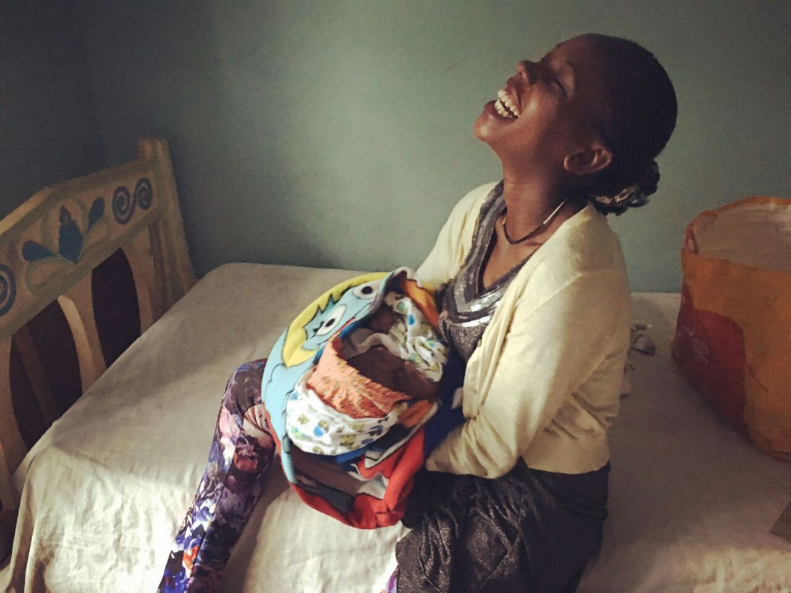
A few days after he arrived at the Home, Baby John developed a severe chest infection that necessitated immediate hospitalization. He did not respond very well to the treatment and his health continued to deteriorate. The paediatrician eventually asked if the Mother could be brought to the Hospital so she could shed some light on what happened when the baby was born.

Through this very brief encounter, the Mother began to develop a bond with her baby. With the information she was able to provide, the correct treatment was given, and within a week he was discharged from hospital. After a couple of weeks at the Home during which his course of medication was completed, in consultation with the social worker from the Kiota Rescue Centre, the Children’s Department and the police, Baby John was formally reunited with his Mother. They are now in a Home in Ruiru, a small town on the outskirts of Nairobi, that caters for young mothers, where she will stay until the trial is complete.

