One Acre Fund Page 1 of 2
Hungry farm families growing their own way out of poverty
Kenya, Rwanda, USA. Contact: stephanie.hanson@oneacrefund.org
Two Page Concept Note + Appendices

Overview
Africa faces an unprecedented food crisis – the price of basic food staples have doubled in the last five years. Families that already spend most of their income on food are facing longer “hunger seasons.” In rural East Africa, 14% of children die before reaching age five, with more than half of deaths related to hunger and malnutrition.

The only permanent solution to Africa’s food crisis is a sustained, dramatic increase in farm production. One Acre Fund is a 501c3 that attacks the hunger problem not through food handouts, but by investing in small farm families to increase their harvests. Our innovative model on average triples raw food production (and doubles farm profitability, net of input cost). We currently work with 22,000 farm families in Kenya and Rwanda, growing at more than 100% per year.

Program Description
Amazingly, 75% of the world’s hungry people are farmers. One Acre Fund makes a simple investment in their farms that dramatically increases yield. We provide a “bundle” of services to the poorest farm families in the world:
- Farm inputs (physical capital): We provide seed and fertilizer
- Credit (financial capital): We provide farm inputs on credit, and we expect repayment
- Education (human capital): We train farmers on how to use these technologies
- Markets (trade): We assist farmers with selling of yields

There are many agricultural programs in the world – what makes ours unique is the complete bundle of services that we provide. Previous farm programs might only provide a small loan to farmers – but farmers would not be able to find seed and fertilizer (farm inputs) in their community. Even if farmers could find farm inputs, they wouldn’t know how to use them (education). Even if they could find the inputs and use them successfully, there would be nowhere to sell their surplus harvest (markets). Farmers need support in more than one area. One Acre Fund’s bundle of services provides a solution for those starting with nothing.

Impact
On average, we triple a farmer’s harvest from ½ ton per acre to 1½ tons per acre. They typically repay us about ½ ton for our services, leaving their net profit at 1 ton per acre (double their original profit).

These results are based on a randomized survey of 700 farm families. Our full-time monitoring and evaluation team physically weighs the harvests of a random sample of the families we serve, and compares that against a comparable control group. This allows us to have high confidence in the quality of our impact. Additionally, we are in the process of an external, randomized test-and-control study with Poverty Action Lab/ MIT with 1,000 of our farmers. These independent academics are engaging in a gold-standard test of our average impact per farmer.

Results
In 2006, our first year of operations, we served 300 farm families. In the last four years, we have grown to 22,000 families. Our solution is built to be broadly scalable, and we will serve 40,000+ families by 2011, and 70,000+ families by 2012. During this high-growth phase, we will achieve a repayment rate of >85%.

“Investment Thesis”
One Acre Fund seeks to be the most cost-efficient and measurable way to convert donor dollars into increased income and food for some of the poorest families in the world.
One Acre Fund Page 2 of 2
Hungry farm families growing their own way out of poverty
Kenya, Rwanda, USA. Contact: stephanie.hanson@oneacrefund.org

One Acre Fund has five core values that distinguish our work:

1. We Serve the Poorest of the Poor as Customers
One Acre Fund proudly serves some of the poorest people in the world, and dignifies them as our customers – our “boss.” Our client base has a baseline child death rate of 14% who do not survive to age five. Our baseline household income averages ~$0.50 per day per person (compared against the standard PPP dollar-a-day poverty threshold). Our entire organization is geared to learn from these “customers” and to dignify them with private-sector-style service.

2. Don’t Give – Invest
One Acre Fund believes the poor have the power to grow their own way out of poverty – they just need the right tools and training. Our “investment package” of seed, fertilizer, and training costs about $120 per family served, and we expect those families to pay back their loan at harvest time.

The power of an investment is that our customers have a hand in their own growth out of poverty. They only partner with us if they are committed to working hard and succeeding. On our end, because our loan funds are “at risk,” we are forced to deliver excellent customer service. This partnership is cemented together by mutual economic interest, and creates permanent, sustainable behavior change among clients.

3. Measurable Impact
One Acre Fund precisely measures our exact impact on farm income. Every season, we take a random sample of our harvesting clients (test), and compare their yields against a random sample of newly-enrolled clients who have yet to plant with us (control). Our survey agents physically weigh the harvests of these farmers, and we calculate the resulting gain in profitability caused by joining our program. We use these kinds of metrics across all operational units, and use this business intelligence to guide our decision-making at every level.

4. Cost-Effectiveness
A further benefit of an investment model is that we recover the funds that we loan to farmers at harvest time, allowing us to invest in them again the next year, and to reach more farm families. Although we rely on donor funds for new site startup and long-term infrastructure, adding new clients to our program is relatively inexpensive because marginal customers are largely self-funding. This creates enormous potential scalability in our work, and we have an ambition to grow far beyond our 30,000 customers initially targeted.

5. Ambition to Scale
The microfinance movement makes small loans to entrepreneurs, enabling them to increase their incomes and pay back the loan. The power of the microfinance model has caused it to scale to nearly every urban and peri-urban area of the developing world – but not yet to farmers, in any significant way.

One Acre Fund makes the idea of “investing in the poor” relevant to farmers. Our package includes targeted services that enable our families to double their income, and pay back loans. 75% of the world’s poor are farmers, and there is an incredible opportunity to help start an entire new industry focused on micro-farm lending. We believe we have a moral responsibility to scale our model to bring our life-changing seed and fertilizer to as many families as possible.
Appendices Appendix A

Appendix A: Client Story/ One-Page Handout

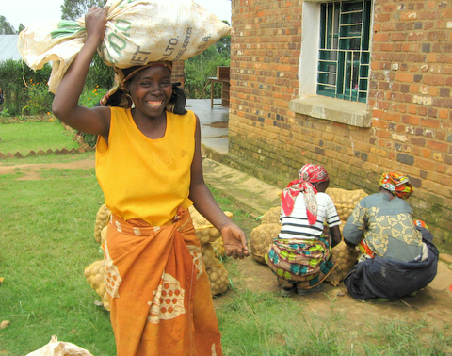  Francine Mukasine in Nyamasheke District of Rwanda, at a One Acre Fund credit distribution day. She will carry her farm inputs back to her home. | Francine Mukasine was excited - today was the day that she would receive One Acre Fund farm inputs that would multiply her harvest. As part of One Acre Fund's work, we deliver farm inputs (seed stock and fertilizer) within walking distance of our farmers' homes. Our farmers carry the farm inputs home, usually on their heads.  Francine will plant a half-acre of land using 140 pounds of seed potato, 80 pounds of fertilizer, and 40 pounds of certified climbing-bean seed. She estimates that she will earn $200 in profit, after repaying One Acre Fund at harvest time. That might not sound like a lot, but that is more than a doubling of annual farm income for Francine's family. Francine has five children, ranging from six months old to twelve years old. She hopes to educate all of
them, and feed and clothe them properly. With the prohibitively high costs faced by rural Rwandese, this could be difficult, but she is excited to work hard and reach her goals.
Much works remains for Francine. There is planting, weeding, pest and disease surveillance - countless hours of manual labor using a hand tool. But this is work that she is good at, and she is eager to get started. This season, Francine feels confident that her hard work will finally pay off!

One Acre Fund at a glance:  - We humbly serve some of the poorest people in the world: 14% of our children do not survive to age 5  - We do not give handouts – we empower farm families to grow their own way out of poverty – these families pay us program fees to participate  - We measure our results – our average impact is to double the farm income of families, and we closely monitor our quality of impact  - We must dream big – there is so much suffering in East Africa, and limitless opportunity. After four years, we now serve 22,000 farm families – in two more years, we will serve 70,000 farm families  - Business execution – we use “practical idealism”  - Join us: www.oneacrefund.org  - Together we serve! | 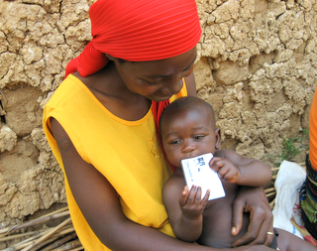  Francine holding her littlest child, Davide. He is holding the family's One Acre Fund membership card, which is apparently good for chewing on.

Appendix B: Program Model in Detail Appendix B

Program model
One Acre Fund’s program model was formed by talking with farmers and discovering what they needed to succeed – a “bottom-up” approach. We found that the individual items they needed to achieve a good harvest were quite common (e.g. finance for farm inputs), but that it was the multiple barriers they faced that prevented them from reaching success. For example:
- Inputs availability: Although finance is widely available throughout East Africa, farmers could not purchase fertilizer and seed because it was not even available in their village.
- Education: Even if fertilizer and seed could be obtained, farmers almost always lacked the knowledge to use it, resulting in a negligible lift in harvest.
- Markets: Lastly, even if farmers had achieved a large harvest, they were unable to connect to markets in order to sell their excess crop at a reasonable price.

In response, we designed a model that delivers a whole, functioning value chain to farmers:
1) Creation of producer groups: One Acre Fund organizes existing women’s groups into producer groups.  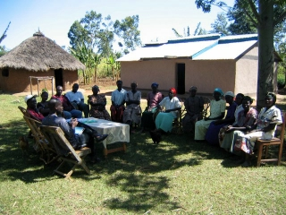 | 2) Farm inputs: One Acre Fund finances and delivers planting materials.  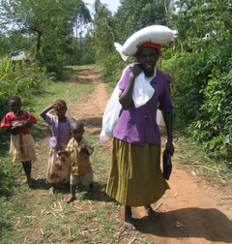
3) Extension: One Acre Fund field officers deliver education to groups, so they know how to use the farm inputs.  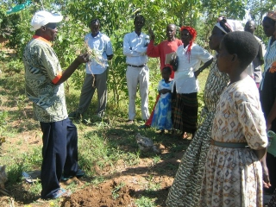 | 4) Output market: One Acre Fund facilitates harvest markets and takes repayment for our services.  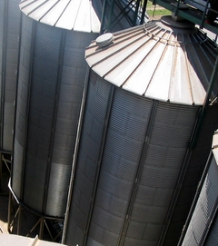

It is the completeness of our service bundle that makes One Acre Fund innovative. Farmers do not need to have anything when they begin our program – only a willingness to work hard. Each piece of our model works together with the other pieces to make a fully-functioning market for farmers:
- Producer groups give farmers market power and reduce transportation cost
- Farm input distribution on credit makes farm inputs accessible, in the farmers’ own village
- Education makes it possible for farmers to actually use farm inputs effectively
- Market facilitation makes it possible for farmers to sell their crop, repay us, and gain income

We have proven that this model generates large income gains for farmers. Now we need to prove that we can execute this at scale. Our milestones for the next three years are to show that we can do this 1) at scale: for 70,000 families, 2) while maintaining impact for poor people: 100% gain in farm income, 3) at financial break-even: all field expenses covered by program fees.
Appendix C: Field Execution Appendix C

Field organization structure
When entering a new community, One Acre Fund first mobilizes existing women’s self-help groups, and consolidates 50-100 farmers into a farm producer group. We attach a field officer to this group, who administers our services: base education, contract signing for credit, local farm input distribution, education services, and receiving of repayment. Over time, each field officer grows to serve 200 farmers.

These field officers are typically recruited from the communities that they work. We don’t hire university-educated horticulturists for our field staff (like most NGOs), because most of what farmers need to know is encapsulated in a few simple lessons. We prefer to employ down-to-earth, hard-working staff who have strong leadership potential within their own communities.
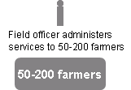

5-10 field officers are supervised by one “field manager.” At full growth, a district of operations will have 5-10 field managers, supervising 50-100 field officers, serving 10,000-20,000 farmers.
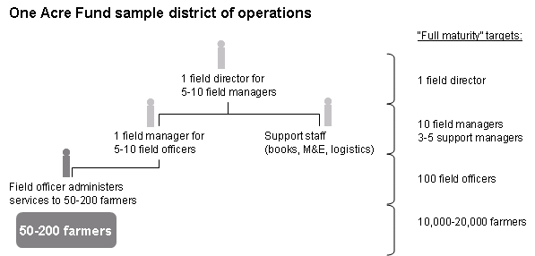

At the district level, we hire one field director to lead overall day-to-day operations. This field director is supported by a bookkeeper, between 1-3 monitoring and evaluation officers, and a logistics person. Because of the large amounts of farm inputs that we are bulk-purchasing for a district (700 tons per season at a scale of 10,000 farmers, delivered to 100 different drop-off points), the back-end logistics can become fairly complicated.
Appendix D: Three-year milestones and vision Appendix D

Three-year Milestones
Our organization is driven by metrics, and we have three major milestones that we strive to reach: scale, quality of impact, and financial sustainability.

Our proposed milestones for the next three years are summarized as follows:

Scale
Current: 22,000 farm families
2011: 40,000 farm families
2012: 70,000 farm families

Impact
- 2x farm profit on average
- Halve child death rate

Financial Sustainability
Current: 50 percent of field costs covered by farm revenue
2011: 65 percent of field costs covered by farm revenue
2012: 80 percent of field costs covered by farm revenue

Scale milestones will be reached by same-district growth, as well as through the launch of new districts. Impact milestones will be closely monitored by our measurement staff, and will be achieved by maintaining or improving program quality. Sustainability milestones are covered in more detail in the program budget. As our program reaches more farmers, we will be able to achieve significant economies of scale.

Vision
Reaching our 2012 milestones will be an important validation point – to have an impactful, financially sustainable program at a “respectable” scale of 70,000 families. Yet this is only a drop in the bucket compared to the ocean of need in East Africa.

We hope to use this validation point as a launching pad to grow a large revolution in small-farm productivity in Africa.
- After this stage, we will continue to scale our own program at anticipated 50-100% per year, which is realistic when benchmarked against microfinance institutions. There are hundreds of corporations worldwide with 50,000+ employees and $1 billion in revenues – we aim to grow as large as those corporations
- We can infect partners with large, existing retail bases of customers to implement our model – even this early, we are in early discussions with three different, well-known partners expressing initial interest in adapting our model to their clients
- We can set up a One Acre Fund franchise system, and equip social entrepreneurs with a toolkit to launch our program in a new geography
Appendix E: Measurement Strategy Appendix E

One Acre Fund strongly believes in measuring our exact impact per client served. Although scalability is a key focus for us – “reach a lot of people” – equally important is the depth of our impact per client. We believe that all non-profit organizations should be measuring this carefully, yet very few do.

Internal evaluation
One Acre Fund currently employs seven full-time monitoring and evaluation (M&E) staff. This is cost-effective, and the total salary bill for these staff is under $10,000 per year.

Every year, our roster database selects a random sample of test and control clients. Test clients are those that have completed a harvest with the One Acre Fund program, while control clients are newly enrolled One Acre Fund clients that have yet to plant with our program. Therefore, the test and control groups are highly similar. Once clients are selected, our M&E staff visit each of their farms, physically weighs a sample of their harvest, and determines farm income.

This past year, we completed a survey of 300 total test-and-control clients. When comparing test to control farmers, we verified a 100% average gain in profitability on every planted acre (slightly more than double profit). In dollar terms, this was approximately $170 USD per client.

One Acre Fund also cares deeply about how gains in income translate to real change in family’s lives. As such, our M&E staff also conduct a twice yearly quality of life survey, where we ask a sample of our farmers for information such as living conditions, school attendance for children, physical and financial assets, and child health. One Acre Fund looks for changes in these metrics over time and compares them to available government data to approximate the impact attributable to our work.

External evaluation
One Acre Fund recently started an external evaluation contract with the Poverty Action Lab (PAL) associated with MIT, Harvard, Yale, and UCLA professors.

PAL as a whole is one of the most highly respected research and evaluation shops in the field, with funding from the Bill and Melinda Gates Foundation. In comparison, the vast majority of international development non-profit organizations use the same pool of “soft” evaluation shops that use sub-academic quality evaluation methods and uniformly give glowing appraisals.

Over the course of this year and next year, PAL will work with 1,000 farmers in Kenya. These farmers will be randomly split into test and control groups, and their harvests carefully measured. Those farmers receiving the full One Acre Fund program will be compared against those receiving nothing, resulting in a reliable external evaluation of our average impact per client. The PAL study will also measure the incremental impact of each component of our model, allowing us to better understand what drives results and how we can improve. Finally, PAL will look at One Acre Fund’s impact per dollar invested and compare that to other interventions in our area. One Acre Fund aspires not only to have real impact, but also to be the most cost effective option for our target population.

We are excited to be working with one of the field’s leaders in the measurement of social impact and look forward to sharing the full results of this work, positive or negative, with our supporters.
Appendix F: 2007-2010 Financials Appendix G

One Acre Fund’s budget is broken into four major pieces.

1. Farmer Revenues for our services. These are funds repaid by our farm families for program services.

2. Field expense primarily includes farm inputs cost, but also includes field staffing (field officers, field managers, support staff), inputs transport, and various ancillary costs like membership cards, sign posts, etc.

(Note that field expenses are incurred approximately 8-10 months before field revenue – therefore, even if revenues match expenses, a substantial amount of working capital is required).

3. Corporate expense includes one US staff person, bank fees, and in-country monitoring and evaluation staffing and will always be funded by donors. The primary cost however is expatriate staff (Americans) working in East Africa. These expatriate staff are engaged in a variety of special projects related to building out our core model – we are investing heavily in systems that we hope to scale to millions of farmers. These expatriate staff are also paid extremely low salaries.

4. Net Donor Field Expense: due to small scale, we currently rely on donor grants to cover a large percentage of our field expense, as well as cover our corporate expense. In 2010, we anticipate raising about $1.4m in donor revenue to cover long-term infrastructure, and new site start-up.

