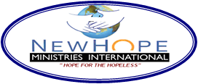

**NEW HOPE COMMUNITY CLINICS**

**PROJECT PROPOSAL**

**“HOPE FOR BETTER HEALTH”**

**Overview**

New Hope Ministries International Inc. is a non-profit organization total health in our community and abroad. We assist the less fortunate according to their needs by taking a missionary team annually to Haiti and Dominican Republic for a short-term humanitarian trip. Since 1995, the team has focused its efforts toward Haiti, a country who is facing some dark periods of its political and social history. We worked in different poorest areas by providing medical care, distributing food, clothing, school supplies, linen, teaching sanitary and community health prevention. Furthermore, we spread the love of God with evangelism sessions in the communities and we organize some socio-educative-activities for the children during the day, providing two meals. New Hope Ministries International Inc. operates two community clinics in partnership with the Ministry of Public health and Population, Haiti. Acronym: (MSPP).

**Demography of the locations**

New Hope Community Medical Center of Hincheis located at the Central area of Haiti approximately 8-10 miles from the capital. It possesses a small laboratory space and a small pharmacy open to the public. The population of Hinche is about 10400 citizens and the clinic serve also two other remote communities. There is only one general hospital at Hinche where the health infrastructure both for curative and preventive services has been gradually deteriorated during the last decade and thoroughly towards the whole Country. New Hope Community Medical Center opened its door in 2008 and have deserving this community and abroad. Our clients are mostly children and pregnant women. However, the services are available to all and a percentage of adults are served.

New Hope Health Center of Changieux has opened since 2016. The center has a laboratory area and a small pharmacy. Changieux is a village located up to the hills of South of Haiti. Along the abroad communities, it has a population of 28-30000 citizens. There is no hospital around except down the hills in a city to riding on motorcycle for two hours. The people survive with agriculture products and do not have access to health system in the neighborhood cities. Consequently, a partnership agreement has developed within New Hope and the Ministry of Health to operates a clinic in the area and to deserve this population as preventive and curative medicine.

**Impact of services**

Both clinics has contributed to the development of community health through changes in environment, minimization of health risks, and development of local initiatives for employment, immunization, prevention of diseases, promotion of health, community actions and education of sanitary issues.

**Hardship period**

For the last two years, both clinics have struggle in the functional operations and services are decreased. We are unable to maintain our medical staff due to an unstable financial viability status. Because of the increased level of poverty, the clients cannot afford to pay their consultation fee.

**Overall goal:** To maintain the clinics in good operational function to provide the essential services to the communities and abroad. One thousand and six hundred (1600) patients, adults and children will benefit of complete medical examination with medicines every month.

**Objectives**

**•** Provide medical services along with medication to one thousand and six hundred (1600) adults and

Children every month.

• Maintain an active fundraising through network and towards communities

• Assessment of public health needs in local communities

• Implementation of maternity community projects.

**Brief description of the project**

The project is to maintain the operations and function of the clinics for those who have no access to healthcare system and live in an extreme lifestyle of poverty. We aim to maintain our clinics active to prevent diseases and promote health and safety, to improve health of local population and abroad. Through partnership, our centers tend to influence changes of people behavior, provide the necessary services, and save their lives.

**Annual** **financial Budget For two clinics**

|  |  |  |  |  |  |  |  |  |
| --- | --- | --- | --- | --- | --- | --- | --- | --- |
| **New Hope Medical #1**  **Clinic of Hinche** | | **Monthly salary** | **New Hope Community Health #2**  **Center of Changieux** | | | **Monthly salary** | | **Total of funds** |
| Medical Staff | | $380 | Medical staff | | | $360 | | $740 |
| Pharmacy technician | | 130 | Pharmacy Technician | | | 120 | | 250 |
| Nurse | | 170 | Nurse | | | 160 | | 330 |
| Lab Technician | | 136 | Lab Technician | | | 126 | | 262 |
| Manager | | 122 | Manager | | | 116 | | 238 |
| Landscaping/Janitor | | 70 | Landscaping/Janitor | | | 50 | | 120 |
| Woman/pregnancy program | |  |  | | |  | |  |
| Pharmaceutical supplies | | 1050 |  | | | 850 | | 1900 |
| Subtotal | | $ 2038 |  | | | $1772 | | **$3810/month** |
|  | |  |  | | |  | |  |
|  |  | | |  |  | |  | |

|  |  |  |  |  |
| --- | --- | --- | --- | --- |
|  |  |  |  |  |

**Monthly expenses for the operations for both clinics: $3,810.00**

**The total needed for the operations of two clinics for a period of one (1) year: $ 45,720.00**

|  |  |
| --- | --- |
| **\*\*\* 100 donors at $ 38.10 per month will save so many lives \*\*\*** |  |

Below are the New community health centers. We rescued a boy with broken arm in the street…

COVID-19 supplies distribution and demonstration

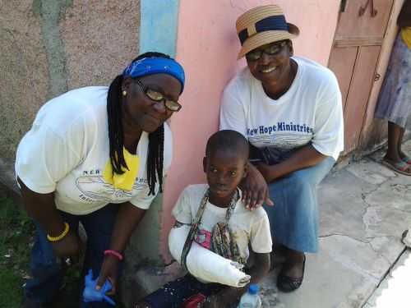 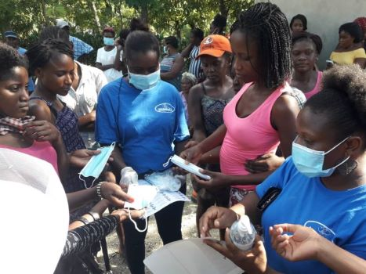 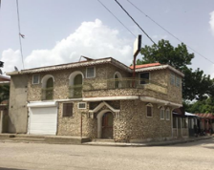

[www.n](http://www.n)ewhopeministriesinternational.com

Email: maumaud11@gmail.com or newhope7@att.net