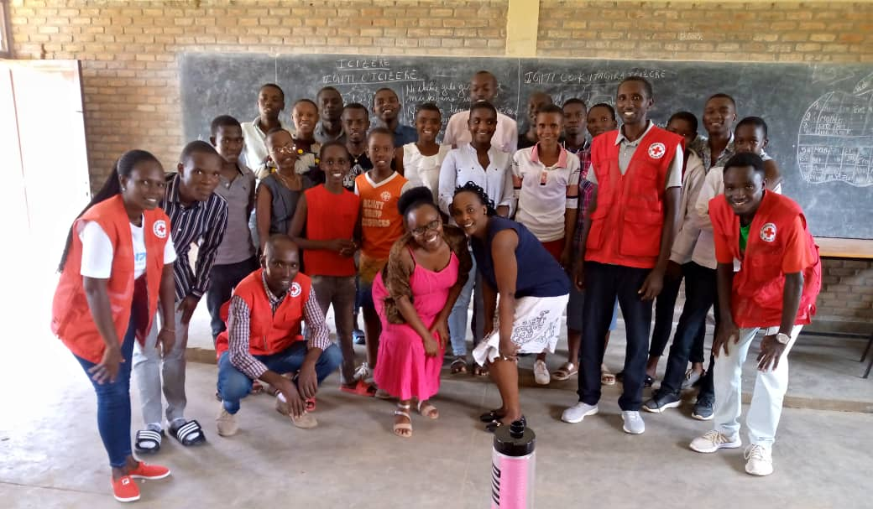
Red Cross students’ volunteers: Group Photo by N.Elie

