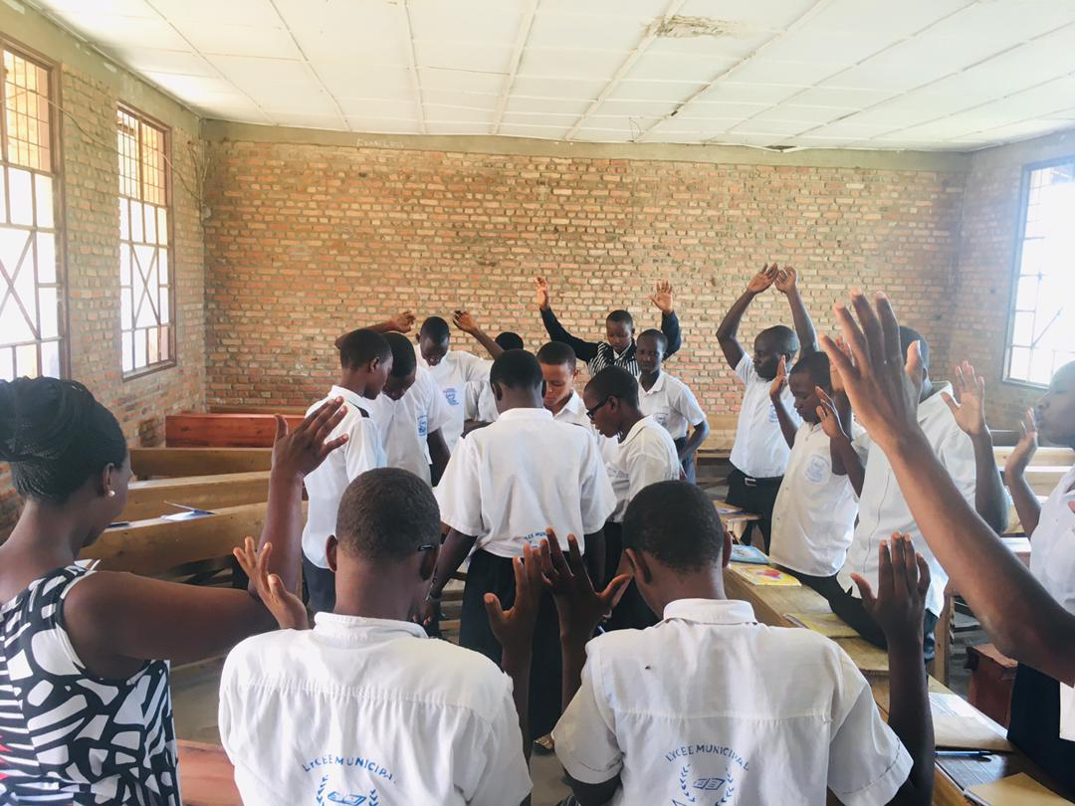

**Prayer and best wishes for returnees**